Drilling Schedule and Survey Work – Weekly Snapshot
Project: | Earthquake Ready Burnside Bridge
Subject: | Drilling and Survey Activities from August to November 2021
Date: | Wednesday, October 13, 2021
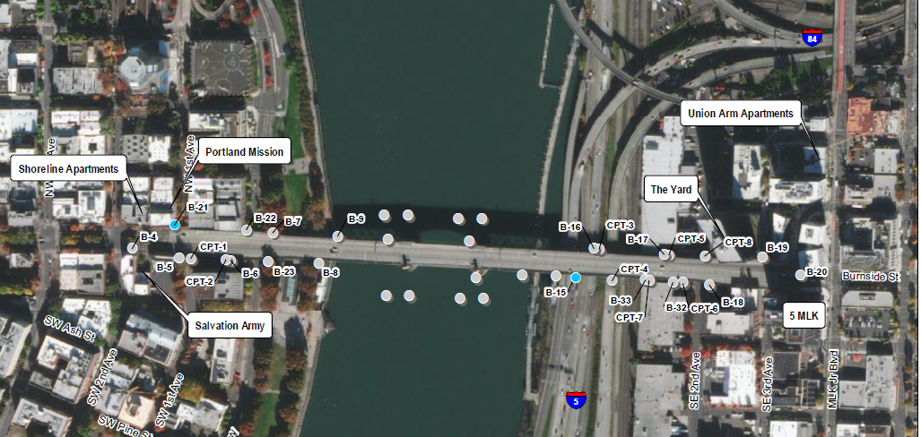
Map of all Drilling Locations from August to November
Schedule (Dates Subject to Change)
Completed Week of 10/4
- B-4 (West – near Salvation Army)
- B-5 (West – near Mercy Corps/Portland Saturday Market building)

Week of 10/11
- No on-land drilling anticipated; only in-river drilling.
- West Side: Land survey work will use rolling traffic control during the day to map roads and other features between 3rd Ave. and the river, from SW Ankeny to NW Couch St.

Week of 10/18
- No on-land drilling anticipated; only in-river drilling.
- West Side: Continued land survey work between 3rd Ave. and the river, from SW Ankeny to NW Couch St. No anticipated traffic control needed.

Week of 10/25
- No on-land drilling anticipated

Week of 11/1
- No on-land drilling anticipated

Week of 11/8
- B-21 (West – NW 1st Ave) – night work starts Sunday night, 11/7
- B-22 (West – Naito)

Week of 11/15
- B-22 (West – Naito)
- B-23 (West – Waterfront Park)

COMPLETE
- B-04 (West – Salvation Army)
- B-05 (West – Mercy Corps/Saturday Market Bldg.)
- B-06 (West – Mercy Corps)
- B-07 (West – Waterfront Park)
- B-08 (West - Waterfront Park)
- B-15 (East - ODOT)
- B-16 (East - ODOT)
- B-17 (East - Pacific Coast Fruit)
- B-18 (East - Pacific Coast Fruit)
- B-19 (East – NE 3rd Avenue)
- B-20 (East- Burnside Bridge Approach)
- B-32 (East – American Medical Response)
- B-33 (East – American Medical Response)
- CPT-1 (West - Mercy Corps)
- CPT-2 (West - Mercy Corps)
- CPT-3 (East - ODOT)
- CPT-4 (East - ODOT)
- CPT-5 (East - Pacific Coast Fruit)
- CPT-6 (East - American Medical Response)
- CPT-7 (East - American Medical Response)
- CPT-8 (East – NE 2nd Ave)

What to Expect
- All locations are within 375 feet of the bridge.
- This work will require large trucks and drilling equipment to obtain the samples.
- The drilling collects samples that are 8-inches in diameter.
- At each location, contractor activities will occur intermittently and last over the course of one to four days.
- While most of the work will occur during the day, some night work will occur. Noise can vary from the sound of an idling car to a garbage truck.
- Traffic control devices and flagging will be in place to direct traffic when needed.
- For noise complaints, call 503-988-4884 and the contractor will assist the County to address complaints within 24 hours or before the next scheduled night work.

SURVEY ACTIVITIES
WHEN: 9/27/21 to 1/24/22, daytime hours, 8am-5pm
WHAT: Topographic and subsurface survey work
You will see surveyors in areas around the bridge (see map below), including along or in the roadway, sidewalks and nearby properties. They are there to collect topographic and subsurface data for things like curbs and gutters, roadway striping, above and underground utilities and pipes, building corners, tree types and sizes, fences, bridge elements, etc.
At times, surveyors will need to be in the roadway or on properties to access manholes, vaults, or valves. If needed, traffic control devices and channeling will be utilized to direct traffic.
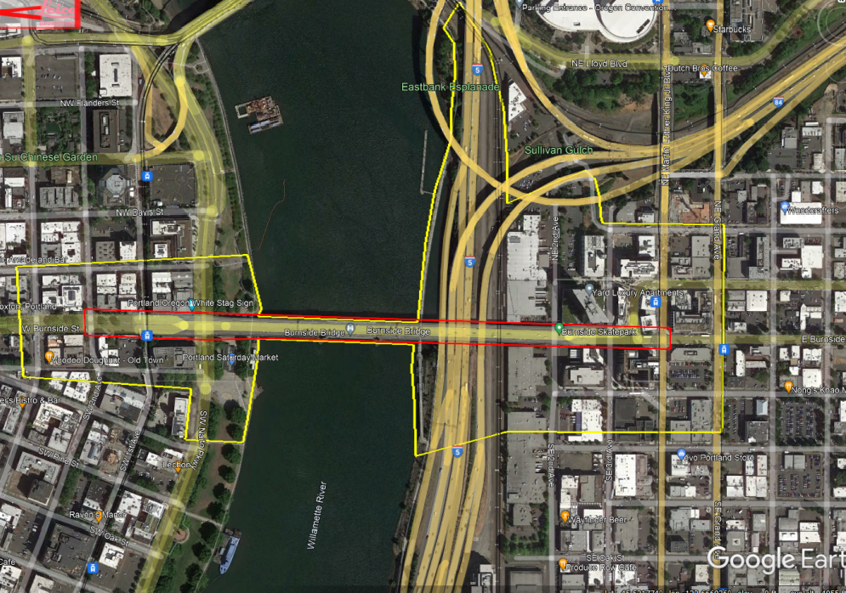
Existing survey work obtained
New survey work limits

