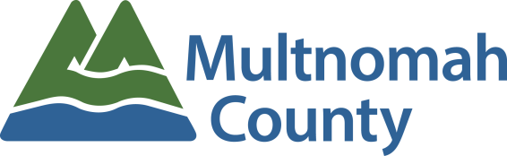
Employee Awards Nomination Form
Superior Public Service to External Customers Award

To promote and recognize individual employees for outstanding customer and public service.

Employee Being Nominated:
Your Name:
Your Email Address:
Your Phone #:

Please be as detailed and specific as possible about the nominee. The information provided will be the sole factor determining the committee’s ranking of nominees. The work should have been done (or the major project completed) between March 1, 2017 and the time the nomination is written.

Please give examples of how this person or team demonstrated excellent customer service with initiative, or implemented procedures to enhance service. (5 points)

Please give examples of how this person or team exhibited commitment, professionalism, communication skills in difficult situations and/or demonstrated good judgment in providing customer service. (5 points)

Please describe how this employee generated lasting or significant positive customer relations. (5 points)

Please provide additional information regarding this employee or team and how you feel they inspired pride in the work of Multnomah County. (5 points)

PLEASE READ BEFORE YOU SUBMIT YOUR NOMINATION:

Every description field above is scored on a 0-5 point system and scored as indicated below. Any field left blank or incomplete will be scored with a 0 or a 1. All scores are then totaled and nominees are ranked based on those totals.

0 = Not Covered
1 = Unclear: Not clearly defined; not explicit.
2 = Noteworthy: worthy of notice or attention
3 = Significant: having or expressing a meaning; important; of consequence.
4 = Distinguished: made conspicuous by excellence;
5 = Extraordinary: exceptional in character, amount, extent, degree, etc…; remarkable; uncommon, rare, phenomenal, special

Submission instructions:
- Save file to your network folder
- Attach completed saved form in to an email to: Employee.recognition@multco.us

