Aging, Disability and Veterans Services Division
2021- 2025 Area Plan Needs Assessment Survey
Summary and Preliminary Analysis

Area Plan Background
Aging, Disability and Veterans Services Division (ADVSD) a division of Multnomah County’s Department of County Human Services (DCHS) is the designated Area Agency on Aging (AAA) for Multnomah County. As the AAA, ADVSD is responsible for developing an Area Plan every four year period that describes the needs of older adults and people with disabilities in the community, current initiatives, and future goals and activities to address those needs and service gaps over the next four years.

As a part of the Area Plan process, ADVSD is required to conduct a needs assessment to engage with older adults and people with disabilities to uncover emerging or existing needs. This survey is one portion of the needs assessment.

Survey Background
ADVSD developed and built an online survey tool to learn from older adults and people with disabilities about their lives, experiences, as well as their needs and priorities related to services. For the purposes of the survey, an older adult or elder is defined as a person 50+ or an elder as defined by their community and people with disabilities 18-59 years of age.

The survey was offered in 17 languages, as follows:
- English | - Oromoo [Oromo]
- Español [Spanish] | - नेपाली [Nepali]
- 繁體中文 [Traditional Chinese] | - ဗမာ [Burmese]
- 简体中文 [Simplified Chinese] | - ቋንቋ [Ahmaric]
- 한국어 [Korean] | - ትግርኛ [Tigrinya]
- Tiếng Việt [Vietnamese] | - فارسی [Farsi/Persian]
- Россия [Russian] | - عربى [Arabic]
- українська [Ukrainian] | - Soomaali [Somali]
- Kiswahili [Swahili]

The survey included 48 issue-related questions, 33 demographic and identity questions, a needs ranking exercise,16 open-ended questions, and 13 comment fields for the community to provide additional information related to each topic area.
The survey was distributed by ADVSD and community partners, as well as promoted through DCHS and Multnomah County communications channels. To increase the number of responses to the survey, ADVSD partnered and funded 11 new and existing community partners with close ties to communities of older adults and people with disabilities with a focus on Black and African-American Elders, LGBTQ+ elders, Transgender and Gender Nonbinary older adults, older adults whose preferred language is not English, older adults with low-incomes, and homebound older adults. ADVSD partnered with the language bank at the Immigrant and Refugee Community Organization (IRCO) to make calls out to individuals to provide phone-based survey support to 128 participants speaking languages other than English. ADVSD staff provided additional calls out to 40 people who previously used ADVSD services. ADVSD paid each eligible survey respondent a $10 gift card as an incentive for taking the survey.

The survey garnered 1,893 total responses. The preliminary analysis included 1,392 responses. Five hundred and one (501) responses weren’t included in the analysis as they did not meet the following criteria:
- Agreement to take the survey
- Answering one or more survey questions
- Meeting primary inclusion characteristics
  - People 50+
  - People with a disability ages 18-59
  - Providing a zip code in Multnomah County
- All people 18+ with the following identities were included:
  - Native American
  - Caregivers
  - Veterans
  - Unhoused or homeless

Needs Ranking Exercise
The survey included an exercise to understand the level of priority or importance that people would assign to nine different needs categories. The categories we identified by reviewing previous Area Plans and included the most commonly identified needs over the past three plans spanning 12 years. This exercise recognizes that community members, particularly historically marginalized community members, are frequently and repeatedly asked to identify or share their needs.
The participant were asked to rank the following:
- Transportation - Transportation that is low-cost and accessible
- Food - Enough food to eat that supports specific dietary preferences, needs and that is culturally appropriate
- Caregiving Support - Services and support for people providing care for spouses, family members or friends with health needs
- Information - Finding information about needed community services, resources or the advice of an attorney
- Income - Enough income or savings to pay for basic needs and feel financially secure
- Healthcare - Medical coverage or health care services to meet mental health, addiction medicine, or physical health care needs
- Social Connectedness - Maintaining personal connections and participating in community activities for fun, learning, and enjoyment
- Race and Identity - Services and programs that recognize and respect race, personal identity, and culture as an inseparable part of life, experience, and wellbeing
- Housing - Housing that is affordable, in good repair, and in a preferable location

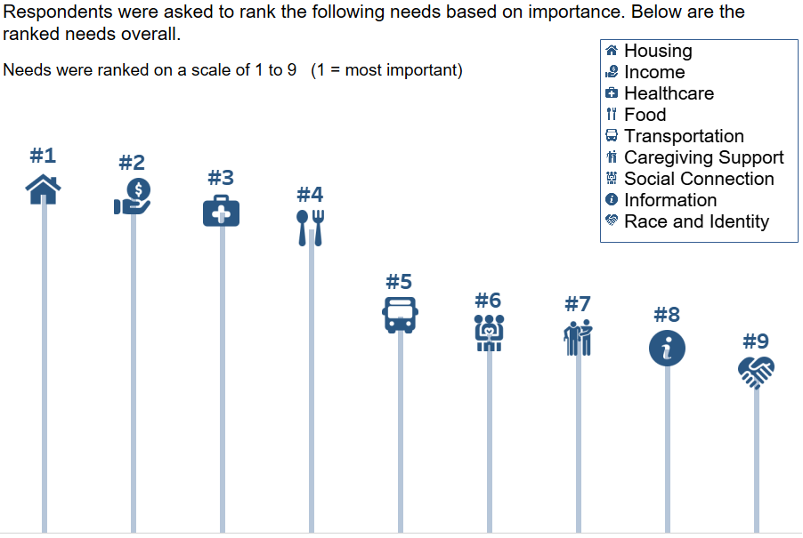

What we learned from community members through the needs ranking exercise:
- Income, housing, food, and healthcare were resoundingly ranked among the top four needs among all respondents to the survey. Among the top four needs, food access is the only need directly addressed by ADVSD through Older American’s Act programs and services.
- Transportation remains a high need among the overall population of respondents.

We asked community members to share any other important needs not included in the ranking activity?
- Improved safety and sense of security
- Employment opportunities and support
- Greater access to public spaces, especially parks and other green spaces
- More technology training and ways to access information for those who do not use technology

Transportation
We asked community members to share the barriers they experience related to transportation. (% out of 966 responses. Respondents could select multiple answers.)
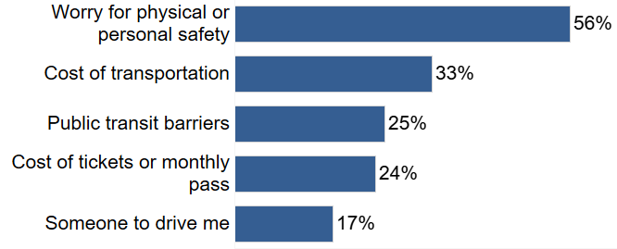

We asked community members to share how often did you use the following kinds of transportation before the COVID-19 pandemic started.
Scale = 1 represents “All of the time” 5 represents “Never.”
The lower the average number next to the mode means the more frequently the mode of transportation was identified as being used pre-pandemic.
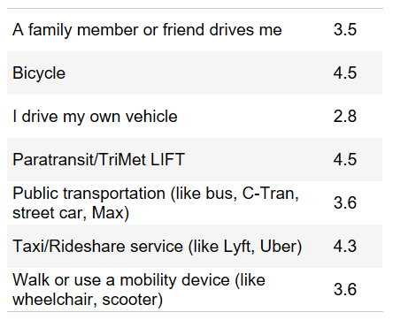

What we learned from the community about Transportation
- 42% have missed a medical appointment due to transportation issues¹
- 59% have been unable to participate in an activity due to transportation issues²

¹ % out of 1314 responses
² % out of 1322 responses

What we learned from narrative comments shared by community members about Transportation resources or needs:
- Inaccessibility of public transit - Accessibility issues regarding public transportation revolves around mobility of community members, current transit routes, and existing infrastructure.
  - Current public transit routes do not have stops or transfers that are within walking distance for those that have mobility issues
  - Transit routes and schedules limit when older adults with no other transit options are able to go out
- Inflexibility of transit services - Those utilizing public transportation and transit services experience issues with scheduling, wait times, and availability of rides.
  - Transit services have a lack of flexibility for scheduling but require older adults to be flexible with wait times
- Easily accessible information regarding transit options
- COVID-19 has greatly reduced the ability to take public transportation.
- The use of personal vehicles is common among older adults but they experience issues with continued costs and utilizing existing infrastructure.

Food

We asked people about which food assistance programs they used over the past year. (% out of 804 responses. Respondents could select multiple answers.)
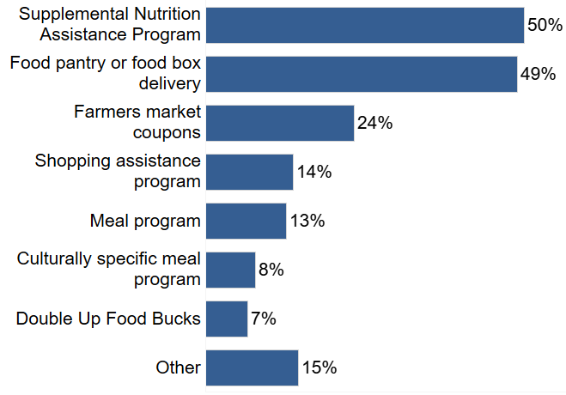
We asked people if they have done any of the following for the first time since the COVID-19 pandemic started in March. Select all that apply.
(% out of 950 responses. Respondents could select multiple options.)
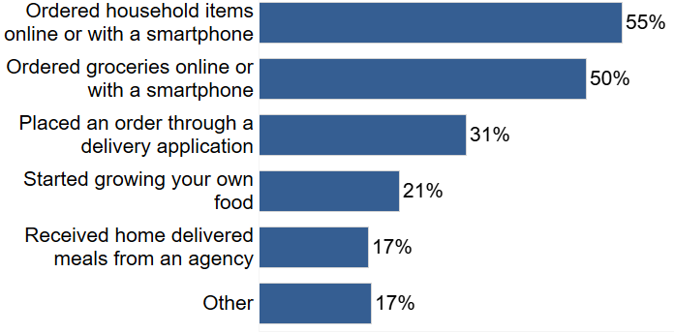

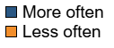
We asked people to share how often they have done the following compared to before the COVID-19 pandemic started. Percentage shows the number of responses out of the number of responses to the question.

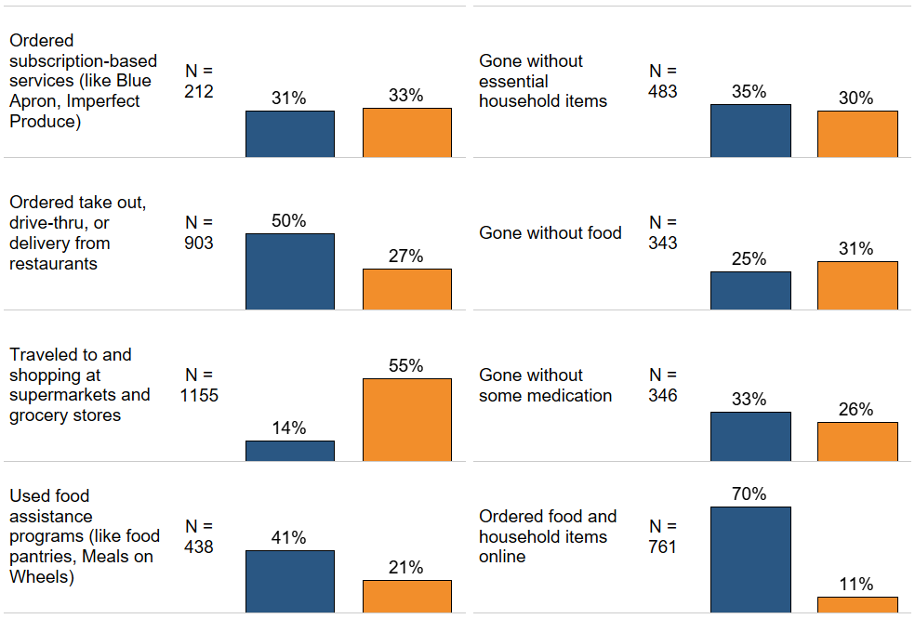

What we learned from narrative comments shared by community members about food resources or needs
- Inaccessibility of fresh produce and dietary specific food items
  - Availability and cost of produce limit what older adults can purchase
  - Older adults with food and meal services experience more issues obtaining items that fit their dietary needs
- Food is a costly regular expense and many face issues buying what they need
  - Those on fixed incomes or who utilize SNAP payments face issues buying what they need
- COVID-19 has changed how they are shopping and what they are able to purchase
  - Older adults get assistance from family to help cover costs and to shop for them
  - Older adults have taken advantage of vulnerable population shopping hours, curbside pick-up, and delivery services but still face barriers to these services

Income
Community members were asked to share their monthly income within a range.

Income | Federal Poverty Level | Percent of respondents in income range*
$530 and under | 50% or under | 8%
$531 - $1,063 | 51 - 100% | 24%
$1,064 - $1,966 | 101 - 185% | 24%
$1,967 - $2,127 | 186 - 200% | 11%
$2,128+ | 201%+ | 34%

*Monthly income: (% out of 1,170 responses)

Top 5 sources of income: (% out of 1,185 responses)
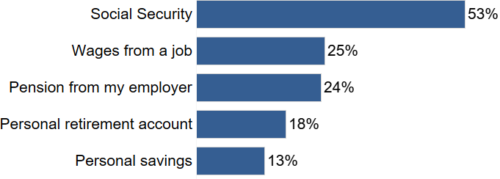

What we learned from narrative comments shared by community members about income or retirement needs:
Other sources of income mentioned include income from self employment and informal jobs, unemployment benefits, VA benefits, SSI, SNAP, and rental income.

- Income, savings, and social safety net are insufficient and are not keeping up with the increasing cost of living.
- Many subsist on fixed incomes, social services, and rely on part-time or “gig” work to supplement their income and afford their basic needs.
- People have to make difficult choices prioritizing which of their basic needs to meet.
- Many existing challenges have been aggravated by the impacts of the COVID-19 pandemic.

We asked people to share their level of agreement with the following statements about their financial situation. (% out of “N” responses which indicated “strongly agree” or “agree” to each statement.)
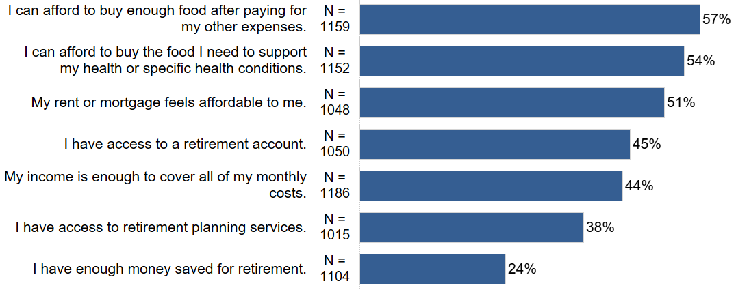

What we learned from the community about retirement:
- 60% are retired and do not work outside their home for wages¹

¹ % out of 1206 responses

Housing
We asked people to share their level of agreement with the following statements about their housing. (% out of “N” responses which indicated “strongly agree” or “agree” to each statement.)
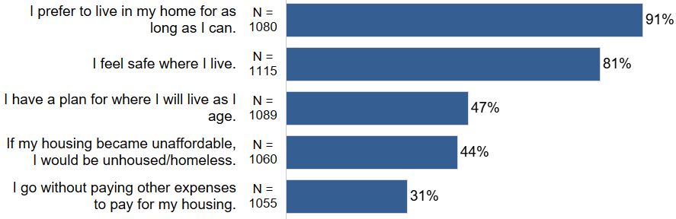

What we learned from the community about housing
- 3% were currently unhoused or homeless¹

¹ % out of 1176 responses

What we learned from the community about about housing
Additional feedback on housing situations and needs:
- Many older adults are housing insecure and would not know what to do if their cost of living increased or housing situation changed
  - The main source of instability is increased rent or property taxes causing unaffordable housing
  - The assistance older adults receive is vital to maintain their housing security but affordability is still an issue
- The cost of housing is a primary concern for many older adults
  - A large portion of income goes towards housing
  - Older adults on fixed incomes struggle with increasing housing costs
  - Homeowners are concerned about the affordability of increased property taxes while renters are concerned about the affordability of increased rents
- Housing conditions are not suitable for older adults
- Receiving assistance with cost or space to live
- Concerns about safety

Health Care
We asked community members if they have health insurance. (% out of 1,191 responses)
Yes: | 95%
No: | 4%
I do not know: | 1%

We asked community members if they have dental insurance.
(% out of 1,195 responses)
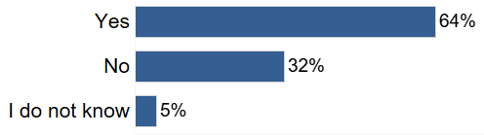

What we learned from narrative comments shared by community members about health care needs and health insurance:

Barriers to having health insurance:
- Lack of money or income to pay for health insurance
- High cost of health insurance, even for some who are employed
- Not knowing how to access options for health insurance
- Experiencing a gap in health insurance, often due to loss of employment and waiting to qualify for medicare or medicaid

What people do when they do not have insurance and need healthcare:
- Pay out of pocket.
- Go without healthcare and just “live with it”.
- Try to stay healthy to avoid the need for health care.

Unmet healthcare needs:
- Dental and vision care
- Treatment for chronic conditions
- Diagnostic and preventative care such as testing, screening, and weight management

Social Connectedness
We asked people to share the ways they prefer communicating with friends, family, or neighbors, in addition to responses indicating “I do not communicate with anyone.” (% out of 1,174 responses. Respondents could select multiple options.)
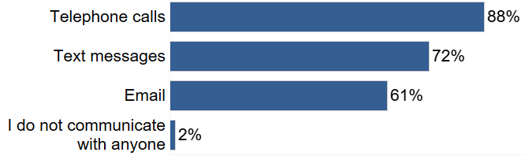

We asked people to share their level of agreement with the following statements about COVID-19.
(% out of “N” responses which indicated “strongly agree” or “agree” to each statement.)

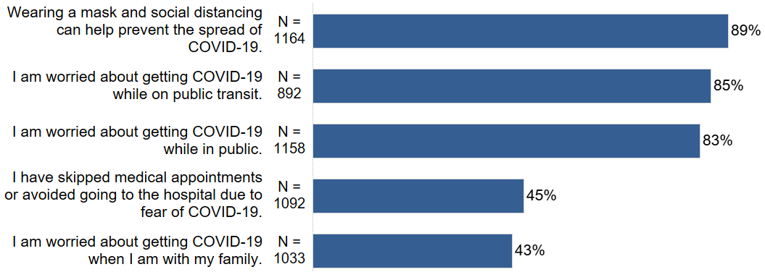

We asked people to share their level of agreement with the following statements about using devices and technology (eg cell phones and internet). (% out of “N” responses which indicated “strongly agree” or “agree” to each statement.)
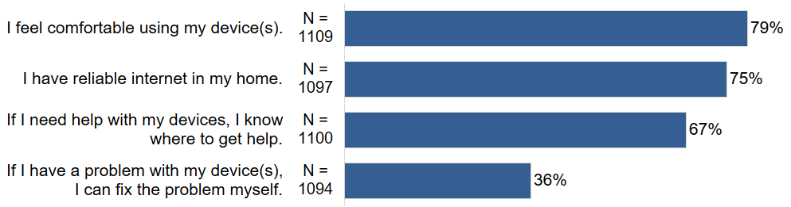

Comments about devices used for communication and finding information:
- Other devices include mail/postal services and writing
- Borrowing devices or getting help to use devices from friends or family
- Having to give up devices or not being able to use them due to costs

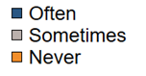
We asked people to share how often they leave home to engage in activities. (% out of N responses.)
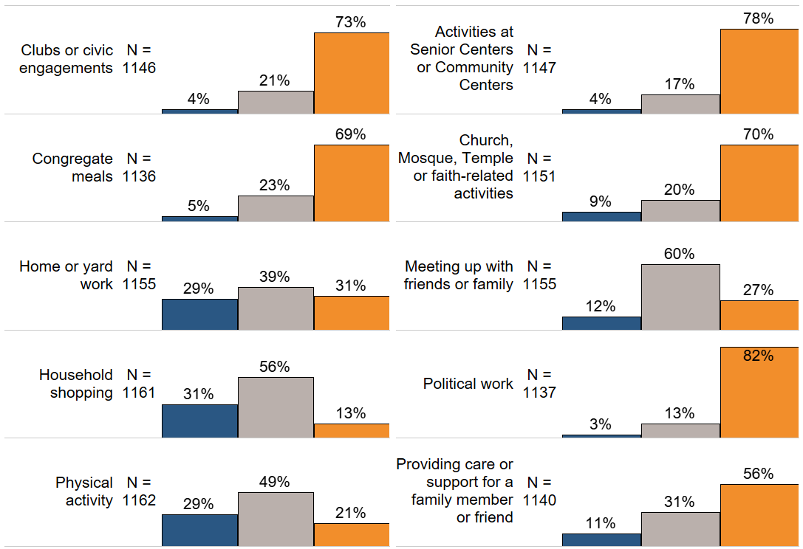

Comments about leaving home to do activities:
- Engagement in social and physical activities are greatly impacted and generally reduced by the pandemic despite some now socializing and engaging in activities virtually.
- People are staying at home or inside much more, including some who are confined to their homes, only going out for necessary trips.
- Performing caregiving responsibilities for household members.

What we learned from the community about social connectedness
- 56% attend meetings online¹

¹ % out of 1173 responses

What we learned from narrative comments shared by community members about their experiences of social connectedness or isolation

- Problems with isolation and loneliness
- Concerns regarding increasing of depression and/or mental health issue
- Difficulty maintaining regularly scheduled appointments for medical/dental care, mainly due to COVID-19 related issues
- Lack of social support for seniors in community since COVID-19
- Avoid using of public transportation since COVID-19

Race and Identity

What we learned about the identities of the respondents
- 23% identified as having a mental health or addiction diagnosis¹
- 16% identified as an immigrant or refugee²
- 3% fled the Holocaust or another genocide³
- 17% identified as homebound⁴

¹ % out of 1141 responses
² % out of 1138 responses
³ % out of 1141 responses
⁴ % out of 1137 responses

What we learned from narrative comments shared by community members about how your personal identity relates to the services you seek or receive?
Comments about chosen race or origin
- Identifying as multiracial or listed multiple race/origins
- Not identifying with a race/origin based label

Comments about sexual orientation
- People’s complexity and fluidity in sexual orientation is not reflected in the response options.

Additional feedback about how identity relates to services sought and received:
- Community members often experience discrimination and other barriers that prevent them from accessing services and experiencing a high quality of life, especially related to one or more of the following identites and characteristics: Older Adults/senior citizens, disability status, gender and sexual orientation, race, ethnicity, or origin, HIV/AIDS and other chronic health conditions, and mental health.
- Range of recognition and understanding of different kinds of privilege and their impacts, especially white privilege.

Information
We asked community members about their sources of information used for services and events. (% out of 1,156 responses. Respondents could select multiple options.)

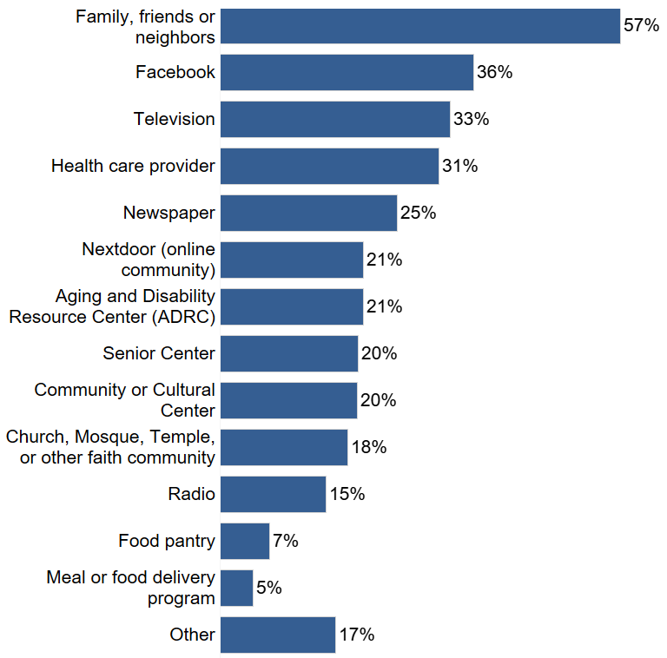
Other information sources used for services and events include online (other than Facebook), AARP, 211 Call Center, and directly from a person such as a resident manager or a caseworker.

What we learned from narrative comments shared by community members about their information resources or needs

- Information about service and resources is difficult to access through current information pathways
- Need for a centralized list of resources in various formats
- Improve communication between Multnomah County and participants
- Specific resources and information types requested:
  - Accessing health care with language support if needed
  - Improve nutrition and spiritual supports in the community
  - Personal care and safety in responding to COVID-19
  - Technology access and utilization supports

Caregiving

We asked people to share the number of hours they provide care in an average week. (% out of 354 responses.)
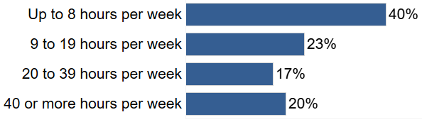

What we learned from the community about Caregiving:
- 36% provide assistance or care¹
- Caregivers primarily cared for a partner/spouse/significant other (25%), a parent/parent in law (22%), a child (20%), or a family friend or chosen family member (14%).²
- Time spent caregiving since the COVID-19 pandemic increased for 44% of caregivers, stayed the same for 40% of caregivers, and decreased for 15% of caregivers, resulting in a net increase in hours spent caregiving for 29% of caregivers.³

¹ % out of 1281 responses
² % out of 374 responses
³ % out of 364 responses

What we learned from narrative comments shared by community members about who they care for and services or supports that would improve their situation as a caregiver
Comments from caregivers about who they care for:
- Client relationships through State, County, care facility, or other formal employment.
- Caring for multiple people, often multiple family members and generations of family members.

Services and supports needed to improve caregiver situations:
- More wrap around services and supports for caregivers and their care recipients, especially unpaid caregivers
- Higher wages and compensation
- More accessible and affordable transportation options for caregivers and care recipients
- Access to specialized equipment, services, training, and advice particular to the needs of individual care recipients
- COVID-19 vaccinations and Personal Protective Equipment
- Better mental health crisis training for emergency responders

Care Receiving
We asked people to share the number of hours they received care in an average week. (% out of 232 responses)
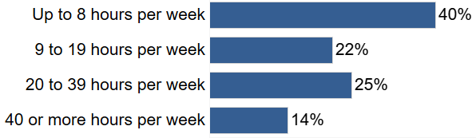

What we learned from the community about receiving care
- 23% receive assistance or care¹
- 51% receive assistance or care from a paid caregiver²
- Care recipients received most of their care from a professional caregiver/nurse (25%), a partner/spouse/significant other (19%), a child (18%), or a family friend or chosen family member (14%).³
- Care needed since the COVID-19 pandemic increased for 29% of care recipients, stayed the same for 61% of care recipients, and decreased for 9% of care recipients, resulting in a net increase in care needed for 20% of care recipients.⁴

¹ % out of 1254 responses
² % out of 258 responses
³ % out of 261 responses
⁴ % out of 238 responses

What we learned from narrative comments shared by community members about who provides care for them and services or supports that would improve their situation receiving care
Comments about other sources of caregiving:
- Community volunteers
- Professional caregivers provided through Multnomah County
- Not receiving care despite qualifying for paid caregiving through the county

Positive feedback about care received:
- Getting the help needed with tasks of daily living, especially help allowing some to continue living independently at home
- Caregivers provide care recipients with needed human attention and connection.
- Caregivers approach their work as a vocation and provide high quality, caring service
- Receiving care from trusted family members and friends

Feedback about what should be changed about care received:
- Increase the number of hours and help provided by caregivers
- More care and support, especially in the areas of daily needs and home improvements
- More reliable and consistent caregivers and service
- Better communication and coordination being caregivers and other service systems
- Improve caregiver selection and training
- Increase compensation and supports for caregivers

Demographics of Survey Respondents
 | Number of responses | Percent out of total responses
Race or Origin | 1,151
White | 719 | 62.5%
Black/African American | 140 | 12.2%
Asian | 129 | 11.2%
Latino/Hispanic | 71 | 6.2%
Native American or Alaska Native | 66 | 5.7%
African | 40 | 3.5%
Middle Eastern | 22 | 1.9%
Slavic | 22 | 1.9%
Native Hawaiian or Pacific Islander | 14 | 1.2%
Chose to self identify | 58 | 5.0%
Primary Language | 1,158
English | 932 | 80.5%
Chinese - Traditional | 51 | 4.4%
Spanish | 40 | 3.5%
Arabic | 20 | 1.7%
Korean | 15 | 1.3%
Vietnamese | 12 | 1.0%
Chinese - Simplified | 11 | 0.9%
Oromoo | 10 | 0.9%
Russian | 10 | 0.9%
Tigrinya | 10 | 0.9%
Nepali | 8 | 0.7%
Ukrainian | 7 | 0.6%
Swahili | 5 | 0.4%
Amharic | 3 | 0.3%
Burmese | 3 | 0.3%
American Sign Language (ASL) | 1 | 0.1%
Farsi | 1 | 0.1%
Somali | 0 | 0%
Chose to self identify | 19 | 1.6%
Survey Language | 1,392
English | 1,182 | 84.91%
Chinese (Simplified) | 71 | 5.10%
Chinese (Traditional) | 18 | 1.29%
Korean | 17 | 1.22%
Arabic | 16 | 1.15%
Spanish | 16 | 1.15%
Vietnamese | 16 | 1.15%
Russian | 14 | 1.01%
Tigrinya | 13 | 0.93%
Oromo | 11 | 0.79%
Burmese | 7 | 0.50%
Amharic | 4 | 0.29%
Ukrainian | 4 | 0.29%
Farsi | 1 | 0.07%
Nepali | 1 | 0.07%
Swahili | 1 | 0.07%
Somalia | 0 | 0%
Gender | 1,140
Female | 809 | 71.0%
Male | 306 | 26.8%
Chose to self identify | 15 | 1.3%
Two Spirit | 13 | 1.1%
Transmasculine | 8 | 0.7%
Gender Expansive | 7 | 0.6%
Transfeminine | 5 | 0.4%
Questioning | 3 | 0.3%
Age | 1,142
18-49 | 49 | 4.3%
50-59 | 215 | 18.8%
60-64 | 210 | 18.4%
65-74 | 466 | 40.8%
75-84 | 165 | 14.4%
85 or above | 37 | 3.2%
Disability | 1,145
Yes | 460 | 40.2%
No | 685 | 59.8%
Visible or Invisible Disability? | 445
Invisible | 275 | 61.8%
Visible | 170 | 38.2%
Vetern or Served in the Military | 1,156
Yes | 140 | 12.1%
No | 1,016 | 87.9%
Homeless or Unhoused | 1,176
Yes | 37 | 3.1%
No | 1,139 | 96.9%
LGBTQ+ | 1,130
Yes | 166 | 14.7%
No | 964 | 85.3%
Sexual Orientation of LGBTQ+ Identifying Respondents | 166
Gay | 49 | 29.5%
Lesbian | 43 | 25.9%
Bisexual | 31 | 18.7%
Queer, pansexual | 22 | 13.3%
Straight or heterosexual | 11 | 6.6%
Questioning | 2 | 1.2%
Do not know | 1 | 0.6%
Chose to self identify | 12 | 7.2%
Caregiver | 1281
Yes | 403 | 31.5%
No | 878 | 68.5%
Care Recipient | 1254
Yes | 286 | 23.8%
No | 968 | 77.2%
Immigrant or Refugee | 1138
Yes | 184 | 16.2%
No | 954 | 83.8%
Fled The Holocaust or Another Genocide | 1141
Yes | 38 | 3.3%
No | 1103 | 96.7%
Income (Federal Poverty Level) | 1170
$530 or less (50% or less) | 89 | 7.6%
$1,967 to $2,127 (51 - 100%) | 123 | 10.5%
$531 to $1,063 (101 - 185%) | 278 | 23.8%
$1,064 to $1,966 (186 - 200%) | 283 | 24.2%
$2,128 or more (201% or more) | 397 | 33.9%
Mental Health or Addiction Diagnosis | 1141
Yes | 259 | 22.7%
No | 882 | 77.3%
Retired | 1206
Yes | 733 | 60.8%
No | 409 | 33.9%
I do not know | 64 | 5.3%
Retired & Working Outside the Home | 791
Yes | 61 | 7.7%
No | 730 | 92.3%
For more information about this summary please contact Robyn Johnson, ADVSD Planning and Development Specialist - robyn.johnson@multco.us

