Drilling Schedule – Weekly Snapshot
Project: | Earthquake Ready Burnside Bridge
Subject: | Drilling Activities from August to November 2021
Date: | Wednesday, September 01, 2021
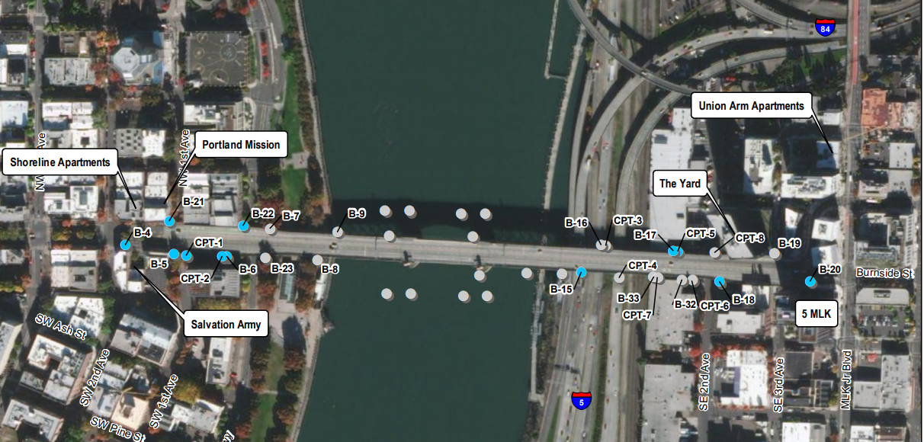
Map of all Drilling Locations from August to November
Schedule (Dates Subject to Change)
Week of 8/30
- B-16 (East - ODOT)
- B-32 (East – American Medical Response)

Week of 9/7
- B-32 (East – American Medical Response)
- B-33 (East – American Medical Response)
- B-5 (West - Mercy Corps)
- B-6 (West - Mercy Corps)

Week of 9/13
- B-7 (West – Waterfront Park)
- CPT-1 (West - Mercy Corps)
- CPT-2 (West - Mercy Corps)
- B-20 (East- Burnside Bridge Approach)
- B-15 (East - ODOT)
- CPT-3 (East - ODOT)
- CPT-4 (East - ODOT)
- CPT-5 (East - Pacific Coast Fruit)
- CPT-6 (East - American Medical Response)
- CPT-7 (East - American Medical Response)
- CPT-8 (East – NE 2nd Ave)

Week of 9/20
- B-8 (West - Waterfront Park)
- B-19 (East - Burnside Bridge Approach)
- B-4 (West - Burnside Bridge Approach)

Week of 9/27
- B-14 (East – ODOT)

Week of 10/4
- B-21 (West – NW 1st Ave)
- B-22 (West – Naito)

Week of 10/11
- B-23 (West – Waterfront Park)

Week of 10/18
- No on-land work

Week 10/25
- No on-land work

COMPLETE
- B-17 (East - Pacific Coast Fruit)
- B-18 (East - Pacific Coast Fruit)

What to Expect
- All locations are within 375 feet of the bridge.
- This work will require large trucks and drilling equipment to obtain the samples.
- The drilling collects samples that are 8-inches in diameter.
- At each location, contractor activities will occur intermittently and last over the course of one to four days.
- While most of the work will occur during the day, some night work will occur. Noise can vary from the sound of an idling car to a garbage truck.
- Traffic control devices and - flagging will be in place to direct traffic when needed.
- For noise complaints, call 503-988-4884 and the contractor will assist the County to address complaints within 24 hours or before the next scheduled night work.

