Notice of Community Needs Virtual Hearing
Annual Action Plan FY 2022-23
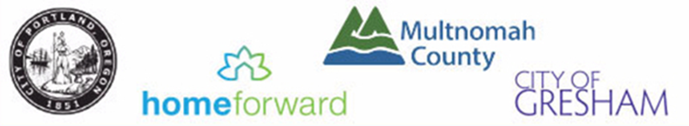

The Portland Consortium, which includes the City of Gresham, City of Portland, and Multnomah County, is beginning its Annual Action Plan process for FY 2022-23 and its 2021-22 Action Plan Amendment process. The 2022-23 Action Plan is the second of five Action Plans in the 2021-25 five-year Consolidated Plan. The process serves as the framework for a community-wide dialogue to identify housing and community development priorities that align and focus funding from the federal Department of Housing and Urban Development (HUD)’s formula block grant programs, Community Development Block Grant (CDBG), HOME Investment Partnerships (HOME), HOME Investment Partnerships American Rescue Plan (HOME-ARP), Emergency Solutions Grants (ESG), and Housing Opportunities for Persons with AIDS (HOPWA), to address ascertained community needs.

The purpose of these hearings is to collect community feedback regarding the housing, infrastructure, economic and social service needs of area residents and prioritize those needs during the preparation of the consortium partners’ 2022-23 Action Plans and 2021-22 Action Plan Amendment for HOME-ARP funding. Due to the public health crisis, these hearings will be held remotely via Zoom. For each jurisdiction, call or review website for instructions regarding public testimony, meeting times, website registration and phone information. The two upcoming virtual opportunities to attend a public hearing in your community and give your feedback are:

City of Gresham & Multnomah County Community Needs Hearing
Nov 3, 2021, 6:00 P.M.–7:30 P.M. via Zoom
Register: To register call 503-618-2814 or contact Rachel.Nehse@GreshamOregon.gov.
Para Español llama a: (503) 988-7440 o Fanny.Rodriguez@MultCo.us.

The City of Gresham and Multnomah County are committed to providing meaningful access. To request translation, interpretation, modifications, accommodations, or other auxiliary aids or services, call 503-618-2814 or email Rachel.Nehse@GreshamOregon.gov three days prior to the meeting.

For additional information on the Consolidated Plan process or the Gresham & Multnomah County community hearing contact Rachel.Nehse@GreshamOregon.gov (Gresham) and fanny.rodriguez@multco.us (Multnomah County)

City of Portland Community Needs Hearing
Date TBD
City of Portland will be conducting a Community Needs Hearing for HUD Federal funds at a later date. Contact Uma.Krishnan@PortlandOregon.gov for any additional information on the entitlement programs.

The City of Portland is committed to providing meaningful access. To request translation, interpretation, modifications, accommodations, or other auxiliary aids or services, contact 503-823-5312, or Relay: 711, three days prior to the meeting.
