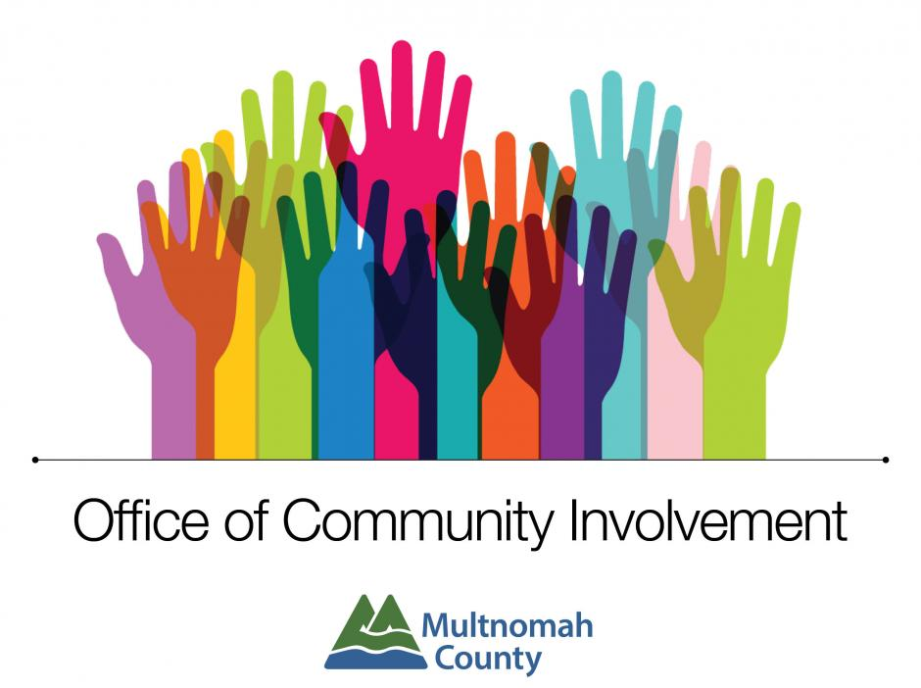
Community Budget Advisory Committees (CBACs) are groups of community members that review and make recommendations on county departmental budgets and operations. CBACs are one of the key ways that the county receives community input on its budget priorities. CBAC volunteers hear directly from department directors and other staff about the county’s programs and services. Together, they make recommendations to the Board of Commissioners about how Multnomah County can best use its resources to serve the community. More information here: https://www.multco.us/oci/community-budget-advisory-committees-cbacs

The requirements for CBAC membership are:
- that you have an interest in the programs and budget process of the County;
- that you are available to attend meetings and participate in deliberations (most CBACs meet monthly, with more meetings during budget season).
- that you are not a current employee of Multnomah County
No budgeting or financial expertise is necessary! CBAC members do not go line by line through the County budget. Meetings are focused on the bigger picture - understanding the County's programs and services, discussing challenges and opportunities that departments are considering in their budget process, and providing input on key budget decisions for the next year.

Application Timeline:
- Information Sessions: Nov 8th at 5:00 PM; Nov 14th at 4:00 PM; Nov 17th at 4:00 PM
- Applications Due- Tuesday, November 21, 2023 by 11:59 PM (extended deadline)
- Review Applications & Follow Up- Mon, Nov 27 thru Thurs, Nov 30
- Notification of Selection- Mon, Dec 4th

Community Budget Advisory  Committee (CBAC) Application | 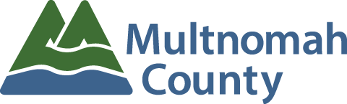
Thank you for completing this CBAC application. Please note that the information provided in this document is public information - personal information will be held in confidence as allowed by law. If you have questions or would like to connect with staff in the Office of Community Involvement, feel free to call us at 503-988-3450 or send an email to community.involvement@multco.us. For an online application, visit multco.us/oci.

General Information:

First Name: ______________________ Last Name: __________________________

Pronouns (e.g., he/him, she/her, they/them): _________________________________

Phone: ___________________________ Email: ___________________________

Home Address (including zip code): ________________________________________

_________________________________________

Employer: _______________________ Occupation: __________________________

Which Community Budget Advisory Committee are you interested in joining? Please indicate a first choice (required) and a second choice (optional) from the list of departments below:
- Department of Community Justice  - Department of Community Services  - Department of County Human Services  - Departments of County Assets & Management  - Health Department | - Joint Office of Homeless Services  - Multnomah County District Attorney  - Multnomah County Sheriff’s Office  - Non-Departmental (includes 16 small County offices)

First Choice: ________________________________________________

Second Choice: ______________________________________________

Please share your typical availability to join a meeting?

𝥁 Daytime (9:00 am-5:00 pm) 𝥁 Evening (5:00 pm-9:00 pm) 𝥁 Both

𝥁 Other (please explain): ___________________________________________

Questions: please share your responses to these questions either in this form or you are welcome to attach an additional document. Each answer should be around 500 words or less.

- Please tell us why you are interested in joining a Community Budget Advisory Committee.

- Please describe any past or current community involvement, including volunteer, committee, and board experience. Optional: please include any experience reviewing budgets.

- If selected, volunteers will be asked to adhere to the Multnomah County Personnel Rules, including the Code of Ethics. Please share any potential reasons you might have any conflicts of interest related to any county department, if applicable. Ex. If you are an employee or a board member for an organization that receives county funding and/or has contracts with the County. Note that County employees are not eligible to serve on Community Budget Advisory Committees.

- Please provide us with a summary of your work and volunteer experience. You may provide a written response or attach a resume. If you wish to submit a formatted resume, you may attach it to this application or email it to community.involvement@multco.us.

- Is there anything else you'd like us to know? Feel free to share additional qualifications for serving in this capacity.

- How did you find out about this opportunity? For our records and to better improve our community outreach.
  - Would you like to sign up for the Office of Community Involvement email list to receive updates about new volunteer opportunities on advisory boards & committees.
𝥁 Yes, please sign me up!
𝥁 I am already signed me up
𝥁 No, not at this time

Optional Questions: The following questions are optional and are used by the Office of Community Involvement to track the effectiveness of our outreach efforts. Answers to these questions will not impact evaluation. Please complete as much or as little as you wish. Individual responses will not be public record.

What is your age:
◻Under 18 ◻18-24 ◻25-34 ◻ 35-44 ◻45-54
◻55-64 ◻ 65-74 ◻Over 75 ◻ Decline to answer

What is your gender (please check all that apply):
𝥁 Male 𝥁 Female 𝥁 Cisgender
𝥁 Transfeminine 𝥁 Transmasculine 𝥁 Non-binary
𝥁 Not sure or Undecided 𝥁 Decline to answer 𝥁 Other:

Which of the following do you identify as your racial and/or ethnic identity (check all that apply):
𝥁 American Indian or Alaska Native 𝥁 Asian or Asian American
𝥁 Black, African American, or African 𝥁 Hispanic or Latino/a/e/x
𝥁 Native Hawaiian or Pacific Islander 𝥁 Middle Eastern and/or North African
𝥁 White, Slavic, or European 𝥁 Decline to Answer
𝥁 Other:

Household Size (people who live with you): 1 2 3 4 5 6 7 8+

Approximate Household Income (per year):
◻Under $30,000 ◻$30,000- $59,999 ◻ $60,000 - $89,000
◻$90,000-199,999 ◻ Over $200,000 ◻Decline to Answer

Which best describes your current housing? Please check all that apply.
𝥁 Rent 𝥁 Own
𝥁 Apartment 𝥁 House 𝥁 Duplex 𝥁 Condo
𝥁 Mobile Home 𝥁 Vehicle, boat 𝥁 Shelter 𝥁 Houseless
𝥁 Decline to Answer 𝥁 Other:

Please return this application to:
Office of Community Involvement
501 SE Hawthorne Blvd., Suite 201 • Portland, Oregon 97214
Email: community.involvement@multco.us

