Parent Calendar

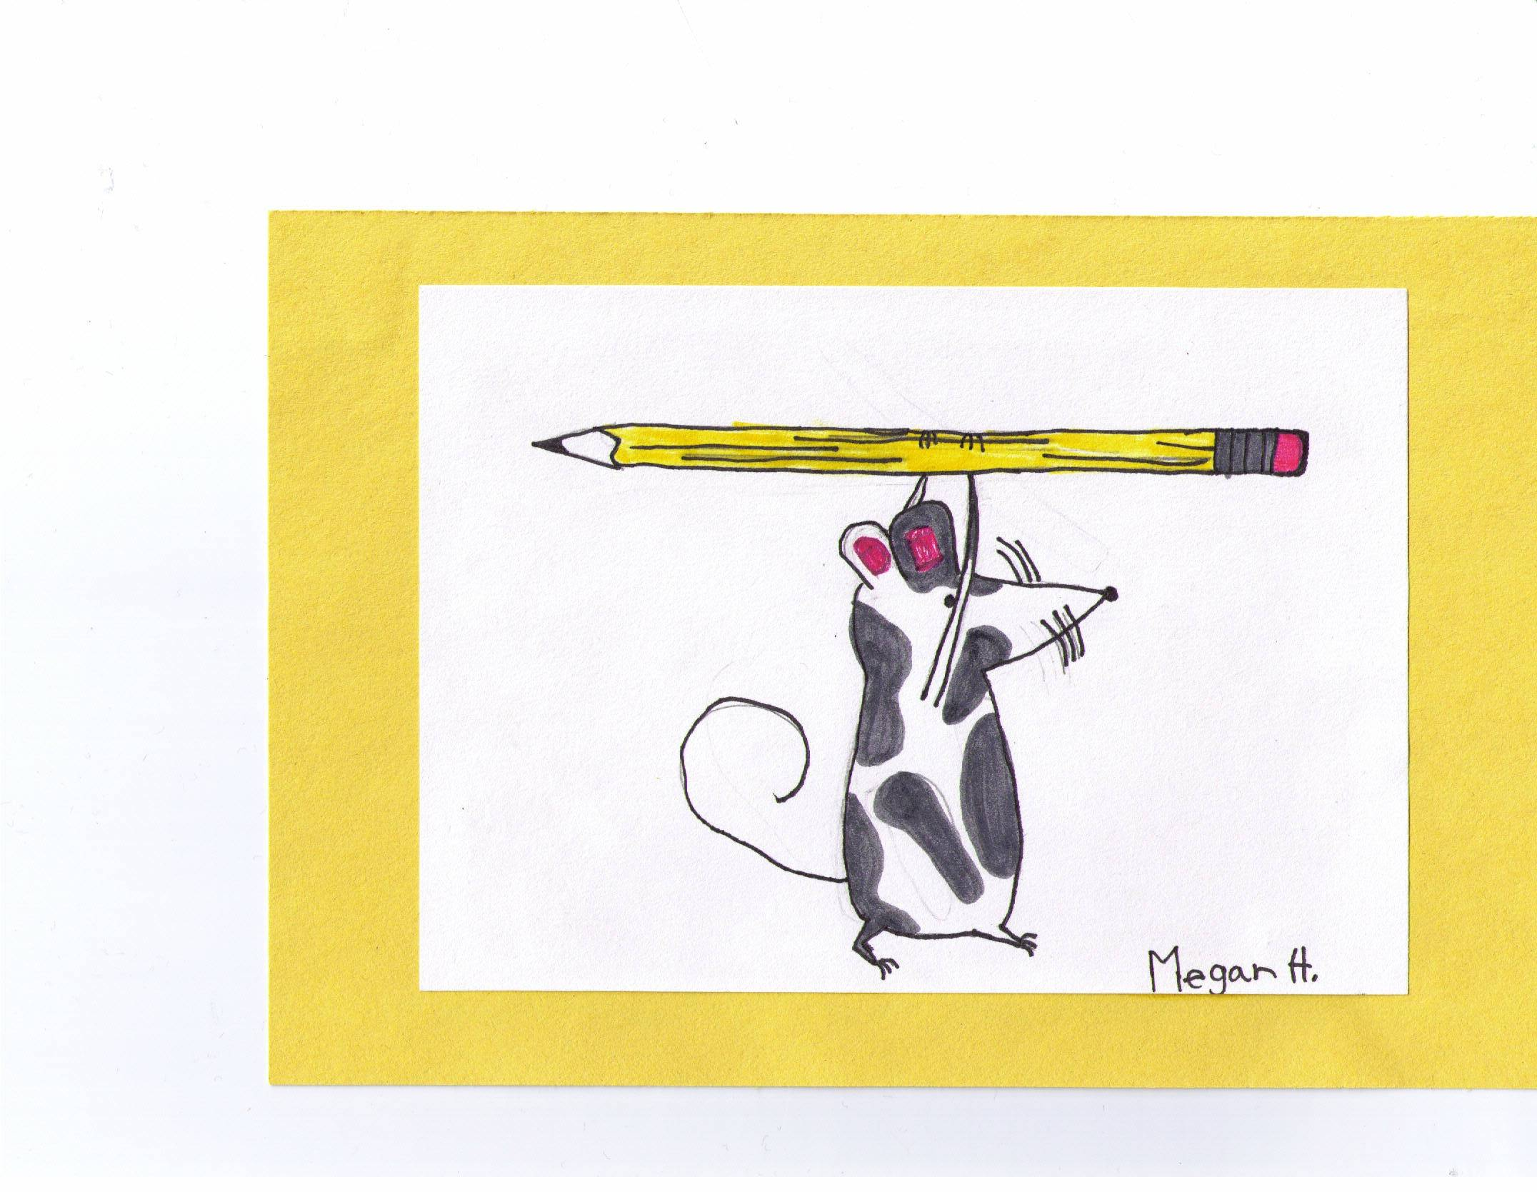

2012
About this Calendar……..

This calendar was developed to help you through the court processes and to help you keep track of court dates and appointments. There is also information about the court processes, common terms that you may hear during the life of your case, and people who may be involved in your case.
Everyone in a juvenile dependency case wants to work to help get kids back with their families whenever possible. Helping parents be a part of this process is important. We hope this calendar helps you keep track of all the things you get asked to do, so you can reach the best results for your children and family.


Important Contact Information

My Judge is:___________________________

Juvenile Court: (503) 988-3022
Address: 1401 NE 68th Ave., Portland
Downtown: 1021 SW 4th Ave., Portland

My Attorney is:_________________________
Phone Number:_________________________
Address:______________________________

Important Contact Information

My Caseworker is:______________________
Phone Number:________________________
Address:______________________________

My SSA is:____________________________
Phone Number:________________________

My CASA is:___________________________
Phone Number:________________________

My Parent Mentor is:_____________________
Phone Number:_________________________

My FIT Case manger is:__________________
Phone Number:_________________________

My D/A Counselor is:____________________
Phone Number:_________________________

My Therapist is:_________________________
Phone Number:_________________________

Other:________________________________
Phone:________________________________

Other:________________________________
Phone:________________________________

Other:________________________________
Courtroom Do’s and Don’ts

Do dress appropriately. DO NOT wear shorts, halter tops, torn jeans, short skirts, t-shirts with inappropriate logos or prints. DO NOT wear a hat in court.

Do arrive early for court. DO NOT be late! The court will not wait for you, and can make decisions about you and your child if you are not there on time.

DO behave in a respectful and calm manner while in court. DO NOT speak out of turn. The court hearing is recorded, so you do have to answer questions out loud, rather than nodding yes or not. Do speak clearly. Do address the Judge as “Your Honor”.

DO NOT bring food or drink in the court. Do not chew gum in court.

DO turn off your cell phone in court. Camera phones are not allowed in the court house. If you bring your cell phone into court, turn it off.

DO contact your attorney before court. Your attorney can not do their job to help you, if you do not stay in contact with them.

DO bring this calendar to court. Write down the date of your next court hearing and any notes you may need to help you remember what you need to do next. Bring any papers you may have that your attorney may need to see. You can not give the Judge any reports or papers that have not been seen by your attorney first.

DO wait for a copy of the court order, and ask your attorney or caseworker if you have questions.
Words you may hear and what they mean……

Allegation: When someone, usually the District Attorney, says a parent or someone else did something to a child. The “allegations” are written in the petition. The person who makes the “allegation” has to prove it in court. This means they have to convince the Judge that it happened.

ASFA: Adoption and Safe Families Act, is a national law that tells states how they have to work juvenile court cases involving child abuse and neglect.

CASA: Court Appointed Special Advocate. This is a person that the court assigns to your child so that there is an independent voice for your child. They are trained volunteers and take their own look at the case and report back to the judge.

CAU: Child Abuse Unit, is part of the court system that helps the court stay organized with all of the information they get to review your case. They will provide you with a packet of court information that you may want to review with your attorney.

CRB: Citizens Review Board. If your child is in foster care, you may have a CRB review. This is a group of trained citizens who review foster care cases and report back to the judge following your case.

DA: District Attorney. This attorney represents the State of Oregon The DA helps DHS with Dependency Petitions. The DA’s job is to bring information and witnesses to the court to show that a parent is responsible for abuse or neglect of their child.

DHS: Department of Human Services. DHS is the agency that is responsible to look into child abuse and neglect reports and then help families fix problems that they find. When DHS looks into child abuse reports they decide if they need the help of the court or not. They may pull together community services so your child can remain safely in your home, or may ask the court to place or keep your child in foster care.

DV: Domestic Violence is any abuse one person has committed against another person who is (or was) a family member, household member, or who had a dating or sexual relationship with the abusive person. This could happen in a lot of ways, such as physical violence, sexual abuse, psychological or emotional abuse, financial abuse or other forms of abuse.

Dependency Case: A case where there is a concern that a child may have been abused or neglected.

Petition: A paper or document that the District Attorney files with the judge that asks the judge to decided if a child has been abused or neglected. The petition is the first document filed in the case but sometimes additional petitions are filed later to add new concerns.

FDM: A Family Decision Meeting is a meeting that involves as many family members and their support system to help figure out what supports are in a family and what areas a family needs help with.

FIT: Family Involvement Team. It is also called FIT for Recovery. This is a program that works with parents who struggle with drug and alcohol problems. It is a team of workers who help support parents as they begin treatment.

ICWA: Indian Child Welfare Act. This is a national law that directs DHS and the juvenile court on how to work with children who are enrolled or may be enrollable in a Native American or Alaskan tribe.

Relinquishment: This is a document that a parent signs when they want to voluntarily place their child for adoption.
Substitute Care: Any placement away from a parent such as foster care, group care, relative foster care or other institution or facility.

TC: Temporary Custody. This is when the court gives custody of children to DHS or in rare circumstances, another person.

TPR: Termination of Parental Rights. This is when the court makes a decision that a parent’s rights to their child should end, and their child should be placed for adoption.

Wardship: A child may be made a ward of the court when a judge decides that the allegations in a petition are true.
April 2012

Sunday | Monday | Tuesday | Wednesday | Thursday | Friday | Saturday
1 | 2 | 3 | 4 | 5 | 6 | 7
8 | 9 | 10 | 11 | 12 | 13 | 14
15 | 16 | 17 | 18 | 19 | 20 | 21
22 | 23 | 24 | 25 | 26 | 27 | 28
29 | 30

Notes: __________________________________________________________________________________________________________________________________________________________________________________________________________________________________________________________________________________________________________________________________________________________________________________________________________________________________________________________________________________________________________________________________________________________________________________________________________________________________________________________________________________________________________________________________________________________________________________________________________________________________________________________________________________________________________________
May 2012

Sunday | Monday | Tuesday | Wednesday | Thursday | Friday | Saturday
 |  | 1 | 2 | 3 | 4 | 5
6 | 7 | 8 | 9 | 10 | 11 | 12
13 | 14 | 15 | 16 | 17 | 18 | 19
20 | 21 | 22 | 23 | 24 | 25 | 26
27 | 28 | 29 | 30 | 31

Notes: __________________________________________________________________________________________________________________________________________________________________________________________________________________________________________________________________________________________________________________________________________________________________________________________________________________________________________________________________________________________________________________________________________________________________________________________________________________________________________________________________________________________________________________________________________________________________________________________________________________________________________________________________________________________________________________
June 2012

Sunday | Monday | Tuesday | Wednesday | Thursday | Friday | Saturday
 |  |  |  |  | 1 | 2
3 | 4 | 5 | 6 | 7 | 8 | 9
10 | 11 | 12 | 13 | 14 | 15 | 16
17 | 18 | 19 | 20 | 21 | 22 | 23
24 | 25 | 26 | 27 | 28 | 29 | 30

Notes: __________________________________________________________________________________________________________________________________________________________________________________________________________________________________________________________________________________________________________________________________________________________________________________________________________________________________________________________________________________________________________________________________________________________________________________________________________________________________________________________________________________________________________________________________________________________________________________________________________________________________________________________________________________________________________________
July 2012

Sunday | Monday | Tuesday | Wednesday | Thursday | Friday | Saturday
1 | 2 | 3 | 4 | 5 | 6 | 7
8 | 9 | 10 | 11 | 12 | 13 | 14
15 | 16 | 17 | 18 | 19 | 20 | 21
22 | 23 | 24 | 25 | 26 | 27 | 28
29 | 30 | 31

Notes: __________________________________________________________________________________________________________________________________________________________________________________________________________________________________________________________________________________________________________________________________________________________________________________________________________________________________________________________________________________________________________________________________________________________________________________________________________________________________________________________________________________________________________________________________________________________________________________________________________________________________________________________________________________________________________________
August 2012

Sunday | Monday | Tuesday | Wednesday | Thursday | Friday | Saturday
 |  |  | 1 | 2 | 3 | 4
5 | 6 | 7 | 8 | 9 | 10 | 11
12 | 13 | 14 | 15 | 16 | 17 | 18
19 | 20 | 21 | 22 | 23 | 24 | 25
26 | 27 | 28 | 29 | 30 | 31

Notes: __________________________________________________________________________________________________________________________________________________________________________________________________________________________________________________________________________________________________________________________________________________________________________________________________________________________________________________________________________________________________________________________________________________________________________________________________________________________________________________________________________________________________________________________________________________________________________________________________________________________________________________________________________________________________________________
September 2012

Sunday | Monday | Tuesday | Wednesday | Thursday | Friday | Saturday
 |  |  |  |  |  | 1
2 | 3 | 4 | 5 | 6 | 7 | 8
9 | 10 | 11 | 12 | 13 | 14 | 15
16 | 17 | 18 | 19 | 20 | 21 | 22
23 | 24 | 25 | 26 | 27 | 28 | 29
30

Notes: __________________________________________________________________________________________________________________________________________________________________________________________________________________________________________________________________________________________________________________________________________________________________________________________________________________________________________________________________________________________________________________________________________________________________________________________________________________________________________________________________________________________________________________________________________

October 2012

Sunday | Monday | Tuesday | Wednesday | Thursday | Friday | Saturday
 | 1 | 2 | 3 | 4 | 5 | 6
7 | 8 | 9 | 10 | 11 | 12 | 13
14 | 15 | 16 | 17 | 18 | 19 | 20
21 | 22 | 23 | 24 | 25 | 26 | 27
28 | 29 | 30 | 31

Notes: __________________________________________________________________________________________________________________________________________________________________________________________________________________________________________________________________________________________________________________________________________________________________________________________________________________________________________________________________________________________________________________________________________________________________________________________________________________________________________________________________________________________________________________________________________________________________________________________________________________________________________________________________________________________________________________
November 2012

Sunday | Monday | Tuesday | Wednesday | Thursday | Friday | Saturday
 |  |  |  | 1 | 2 | 3
4 | 5 | 6 | 7 | 8 | 9 | 10
11 | 12 | 13 | 14 | 15 | 16 | 17
18 | 19 | 20 | 21 | 22 | 23 | 24
25 | 26 | 27 | 28 | 29 | 30

Notes: __________________________________________________________________________________________________________________________________________________________________________________________________________________________________________________________________________________________________________________________________________________________________________________________________________________________________________________________________________________________________________________________________________________________________________________________________________________________________________________________________________________________________________________________________________________________________________________________________________________________________________________________________________________________________________________
December 2012

Sunday | Monday | Tuesday | Wednesday | Thursday | Friday | Saturday
 |  |  |  |  |  | 1
2 | 3 | 4 | 5 | 6 | 7 | 8
9 | 10 | 11 | 12 | 13 | 14 | 15
16 | 17 | 18 | 19 | 20 | 21 | 22
23 | 24 | 25 | 26 | 27 | 28 | 29
30 | 31
Notes: __________________________________________________________________________________________________________________________________________________________________________________________________________________________________________________________________________________________________________________________________________________________________________________________________________________________________________________________________________________________________________________________________________________________________________________________________________________________________________________________________________________________________________________________________________________________________________________________________________________________________________________________________________________________________________________
January 2013

Sunday | Monday | Tuesday | Wednesday | Thursday | Friday | Saturday
 |  | 1 | 2 | 3 | 4 | 5
6 | 7 | 8 | 9 | 10 | 11 | 12
13 | 14 | 15 | 16 | 17 | 18 | 19
20 | 21 | 22 | 23 | 24 | 25 | 26
27 | 28 | 29 | 30 | 31

Notes: __________________________________________________________________________________________________________________________________________________________________________________________________________________________________________________________________________________________________________________________________________________________________________________________________________________________________________________________________________________________________________________________________________________________________________________________________________________________________________________________________________________________________________________________________________________________________________________________________________________________________________________________________________________________________________________
February 2013

Sunday | Monday | Tuesday | Wednesday | Thursday | Friday | Saturday
 |  |  |  |  | 1 | 2
3 | 4 | 5 | 6 | 7 | 8 | 9
10 | 11 | 12 | 13 | 14 | 15 | 16
17 | 18 | 19 | 20 | 21 | 22 | 23
24 | 25 | 26 | 27 | 28

Notes: __________________________________________________________________________________________________________________________________________________________________________________________________________________________________________________________________________________________________________________________________________________________________________________________________________________________________________________________________________________________________________________________________________________________________________________________________________________________________________________________________________________________________________________________________________________________________________________________________________________________________________________________________________________________________________________
March 2013

Sunday | Monday | Tuesday | Wednesday | Thursday | Friday | Saturday
 |  |  |  |  | 1 | 2
3 | 4 | 5 | 6 | 7 | 8 | 9
10 | 11 | 12 | 13 | 14 | 15 | 16
17 | 18 | 19 | 20 | 21 | 22 | 23
24 | 25 | 26 | 27 | 28 | 29 | 30
31
Notes: __________________________________________________________________________________________________________________________________________________________________________________________________________________________________________________________________________________________________________________________________________________________________________________________________________________________________________________________________________________________________________________________________________________________________________________________________________________________________________________________________________________________________________________________________________________________________________________________________________________________________________________________________________________________________________________

April 2013

Sunday | Monday | Tuesday | Wednesday | Thursday | Friday | Saturday
 | 1 | 2 | 3 | 4 | 5 | 6
7 | 8 | 9 | 10 | 11 | 12 | 13
14 | 15 | 16 | 17 | 18 | 19 | 20
21 | 22 | 23 | 24 | 25 | 26 | 27
28 | 29 | 30

Notes: ________________________________________________________________________________________________________________________________________________________________________________________________________________________________________________________________________________________________________________________________________________________________________________________________________________________________________________________________________________________________________________________________________________________________________________________________________________________________________________________________________________________________________________________________________________________________________________________________________________________________________________________________________

