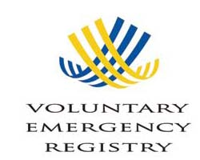

For more information about the registry or assistance registering, contact:

Nickole Cheron  Disability Program Coordinator  1221 SW 4th Ave, Ste 110  Portland, OR 97204  503-823-2036  Fax: 503-823-3050 |  | Senior and Disabled  24 Hour Helpline  421 SW Oak St, Ste 510  Portland, OR 97204  503-988-3646  Fax: 503-988-3656

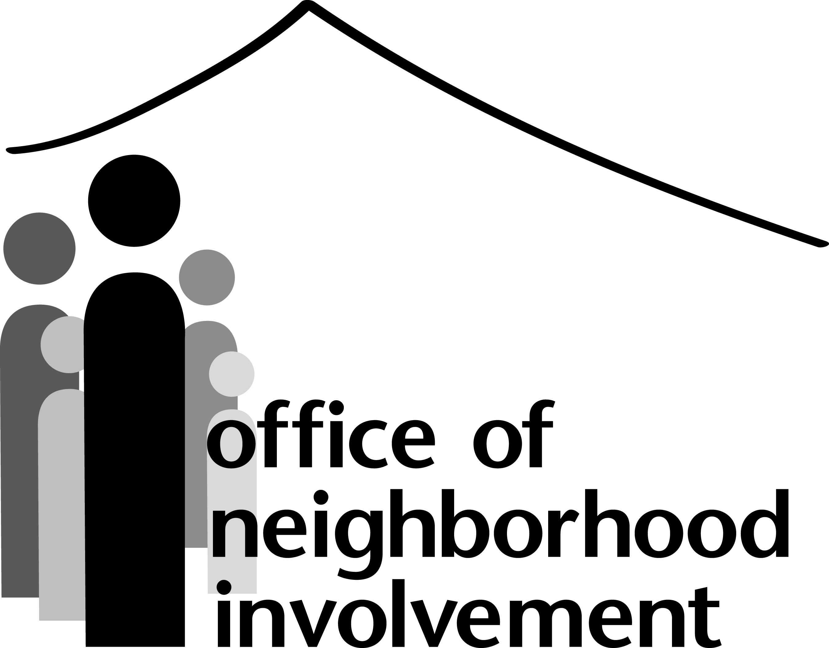


The Voluntary Emergency Registry was developed cooperatively by the City of Portland and Multnomah County
The Voluntary Emergency Registry is a list of persons who need help evacuating their home during an emergency, or who would be unable to evacuate without special notification from emergency response personnel. The registry also includes people who would be unable to remain at home without assistance following a disaster. Information in this list will be provided to the Bureau of Emergency Communications (911) and other emergency response personnel from the City of Portland, Gresham and Multnomah County.
If you want to be included in the registry, please answer the questions and submit the completed application to one of the offices listed on the cover page. The application may be faxed or completed on-line at
http://multnomah.or.networkofcare.org/aging/home/index.cfm

CONSENT AGREEMENT:
I agree to release the information contained in this application to the following agencies involved in Emergency Response and Planning:
- Portland Office of Emergency Management (includes Neighborhood Emergency Teams).
- Gresham Office of Emergency Management.
- Multnomah County Office of Emergency Management.
- City of Portland Disability Program.
- Department of County Human Services.
- Multnomah County Health Department.
- 911 (includes Police and Fire).
I understand that I can limit when this information is released by choosing the “Disaster Only” option below.
NOTE: Every effort will be made to keep your information confidential. In a declared state of emergency, it maybe necessary to release this information to State and Federal agencies coordinating disaster response. Also, if you are completing a non-English version of this form, please see the signature page for more information regarding translation of your registration.
For information about protecting your privacy. You may also contact either the City of Portland (503) 823-2036, or the Multnomah County Aging and Disability Helpline (503) 988-3646.

Registration Types
- All Emergencies – Information will be released whenever there is an emergency at my address.
- Disaster Only – Information will only be released if a disaster is declared by authorized city, county, or State officials.

Please indicate registration type at the beginning of the registration form.
REGISTRATION TYPE:

ALL EMERGENCIES
DISASTER ONLY

Applicant Information
Full Name:
Last |  |  |  |  |  |  |  |  |  | First |  |  |  |  |  |  |  | MI
Address / Contact:
Street Address |  |  |  |  |  |  |  |  |  |  |  |  |  |  |  | Apartment / Unit #
City |  |  |  |  |  |  |  |  |  |  |  | State |  |  | Zip Code
Phone: ( ) |  |  |  |  |  |  |  |  | Cell: ( )
 |  |  |  |  |  |  | Cell Provider:
E-mail Address:
dob: |  |  |  | Gender: |  |  |  | Primary Language:
Living situation:
Do you live in a facility? |  | YES |  |  | NO | If yes, name and type of facility:
If not living in a facility, please describe your living arrangements:

Alone With other non-disabled adults

With a child or children under 18 With other disabled adults
If living with children, are you responsible for them? |  |  |  |  |  |  |  |  |  |  | YES |  | NO
If yes, list names and ages:
Is there someone in your household who could help you in an emergency?  If yes, please fill in section below: |  |  |  |  |  |  |  |  |  |  |  |  |  |  |  |  | YES |  | NO
Special Instructions to find me:

Emergency contact(s)
Contact #1
Last |  |  |  |  |  |  |  |  |  |  |  |  |  |  |  |  |  |  |  | First
Address / Contact:
Street address |  |  |  |  |  |  |  |  |  |  |  |  |  |  |  |  |  |  |  |  |  |  |  |  |  |  |  |  | Apartment/unit #
City |  |  |  |  |  |  |  |  |  |  |  |  |  |  |  |  |  |  |  |  |  |  |  | State |  |  |  | Zip code
Phone: ( ) |  |  |  |  |  |  |  |  |  |  |  | Cell: ( )
E-mail address:
I authorize my emergency contact to complete or update my registration and to receive copies of any notice sent to me: |  |  |  |  |  |  |  |  |  |  |  |  |  |  |  |  |  |  |  |  |  |  |  |  |  |  |  |  |  |  | YES |  |  |  | NO
Contact #2
Last |  |  |  |  |  |  |  |  |  |  |  |  |  |  |  |  |  |  |  | First
Address / Contact:
Street Address |  |  |  |  |  |  |  |  |  |  |  |  |  |  |  |  |  |  |  |  |  |  |  |  |  |  |  |  | Apartment/Unit #
City |  |  |  |  |  |  |  |  |  |  |  |  |  |  |  |  |  |  |  |  |  |  |  | State |  |  |  | Zip Code
Phone: ( ) |  |  |  |  |  |  |  |  |  |  |  | Cell: ( )
E-mail Address:
I authorize my emergency contact to complete or update my registration and to receive copies of any notice sent to me: |  |  |  |  |  |  |  |  |  |  |  |  |  |  |  |  |  |  |  |  |  |  |  |  |  |  |  |  |  |  | YES |  |  |  | NO
Mobility – Please check all that apply to you
I use a wheelchair: |  |  |  | YES |  |  | NO |  |  |  |  |  |  |  |  |  |  |  |  |  | I use a cane/walker: |  |  |  |  |  |  |  |  |  |  | YES |  |  |  | NO
I have difficulty breathing: |  | YES |  |  | NO |  |  |  |  |  | I use an oxygen tank, pump or ventilator: |  |  |  |  |  |  |  |  |  |  |  |  |  | Tank / Pump |  |  |  |  |  |  |  |  | Ventilator
I require help to get out of bed: |  |  |  |  |  |  |  |  | YES |  |  |  | NO
I experience extreme weakness or fatigue that limits my mobility: |  |  |  |  |  |  |  |  |  |  |  |  |  |  | YEs |  |  | NO
vision and hearing
I have difficulty seeing: |  |  |  |  |  | YES |  |  |  | NO |  |  |  | I am blind: |  |  |  |  |  |  |  | YES |  |  |  |  | NO
I use a hearing aid or other device: |  |  |  |  |  |  |  |  |  |  | YES |  |  |  |  | NO |  |  |  |  |  |  |  |  |  | I am deaf: |  |  |  |  |  |  | YES |  |  |  | NO

Other concerns
i have difficulty speaking: |  |  |  | YES |  |  | NO |  |  |  |  |  | I can’t or don’t speak: |  |  |  |  | YES |  |  | NO
I have a mental health condition that affects my ability to respond to an emergency: |  |  |  |  |  |  |  |  |  |  |  |  |  |  |  |  |  | YES |  |  | NO
I need dialysis: | YES | NO
I must use medical equipment that requires electricity: |  |  |  |  |  |  |  |  |  |  |  |  | YES | NO
If yes, please describe:
I have a life threatening condition: |  |  |  |  |  |  |  | YES |  |  | NO
If yes, please describe:
i have a service animal: |  |  | YES |  |  | NO |  |  | Type of animal: Name:
Under stressful conditions, i may become uncooperative, combative or violent: |  |  |  |  |  |  |  |  |  |  |  |  |  |  |  | YES |  |  | NO
I have problems with memory or concentration that would affect my ability to respond to an emergency: |  |  |  |  |  |  |  |  |  |  |  |  |  |  |  |  | YES |  |  | NO
ADDITIONAL MEDICAL INFORMATION
Please include any additional medical information that you think is important:

MEDICATIONS
Please list all current medication(s):
agency assistance – (optional)
AGING AND DISABILITY SERVICES
CONTACT NAME: |  | Phone:
MULTNOMAH COUNTY HEALTH DEPARTMENT
CONTACT NAME: | Phone:
MENTAL HEALTH PROVIDER
CONTACT NAME: |  | NAME OF AGENCY:
PHONE:
DEVELOPMENTAL DISABILITIES
CONTACT NAME: | Phone:
OTHER:
CONTACT NAME: |  | NAME OF AGENCY:
PHONE:

Go to next page (signatures)

signature page
Please check if you wish to receive information about emergency preparedness—
including notification of events, training, other activities:
INSTRUCTION:
To keep the registry current, we will contact you every six months to see if your situation has changed. Please indicate the best way to reach you:
PHONE | MAIL | E-MAIL

I have had the full opportunity to read and consider the contents of this authorization. I understand that by signing this form, I am confirming my authorization of the use and/or disclosure of protected health information to the following:
- Portland Office of Emergency Management (includes Neighborhood Emergency Teams)
- Gresham Office of Emergency Management
- Multnomah County Office of Emergency Management
- City of Portland Disability Program
- Department of County Human Services
- Multnomah County Health Department
- Bureau of Emergency Communications (including re-release to emergency first responders from Fire and Police)
I also understand that I can limit when this information is released by registering using the “Disaster Only” option.
I also understand that registering does not guarantee that I will be evacuated or receive other emergency services during a disaster and that if I am in a life-threatening situation, I should still call 911.
SPECIAL NOTE: if this registration was completed in a language other than English, it may need to be translated by an organization not listed in the consent agreement. However, confidentiality protections required by Multnomah County prevent redisclosure of this document to any person or organization not specified in this agreement.
Applicant signature |  | Date
Name (Please Print)

