When you first log into ADRC, you'll need to set-up your account. This requires changing the temporary password you've been assigned to one you'll remember, adding your email to the account, and answering security questions (see step-by-step instructions below).

Step-by-Step Instructions for accessing ADRC of Oregon & Setting up New Accounts

Begin by navigating to https://adrcoforegon.org/orprovider/ and entering your user name and password.

Once you’ve successfully accessed the system, the first order of business will be to reset your password to one of your preference. The password expires every 60 days, so please add a reminder to your calendar to reset it. Passwords can be changed/reset under "My Account Settings" (at the upper left of the login page):

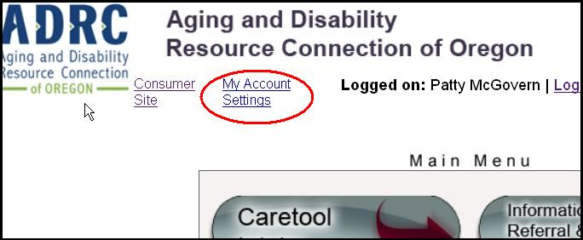

While you are in these settings, you'll also want to check your email address & answer your security questions. It's important to select easy to remember answers, because these will be asked of you in the event you are locked out of the account in the future. These questions are located at the lower left of the password reset screen:

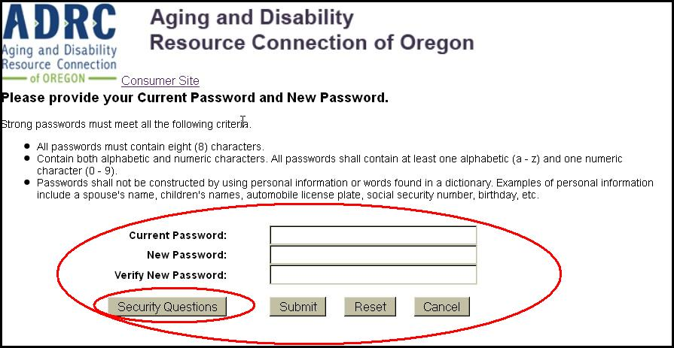

Tip: The security questions are not case sensitive, but they do take into account spaces.

Recommended Browsers: Chrome & Firefox
Clearing the Cache - Clear the cache on your browser frequently to avoid system bugs/issues. Its recommended users set their browser settings so they automatically clear the cache each time your session ends.
Allowing the Browser to “Save/Remember Passwords” – Do allow browsers to save your ADRC password. This is for both security and to prevent issues after your password is reset.

