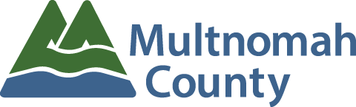

MULTNOMAH COUNTY CHARTER REVIEW COMMITTEE
REGULAR MEETING – November 18, 2015
5:30 – 7:30 p.m.
Multnomah Building, Room 315
501 SE Hawthorne Blvd.
AGENDA

Facilitators: Marco Circosta, Chair’s Office
Rhys Scholes, Office of Government Relations

5:30 Welcome and introduce those not present at previous meeting

5:35 Approve minutes of October 21, 2015 Committee Meeting

5:45 Review and approve Charter Review Committee Policies and Procedures
- Determine procedure for online communication

6:00 Receive public testimony or submitted written testimony

6:20 Background and history of previous Charter Review Committees
- Presenter Rhys Scholes, Office of Government Relations

6:30 Discuss Charter subjects for review
- What issues fall within the scope of the Charter Review Committee
- List issues the Committee would like to further examine
- Information the Committee would like to have presented at the next Committee meeting
- List people the Committee would like to have testify

7:10 Discuss how a work plan will be formed and maintained
- Document format (ex. Shared Word Document, Excel Spreadsheet)
- This will be a working document only, which will be discussed, amended and/or approved at Committee meetings.

7:20 Closing comments

7:30 Adjourn Meeting

