January 15, 2016

Introduction/Background Information
A significant amount of the land in the rural portions of Multnomah County is zoned and used for agricultural production. One of the original, primary goals of Oregon’s statewide planning program is to protect existing farm land for future agricultural use. Towards that end, state and local plans, policies, and laws put a premium on designating specific areas for “exclusive farm use,” limiting non-farm uses in these areas and minimizing conflicts between farm and non-farm uses. State laws significantly restrict the ability to subdivide land or build new non-farm buildings in areas zoned for exclusive farm use.
Specific types of farm-related uses, such as farm stands, wineries, and “agri-tourism” events can help provide additional economic opportunities for farmers but also can create conflicts with adjacent farm owners and rural residents. As a result, they have been the subject of specific state legislation and local planning requirements.
This chapter provides an overview of conditions and planning issues associated with farm land, along with Comprehensive Plan policies and strategies to address them.

farm land Conditions
Agricultural zoning and farm uses are a major component of the fabric of rural Multnomah County. Farm uses are the second largest land use and account for 30,438 acres or 23% of all land in rural Multnomah County.

Figure 1 – Farm Zones, Western Multnomah County
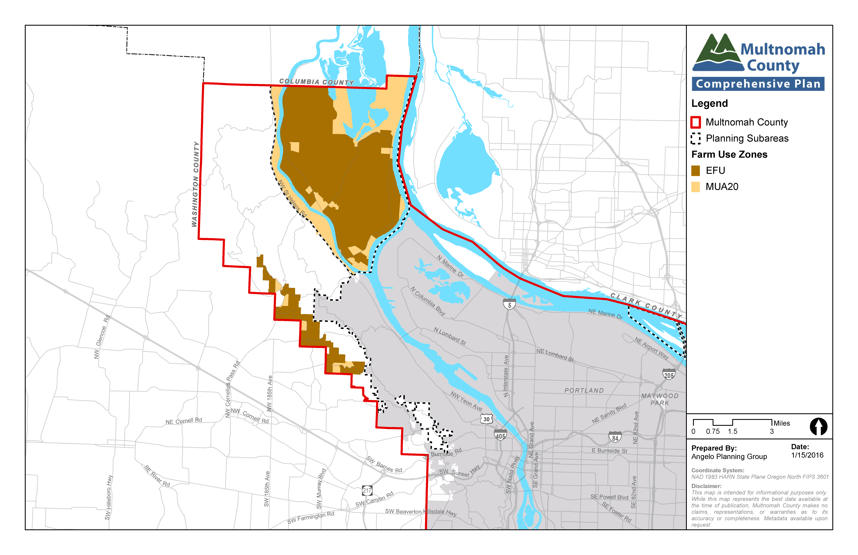
Figure 2 – Farm Zones, Eastern Multnomah County
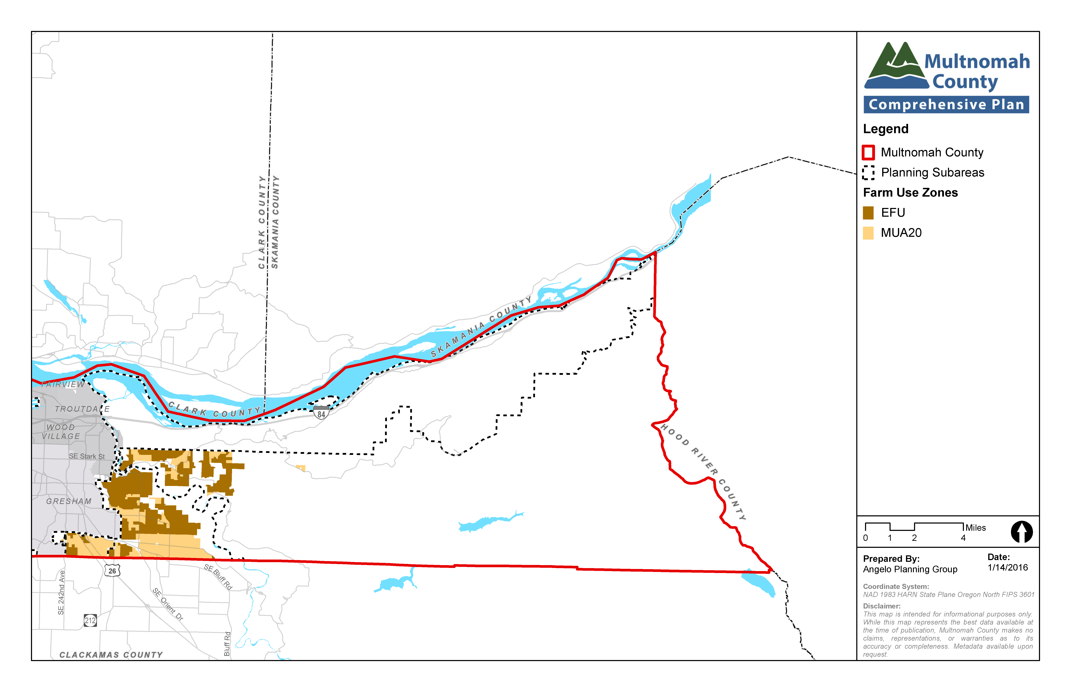

Table 1 – Primary land use based on zoning in Multnomah County
Zone | Acres | % of all lands
Forestry (CFU, 1, 2, 3, 4, and 5) | 98,841 | 74%
Farming (EFU and MUA20) | 30,438 | 23%
Rural Center (RC, OCI, and PHRC) | 322 | 0%
Rural Residential (RR) | 3,513 | 3%
Total | 133,076 | 100%
Exclusive Farm Use (EFU) and Multiple-Use Agriculture (MUA-20) zoning, and associated farm uses, are prevalent in the following areas:
- West Hills: Areas along the west side of the Tualatin Mountains, draining into the Tualatin River watershed, in the Cornelius Pass, Germantown Road, and Bonny Slope subareas
- East of Sandy: Areas due east of the Sandy River, particularly in the area surrounding the community of Corbett
- West of Sandy: The bulk of the subarea, with EFU lands concentrated in the northern half of the area and mixed MUA-20 areas primarily in the southern half of the area
- Sauvie Island: The bulk of the island, with the exception of areas directly adjacent to the Multnomah Channel and the northeastern portion of the part of the island within Multnomah County
While limited residential and other non-farm uses are allowed on agriculturally zoned land in some cases, farm uses make up the majority of these areas, both in terms of number of parcels and overall acreage. The amount and quality of agricultural land in the vicinity of Oregon's most populous metropolitan region speaks to the vigilance of the County's rural residents and urban partners, and the effectiveness of the State and County land use regulations in protecting agricultural lands. There are 598 farms in Multnomah County, generating almost $70 million in value of farm products sold. A small percentage of these farms are located inside city limits and the urban growth boundary.
Table 2 – 2012 Multnomah County Farm Economic Summary
Number of Farms | 598
Land in Farms | 29,983 acres
Average Size of Farm | 50 acres
Market Value of Products Sold | $68,936,000
Average Product Market Value Per Farm | $115,278
Figure 3 – Land in Farms, 2012 by Land Use¹

relevant studies and planning processes
A variety of state, regional, and local plans and policies are relevant to land use planning in Multnomah County, including the following.
Oregon Statewide Planning Goal 3, Agricultural Lands, requires counties to inventory agricultural lands and to preserve and maintain them through farm zoning. Goal 3 is codified in ORS Chapter 215 and Oregon Administrative Rules (OAR) Chapter 660, Division 33.
Multnomah County’s Past Rural Area Plans and the Present Sauvie Island/Multnomah Channel Plan include background information and policies related to farm land that have been incorporated in this Plan.
Multnomah County’s Zoning Code includes Exclusive Farm Use (EFU) and Mixed-Use Agriculture (MUA-20) zoning districts, which specify allowed, prohibited, and conditional uses that support agriculture and protect farm land throughout the County.
Some of these documents are referenced or described in more detail in subsequent chapters of this Plan.

key planning issues and supporting information
A number of key planning issues affect land use planning policies and practices in the rural portions of Multnomah County:
- Implementation of State rules and regulations. Multnomah County must implement statewide goals, administrative rules, and statutes in preparing this Plan and associated development standards. For some rules and regulations, the County may enact policies that are stricter than state requirements because of a desire on the part of County residents to maintain rural character, support agricultural and forest uses, and minimize conflicts between different types of land uses. In a number of cases where there is latitude in this respect, the County has chosen to enact stricter policies than the state. Examples of this are policies associated with parcel aggregation, farm stands and wineries, and application of agri-tourism standards.
- Farm and non-farm dwellings. For the most part, Oregon law is very prescriptive about how and where farm and non-farm dwellings may be allowed within zones designated for exclusive farm use. Multnomah County follows and implements these requirements through the policies found in this Plan and standards in the County’s Zoning Code.
- Impacts of farm stands, wineries and agri-tourism. Farm stands and wineries must be allowed and agri-tourism events may be allowed in agricultural areas per state law because they provide economic benefits to farmers and farm communities. At the same time, counties have discretion to regulate them because they also can have adverse impacts on surrounding properties, farmers, and residents.
  - Farm stands. State law permits counties to allow for farm stands as outright permitted or conditional uses along with related promotional activities such as hay rides, corn mazes, “farm-to-plate” dinners or other small gatherings. The state allows counties to regulate the size and other aspects of these uses, including the impacts of promotional activities at farm stands.
  - Agri-tourism. State law allows counties the option to adopt provisions for agri-tourism and other commercial events or activities that are related to and supportive of agriculture in the Exclusive Farm Use zone. These events and activities are only permitted if they are supportive of and related to the farming operation but can include activities that go beyond those allowed under the farm stand provisions (e.g., school tours, festivals, and rodeos). Counties have a certain amount of discretion to craft specific requirements related to these uses, including the extent to which they are allowed, the impacts they will address, and the applicable review process.
  - Wineries. State law lists wineries as a specific permitted “non-farm” use in EFU zones. Major revisions to the statutes were adopted in 2012 to permit wineries to hold a wide range of marketing and private events including celebratory gatherings. Larger wineries are allowed to have restaurants. Some types of wineries and related activities must be allowed per state law. However, counties have the flexibility to impose standards and criteria on other activities to address potential impacts on surrounding properties and residents.
- Parcel aggregation. Within the County’s resource zones, the County requires that for a parcel to be considered a “lot of record,” contiguous parcels or lots under the same ownership are considered “aggregated” into a single “lot of record” of 19 acres or larger for the purposes of development rights. EFU properties that were adjacent, in common ownership, and under 19-acres in size on February 20, 1990 must always remain in common ownership going forward. Additionally, EFU properties of less than 19 acres adjacent to larger properties are also aggregated with the larger property. Properties that are currently aggregated but were not in common ownership on February 20, 1990 may be conveyed independently. Property aggregation implements the Comprehensive Plan’s goal to protect farm land from development by retaining large parcel sizes for commercial farm use, although it is not required by state law.

Goal, policies and strategies
Goal: To preserve agricultural lands for productive farm use and minimize conflicts between farm and non-farm uses.

policies and strategies applicable County-wide

General policies for Agricultural zones
The policies implement statewide planning goals associated with farm land, as well as the County’s overall goal of protecting agricultural lands from incompatible development and supporting and retaining farming operations. In addition, all of the County’s EFU zones require the landowner of any new dwelling to record a document prohibiting them or their successors from filing a claim for injury from farm practices for which no action or claim is allowed by statute.
These policies pertain to land either in the County’s EFU zone or in the MUA-20 zone.
  - Prohibit creation of new lots or parcels, except as authorized by code, which detracts from agricultural practices and from protection of open space and rural community values.
  - Re-designating land from Agricultural land use to another land use classification should be in accord with the standards set forth by the Statewide Planning Goals, OARs, and in this Plan.
  - Require lot and parcel aggregation standards to reduce parcelization, maintain larger lot and parcel sizes in farm and forest zones, and help minimize impacts of non-farm and forest uses on surrounding farm and forest production. In order to minimize confusion over the development potential of a property, a condition of approval for land use and development permits shall require deed restrictions be recorded that identify the properties that constitute a lot of record along with the development restrictions that go with the lot of record.
    - In addition to recordation of deed restrictions, work with local realtors and title companies to inform them about aggregation requirements and impacts on future property development and land division.
  - Ensure that transportation policies and policies related to the regulation of activities and events in agricultural zones minimize the difficulties conflicting uses impose on farming practices.
  - Develop and adopt a unified permitting process for review of mass gatherings and other gatherings. Establish more restrictive permitting thresholds for the number of visitors and the frequency or duration of events than the maximums authorized by state law.
    - Provide appropriate public notice of applications for gatherings and coordinate these activities with affected local public agencies.
    - Require through conditions that noise levels associated with gatherings comply with state and local noise ordinances to maintain the rural character of the island.

exlusive farm use zones
State law governs a number of land use aspects within areas zoned for exclusive farm use, including where and for whom dwellings can be built within these areas. In general, dwellings are allowed for farm owners, dependents, and workers, with limitations on the number of homes allowed. County policies mirror state policies, recognizing the importance of limiting non-farm development in farm zones to minimize conflicts between farming and non-farm uses.
  - Designate and maintain as exclusive agricultural land, areas which are:
- Predominantly agricultural soil capability I, II, III, and IV, as defined by the U.S. Soil Conservation Service, and
- Of parcel sizes suitable for commercial agriculture, and
- In predominantly commercial agriculture use, and
- Not impacted by urban service, or
- Other areas, predominantly surrounded by commercial agriculture lands, which are necessary to permit farm practices to be undertaken on these adjacent lands
  - Restrict the use of these lands to agriculture and other uses, consistent with state law, recognizing that the intent is to preserve the best agricultural lands from inappropriate and incompatible development.
  - Maximize retention of the agricultural land base by maintaining Exclusive Farm Use designated areas as farm lands with agriculture as the primary allowed use.
  - Do not support zone changes that remove productive agricultural land from the protection afforded under Goal 3 of the Oregon Statewide Planning Program.
  - Allow non-agricultural uses, such as residences, on Exclusive Farm Use Lands as permitted by Oregon Statutes and Administrative Rules, with additional development standards and lot aggregation requirements to ensure protection of agricultural lands and natural and environmental resources. Limit new non-agricultural uses, and expansion of existing non-agricultural uses. This will result in a farm protection program for the County that is more restrictive than what state statutes and rules require.
  - Require approval of dwellings and other development to be contingent upon compliance with Lot of Record standards as contained in the EFU zoning code.
  - Ensure that proposed new dwellings in the Exclusive Farm Use designated areas receive appropriate public review by providing notice and review opportunity prior to any land use decision.

Multiple Agricultural use land
County policies for these areas promote agricultural activities and minimize conflicts between farm and non-farm uses but are less stringent than policies in Exclusive Farm Use zones.
  - Designate and maintain as multiple use agriculture land, those areas which are:
- Generally agricultural in nature, with soils, slope, and other physical factors indicative of past or present farm use, and
- Parcelized to a degree where the average lot size, separate ownerships, and non-farm uses are not conducive to commercial agricultural use, and
- Provided with a higher level of services than a commercial agricultural area has, or
- Located in micro-climates, which reduce the growing season or affect plant growth in a detrimental manner (flooding, frost, etc.)
  - Restrict uses of agricultural land to those that are compatible with exclusive farm use areas in recognition of the necessity to protect adjacent exclusive farm use areas.
  - Protect farm land from adverse impacts of residential and other non-farm uses.
    - Ensure that new, replacement, or expanding uses on MUA zoned lands minimize impacts to farm land and forest land by requiring recordation of a covenant that recognizes the rights of adjacent farm managers and foresters to farm and practice forestry on their land.
    - Amend the Multiple Use Agriculture zone to include deed restrictions protecting surrounding agricultural and forestry practices as a requirement for approval of new and replacement dwellings and additions to existing dwellings.
  - New non-agricultural businesses should be limited in scale and type to serve the needs of the local rural area.

Farm stands, wineries and agri-tourism
County policies on these uses are intended to balance the potential economic benefits of these uses to farm owners and the need to address and minimize their potential adverse impacts on the community, surrounding properties, and farming operations, as well as impacts on roads and other public infrastructure. The policies and strategies implement state law and administrative rules as well as local community needs and preferences.
In establishing rules for farm stands, the County has taken a tiered approach, with higher level of review and stricter standards for farm stands with more potentially significant impacts to surrounding properties. County-wide policies are based in large part on policies developed during the 2015 Sauvie Island/Multnomah Channel Rural Area Plan update process.
The County has taken a similar approach to wineries while also allowing those activities that must be permitted under state law. For both farm stands and wineries, County policies incorporate a number of prescriptive standards which will serve as placeholders to address potential impacts until the County has updated its Zoning Code to provide more detailed standards related to those uses and associated activities.
The County has tailored its approach to agri-tourism, with different policies applied to the western and eastern portion of the County. This is based on significant community discussion of this issue during completion of the 2015 Sauvie Island/Multnomah Channel Rural Area Plan and the 2016 County Comprehensive Plan Update. Plan policies identify where agri-tourism will be allowed (above and beyond similar activities associated with farm stands) and the types of impacts that will be regulated through the County’s Zoning Code.
  - Limit the area, location, design, and function of farm stand promotional activities and gatherings to the extent allowed by law to retain a maximum supply of land in production for farm crops or livestock, to ensure public health and safety, minimize impacts on nearby farming operations, residents, roads, traffic circulation, wildlife and other natural resources, and maintain the rural character.
  - Fee-based promotional activities at farm stands shall be limited to those that promote the contemporaneous sale of farm crops or livestock at the farm stand and whose primary purpose is significantly and directly related to the farming operation.
- Permitted farm stand promotional activities include harvest festivals, farm-to-plate dinners, corn mazes, hayrides, farm animal exhibits, cow trains, small farm-themed gatherings such as birthday parties and picnics, school tours, musical acts, farm product food contests and food preparation demonstrations, and similar activities consistent with this policy.
- Unless authorized at farm stands by statute, administrative rule or an appellate land use decision, fee-based events, such as weddings, corporate retreats, family reunions, anniversary gatherings, concerts, and amusement park rides, and other activities for which the primary focus is on the underlying cause for the gathering or activity rather than the farm operation, are prohibited.
    - Develop and adopt a tiered review process for farm stand operations on EFU land distinguishing between operations that include promotional activities and those that do not.
    - The County shall develop reporting requirements in sufficient detail to assess compliance with the 25% total limit on annual farm stand income from fee-based promotional events and from the sale of retail incidental items, including food or beverage items prepared or sold for on-site consumption. The County may audit farm stands to ensure compliance with this requirement. Implementation of this strategy should balance a reasonable expectation of financial privacy and burden with the need to request information necessary to reasonably demonstrate compliance with the 25% total limit standard.
  - Farm stands that occupy one acre or less (including parking) and do not include promotional activities or events shall be reviewed through the County’s Type I process, based on objective standards.
  - Farm stands that occupy more than one acre or include promotional events or activities shall be reviewed under the County’s Type II application process. Proposed farm stands that would occupy more than one acre or include promotional events or activities shall be sited in order to limit the overall amount of acreage proposed for the farm stand structures and events. Until implementing code is adopted, the following standards shall apply:
- The amount of land identified for the farm stand structures and associated permanent parking shall not exceed two acres.
- The amount of land identified for farm stand promotional activities shall be the minimum necessary to accomplish the objective of supporting farming operations on the property. Absent compelling need for additional area, the area identified for promotional events, including corn mazes and event parking, shall not exceed five percent or five acres of the property on which the farm stand is located, whichever is less.
- Applicants for development of farm stands on land zoned Exclusive Farm Use (EFU) to demonstrate need for the amount of acreage they propose to remove from the agricultural land base for nonfarm uses, including promotional events.
- An applicant may seek approval to accommodate temporary parking on additional acreage during September and October of a calendar year on areas that have already been harvested or used for pasture during the current growing season. The temporary parking area shall not be graveled or otherwise rendered less productive for agricultural use in the following year.
- An applicant owning or leasing multiple properties in farm use in Multnomah County shall be limited to only one Type II farm stand in Multnomah County.
- Multnomah County may require consideration of alternative site plans for the property that use less agricultural land or interfere less with agricultural operations on adjacent lands.
- Farm stand signage shall comply with County sign ordinance standards to maintain and complement the rural character of the surrounding community.
  - Fee-based promotional activities at wineries shall be limited to those that promote the contemporaneous sale of wine at the winery and whose primary purpose is significantly and directly related to the winery operation.
- Unless authorized at wineries by statute, administrative rule or an appellate land use decision, fee based weddings, corporate retreats, family reunions, anniversary gatherings, concerts, amusement park rides, and other activities for which the primary focus is on the underlying cause for the gathering or activity rather than the winery operation, are prohibited.
- Create standards that limit the area and extent of wineries and associated agri-tourism activities to the extent allowed by law in order to retain a maximum supply of land in production for farm crops or livestock, to ensure public health and safety, to minimize impacts on nearby farming operations, residents, roads, traffic circulation, wildlife and other natural resources, and to maintain the rural character of Multnomah County’s agricultural areas.
- To the extent allowed by law, develop additional standards for wineries that address potential offsite impacts such as hours of operation, the number and duration of events, noise, lighting, signs, parking, and circulation, and the size, design, and placement of structures associated with the winery.
- Until implementing code is adopted, the following shall apply:
- Proposed wineries that would occupy more than one acre or include agri-tourism events or activities shall be sited in order to limit the overall amount of acreage proposed for the winery structures and events.
- The amount of land identified for agri-tourism activities at wineries shall be the minimum necessary to retain productive farm land on the property.
- An applicant may seek approval to accommodate temporary parking on additional acreage during peak season on areas that have already been harvested or used for pasture during the current growing season. The temporary parking area shall not be graveled or otherwise rendered less productive for agricultural use in the following year.
- An applicant owning or leasing multiple properties in farm use in Multnomah County shall be limited to only one winery in Multnomah County.
- Multnomah County may require consideration of alternative site plans for the property that use less agricultural land or interfere less with agricultural operations on adjacent lands.
- Signage shall comply with county sign ordinance standards to maintain and complement the rural character of Multnomah County’s agricultural areas.

West Hills policies and strategies
  - Do not adopt the agri-tourism provisions of ORS chapter 215 for the Sauvie Island/Multnomah Channel and West Hills rural areas. In these areas, restrict agri-tourism related uses and activities in the EFU zone to only what is allowed in conjunction with farm stands and wineries.

Sauvie Island and Multnomah Channel policies and strategies
  - Do not adopt the agri-tourism provisions of ORS chapter 215 for the Sauvie Island/Multnomah Channel and West Hills rural areas. In these areas, restrict agri-tourism related uses and activities in the EFU zone to only what is allowed in conjunction with farm stands and wineries.
  - Support the direct sale of farm crops and livestock raised on Sauvie Island farms through u-pick facilities and farm stands in a manner that retains a maximum supply of agricultural land in productive farm use and minimizes impacts on nearby farming operations, residents, roads, traffic circulation, wildlife, and other natural resources.

West of Sandy policies and strategies
  - Adopt agri-tourism provisions within the EFU zone in the East of Sandy River and West of Sandy River rural areas that are more restrictive than what ORS chapter 215 allows, subject to approval standards addressing issues including, but not limited to, the following:
- Number and duration of events, both individually and collectively
- Attendance levels and hours of operation
- Parking and traffic management
- Noise
- Signage
- Lighting
- Sanitation, solid waste and related matters
- Security
- Inspection of events
- Siting
- Notification requirements
- Permit review and renewal processes
- Complaint history
  - Agri-tourism activities and events shall be subject to a tiered review process depending upon the number and/or size of activities and events held.
    - The County will involve interested members of the Comprehensive Plan update Community Advisory Committee and other community members when preparing code language regarding agri-tourism.

East of Sandy policies and strategies
  - Adopt agri-tourism provisions within the EFU zone in the East of Sandy River and West of Sandy River rural areas that are more restrictive than what ORS chapter 215 allows, subject to approval standards addressing issues including, but not limited to, the following:
- Number and duration of events, both individually and collectively
- Attendance levels and hours of operation
- Parking and traffic management
- Noise
- Signage
- Lighting
- Sanitation, solid waste and related matters
- Security
- Inspection of events
- Siting
- Notification requirements
- Permit review and renewal processes
- Complaint history
  - Agri-tourism activities and events shall be subject to a tiered review process depending upon the number and/or size of activities and events held.
    - The County will involve interested members of the Comprehensive Plan update Community Advisory Committee and other community members when preparing code language regarding agri-tourism.

2012 Census of Agriculture

