January 15, 2016

Introduction/Background Information
Land zoned and used for timber production make up the largest land use category within the rural portions of Multnomah County. One of the original, primary goals of Oregon’s Statewide Planning Program is to protect existing forest lands for future forest uses and practices, including harvesting timber. Towards that end, state and local plans, policies, and laws put a premium on designating specific areas for “commercial forest use,” regulating timber production through the Oregon Forest Practices Act, and restricting the number and siting of dwellings, non-forest dwellings and other uses in these areas to minimize conflicts between forest and non-forest uses. Forest practices are balanced with sound management of soil, air, water, and fish and wildlife resources to provide for natural resource protection, recreational opportunities and agriculture.
This chapter provides an overview of conditions and planning issues associated with forest land, along with Comprehensive Plan policies and strategies to address them.

Forest land Conditions
Forest lands for timber production, natural habitat, recreation and open space are an important part of the character and economic base of Multnomah County. Forest uses are the largest land use and account for 98,841 acres or 74% of all land in rural Multnomah County. These lands include the Mt. Hood National Forest, the Columbia River Gorge National Scenic Area, land surrounding the Sandy River, and most of the Tualatin Mountains in the West Hills. The County's Commercial Forest Use (CFU) zones and special districts for the Columbia River Gorge National Scenic Area (GGF and GSF) protect forest lands for commercial timber growing and harvesting, replanting, and production of forest-related products. These areas also provide opportunities for recreational use, as well as many environmental benefits, such as wildlife habitat, riparian areas, clean air, stormwater filtration, and carbon sequestration.
Figure 1 – Forest Zones, Western Multnomah County
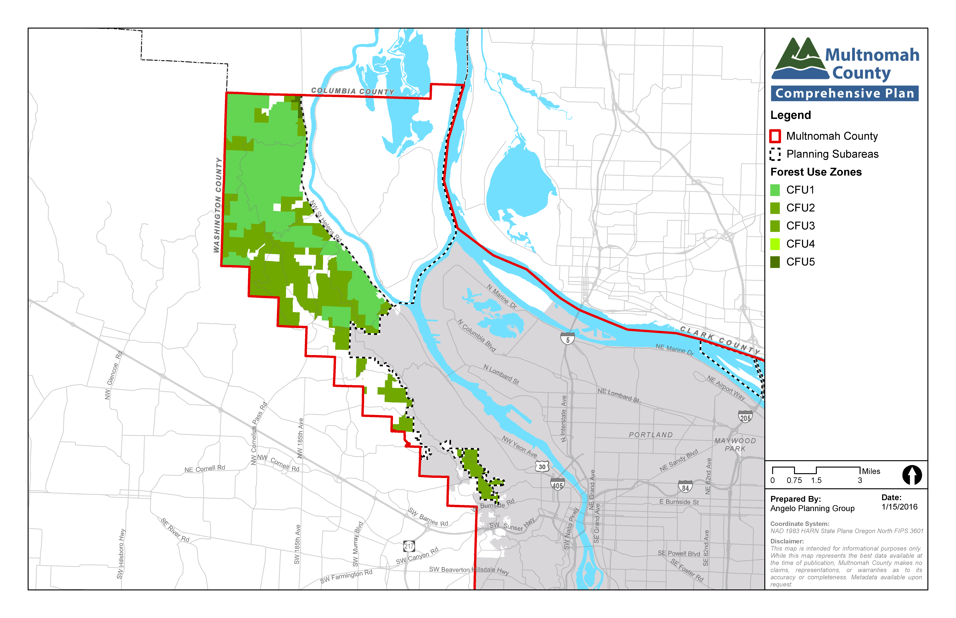
Figure 2 – Forest Zones, Eastern Multnomah County
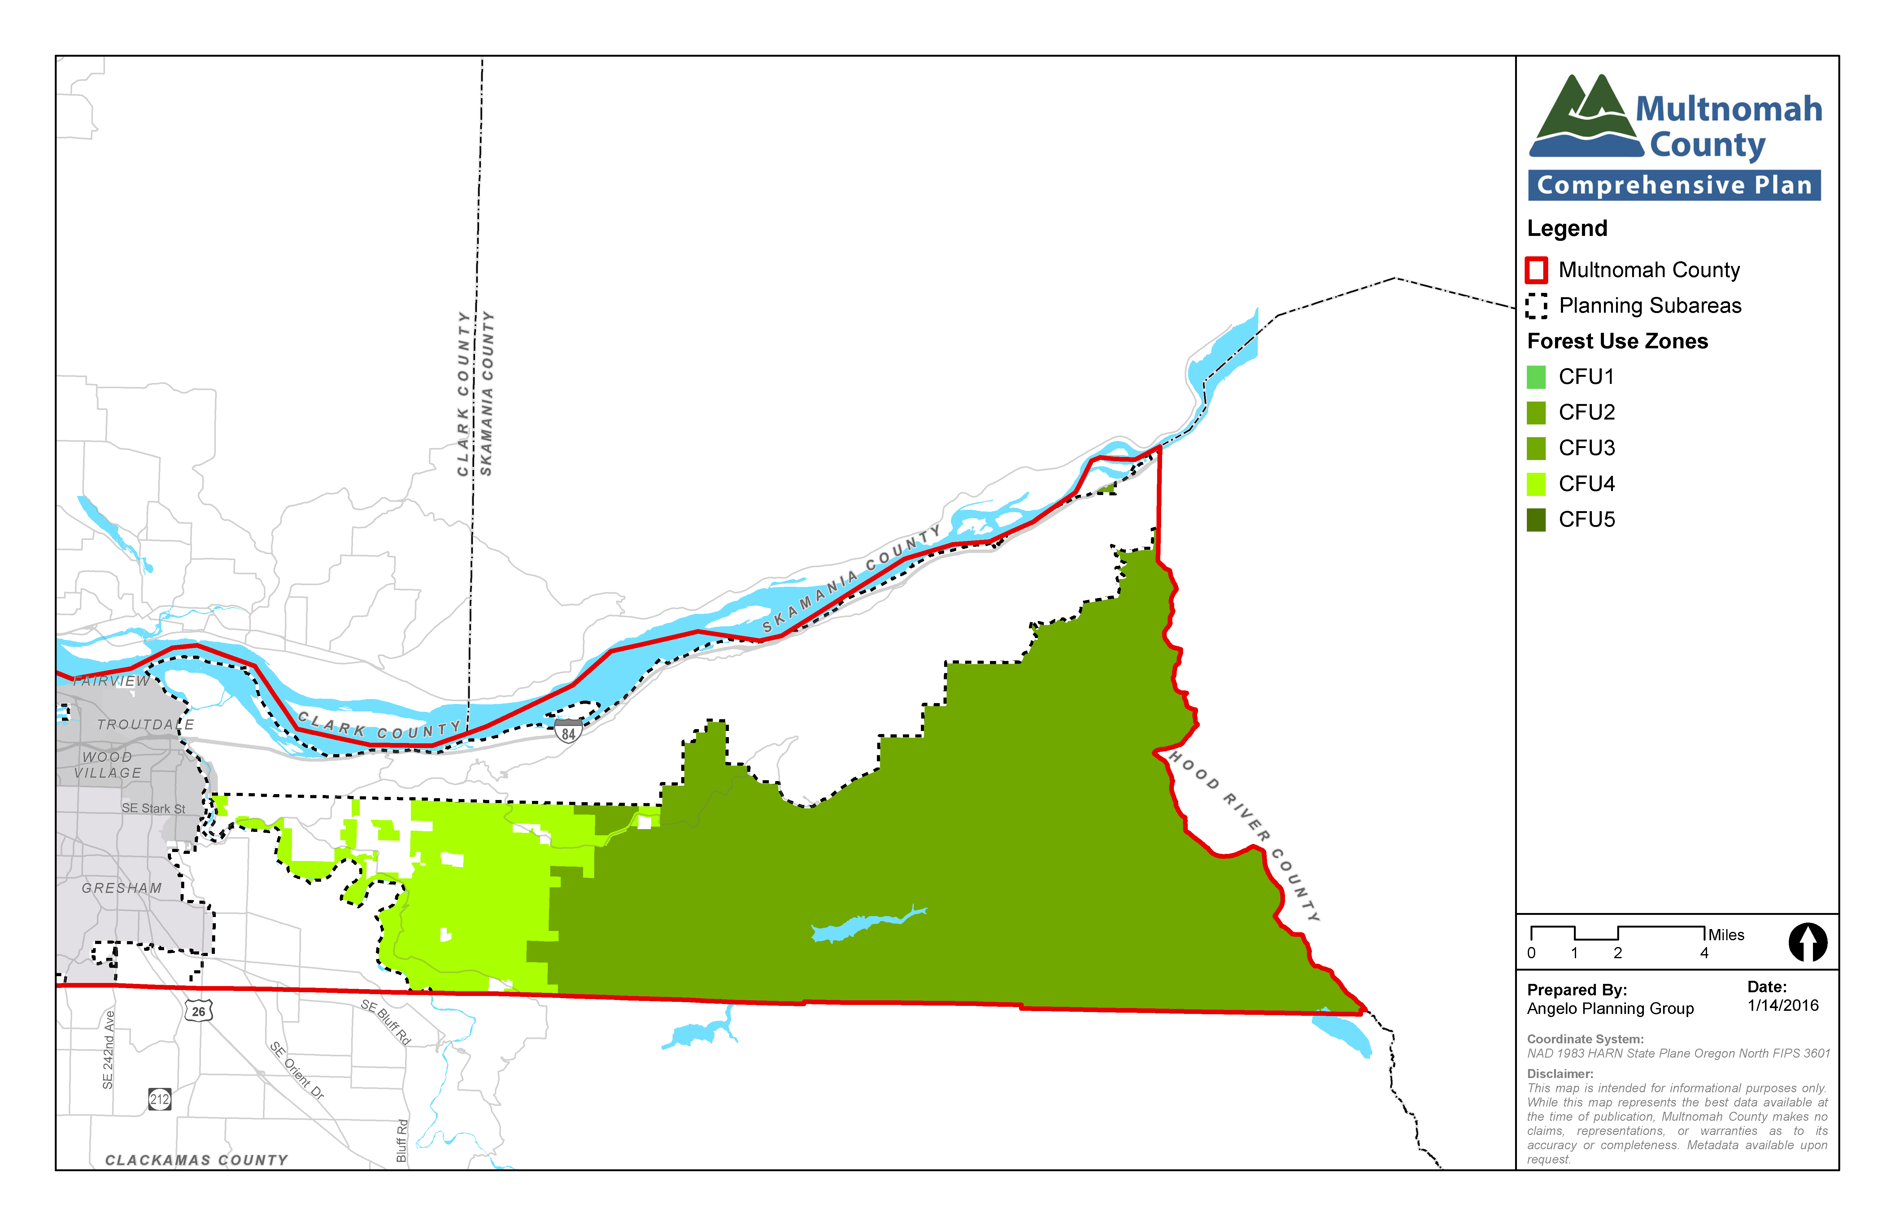

Table 1 – Primary Land Use Based on Zoning in Multnomah County
Zone | Acres | % of all lands
Forestry (CFU, 1, 2, 3, 4, and 5) | 98,841 | 74%
Farming (EFU and MUA20) | 30,438 | 23%
Rural Center (RC, OCI, and PHRC) | 322 | 0%
Rural Residential (RR) | 3,513 | 3%
Total | 133,076 | 100%

relevant studies and planning processes
A variety of state, regional, and local plans and policies are relevant to land use planning in Multnomah County, including the following.
Oregon Statewide Planning Goal 4, Forest Lands, requires counties to inventory forest lands and adopt policies and ordinances that will conserve forest lands for forest uses. Associated statutes and administrative rules are found in ORS Chapter 215 and OAR Chapter 660, Division 6.
The State Forest Practices Act establishes rules and standards for timber management and harvesting. Counties cannot impose zoning restrictions that conflict with these forest practice rules unless a county adopts its own comprehensive forest practices ordinance in place of the State’s which has not been done in Multnomah County.
Multnomah County’s Past Rural Area Plans include background information and policies related to forest land that have been incorporated in this Plan.
Multnomah County’s Zoning Code contains a Commercial Farm Use zoning district which specifies allowed, prohibited, and conditional uses that support and protect forestry practices throughout the County. There are currently six CFU zones applied throughout the County (CFU and CFU 1-5) with slight variations to each zone.

key planning issues and supporting information
A number of key planning issues affect land use planning policies and practices in the rural portions of Multnomah County:
- Implementation of State rules and regulations. State rules are very specific about the use of lands designated forest use. Forest operations, practices, and auxiliary uses are subject only to the regulation of uses found in ORS 527.722. These include:
(1) uses related to, and in support of, forest operations;
(2) uses to conserve soil, water, and air quality, and to provide for fish and wildlife resources, agriculture, and recreational opportunities appropriate in a forest environment;
(3) locationally dependent uses;
(4) large acreage dwellings authorized by OAR 660, Division 6; and
(5) template dwellings authorized by OAR 660, Division 6; and
(6) heritage dwellings, authorized by OAR 660 Division 6.
These uses are further subject to standards set forth in Statewide Planning Goal 4 and Oregon Administrative Rule 660, Division 6. The Comprehensive Plan and Zoning Code are consistent with and implement these requirements.
- Siting of dwellings and accessory structures. Oregon state law provides very specific guidance on the location of dwellings in forest zones. Dwellings can be permitted via three different methods – large tract dwelling, template dwelling, or heritage dwelling. Those terms speak to the underlying conditions that must be met in order for a dwelling to be allowed. In the preparation of this Comprehensive Plan, discussion of this issue among the community generally and the Advisory Committee in particular centered around whether to retain existing County policies and standards, which are consistent with but are more restrictive than state regulations related to how and where to allow forest dwellings, or whether to revise them to simply comply with the minimum requirements of state law.

goals, policies and strategies
Goal: To conserve forest lands in forest zones for timber production, while practicing sound management of natural resources and hazards, providing for compatible recreational activities, and minimizing conflicts between forest production and non-forest production uses and activities.

policies and strategies applicable County-wide

General policies (allowed uses and practices) for CFU zones
Similar to agricultural land protection, the Oregon land use planning program gives priority to protection of forest lands for commercial forest production and harvesting over other permitted uses. This is reflected in the state law which grants CFU zoned properties immunity from private action based on normal and customary forest practices.
The State Forest Practices Act also establishes rules and standards for timber management and harvesting. According to the Oregon Department of Forestry, counties cannot impose zoning restrictions that conflict with these forest practice rules unless the County adopts its own comprehensive forest practices ordinance in place of the State’s. Multnomah County does not have its own forest practices ordinance. The following policies are consistent with and implement state requirements and local community intentions related to use of forest lands.
  - Designate and maintain as commercial forest land, areas which are:
- Predominantly in Forest Cubic Foot Site Class I, II, and III for Douglas Fir as classified by the U.S. Soil Conservation Service; and
- Suitable for commercial forest use and small woodlot management; and
- Potential reforestation areas, but not, at the present, used for commercial forestry; and
- Not impacted by urban services; and
- Cohesive forest areas with large parcels; or
- Other areas which are:
  - Necessary for watershed protection or are subject to landslides, erosion or slumping; or
  - Wildlife and fishery habitat areas, potential recreation areas, or of scenic significance.
  - Maximize retention of forest land by maintaining Commercial Forest Use designated areas with forestry as the primary allowed use.
  - Require that applications for new development comply with Lot of Record standards described in the CFU zoning code.
  - Allow forest management with related and compatible uses and restrict incompatible uses from the commercial forest land area, recognizing that the intent is to preserve the best forest lands from inappropriate and incompatible development.
  - Do not support zone changes that remove productive forest land from the protections of Goal 4 of the Oregon Statewide Planning Program.
  - Redesignating land from Commercial Forest Land Use to another land use classification should be in accord with the standards set forth by the LCDC Goals, OAR’s, and in this Plan.
  - If current statewide planning regulations of Commercial Forest Use lands are changed, Multnomah County should not allow new subdivision lots of less than 80 acres in the CFU district in order to preserve forest practices and natural resources such as wildlife habitat, streams, and scenic views.

Forest dwellings (including siting policies)
State laws and administrative rules provide clear, detailed guidance and options for when and how dwellings can be located in forest zones. They provide three options - large tract dwelling, template dwelling, or heritage dwelling. County standards and policies are consistent with these options but also vary by rural planning area and include some provisions that are stricter than the state requirements, including requiring parcel aggregation and additional requirements related to heritage dwellings. This Plan continues to support this approach, consistent with the County’s overall goals to support forestry operations, promote rural character, and minimize conflicts between forest and non-forest uses in CFU zones.
In CFU zones, the County’s Zoning Code also seeks to minimize conflicts between forest management activities and residences by requiring dwellings to meet forest practices setback standards from adjacent forest lands and by requiring dwellings and other structures to be sited where they have the least impact on nearby or adjoining forest lands and other neighboring land uses. In addition, all of the County’s CFU zones require the landowner of any new dwelling to record a document prohibiting them or their successors from filing a claim for injury from forest practices for which no action or claim is allowed by statute.
The following policies address these topics.
  - Allow non-forest uses, such as residences, on Commercial Forest Use Lands as permitted by Oregon Administrative Rules, subject to lot aggregation requirements and other development standards that exceed minimum state requirements to better ensure public safety, public health and welfare, and protection of natural and environmental resources. Limit new non-forest uses and expansion of existing non-forest uses. This will result in a forest protection program for the County that is more restrictive than what state statutes and rules require.
  - Allow no dwellings, or other uses which are incompatible with commercial forestry, on lands of the Mt. Hood National Forest and adjacent large commercial timber parcels.
  - Allow new template dwellings under the current standards of the CFU zone that are more restrictive than state requirements.
  - Recognize differences among Commercial Forest Use zoning around the County by allowing non-forestry related uses, such as residences, on Commercial Forest Use Lands not in the Mt. Hood National Forest or on large commercial forest tracts adjacent to the National Forest Boundary, according to any or all of the following conditions:
- Dwellings on 160 acre tracts or 200 acre non-contiguous tracts;
- Dwellings on existing lots of record owned continuously by the current owner or antecedents of the current owner since 1985 which are capable of producing less than 5,000 cubic feet per year of commercial timber;
- Dwellings on existing lots of record which contain at least eleven existing lots and five existing dwellings within a 160 acre square template centered on the lot of record containing the proposed dwelling;
- Dwellings authorized under ORS 195.300 through 195.336 (Measure 49 claims).
  - All approved dwellings in Commercial Forest Use zones must meet additional development standards and lot aggregation requirements to ensure public safety, public health and welfare, and protection of natural and environmental resources.
  - Except where disaggregation is currently allowed in the East of Sandy River rural area, prohibit creation of new lots or parcels, except as authorized by code, which detracts from forestry practices and from protection of open space and rural community character.
  - Allow new dwellings on lands designated for commercial forest use only when it can be demonstrated that they will have no significant impact upon forestry practices, open space, public facilities, wildlife habitat, and rural community character.
  - Ensure that any proposed new dwelling in the commercial forest use designated areas receives appropriate public review by providing comprehensive notice and review opportunity prior to any land use decision.
  - Adopt provisions within the CFU zones that require clustering of dwellings near existing public roads, and clustering of dwellings, structures, and adjacent development to minimize conflicts with wildlife, natural and environmental resources, forest and agricultural practices, public safety, and infrastructure. Allow for exceptions based on topographical and other unique constraints of the property.
  - Require clustering of dwellings and accessory structures in CFU zones to establish a clear relationship between the primary use and accessory use and to minimize the amount of tree removal and clearing between buildings.

West Hills policies and strategies
There are no forest land policies specific to the West Hills area.

Sauvie Island and Multnomah Channel policies and strategies
There are no forest land policies specific to the Sauvie Island and Multnomah Channel areas.

West of Sandy policies and strategies
There are no forest land policies specific to the West of Sandy area.

East of Sandy policies and strategies
There are no forest land policies specific to the West of Sandy area.

