January 15, 2016

Introduction/Background Information
Natural landscape features provide a community with valuable resources but, under certain conditions, these resources may also present a hazard. For example, rivers, and creeks are important for storm water conveyance, wildlife habitat, and water quality. However, these resources can threaten property and people unless planning and precautions are taken to address such risks. Even after undertaking such actions, natural disasters can leave people in rural areas of the County without access to services for an extended period of time and it is important for residents and business owners to work individually and collectively to be prepared to respond to such conditions.
From a land use and comprehensive planning perspective, Goal 7 of Oregon’s statewide planning goals requires cities and counties to adopt Comprehensive Plan policies and implementation measures to reduce risks associated with a variety of natural hazards, including landslides, flooding, wildfires, earthquakes, tsunamis, and coastal erosion. The goal and its administrative rules call for local governments to coordinate with state and federal agencies and members of the public to use available up-to-date data to identify areas prone to natural hazards, assess risks from those areas, and amend policies and regulations to avoid development in areas subject to hazards when risks from them cannot be mitigated. Because lands in Multnomah County are not subject to risks from coastal erosion or tsunamis, the primary hazards to be addressed in the County are those from landslides, flooding, wildfire, and earthquakes.
The potential for incidents related to natural hazards is likely to increase in the future due to climate change. Climate change is expected to result in more frequent, intense, and longer lasting heat waves, droughts, rainstorms, floods, wildfires, and landslides in the future. In addition, adverse impacts of natural hazards frequently disproportionally affect vulnerable populations – such as older adults, people with disabilities and people experiencing poverty – because those groups have fewer resources to avoid, plan for or recover from them. All of these trends highlight the importance of planning for, responding to, and minimizing the impacts of hazards. It is also important to recognize the relationship between these activities and the goals of strengthening our economy and promoting equity among County residents.
This chapter provides an overview of conditions and planning issues associated with these natural hazards, along with Comprehensive Plan policies and strategies to address them. Additional planning related to natural hazards, including strategies for responding to them, is conducted by the County’s Office of Emergency Management and is presented in the County’s Natural Hazards Mitigation Plan.

natural hazards Conditions

Landslides
Landslides can threaten people, property, and natural resources, and often occur in connection to other hazards such as erosion, flooding, and earthquakes. Susceptibility to landslides is related to the steepness of a slope, instability associated with previous landslides, soil type, and moisture content. Multnomah County currently regulates development on steep slopes to address risks in such areas related to erosion or landslides. The incidence of landslides is likely to increase in the future due to the impacts of climate change as increased winter rainfall leads to more soil and slope instability, particularly following prolonged periods of precipitation when the soil is saturated with water.
The County’s Hillside Development overlay zone (HD) is primarily applied to areas with steep slopes as well as land within the Tualatin River drainage basin. The HD zone includes a number of requirements related to the assessment and documentation of risk and restrictions on development where slopes exceed 25%. Where slopes exceed 25%, property owners are required to obtain a report and recommendations from a geotechnical professional, documenting the risks associated with potential landslides and measures that can be taken to mitigate those risks. Development on areas with lesser slopes (10-25%) require review under the County’s Grading and Erosion Control (GEC) code and includes the potential to require further investigation or to mitigate risks in these areas, when warranted.
Since the Hillside Development Overlay Zone was put into effect, newer data has become available from the Oregon Department of Geology and Mineral Industries (DOGAMI) that identifies other locations that also may be susceptible to landslides, such as locations of previous landslides and/or other areas where soil conditions increase susceptibility. The maps on the following pages identify these areas. [Changes to the maps shown below are pending.]
This issue is applicable to most rural areas within the County although it has limited applicability in the Sauvie Island/Multnomah Channel area, given the relatively flat topography in that area. Significant portions of the West Hills and East of Sandy Rural Planning Areas in particular are susceptible to landslides and erosion.
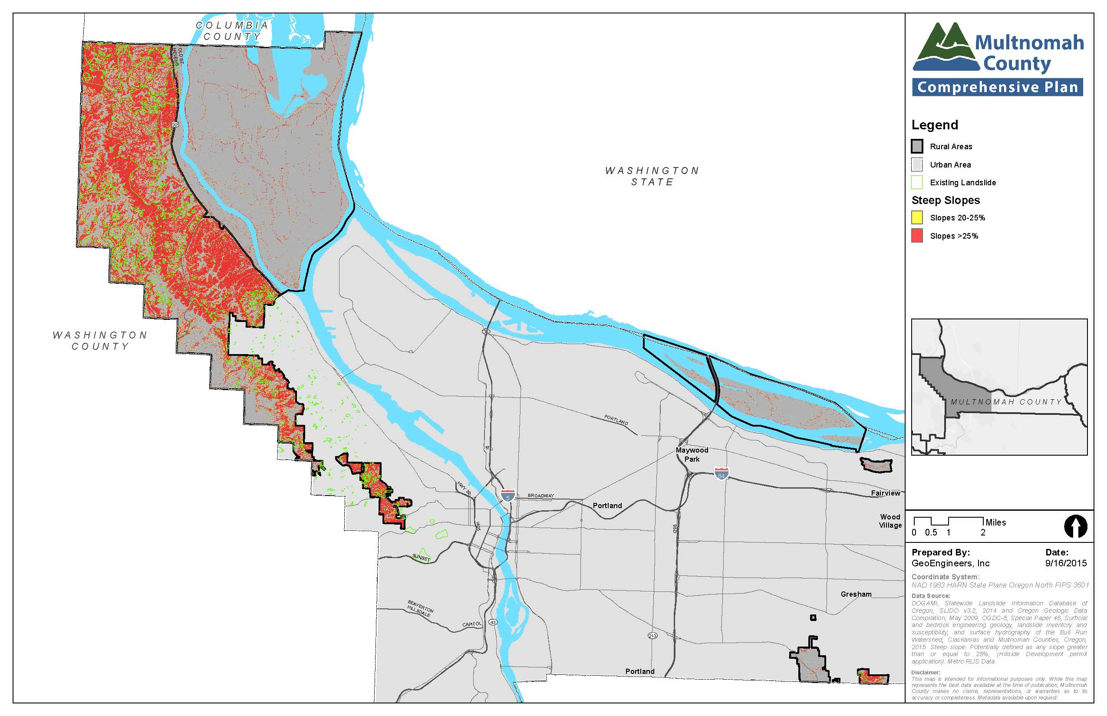
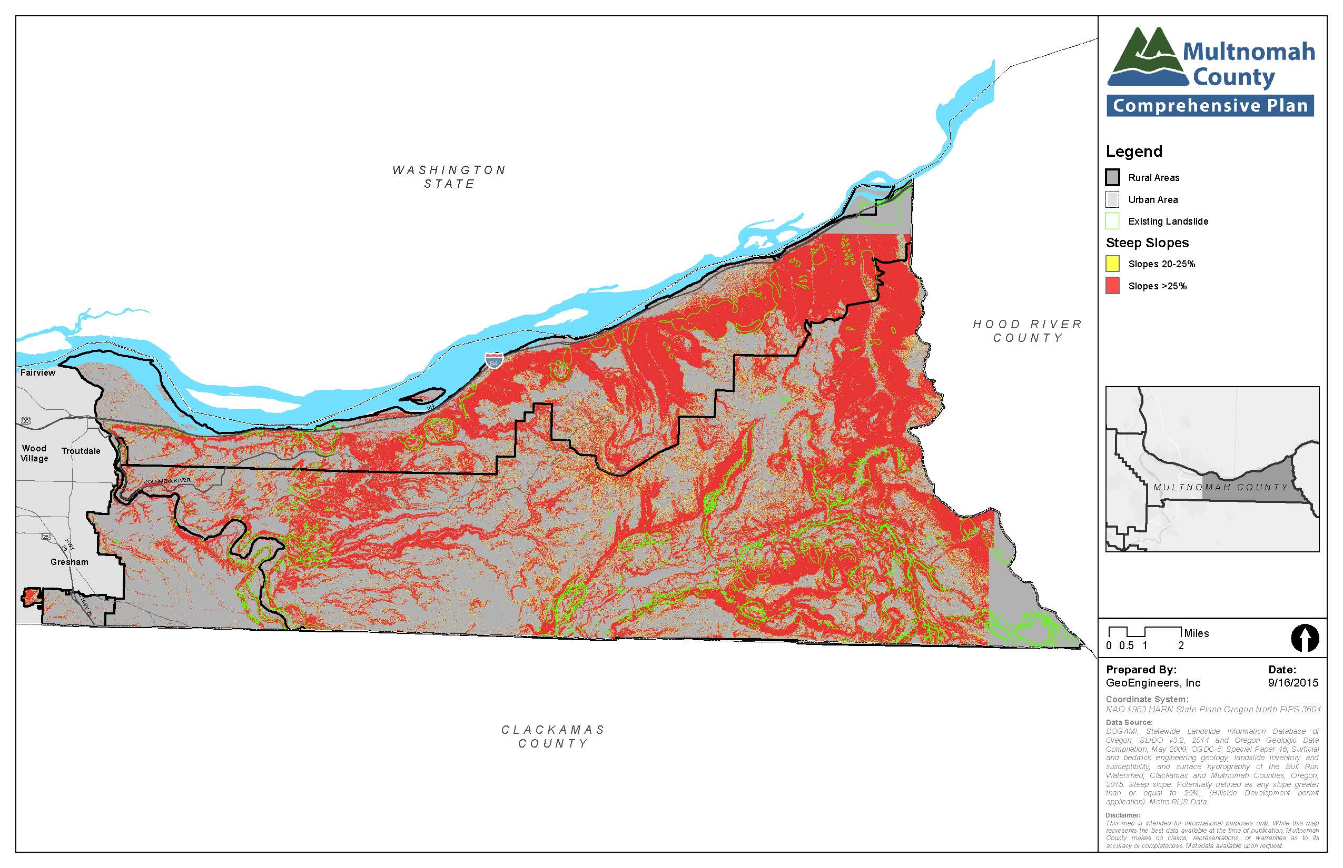
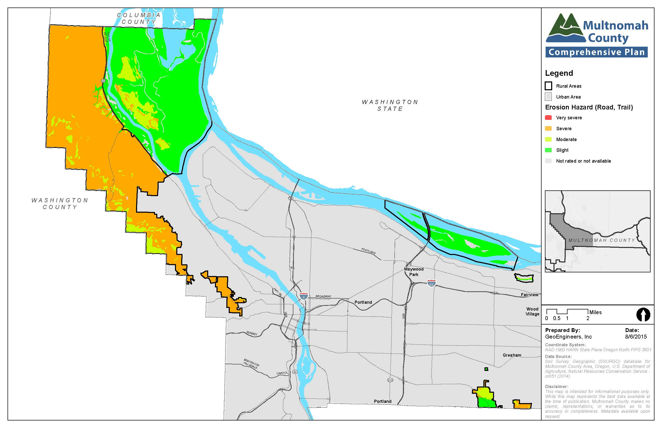
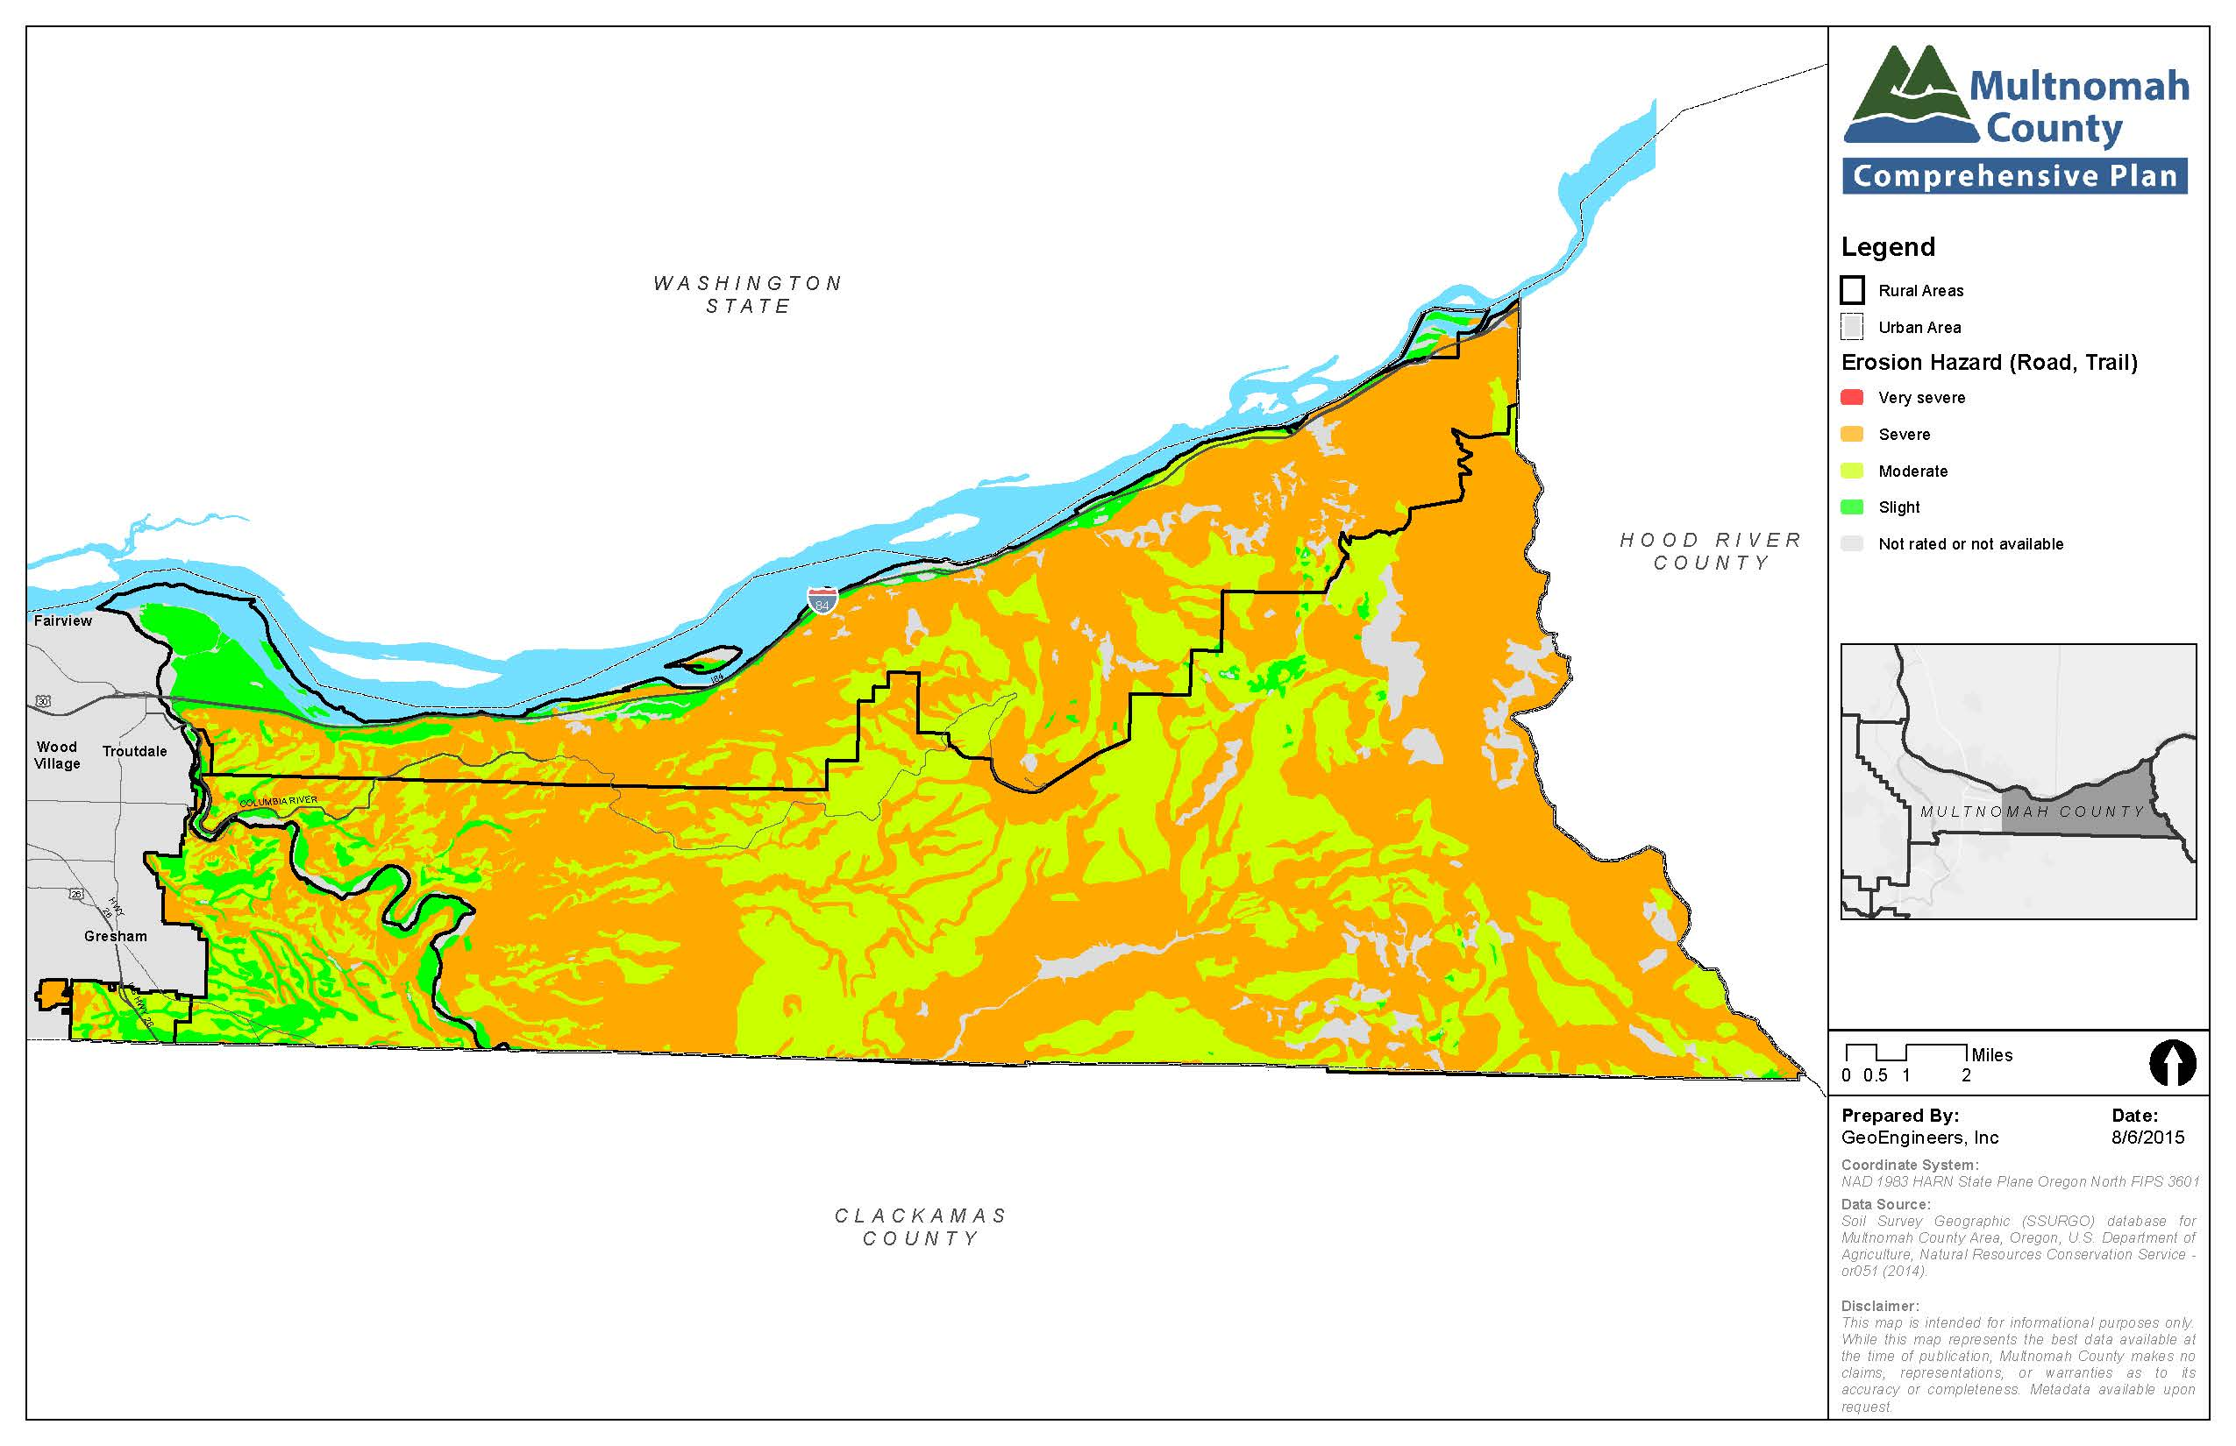

Flooding
Floods are influenced by a number of factors, including the amount and intensity of precipitation, geography and geology, and development activity. Flooding can impact private property, public infrastructure, and economic loss from business interruption. These effects are typically felt within the “floodplain” of a river or stream. At the same time, if left undisturbed, floodplain areas can act to store excess floodwater and reduce potential impacts of flooding.
Like other local jurisdictions in Oregon, Multnomah County has policies and regulations that limit or regulate development in areas prone to flooding, including floodways and floodplains. A variety of County policies and regulations address this issue, including participation in the National Flood Insurance Program. Flood insurance maps for the County were updated in 2009 and the County’s Zoning Code was updated in 2008 to add regulatory requirements to preserve floodplain function. In addition, the County’s Significant Environmental Concern overlay zones (SEC-s and SEC–wr) help preserve and enhance riparian areas, which in turn reduces the potential for stormwater runoff and landslides that contribute to flooding events.
In 2011, County staff completed and provided an assessment of potential changes to flood-related regulations to the Planning Commission. The 2012 Multnomah County Natural Hazards Mitigation Plan noted that existing County regulations exceed minimum federal requirements and did not identify any additional recommended changes to the County flood-related regulations.
There is the potential for flooding in most rural areas within the County although the potential is more limited in the West Hills given the absence of larger rivers or streams subject to significant flooding in that area. It is most applicable to areas near the Sandy River and its tributaries, the Willamette River/Multnomah Channel and some of the smaller creeks west of Sandy River (e.g. Johnson and Beaver Creek). Steeper areas are typically more susceptible to flash flooding as opposed to lowland floods. The potential for and incidence of flooding is expected to increase in the future as global climate change results in more frequent and intense winter rains. The following maps identify floodplains for rivers in the County.
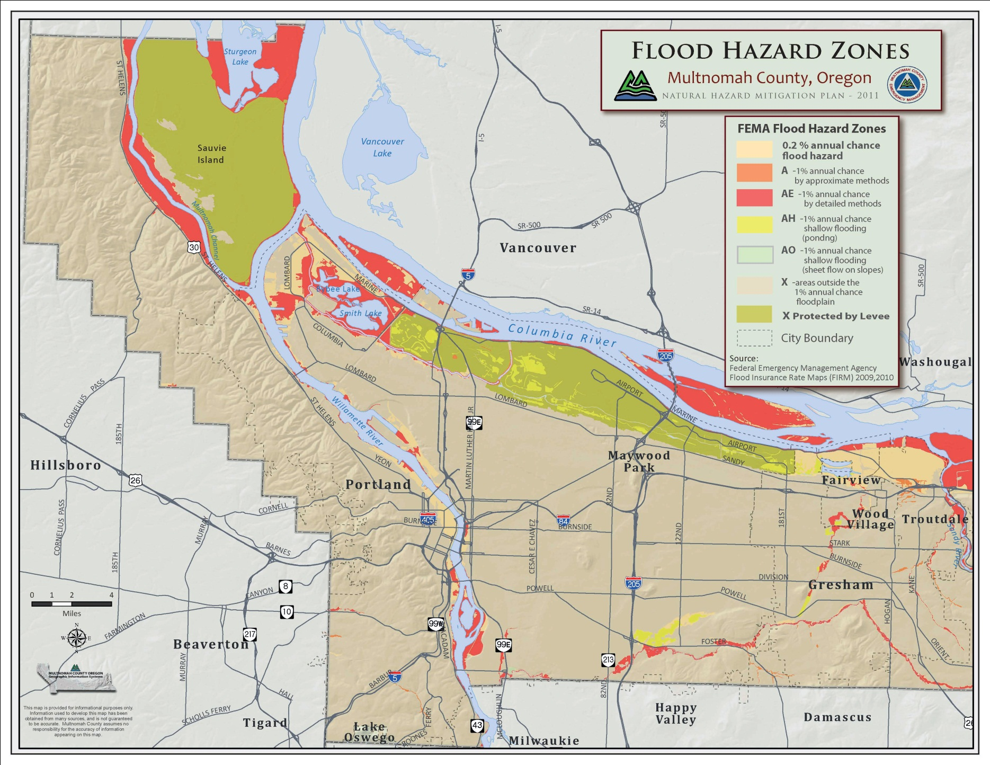
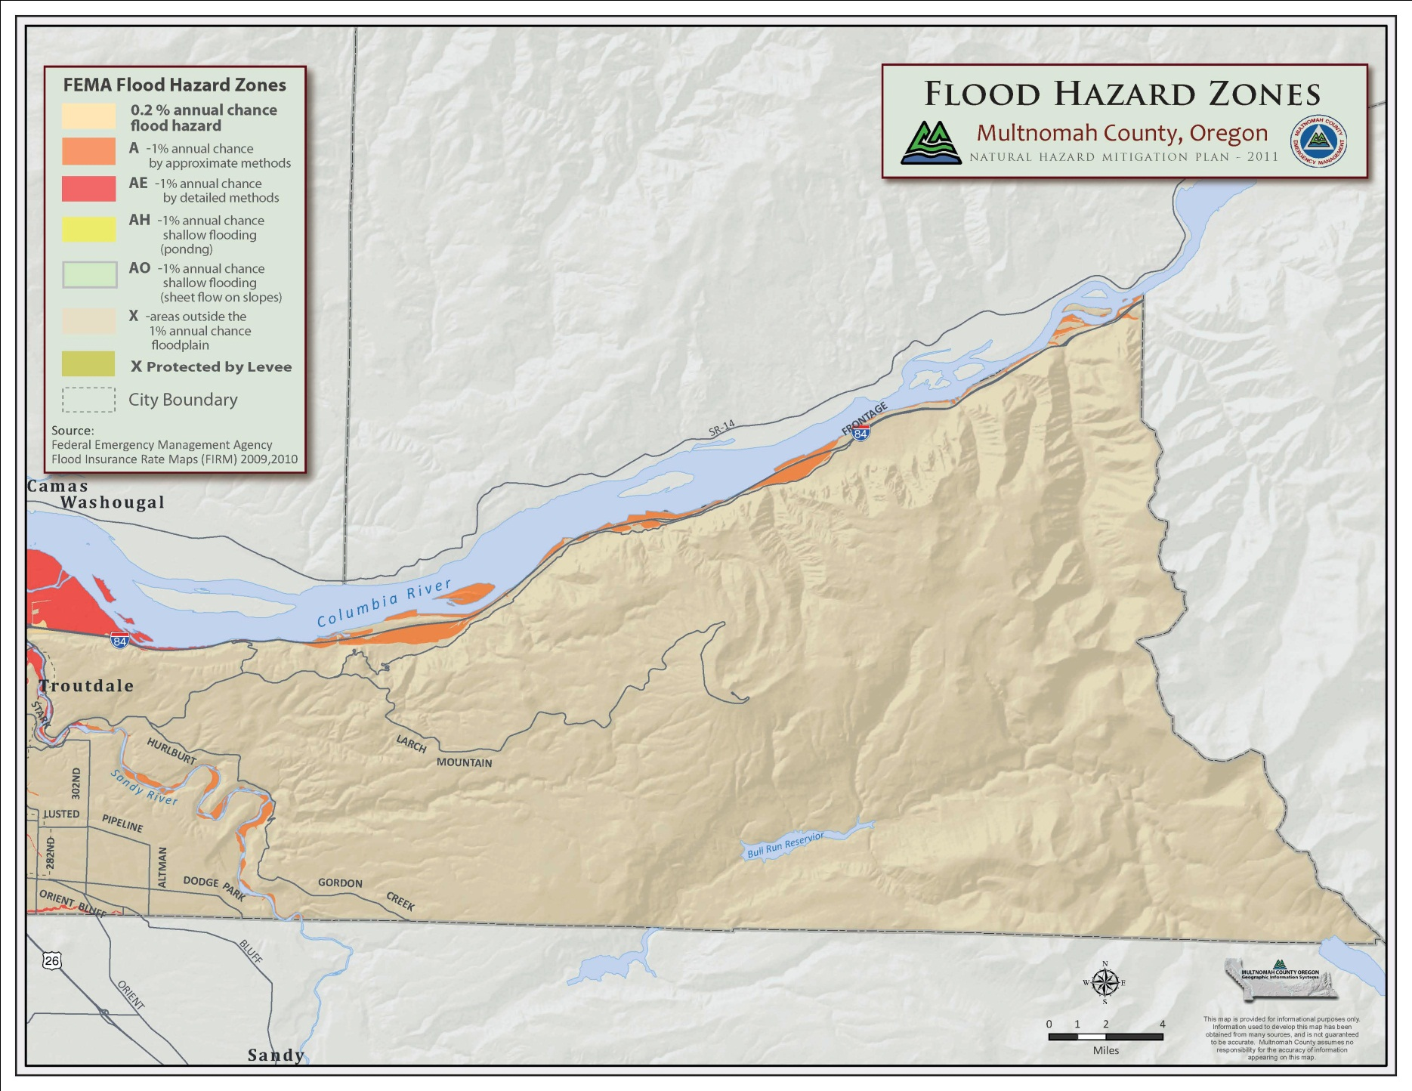
In some places, areas subject to flooding can change as river channels shift. This is particularly the case along the Sandy River, where the river channel has “migrated” significantly over time. DOGAMI has completed a channel migration study for only one river in Multnomah County – the Sandy River – and has prepared preliminary maps of and recommendations associated with migration of the river’s channel. [A better map will replace the above version]

wildfires
The County’s 2016 Natural Hazards Mitigation Plan (NHMP) includes updated mapping of wildfire risks, including new West-side Wildfire Risk Assessment data from the Oregon Department of Forestry (ODF), which addresses a portion of Multnomah County. Areas identified as potentially at risk include land zoned for commercial forestry use (CFU), as well as for rural residential and other uses. These areas are located primarily in the East of Sandy River and West Hills areas where larger forested areas are located. They also include land in the West of Sandy River area in forested areas just west of the Sandy River. Until it can be more thoroughly field-checked, the ODF assessment provides general guidance for application of strategies to reduce the risk of wildfires. The 2011 Multnomah County Community Wildfire Protection Plan includes mitigation strategies for urban/wildland interface fires. That Plan included development of a homesite assessment program, which had not been incorporated in changes to zoning code regulations related to wildfires as of 2016. The Multnomah County Climate Action Plan also includes suggested actions for addressing wildfire risk.
The County currently has a limited number of requirements associated with reducing risk related to wildfires in the CFU zones and no requirements in the other zones. The zoning code requirements generally match the guidance from the ODF and Oregon Administrative Rule chapter 660, division 6, rule 29 and rule 35. Rule 29 and rule 35 requires that counties adopt the fire-siting standards provisions in the publication, "Recommended Fire Siting Standards for Dwellings and Structures and Fire Safety Design Standards for Roads" developed by ODF. Policies and standards related to wildfire protection are intended to protect people and property, as well as to protect natural resources by reducing the opportunity for wildfires to spread.
[The above map will be replaced by a better map with expanded legend.]

earthquakes
Much has been written about the potential for a future large earthquake in the Pacific Northwest based on the presence of potential sources of earthquakes and how often they typically occur. The magnitude or strength of an earthquake is one factor in predicting the damage it will cause. Larger magnitude earthquakes affect larger geographic areas, with much more widespread damage than smaller magnitude earthquakes. However, for a given site, the magnitude of an earthquake is not a good measure of the severity of the earthquake at that site. Rather, for any earthquake, the intensity of ground shaking at a given site depends on four main factors:
- Earthquake magnitude
- Earthquake epicenter, which is the location on the earth’s surface directly above the point of origin of an earthquake
- Earthquake depth (focus)
- Soil or rock conditions at the site, which can either amplify or suppress earthquake ground motions
An earthquake will generally produce the strongest ground motions near the epicenter with the intensity of ground motions diminishing with increasing distance from the epicenter. In addition to the factors above, the intensity of ground shaking is also affected by soil types. Soft soils may amplify ground motions and increase the level of damage.
The sources of potential future earthquake damage in Multnomah County include:
- “Interface” earthquakes on the boundary between the subducting Juan de Fuca oceanic plate and the North American plate. These earthquakes could have the highest magnitudes of potential earthquakes (up to 9.2 magnitude). They would likely occur about 12 to 40 miles offshore from the Pacific Ocean coastline. Ground shaking from such earthquakes would be very strong near the coast. Strong to moderately strong ground shaking would be felt throughout Multnomah County, with the level of shaking decreasing towards eastern Multnomah County. At the same time, ground shaking could vary considerably in specific locations due to differences in underlying geologic conditions. The duration of a quake also would affect the amount of ground shaking and resulting damage levels. In general, subduction zone earthquakes tend to last longer than other types of earthquakes.
- “Intraplate” earthquakes within the Juan de Fuca oceanic plate. These earthquakes have lower magnitudes (up to 7.5). They occur quite deep in the earth, about 18 to 25 miles below the surface with epicenters that would likely range from near the Pacific Ocean coast to about 30 miles inland. Thus, epicenters from these types of earthquakes could be located west of Portland. Ground shaking from such earthquakes would be very strong near the epicenter and would be felt throughout all of Multnomah County, with the level of shaking decreasing towards eastern Multnomah County.
- “Crustal” earthquakes within the North American Plate. These earthquakes within the North American plate are possible on faults mapped as active or potentially active as well as on unmapped (unknown) faults, including within Multnomah County. Based on the historical seismicity in Western Oregon and on analogies to other geologically similar areas, small to moderate earthquakes up to magnitude 5 or magnitude 5.5 are possible almost any place in Multnomah County. Such earthquakes would be mostly smaller than the 1993 Scotts Mills earthquake (magnitude 5.6). There is also a possibility of larger crustal earthquakes in the magnitude 6+ range, albeit, in the absence of known, mapped faults, the probability of such events is likely to be low.
Liquefaction can also increase the severity of damage during an earthquake. Liquefaction is a process where loose, wet sediments lose strength during an earthquake and behave similarly to a liquid. Once a soil liquefies, it will tend to settle vertically and/or spread laterally. With even very slight slopes, liquefied soils tend to move sideways downhill (lateral spreading). Settling or lateral spreading can cause major damage to buildings and to buried infrastructure such as pipes and cables. Figure __ shows areas within Multnomah County with high liquefaction potential. Even in areas mapped as high liquefaction potential, the actual degree and extent of liquefaction can vary depending on factors such as earthquake intensity and duration.
In considering how to mitigate the effects of an earthquake, planners and public officials typically focus on the following strategies:
- Require new buildings to be built to building codes that will help the structures withstand the effects of an earthquake with less damage and resulting injury.
- Renovate or replace critical structures such as bridges, hospitals, schools, and other similar buildings and require that they be built to a higher seismic standard to improve their ability to withstand earthquakes.
- Avoid locating certain types of structures, including those described above, in areas with the greatest potential for damage from an earthquake.
A number of actions related to these strategies are found in the County’s Natural Hazards Mitigation Plan. However, given the inability to accurately predict exactly where and when earthquakes will occur and the potential damage they will inflict, it is generally not practical to limit where different types of land uses can be located to avoid or mitigate earthquake impacts. As a result, fewer broad land use policies or actions can be taken to mitigate earthquake impacts at the Comprehensive Plan level.

relevant studies and planning processes
A variety of local, state, regional, and local plans and policies are relevant to planning for natural hazards in Multnomah County, including the following.
Oregon’s Statewide Planning Goal 7, Areas Subject to Natural Disasters and Hazards, deals with development in places subject to natural hazards such as floods or landslides. It requires that jurisdictions apply “appropriate safeguards” when planning for development there.
Multnomah County’s Natural Hazards Mitigation Plan is an educational and planning document, which meets federal planning requirements by addressing hazards, vulnerability, and risk. The mitigation plan is a necessary requirement for federal mitigation grant fund eligibility. Relevant policies from that document have been incorporated into various chapters of this Plan. The Natural Hazards Mitigation Plan also is referenced here as a supporting document of the Comprehensive Plan.
Multnomah County Emergency Management planning documents. The Multnomah County Office of Emergency Management provides a variety of materials related to preparing for emergencies, including a Mass Shelter Plan, Emergency Preparedness Checklist, Emergency Supplies Shopping Calendar, Pet Emergency Plan, and Earthquake Home Hazard Hunt, among others.
The Federal Emergency Management Agency (FEMA) provides Hazard Mitigation Assistance (HMA) Guidance, to assist counties with Mitigation Plans. The HMA outlines strategies for the mitigation process by interpreting the Federal statutes, regulations, and best practices.
Oregon Department of Forestry administrative rules, chapter 660, division 6, rule 29 and rule 35 provide siting and fire-siting criteria for new homes and structures. Rule 29 and rule 35 include standards for siting new dwellings in forest and agriculture/forest zones, which are designed to make such uses compatible with forest operations and agriculture, to minimize wildfire hazards and risks, and to conserve values found on forest lands.
Multnomah County Community Wildfire Protection Plan provides a foundation for coordination and collaboration among agencies and the public to identify and prioritize future wildfire projects and assists in meeting federal planning requirements and qualifying assistance programs. The Plan integrates wildfire awareness into public outreach and education, emergency operations, and vegetation management programs to promote actions that create safe communities and a more wildfire resilient landscape.
Oregon Department of Geology and Mineral Industries (DOGAMI) documents and provides a variety of data, including identifying geologic hazards. DOGAMI provides ongoing scientific study of hazards, such as earthquakes and landslides, to help jurisdictions understand the risks and prepare mitigation.
The County’s Climate Action Plan also includes information about increased risks from natural hazards associated with climate change and associated strategies and actions to address them. That information has been included and referenced in this Plan.

key planning issues and supporting information
A number of key planning issues affect natural hazards planning policies and practices in the rural portions of Multnomah County:
- Coordination with Natural Hazards Mitigation Planning. The County’s Office of Emergency Management maintains and regularly updates the NHMP, which spells out a variety of actions and strategies to address and mitigate the potential impacts of natural hazards. In preparing this chapter of the Comprehensive Plan, County planning staff coordinated extensively with Emergency Management staff who were in the process of updating the NHMP.
- Balancing natural hazard mitigation with protection of natural resources. Reducing the risk of certain hazards, such as wildfires must be balanced with protecting natural resources such as trees and wildlife habitat. The County’s wildfire protection standards and policies address this balance to some degree. This issue also will be addressed in implementing additional wildfire protection standards for areas not previously subject to such standards (e.g., rural residential areas).
- Establishing appropriate thresholds for limiting development in landslide risk areas. Consistent with the state planning requirement to use up-to-date data to assess and mitigate the risks of damage from natural hazards, the County will use landslide susceptibility data from the Oregon DOGAMI in applying requirements to address those risks. At the same time, the County will also use slope gradient thresholds to apply requirements for investigation and mitigation of landslide risks. County staff, the Community Advisory Committee (CAC) that assisted with policy development and the public had extensive discussion of the appropriate thresholds to use for these requirements and reviewed standards used by other jurisdictions in Oregon and Washington in identifying thresholds to be used in Multnomah County.
- Addressing channel migration. In updating this Plan, County staff and the project’s CAC discussed the issue of expanding floodplain protection to areas beyond the existing 100-year floodplain to address channel migration. There was general community support for that strategy and it has been incorporated in the Plan.

policies and strategies

policies and strategies applicable County-wide
The policies in this section focus on assessing the risks from and avoiding or mitigating damage to people, property, and natural resources from potential natural hazards from a land use planning perspective. Additional actions related to County facilities and emergency management planning and actions are found in the County’s adopted Natural Hazards Mitigation Plan.

Areas Susceptible to Landslides
  - Direct development and landform alterations away from areas with development limitations related to potential hazards associated with steep slopes (over 25%) and other areas shown to be potentially susceptible to landslides or their impacts based on available County and state data associated with these hazards. Allow for exceptions based upon a showing that design and construction techniques can prevent or mitigate public harm or associated public cost and prevent or mitigate adverse effects to nearby properties.
    - Update the County’s regulatory slope hazard map, as needed, to more accurately reflect the location of steep slopes and areas potentially susceptible to landslide hazards.
    - Evaluate and revise the Hillside Development and Erosion Control Overlay zone, as needed, to implement up-to-date regulatory approaches for addressing landslide hazards.
  - Protect lands having slopes greater than 25% and lesser slopes shown to be potentially susceptible to landslides from inappropriate development or slope alteration. Consider possible adverse effects on nearby homes and public and private infrastructure.
    - Designate lands with slope greater than 25% and lesser slopes determined to be potentially susceptible to landslides as having development limitations and apply appropriate standards to new development on these designated lands. Slope alteration and site disturbance shall be minimized and measures taken to stabilize slopes, minimize erosion, and replant areas where vegetative cover will be removed.
    - Investigate the advisability of requiring property owners to record landslide-related limitations as deed restrictions.

earthquake hazards
  - Direct development away from areas with hazards associated with potential liquefaction resulting from major earthquakes.
    - Determine the types of uses or improvements and the extent to which they should be restricted within areas subject to liquefaction.
  - Protect against seismic hazards to structures and ground areas susceptible to earthquake damage.
    - Encourage and promote appropriate building code revisions for areas of greatest seismic hazard, when information on the location of such areas becomes available.

flooding
  - Regulate flood management areas in order to reduce the risk of flooding, prevent or reduce the risk to human life and property, and maintain functions and values of floodplains such as allowing for the storage and conveyance of stream flows through existing and natural flood conveyance systems.
    - For areas of Multnomah County within Metro’s jurisdictional boundary, establish standards to reduce the risk of flooding and maintain the functions and values of floodplains pursuant to Title 3 of the Metro Urban Growth Management Functional Plan.
  - Reduce potential hazards related to flooding and channel migration through the following strategies:
    - Limit the types of land uses allowed in floodways, floodplains, and channel migration areas to minimize public harm or associated public cost due to flooding.
    - Establish development standards for development in flood prone areas to mitigate potential adverse effects to surrounding properties and to maintain or increase flood storage and conveyance capacity; periodically update standards based on best practices for minimizing damage and risks from flooding.
    - Meet minimum requirements to be eligible to participate in the National Flood Insurance program.
    - Update mapping of floodways and floodplains based on established channel migration data from state or federal agencies or other sources, as needed or as initiated by the County.

wildfire risks
  - Require development in areas prone to wildfire risks to meet fire safety and mitigation standards.
    - Use current mapping data related to wildfire risk in determining the location of fire prone areas, supplemented by on-site assessments, if needed.
    - To reduce wildfire risk and associated impacts while protecting wildlife habitat, expand requirements to areas identified as prone to wildfires but not currently subject to regulations after revising standards to better ensure wildlife habitat compatibility. Weigh and balance wildlife habitat needs with effective wildfire risk reduction.
    - Ensure that agencies responsible for fire protection are provided an opportunity to comment on development applications prior to approval of the application.
    - Investigate and consider updating County zoning code requirements to address areas with multiple hazards in an integrated manner.

SAUVIE ISLAND AND MULTNOMAH CHANNEL POLICIES AND STRATEGIES
  - Coordinate with the Sauvie Island Rural Fire Protections District (RFPD) on emergency/disaster preparedness planning and evacuation plans for Sauvie Island residents.

