January 11, 2016

Introduction/Background Information
Goal 8 of Oregon’s statewide planning goals requires cities and counties to satisfy the recreational needs of its citizens, community members, and visitors, and, where appropriate, to provide for the siting of necessary recreational facilities including destination resorts. The goal and its administrative rules call for local governments who have responsibility for providing recreation services and facilities to plan for them in locations and amounts that are consistent with the jurisdiction’s resources available to provide them, and to do so in coordination with private entities.
Multnomah County made a policy decision in the early 1990s that it did not have the resources to plan for recreation areas and facilities on a countywide basis in the urban or rural areas of the County and that other government agencies are better suited to plan for and provide recreation in Multnomah County. Starting in 1993 Multnomah County transferred ownership and management of a number of County recreation facilities to the Metro regional government. These included Blue Lake Park, Oxbow Park, and a number of boat ramps, beaches, and other facilities. As described in this chapter, a variety of regional, state, and federal agencies provide for a wide range of recreational activities within the rural areas of Multnomah County.
This chapter provides an overview of conditions and planning issues associated with park and recreation planning, along with Comprehensive Plan policies and strategies to address them.

Park and Recreation Conditions

Parks and Natural Areas
Multnomah County does not own or manage any parks or recreational facilities. However, a variety of other local, regional, state, and federal agencies, as well as private organizations, provide for a wide range of recreational activities in or directly adjacent to the County’s rural lands. Examples include the following:
- City of Portland. Forest Park is adjacent to the West Hills area and is owned and managed by the City of Portland. It includes the lower portions of the Balch Creek Basin and is the City’s largest recreational area, as well as the largest natural area park within an incorporated city in the United States. Protection of its integrity as a natural park amidst urban development and as home to numerous native plant and animal species is a high priority for both the City of Portland and Multnomah County as well as for neighborhood and conservation organizations. The City of Portland has adopted a Natural Resources Management Plan for Forest Park, which is designed to protect and enhance the natural resources in the park.
- Metro. The Metro regional government assumed ownership and operation of a number of park and recreational facilities previously owned and operated by the County, including Oxbow Park, Blue Lake Park, and a number of boat ramps and other facilities. Metro also operates the Howell Territorial Park on Sauvie Island, as well as a number of natural areas and nature preserves in Multnomah County managed primarily for ecological values.
- Oregon Department of Parks and Recreation (ODPR). The state owns and operates nine state parks or recreation areas within the rural parts of Multnomah County, including Benson, Rooster Rock, Dabney, Government Island, Lewis and Clark, Ainsworth, Women’s Forum, George W. Joseph, Guy W. Talbot, and Wapato. The majority of these are in the eastern portion of the County and several are in the Columbia River Gorge National Scenic Area. Only the Wapato recreation and wildlife area is in the western portion of the County (on Sauvie Island). The ODPR also manages additional scenic corridors and trailheads in Multnomah County, primarily in the Columbia River Gorge.
- Oregon Department of Fish and Wildlife. This agency manages two wildlife areas on Sauvie Island – the Sauvie Island Wildlife Area and the JR Palensky Wildlife Mitigation Area.
- United States Forest Service (USFS). The USFS manages a significant amount of land in the Mt. Hood National Forest in the eastern half of the County within the Columbia River Gorge and East of Sandy areas, including numerous recreation areas and trails. Within Multnomah County, these opportunities are almost entirely within the Columbia Gorge National Scenic Area. The facilities in the Gorge are some of the most heavily visited recreation areas in the state of Oregon. On lands outside of the National Scenic Area, only limited recreation on hiking trails is currently allowed or foreseen in the future. Much of the area along the eastern edge of the National Forest, adjacent to private lands which lie on tributaries of the Sandy River, is closed to recreational activities because it is part of the Bull Run watershed (municipal drinking water supply for Portland).
- United State Bureau of Land Management. The US Bureau of Land Management (BLM) manages approximately 643 acres of federally owned land in the northern portion of the West Hills, divided into six non-contiguous parcels. The BLM also manages about __ acres in east County. Currently these lands are managed primarily for timber production.
Sandy River parks are a major recreational attraction (approximately 1 million visitors annually). The river is designated as a State Scenic Waterway and a Federal Wild and Scenic River between Dodge Park and Dabney State Park. The river provides easy access and outstanding habitat for anadromous fish, due to its outfall into the Columbia below that river's dam system, and the relative lack of development in its watershed. The river is also large enough to allow for non-motorized boating (rafting) and floating. Because it is classified as a navigable waterway, the submerged and submersible lands along the river are “waters of the state” and are managed and regulated by the Oregon Department of State Lands. The parks along the river provide the opportunity for nature study and day use, including rafting, kayaking, and river floating. Several private camps are located adjacent to the river.

Trails
In addition to the facilities described above, people use a combination of trails and rural roads for recreational walking and bicycling. Recreational trails include those managed by local, regional, state, and federal agencies, which sometimes cross multiple jurisdictions. Regional trails include the Springwater Trail, connecting downtown Portland to the rural community of Boring; the Westside Trail, connecting Forest Park to the Bethany area; the Helvetia Trail (which includes the Burlington Northern rails-to-trails conversion and would connect the Helvetia area over Cornelius Pass to the Pacific Greenway Trail); and the Pacific Greenway Trail (extending the Wildwood Trail towards Scappoose and the Oregon Coast).
The Burlington Northern railroad right-of-way from Highway 30 through Cornelius Pass to Washington County is being considered for a rails-to-trails conversion, which could provide an off-road cycling route through the hills near Cornelius Pass Road and provide a key portion of the Helvetia regional trail.
A significant amount of recreational bicycling occurs on County roads throughout the rural portions of the County, particularly on Sauvie Island, the West Hills, and East of Sandy areas, as well as the Columbia River Gorge National Scenic Area.
Figure 1 – Parks & Open Space, Western Multnomah County
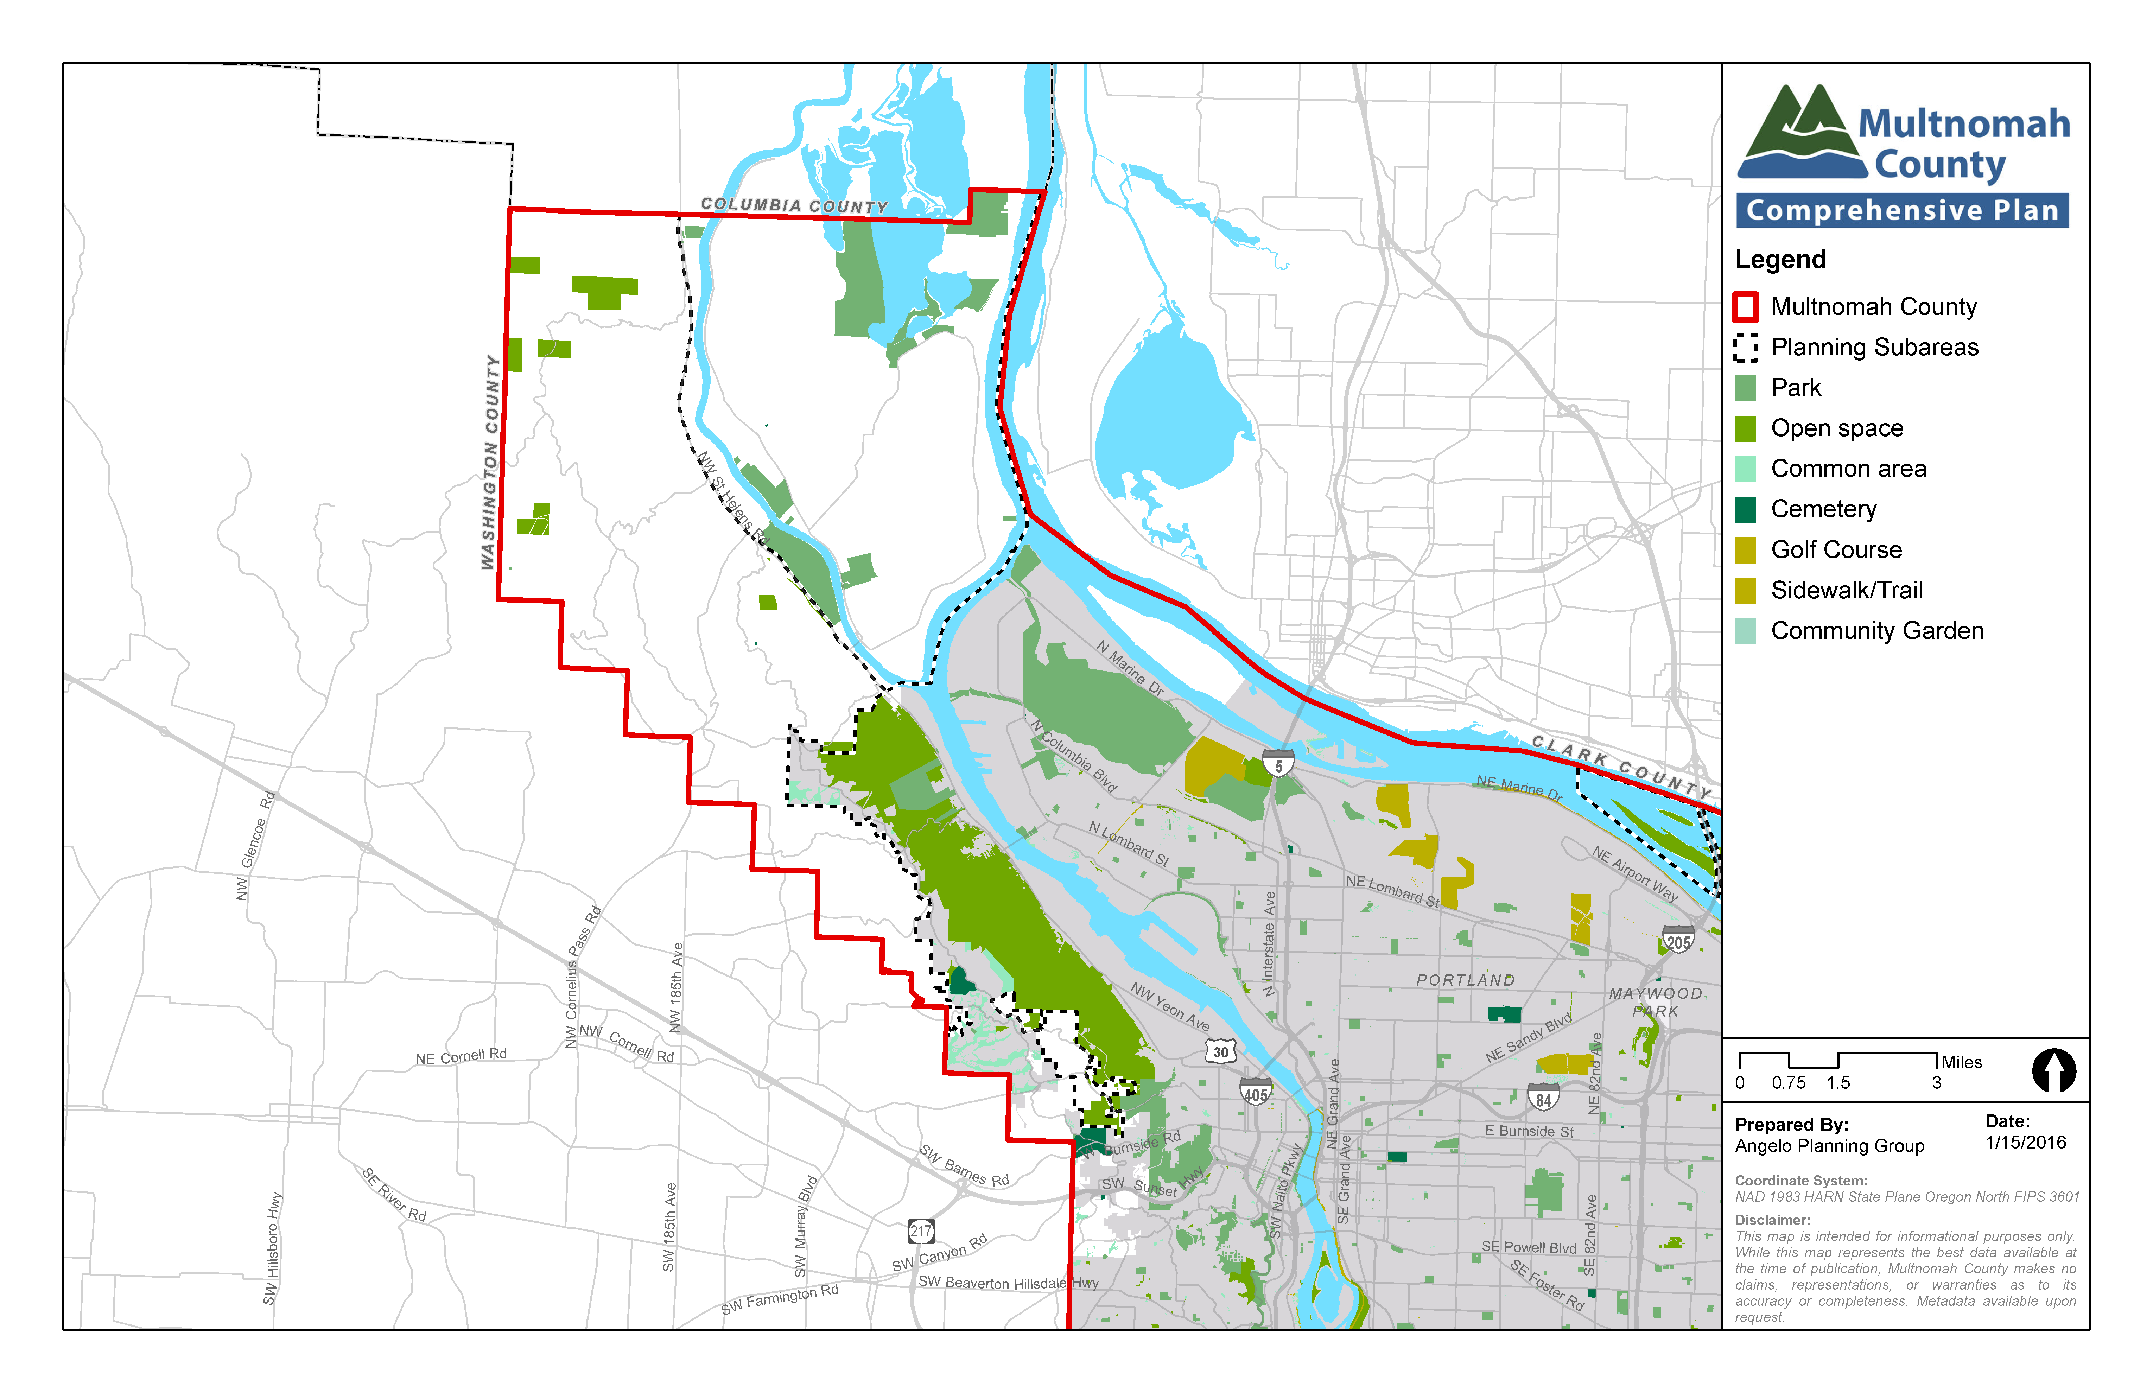
Figure 2 – Parks & Open Space, Eastern Multnomah County
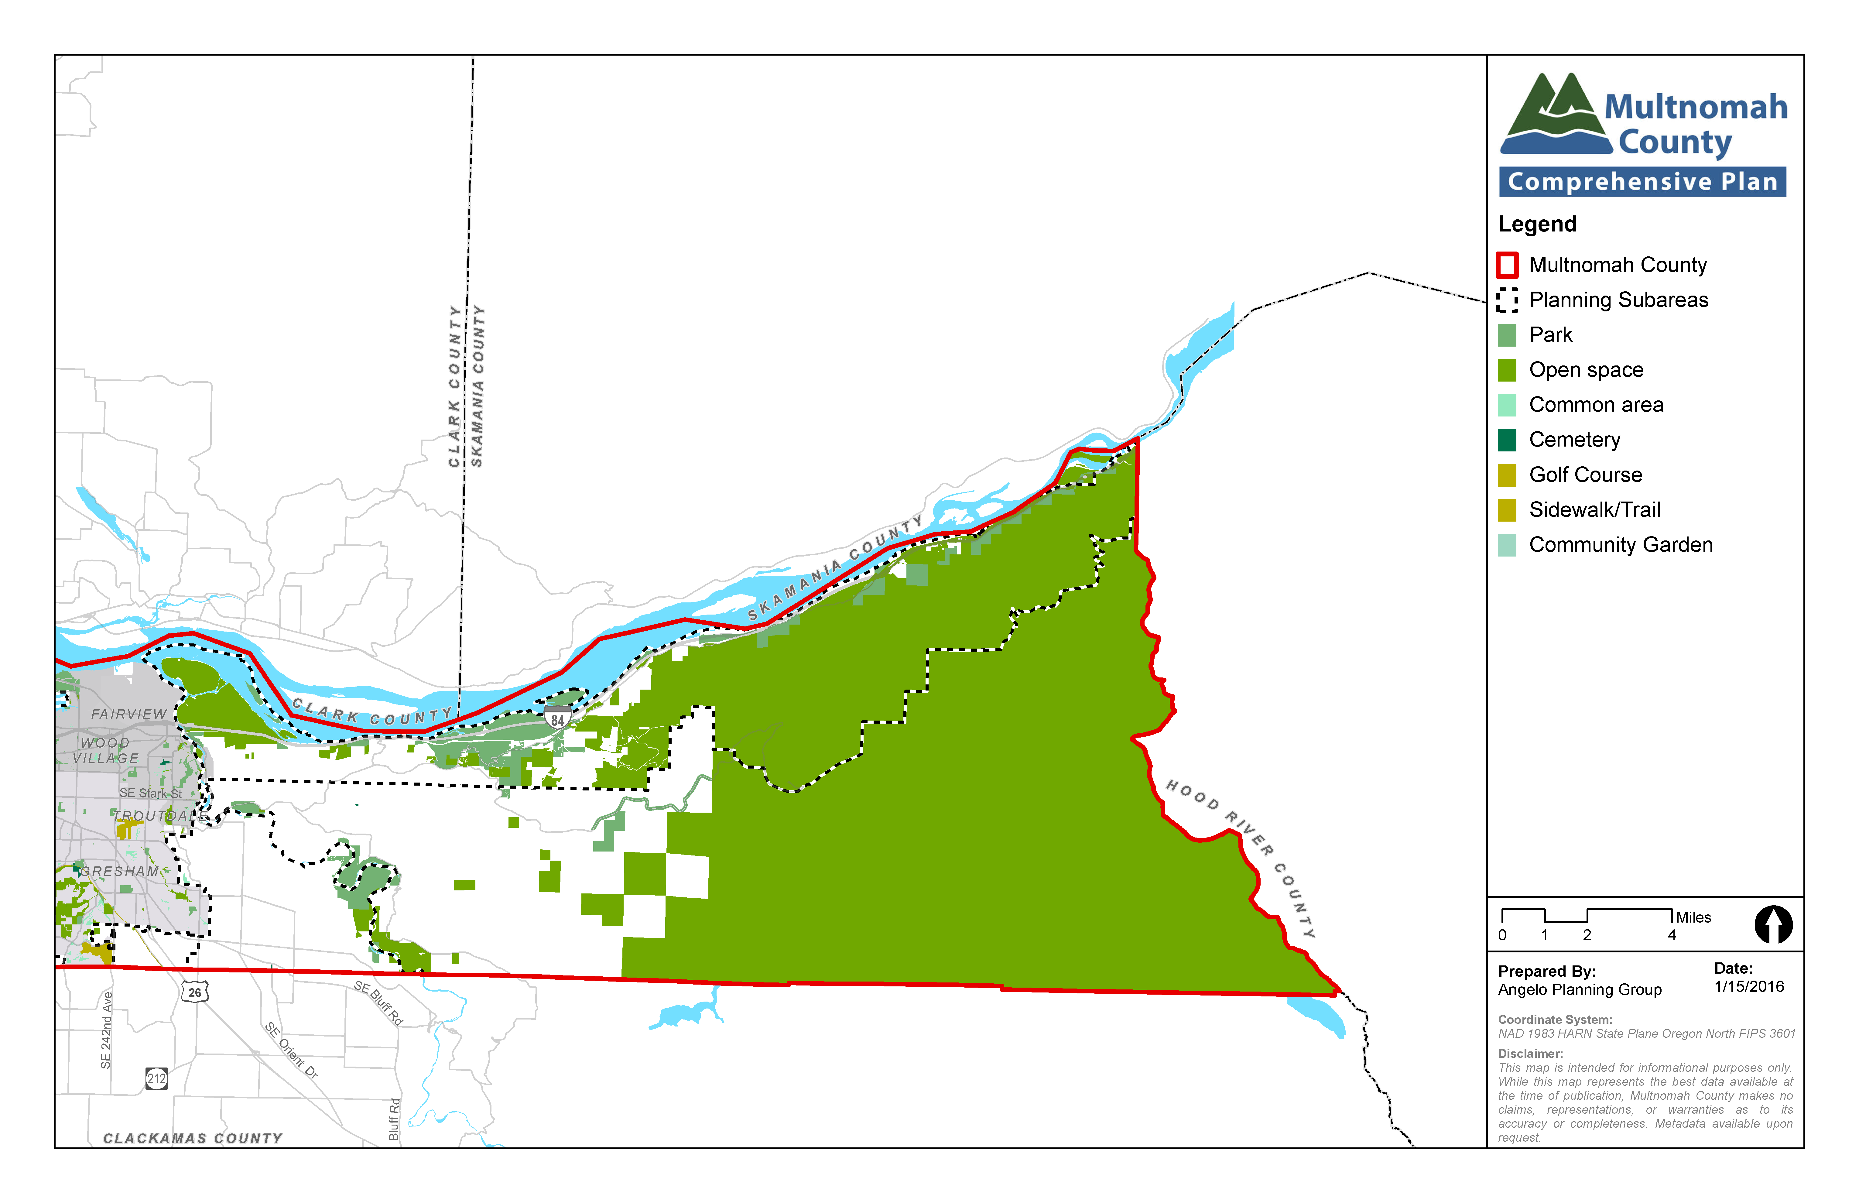

relevant studies and planning processes
A variety of local, state, and regional plans and policies are relevant to planning for parks and recreation in Multnomah County, including the following.
Oregon’s Statewide Planning Goal 8, Recreation Needs, calls for each community to evaluate its areas and facilities for recreation and develop plans to deal with the projected demand for them.
Metro has a variety of Parks and Open Space planning documents, including policies associated with land acquisition, natural resource protection and management, recreational planning, and individual facility master plans. The agency’s parks and nature system, including overarching values, operating procedures, facility descriptions and key strategies, is outlined in the Metro Parks and Nature System Plan (2016).
Columbia River Gorge National Scenic Act establishes a national scenic area to protect and provide for the enhancement of the scenic, cultural, recreational, and natural resources of the Columbia River Gorge. It also protects and supports the economy of the Columbia River Gorge area by encouraging growth to occur in existing urban areas located throughout the Gorge.
The Mt. Hood Land and Resources Management Plan guides all natural resource management activities and establishes management standards and guidelines for the Forest. It describes resource management practices, levels of resource production and management, and the availability and suitability of lands for resource management.
The Oregon Department of Parks and Recreation provides information on state park master plans and the Statewide Comprehensive Outdoor Recreation Plan (SCORP). The SCORP provides guidance to counties for delivering quality outdoor recreational opportunities.
The Forest Park Natural Resources Management Plan formulates goals, strategies, and actions to protect and enhance park resources and manage recreation use. The plan includes recommendations, strategies and actions, identifies projects, and provides regulations that govern park activities.
Individual park or recreation facility plans, such as those for Oxbow Park, Columbia River Gorge facilities, Howell Territorial Park and others guide activities at those sites.

key planning issues and supporting information
A number of key planning issues affect parks and open space planning policies and practices in the rural portions of Multnomah County:
- Coordination with other agencies, including land use permitting. While the County does not provide recreational services, it does coordinate with those agencies that do. This includes sharing information with other agencies and the public and reviewing land use permits for park and recreation facilities in some cases. In reviewing land use permits, the County must consider its Zoning Code requirements, as well as the policies of this Plan.
- Balancing recreational use with protection of natural resources. Oftentimes, recreational facilities are located within environmentally sensitive areas where it is important to balance recreation needs with natural resource management and protection objectives, particularly for riparian areas and wildlife habitat. This issue was raised by community members during preparation and update of this Comprehensive Plan and a number of policies direct the County to balance these two different types of objectives.
- Recreational bicycle use on County roads. A significant number of people use County roads for recreational bicycling. This was a topic of significant discussion during Comprehensive Planning and Rural Area Planning processes. Much of the discussion focused around ensuring that bicycling on County roads can occur safely, that conflicts between different types of road users are minimized, and that bicyclists and motorists are courteous and respectful towards each other. The County’s TSP includes a number of policies related to this topic.

policies and strategies

policies and strategies applicable County-wide
The policies in this section focus on coordination with other agencies in planning for and providing recreational facilities and services and with balancing recreational needs with goals for natural resource protection. Additional related policies can be found in Chapter 5 of this plan and in the County’s Transportation System Plan (referenced in Chapter 12).

Parks and Recreation Planning
  - Support efforts of the Intertwine Alliance and other organizations in establishing a coordinated approach to create and maintain a strong, interconnected regional network of parks, trails, and natural areas.
  - Encourage the development of recreation opportunities by public agencies and private entities consistent with wildlife habitat and wildlife corridor protection.
  - Coordinate with other agencies in strategically siting new public recreational facilities to take advantage of existing infrastructure that allow for multi-modal access opportunities and shared parking. An example would be joint use of park and school facilities by locating them adjacent, or close, to each other.
    - Include provisions in the Zoning Code for privately owned and operated recreational facilities as conditional uses in appropriate zones.
  - Ensure that the residents of areas outside of the urban growth boundary are represented on parks and open space issues.
    - Encourage Metro to appoint residents representing different rural areas of Multnomah County to Metro's parks and greenspaces citizens' advisory boards.
  - Consider the impacts of proposed recreation facilities on nearby private properties and require applicants to avoid and minimize significant adverse impacts to nearby properties.

Development Requirements
  - Require areas for bicycle parking facilities in development proposals where appropriate.

West Hills policies and strategies
  - Support the natural systems and recreational values of Forest Park and adjacent areas in concert with the City of Portland, Metro, and other agencies.
    - Promote and provide incentives for voluntary use of conservation easements and habitat protection by property owners

Sauvie Island and Multnomah Channel policies and strategies
  - Continue to coordinate with Metro to ensure compliance with Rural Reserve designations, implementation of Metro’s Greenspaces Master Plan, and planning for Howell Park. In particular, work with Metro to:
- Ensure activities will complement natural and environmental resources of local and regional significance; and
- Ensure that Howell Territorial Park uses and improvements maintain harmony with the rural character of the plan area as well as natural and cultural resources.
  - Support only those recreational activities within the SIMC area that are complementary to and do not negatively impact natural and environmental resources on Sauvie Island and along the Multnomah Channel and its tributaries that are identified in Goal 5 and in the Metro Greenspaces Master Plan and lands approved in Metro's Acquisition Refinement Plan.

West of Sandy Policies and Strategies
  - Support upgrades and improvements to Oxbow Park consistent with the character of the surrounding area.
    - Work with Metro to develop a park zoning district for Oxbow Park.

East of Sandy policies and strategies
  - Maintain and enhance the recreational value of the Sandy River and Columbia River and adjacent areas in concert with the Columbia River Gorge Commission, Metro, Oregon Parks and Recreation Department, US Forest Service, and other agencies.
    - Implement this policy through the National Scenic Area and Significant Environmental Concern provisions within the Multnomah County Zoning Code, and participate in other agency plans such as a future National Scenic Area Management Plan update and Metro's Oxbow Park Master Plan.

