January 8, 2016

Introduction/Background Information
Goal 10 of Oregon’s statewide planning goals requires cities and counties to plan for housing needed to support their residents, including providing for a variety of housing types at price levels that are affordable to residents with a range of incomes. For urban areas, the goal and its administrative rules call for local jurisdictions to identify projected future housing needs through preparation of a housing needs analysis and to ensure that adequate land is available to meet those future needs. For rural areas, Counties are not required to undertake such analyses.
Under the statewide planning program, the vast majority of housing is expected to be located within the urban growth boundaries of cities. In this respect, residents have access to a wide variety of housing options in the urban parts of Multnomah County. However, due to state and regional policies, statutes, and administrative rules, as well as the lack of municipal water and sewer systems in most rural parts of the County, a limited number and range of housing types can be developed in those rural areas. In most areas, only single family homes, including manufactured homes are allowed. Farmworker housing also is allowed in exclusive farm use zones. More dense forms of housing such as apartments are not allowed in the County’s rural zones.
This chapter provides an overview of conditions and planning issues associated with rural housing, along with Comprehensive Plan policies and strategies to address them.

Housing Conditions
In rural Multnomah County, there are generally more Family Households compared to the County as a whole and the rest of the state. Family Households are defined by the U.S. Census Bureau as “a group of two or more people related by birth, marriage, or adoption and residing together”. Housing is heavily owner-occupied in all parts of rural Multnomah County. Owner-occupied housing tends to have a larger average household size compared to renter-occupied households.
Households in rural areas of Multnomah County generally have higher incomes compared to the County as a whole. In particular, households in the West Hills have a significantly higher median income. Similarly, all parts of rural Multnomah County tend to have older household members as the median age in rural Multnomah County is higher.
The vast majority of housing in the rural areas of the County is made up of owner-occupied, single-family dwellings, including manufactured home on individual lots. Housing is spread throughout the different rural planning areas in the County, including in farm and forest zones, mixed use agricultural zones, rural residential areas, and rural centers. On average, the amount and density of housing or residential development is fairly low in these areas but it is higher in the West Hills and West of Sandy areas. Those two areas have just under 4,000 households each and have higher densities of housing than the Sauvie Island/Multnomah Channel (SIMC) or East of Sandy areas although they are still well under one person per acre. Densities and concentrations of housing are higher in rural residential areas and rural centers than in farm and forest zones. Rural residential areas and rural centers tend to make up a relatively small proportion of land in rural areas but include a significant percentage of the housing in a given rural planning area.
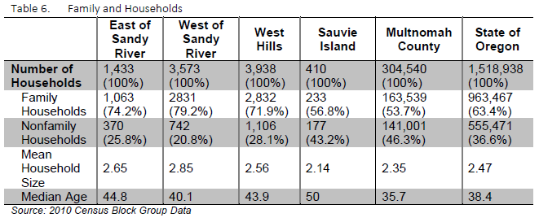
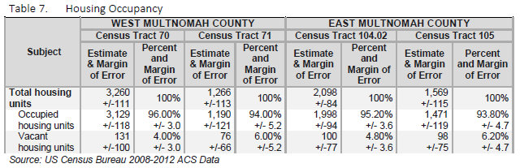
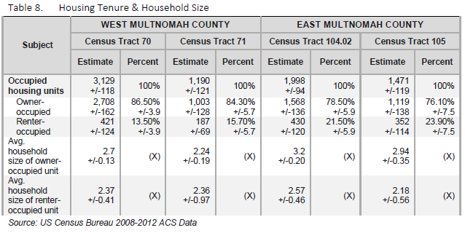
In the Sauvie Island/Multnomah Channel area, approximately 350 floating homes existed or had been approved on the Multnomah Channel (2014). Moorages and marinas where these homes are located are leased through the Oregon Department of State Lands which owns and manages “submerged and submersible” land within the state’s navigable waterways. Floating homes are subject to state laws and County Zoning Code provisions. The subject of regulating floating homes and live-aboard boats was discussed extensively during the 2013-2015 Sauvie Island/Multnomah Channel rural area planning process and this Plan incorporates policies and strategies adopted as part of that Plan.

relevant studies and planning processes
A variety of state, regional, and local plans and policies are relevant to planning for housing in Multnomah County, including the following.
Oregon’s Statewide Planning Goal 10, Housing, specifies that local jurisdictions must plan for the housing needs of their citizens. However, the majority of the Goal 10 and associated administrative rule and statutory provisions apply to land within urban growth boundaries, with relatively few requirements for meeting housing needs in rural areas.
The regional Urban Growth Boundary (UGB) separates existing urban and rural areas, with housing needs for the County primarily being met inside the UGB. In addition, Urban and Rural Reserves located outside of the urban growth boundary (UGB) provide future guidance on urban expansion. Urban Reserves are intended to facilitate long-term planning for urbanization in the Portland metropolitan area and to provide greater certainty about the future expansion of the UGB. Rural Reserves are intended to provide long-term protection for large blocks of agricultural land and forest land, and for important natural landscape features that limit urban development. OAR 660-027 provides regulations to balance Urban and Rural Reserves that best achieves livable communities.
The Rural Residential Rule (OAR 660-04-0040) states that, “… a local government shall not allow more than one permanent single-family dwelling to be placed on a lot or parcel in rural residential areas”.
Multnomah County’s Zoning Code is organized by rural and urban subareas, overall administrative procedures, and general building regulations. The rural and urban subareas (Rural Zoning Code and Urban Zoning Code) contains detailed descriptions of zoning districts and specify what uses are allowed outright, or conditionally in each zone. In addition, the codes contain procedures for various land use issues, including design review, variances, and land divisions. The administrative procedures are the processes and procedures by which the County reviews and decides upon applications for all permits relating to the use of land. The building regulations, applicable to most unincorporated areas, include permit processes for electrical, plumbing, and grading, as well as street standards.
The state Unincorporated Communities Rule provides guidance for the development of residential and other uses within designated unincorporated communities. The County’s designated unincorporated communities are zoned as Rural Centers and generally allow for denser development and a wider range of housing types in these areas, in comparison to other rural portions of a county.

key planning issues and supporting information
A number of key planning issues affect housing policies and practices in the rural portions of Multnomah County:
- Consistency with state requirements. As mentioned above, state requirements are very prescriptive in terms of the types and amount of housing that can be allowed in farm, forest, rural residential, and rural center zones. Restrictions on public water and sewer service in rural areas can further constrain the types of housing that may be developed in these areas.
- Accessory dwelling units. Some community members have expressed a desire to allow for accessory dwelling units (ADUs) in rural areas of the County to help meet the needs for more affordable types of housing and to provide options for dependent family members. ADUs are secondary dwellings created on property that already has a primary home. The second unit is created auxiliary to, and is generally smaller than the primary dwelling. Despite this desire, a combination of state rules prevents the County from being able to allow these units in the future in most rural areas, with the exception of secondary dwellings as temporary health hardship dwellings, accessory farm dwellings, and farm help dwellings for a relative of the farm operator in selected zones. Beyond this, County staff identified only one opportunity for allowing additional ADUs – in the Springdale Rural Center. However, a majority of community members who commented on this issue during the most recent Comprehensive Plan update process did not support allowing ADUs in that area.
- Floating homes and live-aboard boats. The subject of regulating floating homes and live-aboard boats was discussed extensively during the 2013-2015 Sauvie Island/Multnomah Channel rural area planning process. Specific planning issues included access problems to marinas and moorages caused by railroad crossings; state requirements associated with allowing for new floating homes or expansion of marinas or moorages; how rural character is defined for floating homes; and the need to address live-aboard boats as residences.

goal, policies and strategies
Goal. To support housing opportunities for rural County residents, including lawfully authorized marinas and moorages and floating residential units, while meeting health and safety concerns, minimizing environmental impacts, and complying with state land use requirements.

policies and strategies applicable County-wide
The policies in this section focus on general housing issues and needs, with an emphasis on helping to meet certain types of housing needs in the rural areas of the County and with policies associated with marinas, moorages, and floating homes in the Sauvie Island/Multnomah Channel area.
  - Encourage the provision of housing affordable to residents of all incomes and household types.
  - Maintain a non-exclusionary housing policy.
  - Support efforts to conserve existing housing stock, particularly housing that is affordable to community members with low and moderate incomes.
  - Accommodate innovative housing development opportunities which decrease development costs to improve housing affordability.
  - Encourage innovative housing construction techniques which increase energy efficiency and reduce carbon emissions.
  - Reevaluate regulations and, where possible, streamline or eliminate requirements to reduce development costs.
  - Support the provision of housing for the elderly, including low-maintenance, small units within existing communities.
  - Support the provision of housing in sizes and styles which suit the needs of smaller households, including single adults and couples without children.
  - Cooperate with the private sector to expand the supply of housing which is affordable to low and moderate income residents.
    - Work with the regional government to determine expected housing demand in the unincorporated County based upon demographic and housing trends, transportation improvements, and economic development in the region.
    - Work with trade associations, community groups and other interested groups to reduce the cost of housing through the formulation of:
- Alternative road and improvement standards;
- Legislative amendments to the Oregon Specialty Codes;
- Expeditious design review, building permit, and land division processes;

  - Allow for mobile homes on individual lots as a use on lots where single family dwellings are allowed, consistent with state law, and provide land use standards for such dwellings.

West Hills policies and strategies
There are no policies specific to this rural planning area.

Sauvie Island and Multnomah Channel policies and strategies
  - New floating residences shall only be located within the 17 approved marina and moorage facilities located within and along the Multnomah Channel subject to existing limits on the number of dwelling units approved at each facility.
Existing marina and moorage facilities may be reconfigured within their respective DSL lease areas. No new floating homes will be approved beyond the existing approved number of dwelling units.
- Significant reconfigurations within existing marina and moorage facilities shall only occur through the Community Service and Conditional Use process subject to all applicable County zoning standards. A reconfiguration shall not create more than a single row of floating residential units.
- Coordinate with the National Oceanic and Atmospheric Administration Fisheries Division (NOAA Fisheries) to amend the Willamette River Greenway overlay zone to include objective design standards that protect salmon habitat and fish passage within and along the Multnomah Channel. Coordinate with the Oregon Department of State Lands (DSL) to ensure compliance with the Endangered Species Act (ESA) through its in-water leasing program.
- Adopt building, plumbing, electrical, and mechanical standards for floating structures.
- As directed by Portland’s Bureau of Environmental Services and/or Oregon’s Department of Environmental Quality, marina and moorage owners must provide for safe and easy collection and disposal of sewage from marine uses in Multnomah Channel.
  - Require marinas and moorages with floating structures to meet state standards for sewage collection and disposal similar to those standards that apply to dwellings on land.
  - Boat slips serving boats with onboard cooking and/or sanitation facilities must be provided with an onsite mechanism for disposal of sewage, either through connections at each slip or through the availability of on-site alternative pump out facilities which are reasonably safe from accidental spillage.
- The number of floating homes, combos, and live-aboards at a marina or moorage facility shall not in combination exceed the number of floating residential units for which the facility has obtained County land use approval. Where the number of existing floating residential units at a marina or moorage facility exceeds the number of floating residential units that the County has approved at that marina or moorage on the effective date of the 2015 Sauvie Island/Multnomah Channel Rural Area Plan (October 3, 2015), then within one year following that date the marina or moorage owner shall provide the County with a plan to bring the facility into compliance over the coming years.
  - Maintain a current inventory of all marinas and moorages. Include all dwellings, boat slips, floating structures, live-aboards and supporting infrastructure in the inventory. The County Transportation and Land Use Planning Department shall notify all moorage owners to submit the required inventory within 120 days of the effective date of the Sauvie Island/Multnomah Channel Rural Area Plan (October 3, 2015) and may require updates as needed.
  - Review consistency of definitions of floating home, houseboats, boathouses, live-aboards, combos, etc. used by agencies such as the Multnomah County Assessor, the City of Portland, and the State when amending the Zoning Ordinance. Adopt a definition that includes all of these in some category (such as floating residential units) to which all policies apply.
  - Allow live-aboards to be used as full time residences within a marina or moorage and count the live-aboard slip in the total number of residences approved for the marina or moorage. This option requires Community Service (CS) approval and requires that boats meet health, safety, and environmental standards (i.e. electrical, water, and sanitation) for occupied boats docked in a marina or moorage.
  - Consider standards to allow temporary use of live-aboard boats within marinas and moorages. This option requires that boats meet health, safety, and environmental standards (i.e. electrical, water, and sanitation) for occupied boats docked in a marina or moorage.

West of Sandy policies and strategies
There are no policies specific to this rural planning area.

East of Sandy policies and strategies
There are no policies specific to this rural planning area.

