January 15, 2016

Introduction/Background Information
Goal 11 of Oregon’s statewide planning goals requires cities and counties to plan for the provision of public facilities needed to support development. The goal and its administrative rules call for cities and counties to “plan and develop a timely and efficient arrangement of public facilities and services to serve as a framework for urban and rural development.” Within unincorporated urban areas of the County, pursuant to intergovernmental agreements, cities and special districts plan for public facilities to serve urban development. In the rural portions of the County outside the urban growth boundary, the County intentionally limits facilities to those appropriate to serve rural development allowed by state law. Outside of designated unincorporated communities, public sewer lines cannot be extended into these areas, except to address health hazards or to respond to other special circumstances. Historically, public water lines have been located within a number of rural water districts, including in Corbett and other locations.
Other public facilities may be provided and located in rural areas, including schools, fire and police facilities, utilities, and communication facilities. With the exception of County Sheriff facilities and services, these other public facilities are primarily provided by other non-county public agencies or the private sector. The primary role of the Comprehensive Plan in relation to these facilities is to provide policies for coordination and regulation of these facilities, including where and how they can be sited.
This chapter provides an overview of conditions and planning issues associated with public facilities, along with Comprehensive Plan policies and strategies to address them. Park and recreational facilities, as well as transportation facilities, also fall under the category of public facilities, but these are addressed separately in chapters 8 and 10 of this Plan.

Public facilities Conditions
In rural Multnomah County, most sewer, water, and drainage facilities are installed and maintained on-site by individual property owners or other private entities with the exception of road drainage facilities. For most rural households and businesses, domestic water is obtained via private wells and most wastewater is treated by on-site septic systems although municipal sewer service is provided in a few scattered locations inside the Urban Growth Boundary per agreements with other providers (e.g., Cities of Fairview, Gresham, and Portland). Additionally, Multnomah County operates the Dunthorpe-Riverdale Sanitary Service District, which provides sanitary sewer to residents in the unincorporated Dunthorpe neighborhood as well as a few properties in Clackamas County and the City of Portland. No additional municipal service is planned for the rural areas in the future. In a few rare cases, wastewater is collected in storage tanks and transported off-site for treatment.
The Multnomah County Environmental Health Department conducts water system surveys of small water systems once every 3-5 years, depending on the population served, to ensure that they are being maintained properly. The Department also reviews permits for and inspects wastewater collection and treatment facilities for consistency with state requirements. Multnomah County contracts with the Portland Bureau of Development Services (BDS) to review all applications for on-site sewage disposal systems including those for marinas and floating home moorages along Multnomah Channel.
A number of schools are located within rural portions of Multnomah County, including those operated by the Beaverton, Centennial, Corbett, Gresham-Barlow, Portland, Reynolds, and Scappoose School Districts. Public schools in unincorporated areas include Corbett Grade School, Middle School, and High School, East Orient Elementary School, Pleasant Valley Elementary School, Sam Barlow High School, Sauvie Island Academy, Skyline K-8 School, and West Orient Middle School. Planning for these facilities is undertaken entirely by the school districts. The County’s primary role in relation to them is to review land use permits associated with improvements to these schools or proposals for construction of new schools.
Figure 1 – School Districts within Multnomah County
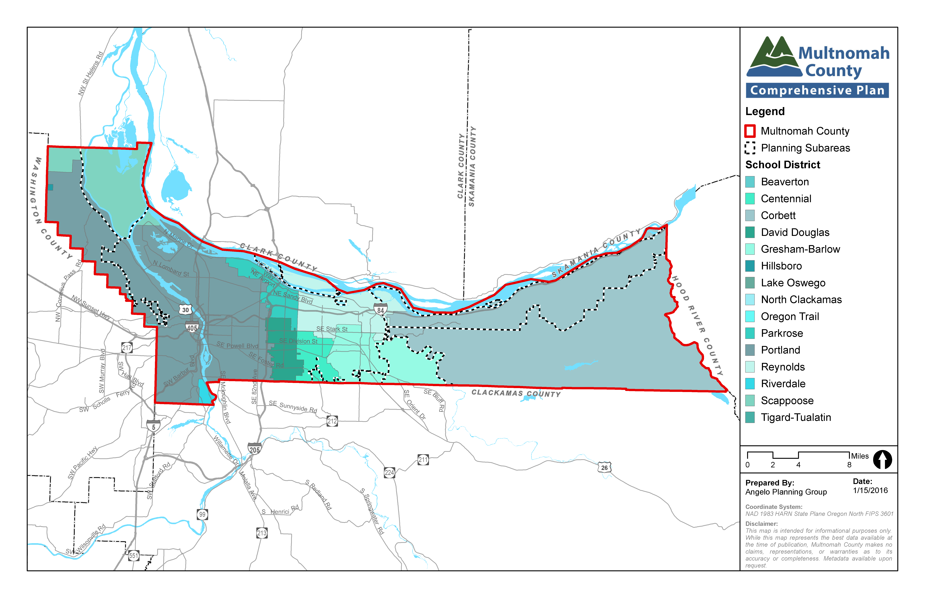
The Multnomah County Sheriff’s Department provides police services in the unincorporated portions of the County. Fire protection and other emergency response services are provided by independently operated Multnomah County rural fire districts #10 and #14, as well as the Sauvie Island Fire District, Scappoose Fire District, and Tualatin Valley Fire and Rescue District. Ambulance service is provided by private companies that are authorized to operate in the County. From a land use and comprehensive planning perspective, the County’s main role in relation to these services is to review land use permits associated with proposed facility improvements and to notify them about development proposals that may affect their service capabilities and facility needs.
Figure 2 – Fire Districts within Multnomah County
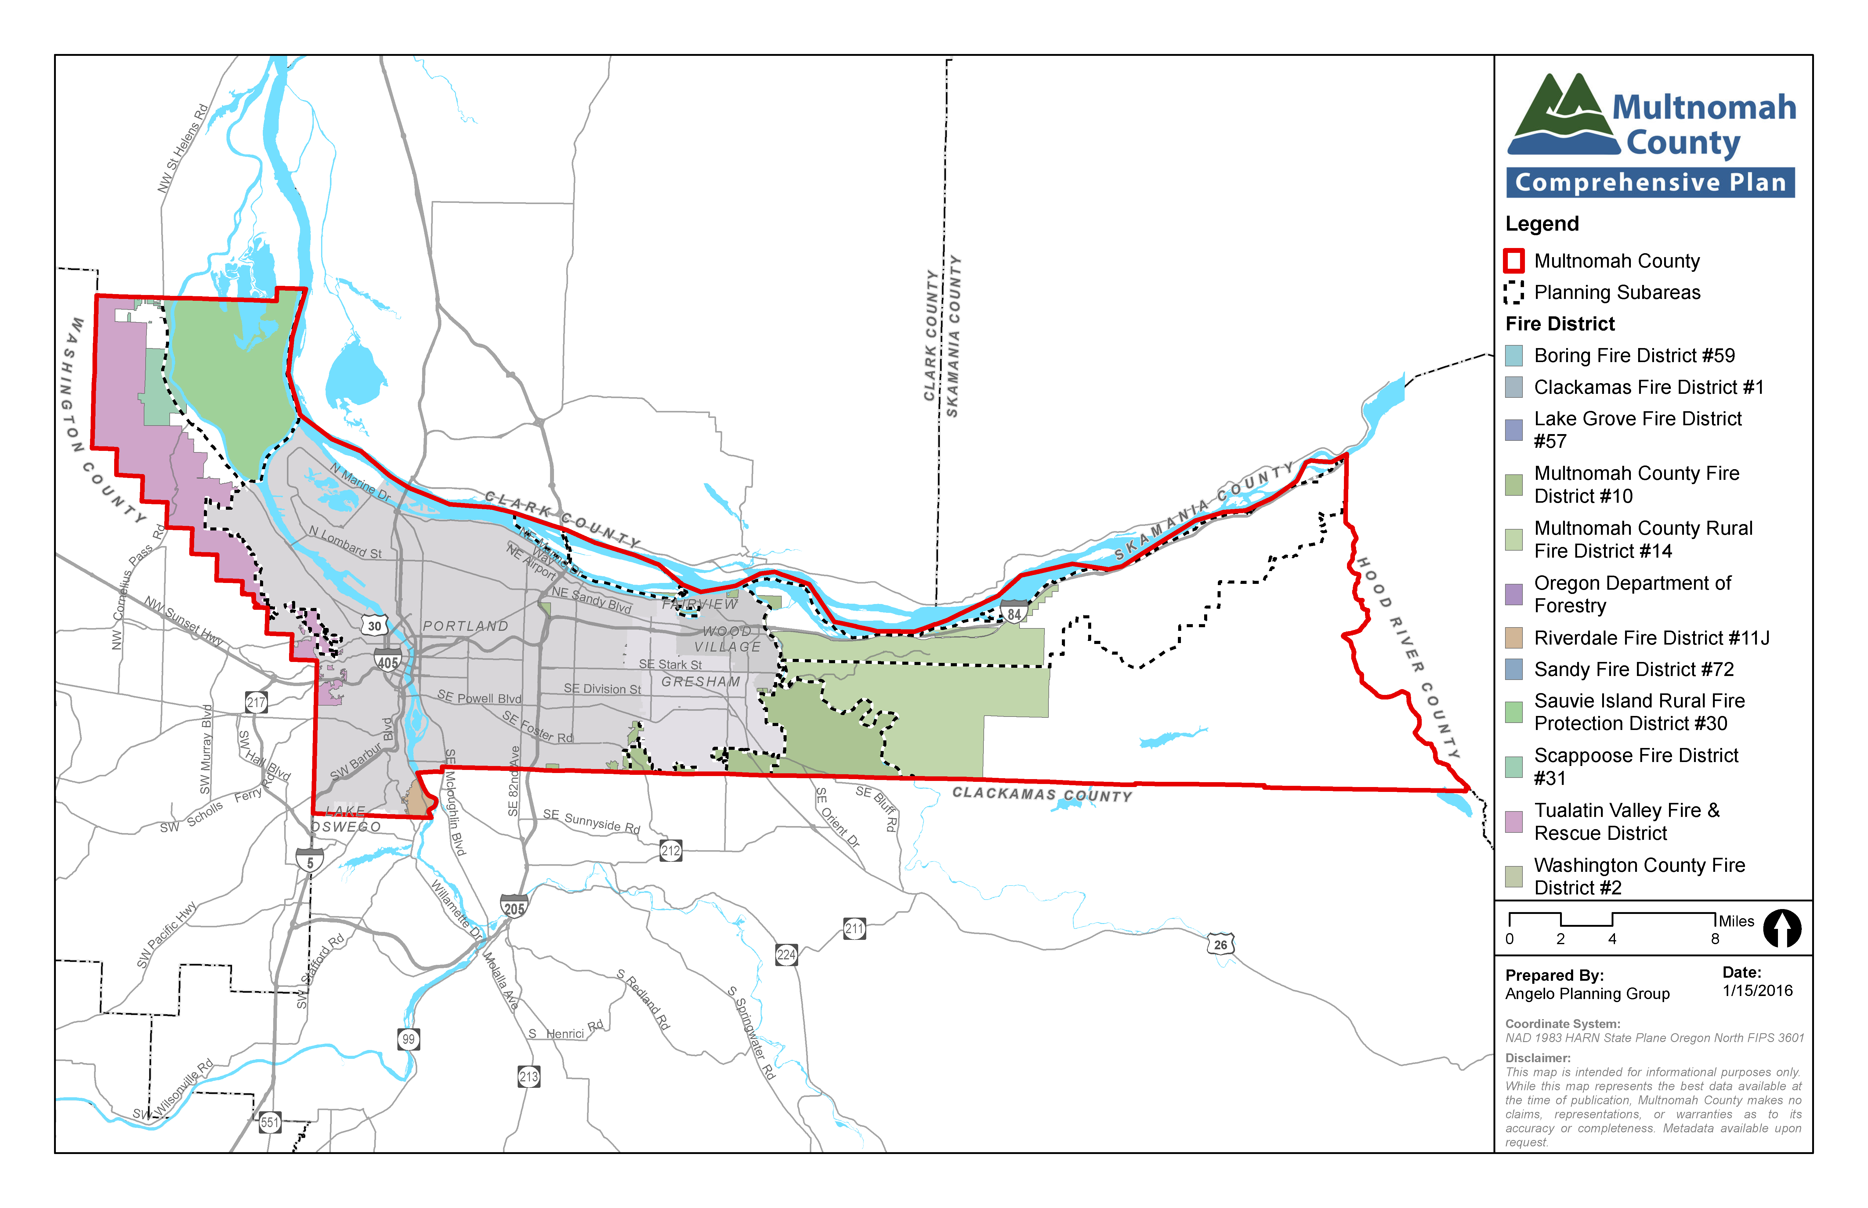
Energy facilities, including electrical and natural gas distribution lines, electrical substations, and related facilities are provided and maintained by private utility companies. A number of large electrical and gas transmission lines cross rural portions of the County, particularly the West Hills, Sauvie Island, and East of Sandy River areas. Communication facilities, including cable and satellite television, telephone, and internet services also are provided by a variety of private entities.
New facilities and modifications to existing facilities are needed to meet the energy and communications needs of county residents, businesses and other community organizations. The County reviews applications for new facilities and coordinates facility improvements with road repair and construction activities. The County also coordinates with state and federal agencies regarding siting and development of energy facilities.
Solid waste collection service within the rural areas of the County is provided by several private waste haulers. The County licenses these haulers and administers rules that the haulers must follow. These rules are intended to ensure a comprehensive and consistent level of recycling services for the region and to assist the region in meeting state waste recovery, reduction, and recycling goals, as well as related conservation of natural resources and reduced greenhouse gas emissions.

relevant studies and planning processes
A variety of state, regional, and local plans and policies are relevant to planning for public facilities in Multnomah County, including the following.
Oregon’s Statewide Planning Goal 11 provides overall guidance for planning for public facilities, with an emphasis on water, wastewater, and stormwater facilities. Counties are directed to plan for public facilities in rural areas, consistent with the rural nature of those areas. They also are required to develop and adopt community public facility plans, typically as part of preparing unincorporated community plans, regulating facilities and services for certain unincorporated communities outside urban growth boundaries. The Goal 11 administrative rule also provides guidance on where sewer and water lines may be located, as well as needed coordination with other service providers.
The state Unincorporated Communities Rule provides guidance related to the provision of and planning for public facilities and services within unincorporated communities that have been acknowledged by the State.
The Oregon Department of Environmental Quality (DEQ) establishes standards for water and wastewater facilities and services, including standards for treatment and allowable types of systems that can be used in rural areas.
The Oregon Department of Energy (DOE) and the Federal Energy Regulatory Commission (FERC) regulate the siting and design of certain types of energy production and distribution facilities via Oregon administrative rules and statues and federal requirements.
Multnomah County’s Zoning Code includes standards related to the siting and design of a variety of public facilities, including their location, allowed uses within them, and the design of sites and structures.
County solid waste regulations include standards for residential and business waste collection and recycling, including public information requirements, licensing of solid waste service providers, and enforcement for non-compliance of County regulations.
Local service provider plans, including those for school districts, police and fire districts, energy and telecommunications providers, and others provide important information about the need for future facilities and services.
The Urban Growth Boundary (UGB) establishes the line between urban and rural densities, and largely controls the level of public facilities and services that will be provided to development outside the UGB.

key planning issues and supporting information
A number of key planning issues affect public facilities policies and practices in the rural portions of Multnomah County:
- Impact of wastewater on water and other natural resources. As described above, water and wastewater facilities in rural areas must be appropriate and suitable to serve rural levels of development and may not be designed to promote urban development in rural areas. Wastewater treatment in particular depends on site characteristics, including soil and drainage conditions and the size of the property. Community members expressed concerns about the potential for development to exceed the carrying capacity of the land, cause groundwater contamination and/or create other adverse impacts. County regulations and monitoring practices ensure that water and wastewater treatment processes and facilities comply with state requirements and are consistent with the carrying capacity of a given property.
- Innovative technology. Community members and the Community Advisory Committee (CAC) debated the use of innovative technology and sustainable practices to treat wastewater and stormwater and reduce water consumption. They noted that such practices could allow for development of properties that might otherwise be limited by soil conditions or other factors. Others expressed concerns about potential increases in the amount or density of development that could result if non-conventional wastewater treatment systems are allowed. County development and density requirements cannot be superseded by use of alternative or innovative wastewater treatment facilities. In addition, such facilities must still comply with local and state requirements and cannot exceed the capacity of a given site.
- Siting of energy and communications facilities. New facilities and modifications to existing facilities are needed to meet the energy and communications needs of County residents, businesses, and other community organizations. At the same time, community members noted concerns about siting utilities in rural areas that are intended solely to serve adjacent urban areas and recommended that the County develop criteria to ensure that such facilities could only be located in rural areas if no viable urban location is feasible.
- Coordination of repair and installation of utility and communication lines. Community and CAC members recommend policies and practices to ensure that road repair projects and utility installation are well-coordinated to reduce the need for multiple construction projects on the same facility. They also recommend undergrounding of utility lines wherever possible.
- Rest stops. Although tied to transportation, another public facilities issue raised and discussed by the CAC was the need for restrooms along the most heavily used travel routes to accommodate recreational and tourist users. The CAC recommends policies and practices for placement of rest stop facilities with sufficient safeguards to address potential impacts to the surrounding community.
- Alternative Use of School Buildings. Vacant or under-utilized public school buildings may have serious detrimental effects on the neighborhoods that surround them if allowed to stand idle and fall into disrepair. There are many benefits to the community when the buildings are occupied and reused. Cooperative pre-planning by the school district, local government and the people of the community can help to identify those beneficial uses and provide flexibility in securing their location. School districts can plan and budget for reuse of their space resources more effectively if appropriate alternative uses are determined and accepted in advance. Longstanding policies to promote the efficient alternative use of vacant and under-utilized public school buildings remain important to the rural communities and have been retained in this Comprehensive Plan.

goal, policies and strategies
Goal: To coordinate and collaborate with service providers and affected agencies to ensure an appropriate level of public services to rural areas of the County, consistent with their rural character.

policies and strategies applicable County-wide
The policies in this chapter focus on coordination with other service providers, minimizing and mitigating impacts of public facilities, regulating the siting and design of facilities, and ensuring that public facilities meet the needs of the rural areas of Multnomah County.

General Policies and Strategies
  - Taking the following factors into consideration, plan and ensure a timely and efficient arrangement of public facilities and services to serve as a framework for appropriate levels of development of land within the County’s jurisdiction.
1. The health, safety, and general welfare of County residents;
2. The level of services required, based upon the needs and uses permitted in urban, rural, and natural resource areas;
3. Environmental, social, and economic impacts.
  - Develop and implement public services and facilities plans and capital improvements programs that will result in the following:
1. Coordination of land use planning and provision of appropriate types and levels of public facilities.
2. Coordination of a full range of public facilities and services among all agencies responsible for providing them.
3. Provision of adequate facilities and services for existing uses.
4. Protection of natural resource and rural areas.
  - Support the siting and development of public facilities and services appropriate to the needs of rural areas while avoiding adverse impacts on farm and forest practices, wildlife, and natural and environmental resources including views of important natural landscape features.
  - Reduce Multnomah County’s long-term public works costs by eliminating marginal facilities and extending the life of others through timely maintenance and functional upgrading.
  - Set and schedule capital improvements project expenditures based on an evaluation which includes the consideration of the following:
1. Public health, safety, and general welfare
2. County liabilities, assets, and resources
3. Existing service system maintenance and update costs
4. Minimization of costs due to coordination of scheduled public works projects
5. Private and public resource availability for financing and maintaining service system improvements
6. Conformance with the Comprehensive Plan
7. Time required to provide service and reliability of service
8. Equity in meeting the needs of low-income and minority populations
  - Use capital improvements programming and budgeting to achieve levels of public facilities and services appropriate to rural areas.
  - Coordinate plans for public services and facilities with plans for designation of urban boundaries, urbanizable land within the UGB, rural uses outside the UGB, and for the transition of rural to urban uses within UGB expansion areas.
  - Identify needs and priorities for public works capital improvements in conjunction with the Comprehensive Plan.
  - To achieve desired types and levels of public facilities and services, consider existing and new, creative methods and devices such as, but not limited to, the following:
1. Tax incentives and disincentives
2. Public and private grants
3. Land use controls and ordinances
4. Multiple use and joint development practices
5. Fee and less-than-fee acquisition techniques
6. User fees
7. Public/private partnerships
    - Seek grants and similar financial resources to fund capital improvements projects, where possible.
    - Strive to achieve a long-term facilities plan and capital improvements program integrated with the cities and special service districts.
  - Except as otherwise provided by law, new electrical substations and water system storage tanks or reservoirs intended to solely serve uses within the urban growth boundary shall not be located outside the urban growth boundary unless it can be demonstrated that there is no practical alternative site within the urban growth boundary that can reasonably accommodate the use.
    - Amend the County Zoning Code to require a finding that all reasonable alternatives to the location of the electrical substation or water system storage tank or reservoir have been explored and that all of the alternatives are impractical. The cause for an alternative to be impractical shall not be of the applicant’s own making and shall not be based solely on financial grounds.
  - For development that will be served by a power utility company, the utility company must be willing and able to provide the power needs of the development.

Water supply and wastewater treatment systems
  - A water supply system for new development shall be by either of the following methods:
- Connection to a public water system having adequate capacity to serve the development and all other system customers
- A private water system that produces safe drinking water with sufficient volume and pressure to meet applicable Building Code and Fire Protection Code
  - Wastewater disposal for new development shall be by any of the following methods:
- Connection to a public sewer system having adequate capacity to serve the development and all other system customers
- A private system that meets Oregon Department of Environmental Quality regulations

stormwater drainage
  - Stormwater drainage for new development and redevelopment shall prioritize water quality and natural stream hydrology in order to manage stormwater runoff in accordance with the following:
- The runoff from the site shall not adversely affect the water quality in adjacent streams, ponds, or lakes, or alter the drainage on adjoining lands, or cause damage to adjacent property or wildlife habitat.
- Stormwater infiltration and discharge standards shall be designed to protect watershed health by requiring onsite infiltration in order to mimic pre-development hydraulic conditions so that post-development runoff rates and volumes do not exceed pre-development conditions.
- Apply Low Impact Development Approaches (LIDA) in order to conserve existing resources, minimize disturbance, minimize soil compaction, minimize imperviousness, and direct runoff from impervious areas onto pervious areas.
- Protect and maintain natural stream hydrology (or flow), with an emphasis on reducing hydromodification impacts such as stream incision and widening.
- Develop and adopt drainage system design guidelines and standards to accommodate fish and wildlife passage where appropriate.

Energy Facilities
  - Work with utility and communications companies that own transmission, distribution and communication lines to bury the lines to provide more secure power and communications service during emergency situations and improve scenic qualities.
    - Determine the costs and benefits of burying power and communication lines in conjunction with utility and telephone service providers and community representatives.
    - Amend the Zoning Code to require new or replacement development to underground personal power and communication lines serving the development, with exceptions for unusual circumstances.
  - Ensure that public service providers and utility providers have the capability to serve proposed new development by inviting their review and comment on development applications that may impact them.
    - Circulate development proposals to affected service and utility providers (i.e. County Sheriff’s Office, School Districts, Water Districts, Fire Districts, etc.).

solid waste management
  - Implement a solid waste and recycling management program that complies with State law, the Regional Solid Waste Management Plan, and the County’s intergovernmental agreement with Metro.
    - The County should revise its solid waste and recycling management program as needed to comply with amendments in state law, the Regional Solid Waste Management Plan, or its intergovernmental agreement with Metro.

police, fire and emergency response facilities
  - As appropriate, include school districts, police and fire protection, and emergency response service providers in the land use process by requiring review of land use applications from these agencies regarding the agency’s ability to provide the acceptable level of service with respect to the land use proposal.
    - Encourage school districts to review land use proposals for, among other factors as determined by the school district, impacts to enrollment and the district’s ability to meet community educational needs within existing or planned district facilities and impacts to traffic circulation and pedestrian safety.
    - Encourage police, fire protection, and emergency response service providers to review land use proposals for, among other factors as determined by the agency, sufficiency of site access and vehicular circulation and, for fire protection purposes, the availability of adequate water supply, pressure, and flow, whether provided on-site or delivered from off-site.

Rest stops
  - Explore opportunities to provide public rest stop facilities for the most heavily used travel routes, especially along popular recreational and tourist routes.
    - Rest stop facilities may include amenities such as restrooms, picnic tables, garbage disposal containers and water fountains.
    - Inform the traveling public of rest stop locations through wayfinding signage.
    - Partner with those agencies most involved in providing public parks and rest facilities, such as ODOT, OPRD or Metro, to determine suitable locations for these facilities.
    - Involve affected stakeholders in the decision making process for rest stop locations and amenities.
    - Rest stop facilities should be either a review use or a conditional use to ensure that compatibility with the surrounding neighborhood and environmental impacts are addressed.

alternative uses of public school buildings
  - Promote the efficient alternative use of vacant or under-utilized public school buildings by authorizing those uses, which are beneficial to, or compatible with the community.
  - Facilitate alternative use of existing school building space
- The school district board finds that the space is surplus to current or anticipated need for school purposes, and
- Citizens of the community are afforded opportunity to be involved during decisions on an alternative use proposal, and
- The alternative use will provide:
  - An appropriate public facility, or
  - A public non-profit service to the immediate area or community, or
  - An alternate use that is consistent with the local community’s needs in a location and under circumstances reasonably suitable for the purpose.
    - Assist school districts, community groups, and citizens in the cooperative planning and development of programs for the appropriate alternative use of existing public school buildings.
    - Alternative uses of vacant or under-utilized public school buildings shall be allowed only in “exception” zoning districts.

West Hills policies and strategies
There are no policies specific to this rural planning area.

Sauvie Island and Multnomah Channel policies and strategies
  - Cooperate with the Sauvie Island Drainage Improvement Company and state and local agencies to address drainage, flood control, and roadway functions of existing levees while restoring natural systems where appropriate. Provide notice to the Drainage Company of any proposed code amendment or development on lands on and/or adjacent to Drainage Company infrastructure.

West of Sandy policies and strategies
There are no policies specific to this rural planning area.

East of Sandy policies and strategies
There are no policies specific to this rural planning area.

