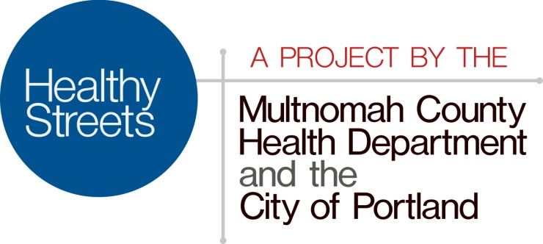

Frequently Asked Questions

What is Healthy Streets?
Healthy Streets is a 12-month pilot project by the Multnomah County Health Department and City of Portland to reduce the number of discarded syringes in downtown Portland.
Beginning Feb. 3, 2016, two secure bins will be in key locations on Portland’s waterfront to encourage proper disposal of needles by injection drug users. A biohazard contractor will empty the bins regularly.
The pilot includes targeted outreach to injection users by Multnomah County health workers, as well as a public awareness campaign.

Where is this problem coming from?
Injection drug use is a complex and serious public health and safety challenge for our community. In the last few years, there has been a significant recent increase in heroin use in Portland. Despite the success of local syringe exchange programs, some users choose not to participate for a range of reasons including privacy concerns, disability from injury, disease or mental illness, fear of police or a lack of a safe place to store syringes.

Did something change?
Injection drug use has increased as part of the overall rise in opiate use, according to health studies, surveys and law enforcement. Members of the public, park users, businesses, community partners and media are rightly concerned about finding used syringes in public spaces, specifically, Tom McCall Riverfront Park and the East Bank Esplanade.

Are the needles dangerous?
The risk of a member of the public contracting a disease or being injured by the needles is very low but finding a used syringe is an understandable concern for everyone involved. Ick!

What should I do if I find a syringe?
Call the Multnomah County Health Department at 503-988-3030 for directions on proper disposal.

What if I see the box is full or has been damaged?
Call the Portland Bureau of Transportation Dispatch at 503-823-1700, available 24/7.

I discovered a box of used diabetic needles in a relative’s home. Can I use the box to get rid of them?
No. Landlords and residents needing to dispose of syringes should contact Metro at 503-234-3000 or www.oregonmetro.gov/recycling.

Will this solve the problem on the waterfront?
This year-long pilot project is part of a comprehensive public health strategy to reduce the harm of drug addiction through controlling the spread of diseases, strengthening outreach to injection drug users and their community about treatment, reversing drug overdoses and working cooperatively with police and other agencies.

Has this worked elsewhere?
Yes. Cities like ours successfully use this type of community-based method of safe needle disposal in combination with syringe exchange programs. But the response in our community is unknown. As a pilot, the Health Department will track how effective these are, as well as any problems.

What problems do you anticipate?
City bureaus and the Health Department are working closely with the community to use lighting and location to encourage proper use of the drop boxes but discourage vandalism and graffiti.

What will this cost?
- The pilot program is expected to be less than $20,000. Under an intergovernmental agreement, the city will cover the twice-weekly disposal costs with the county covering the cost of outreach by community health workers.

Why is the Health Department involved?
This effort is part of the Health Department’s comprehensive public health strategy to reduce the harm associated with of drug addiction:
- By controlling the spread of diseases like Hepatitis C and HIV from people sharing syringes.
- By creating disposal options to get used syringes off the streets and out of circulation so they are less likely to be thrown away or left in public places.
- By preventing fatal overdoses through trainings and distribution of naloxone, a drug which reverses the effects of opiates.
- Through increased outreach by community health workers who can link people injecting drugs to wound care and services, including drug treatment.

What city agencies are involved?
- The pilot is a partnership between the Portland Bureau of Transportation, Portland Parks and Recreation and Multnomah County. The bins are located on Portland Parks and Recreation property and the Transportation bureau’s dispatch operators will help to coordinate the regular emptying of the bins.
- For more information at Multnomah County: Julie Sullivan-Springhetti, 503-709-9858, or julie.sullivan-springhetti@multco.us
- For more information at the City of Portland: John Brady, 503-823-7375, John.Brady@portlandoregon.gov

