Instructions for entering a referral to Oregon Medicare Savings Connect in the ADRC I&R call module:

Search by needs category, taxonomy term as shown
Enter keyword MIPPA
Enter County or ZIP code, click search

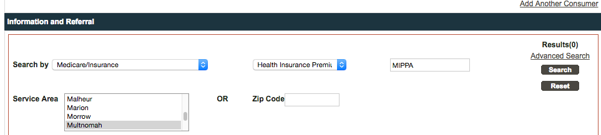

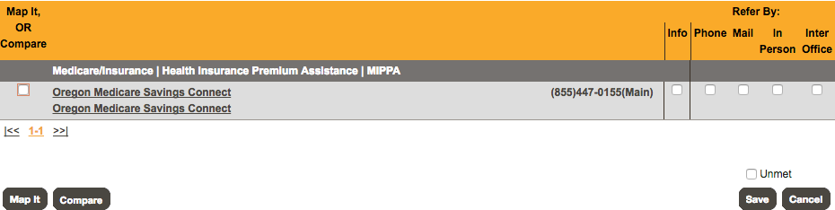

Choose Oregon Medicare Savings Connect; click Refer by method, and Save Selected Referrals
Enter data notes and choose Referral as call outcome

