Multnomah County Central Courthouse

April 21 Public Open House

DATE: Thursday, April 21, 2016

TIME: 4:00 p.m. to 6:00 p.m.

LOCATION: Central Courthouse Main Jury Room

The fifth public open house for the Multnomah County Central Courthouse Project was held April 21, 2016 from 4 – 6 p.m. in the Central Courthouse Main Jury Room. The purpose of the meeting was to provide an update on the project, introduce the design team, maintain and build relationships with stakeholders, courthouse employees and the public and collect public comments and questions.

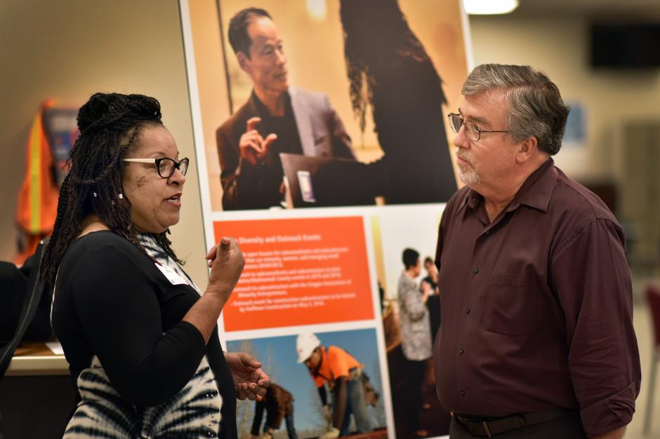
In total, 80 people attended the open house, including representatives from city, county and state government, legal practices, architectural and engineering firms, non-profit groups and members of the public. The open house was advertised through emails to the project mailing list and interested stakeholders, a media release, Multnomah County’s social media accounts, the project website, invitations posted in the Courthouse and at a County Commissioner Board meeting.

Project team members from Multnomah County, SRG Partnership, Hoffman Construction, Day CPM Services and EnviroIssues staffed the event. Attendees were welcomed and provided with a project fact sheet and comment form at a sign-in table by project staff. People were encouraged to view the displays, ask questions of project staff and contribute comments on comment cards or via email following the event. The stations at the open house included:

- Welcome and sign-in
- Project overview – included information about the project scope and need for a new courthouse.
- Entry and access – display featured the entrance from SW First and SW Madison, and visual depictions of the building, perspective from the lobby and a lobby cross-section
- Connecting with Naito – included information about site master plan, design features and view from Waterfront Park
- Sustainable design – display featured sustainability goals of the project and examples of implementation
- A peek inside – displays offered a look at designs for interior public spaces and potential views looking toward the Willamette River
- Construction planning – display included an overview of considerations involved in construction planning
- Schedule and budget – featured a timeline for the project and information about estimated project costs
- Diversity – display reviewed diverse project team, diversity goals of the project and outreach events planned to achieve these goals.
- Public input – featured a display about how public input has informed the project, including previous open houses and comment at public board meetings
- Comment station

Comment overview

Attendees asked questions and provided feedback to the project team, and 12 people submitted written comments. The themes discussed in these comments included accessibility, equity opportunities related to the project, provision of resources (e.g., library services, pet facilities, daycare), entry and egress, safety, building design and sustainability. Many people expressed enthusiasm for the project plans and several suggested features and ideas for the project team to consider. Some attendees raised concerns about project cost, the modern design and building height.

Comments received

Written comments:
- It would be great to have a drop off zone in front or valet for vulnerable adults so they could be left in a safe place. Not clear if 21st Audio and Tech includes more advanced assistive devices.
- There needs to be a drop off area for disabled people. A place that is safe from traffic.
- I'm the new age-friendly program coordinator at Elders in Action (and a long-time educational gerontologist). I've heard that age(ing) issues are being considered during the design process. If Elders in Action and I can be of any assistance, please let me know.
- What disability/aging organizations have weighed in on courthouse design and services?
- Older victims need special considerations beyond ADA design (including volunteers to guide through courthouse/assistive hearing devices/priority court times so they don't have to wait as long).
- I'm concerned about what's going to happen to the original courthouse and its contents of tons of imported [illegible] marble and old growth timber. And it's all paid for... why, when we have so many other financial needs in the county—including courthouse staffing needs--are the public and public agencies taking on such a huge new debt? I double that $300,000,000 is really the final price tag. Let's hear the facts about decommissioning the original courthouse and the cost of the new courthouse? Thank you.
- I think it looks great. A lot of attention was spent focusing on what doesn't work at the current location, which is very promising.
- Lovely presentation. Looking forward to the new site.
- Will the courtrooms be designed so as to permit the seating of alternative jurors in seating areas allowing the same view as regular jurors? (I try cases which always require the seating of alternative jurors).
- Employee lockers that can store/hang shirts (deep). Many of us value our self-propelled commute and any space we can have to hang/dry/store clothes. Thanks!
- It would be preferable to have natural lighting in the high volume courtrooms. Even borrowed light is preferable to none at all. Doors entering the courtroom should be glass to take advantage of the well-lit waiting area.
- How about a pet relief area for a courthouse pet?
- Library. We are the only other law library in the vicinity. Concerned about serving attorneys and pro se litigants.
- Sustainability features should include operable glass. Windows should open! Design is too modern and sticks out. A little more order and symmetry is needed so it looks like a courthouse and not an apple store!
Comments relayed to project staff verbally:

- Sheriff’s deputies asked whether the main entrance will be "blast proof."
- People asked whether the building will be LEED-certified (it will be seeking Gold certification).
- People like the prominent site and the views it will provide to public visitors to Courthouse.
- Some asked about judges’ bathrooms.
- People asked how Jefferson Station is going to be incorporated in to the project.
- What will be impact to accessing the parking garage across the street during construction?
- People expressed enthusiasm for equity opportunities on the project. One individual asked about follow-through of the equity program and discussed other jurisdiction challenges.
- A union representative was excited about the way the project will track Journey workers.
- A member of the Harrison Square Tenants Association was disappointed about the height of the building and other buildings in downtown Portland.
- An individual asked about a petting station within CourtCare and listed other jurisdictions that have that feature.
- Some expressed interest in the in-custody defendant circulation path, sally port and secure elevators.
- People liked inclusion of private circulation for judges and separate entry/exit for public service counter clerks. Some asked for more information about entry/egress.
- People were enthusiastic about the view from public corridors outside courtrooms. Staff said they would want to take their breaks there.
- Some expressed interest is seeing more plans.

