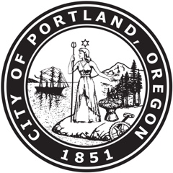
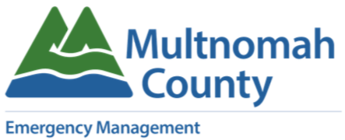

ARE YOU A CULLY AREA BUSINESS OWNER WITH ECONOMIC LOSSES DUE TO THE MARCH 12th FIRE?
Local businesses may be eligible for low-interest long term Small Business Administration (SBA) loans to help them recover from economic impacts of lost revenue. Current rates are in the high 2% - low 3%. If you are interested in applying, please email the form to Multnomah County Emergency Management at: em.dutyofficer@multco.us by April 10, 2018.
At least five County businesses need to fill out the SBA worksheet in order for Oregon to request this federal program. If you are interested but need more time to complete the form, or to research the program, please let us know about your interest by emailing: em.dutyofficer@multco.us or call 503-988-6700, option 1, by April 10, 2018. You can opt out later if you change your mind about applying.
We may also be able to seek an extension, if that is needed. The details regarding the SBA program in italics below are from the Oregon Office of Emergency Management and SBA.
Economic Injury Disaster Loans
If you have suffered substantial economic injury and are one of the following types of businesses located in a declared disaster area, you may be eligible for a Small Business Agency (SBA) Economic Injury Disaster Loan (EIDL):
- Small business
- Small agricultural cooperative
- Most private nonprofit organizations

Loan Amounts and Use
Substantial economic injury means the business is unable to meet its obligations and pay its ordinary and necessary operating expenses. EIDLs provide the necessary working capital to help small businesses survive until normal operations resume after a disaster.
The SBA can provide up to $2 million to help meet financial obligations and operating expenses that could have been met had the disaster not occurred. Your loan amount will be based on your actual economic injury and your company’s financial needs, regardless of whether the business suffered any property damage.
Eligibility and Terms
The interest rate of EIDLs will not exceed 4 percent per year. The term of these loans will not exceed 30 years. The repayment term will be determined by your ability to repay the loan.
EIDL assistance is available only to small businesses when SBA determines they are unable to obtain credit elsewhere.
A business may qualify for both an EIDL and a physical disaster loan. The maximum combined loan amount is $2 million.

