Oregon Humanities Conversation Projects Presents:

**“To Cut or Not to Cut: Censorship in Literature”**

FREE DISCUSSION ABOUT CENSORSHIP IN LITERATURE

This event is part of the Oregon Humanities’ statewide Conversation Project

Recent efforts to remove the n-word in literature-from a recent edition of Mark Twain’s Huck Finn in which the word is changed to “slave” to the attempt to halt a high school production of August Wilson’s Joe Turner’s Come and Gone because of its “offensive” Language-raise questions about censorship. Is censorship ever a good thing? Should accommodations be made considering the difference between a character’s and author’s point of view? Reed College professor Pancho Savery will facilitate a discussion that examines these questions, as well as their importance beyond conversations about literature.

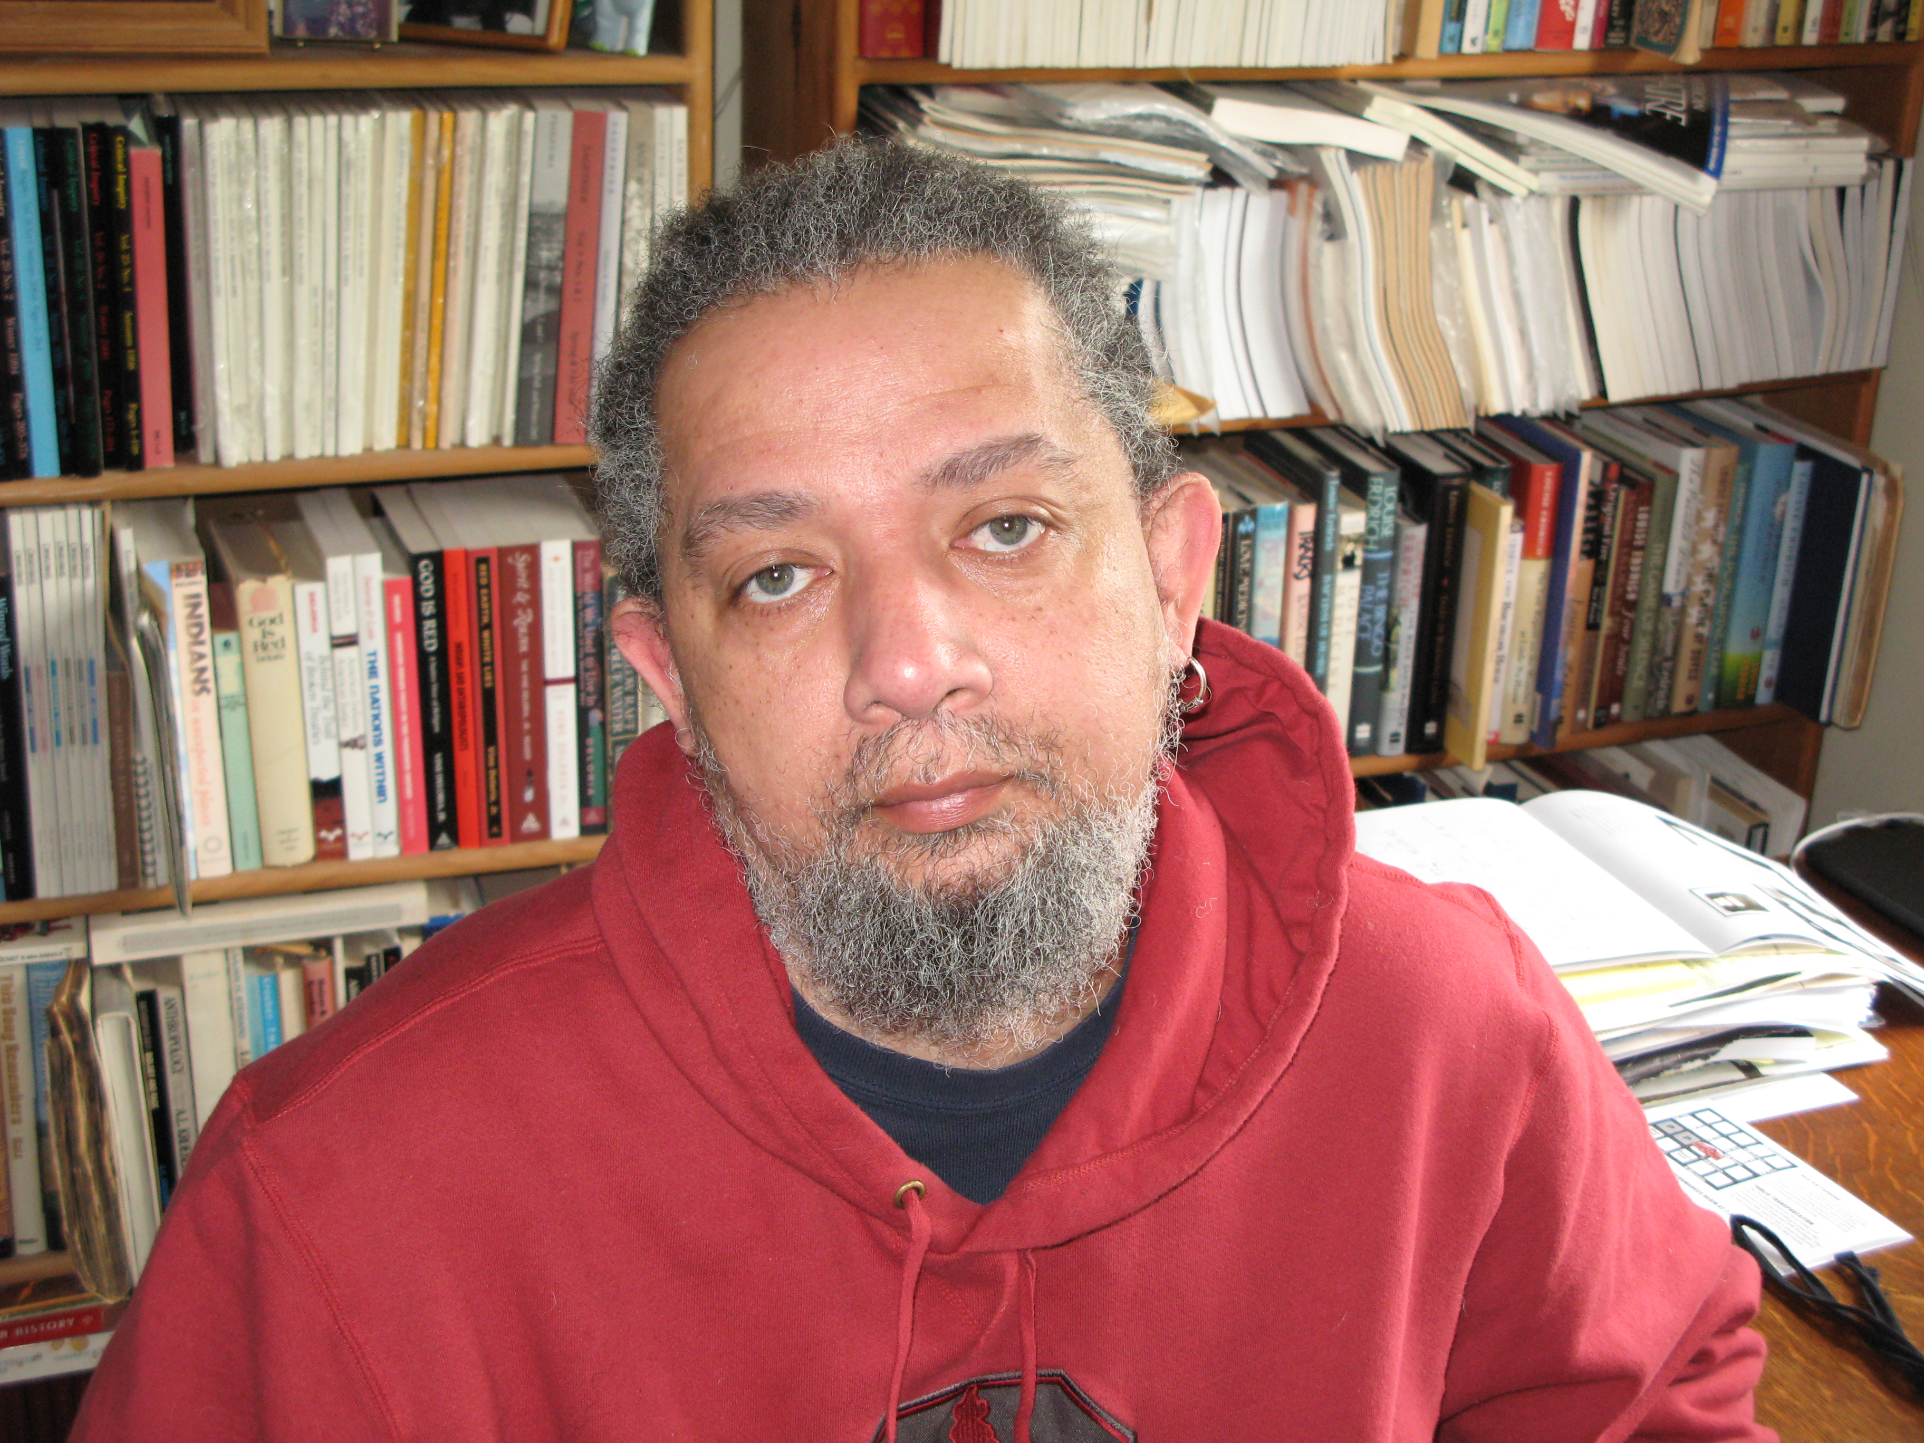

Upcoming D & R Lunch and Learns:

**“Something Old, Something New: Exploring the State of Marriage”** Friday, February 14th, 2014

# D&R_Campaign_4CLogo Lunch & Learn

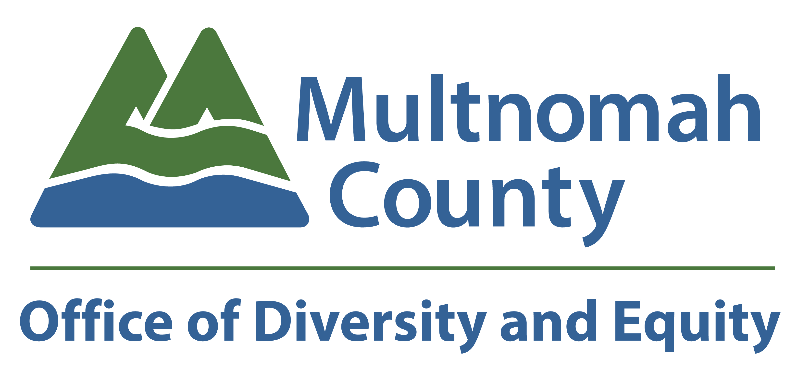

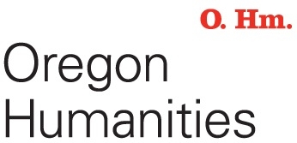

**Event Location:**

**Multnomah County Boardroom**

**501 SE Hawthorne Blvd, Portland Oregon 97214**

**Event Time: Wednesday, January 15th, 2014**

**12:00pm-1:30pm**

### **Want to attend this Lunch & Learn?**

### **Please RSVP to:**

### **Shawn Postera at** **(503) 988-7348 or**

### [**shawn.postera@multco.us**](mailto:shawn.postera@multco.us)

**501 SE Hawthorne Blvd. Portland, Oregon 97214**