**OREGON COVID-19 TESTING RESOURCE REQUEST COVER SHEET**

*Laboratory supplies are in short supply nationally and laboratory resources provided by the State COVID-19 Management Team are intended to be used in a timely fashion and not meant to be stockpiled long term. Resource request orders for laboratory supplies will be filled on a weekly basis and as more inventory comes in.* ***Please use this form to indicate only the laboratory resources you are requesting and provide your delivery info at the bottom.*** *Additional details about each item are listed further below.*

|  |  |  |
| --- | --- | --- |
| **SPECIMEN COLLECTION KITS** | **Quantity Requested** | |
| 1. NEST Biotechnology (NP swab and VTM) |  | |
| 1. MiraClean Technology (NP swab and VTM) |  | |
| 1. Remel Microtest M4RT (NP and VTM) |  | |
| If the individual item you selected above (#1, 2 or 3) is unavailable in the inventory, will either of the other two options work as an alternative for you? Please indicate “Yes” or “No” in the box to the right. | |  |

|  |  |
| --- | --- |
| **SWABS / APPLICATORS** | **Quantity Requested** |
| 1. US Cotton Synthetic (Nasal) **BULK** |  |
| 1. NEST (NP) |  |
| 1. Puritan Pure Flock (NP) |  |
| 1. COPAN FLOQ (NP) |  |
| 1. Puritan Foam Tipped, 6” plastic handle (OP) |  |
| 1. Puritan Polyester Tipped, 6” plastic handle (OP) |  |
| 1. Puritan Polyester Tipped, 6” solid plastic handle (OP) **BULK** |  |
| 1. Puritan PurFlock Ultra, 6” solid plastic with breakpoint (NP) |  |

|  |  |
| --- | --- |
| **TRANSPORT MEDIA** | **Quantity Requested** |
| 1. PrimeStore MTM, 2 mL (molecular) |  |
| 1. PrimeStore MTM, 1.5 mL (molecular) |  |
| 1. Greiner Bio-One Vacuette Virus Stabilization, 3 mL (Saline) |  |
| 1. Remel, 0.85% Saline, 3 mL |  |
| 1. BD BBL Saline Normal, 3 mL |  |
| 1. SARSTEDT (82x13, small tubes) 3 mL (Saline) |  |
| 1. NEST VTM |  |
| 1. Remel, 3 mL VTM |  |
| 1. Hardy Diagnostics, 3 mL VTM |  |

|  |  |
| --- | --- |
| **SPECIMEN TRANSPORT BAGS** | **Quantity Requested** |
| 1. Fisher, 6x9” with absorbent pads |  |

|  |  |
| --- | --- |
| **ABBOTT ID NOW TESTING SUPPLIES** | |
| **Do you have access to an Abbott ID NOW machine? (Yes/No)** |  |
| **Amount of Abbott ID NOW Test Kits Requested (24 tests per kit):** |  |
| **Amount of Abbott ID NOW Control Kits Requested (12 positive and 12 negative controls per kit):** |  |

|  |  |
| --- | --- |
| **LABCORP or QUEST DIAGNOSTICS LABORATORY TESTING** | |
| **Amount of Laboratory Tests Requested:** |  |
| **Please specify Quest or LabCorp:** |  |

**Note:** *Collection kits from Quest or LabCorp will be sent along with the corresponding test request form*

**Shipment Delivery Details:**

**Shipping Address:**

|  |  |  |  |  |
| --- | --- | --- | --- | --- |
| **Facility/Building Name:** | |  | | |
| **Address:** |  | | | |
| **City, Zip:** |  | | **Hours of operation:** |  |

**Point of Contact:**

|  |  |  |  |
| --- | --- | --- | --- |
| **Name:** |  | | |
| **Phone:** |  | **Fax #:** |  |
| **Email:** |  | | |
| **Hours of operation** |  | | |

**Urgency Level of this resource request:**

|  |  |
| --- | --- |
| **Routine** |  |
| **Urgent** |  |
| **Life Safety** |  |

**Please attach this completed form in OpsCenter with your request.**

**ADDITIONAL DETAILS ABOUT EACH OF THE ABOVE ITEMS**

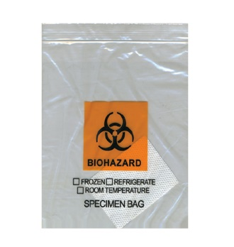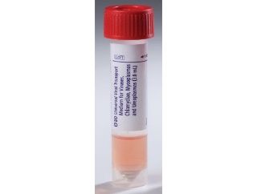**Specimen Collection Kits:** Consist of: (1) swab, (1) vial/tube of transport media, and (1) specimen transport bag with absorbent material inside. The individual types of swab and transport media may vary between kits depending on the manufacturer. A laboratory requisition form, also known as a lab test request form, must also be completed and accompany each specimen being sent for testing. Lab test request forms can be obtained from the individual testing laboratories samples will be sent to. Below is an example image:

Swab

=

+

+

Specimen Transport Bag

Transport Media

Specimen Collection Kit

**Swabs/Applicators**: There are various types of swabs that may be utilized for COVID testing and the appropriate swab type to use will be dependent on which particular COVID lab test is being performed, on which lab testing instrument, and the particular lab requirements you are sending samples to for testing. You will need to consult with the lab specific testing requirements for acceptable sample types to submit to know which swab type will be acceptable to collect a sample with. Below are example images.

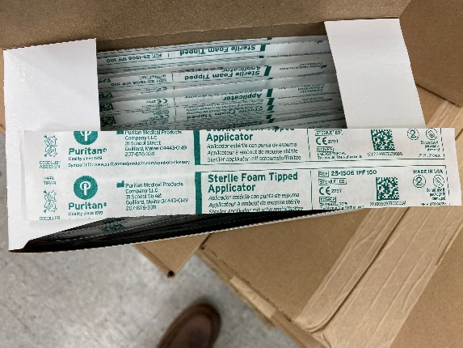 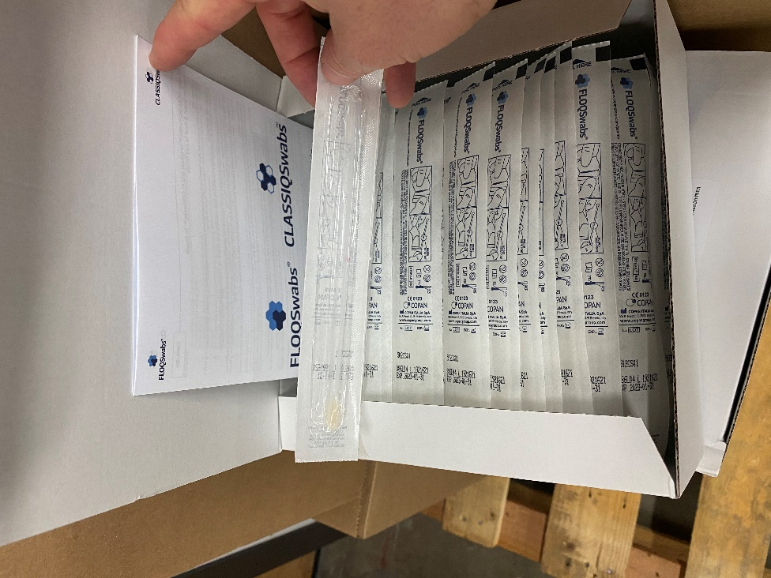 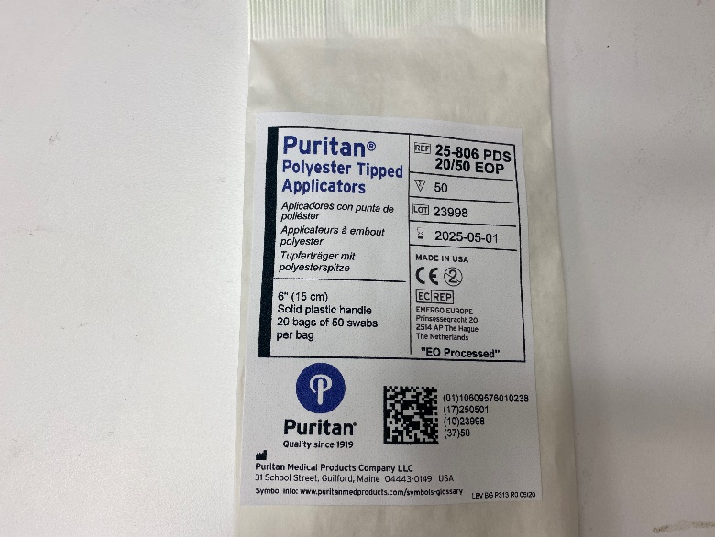

Polyester Tipped (OP) BULK

FLOQ (NP)

Foam Tipped (OP)

**Transport Media:** There are various types of transport media that may be utilized for COVID testing and the appropriate media to collect and submit samples in will be dependent on which particular COVID lab test is being performed, on which lab testing instrument, and the particular lab requirements you are sending samples to for testing. You will need to consult with the lab specific testing requirements for acceptable sample types to submit to know which transport media will be acceptable to use. Example images below:

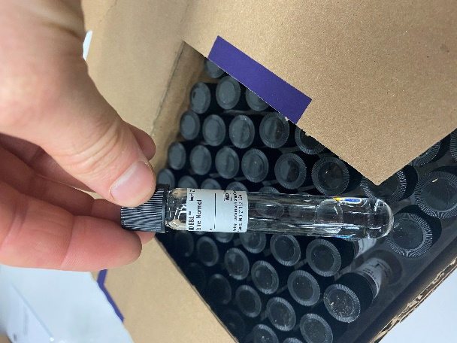 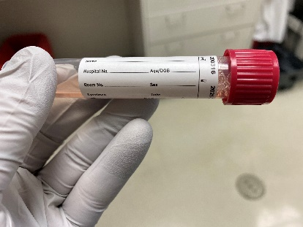 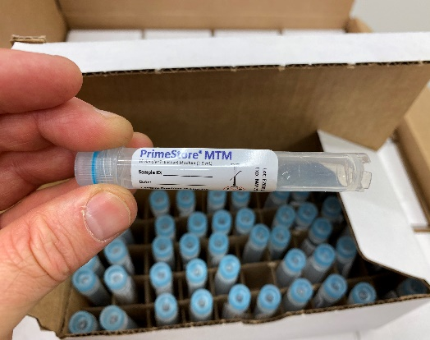 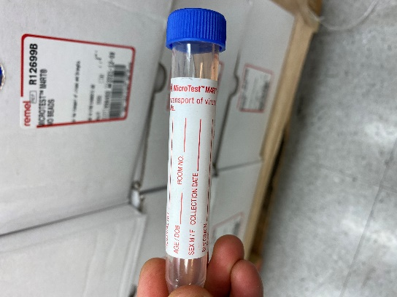

VTM

MTM

VTM

Saline

**Specimen Transport Bags:**  (Sometimes referred to as a ‘biohazard’ specimen bag). Leakproof container used to safely transport and store specimens. Typical sizes are 6” x 9” and will be a “Ziplock style” bag. Specimen transport bags must contain absorbent material inside sufficient to absorb the entire quantity of hazardous material (specimen). The absorbent pad is usually a small white square pad, but may be other appropriate absorbent material. Example image below.

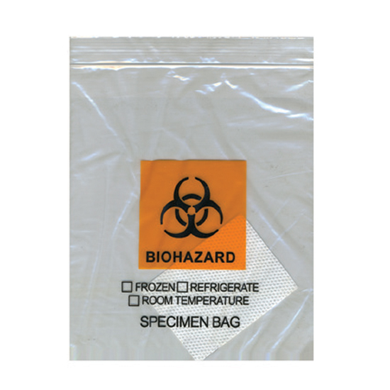

Specimen Transport Bag

**Abbott ID NOW Test and Control Kits:** Abbott ID NOW COVID-19 test kits are needed to run patient samples on the Abbott ID NOW instrument for COVID-19 testing. Each test kit comes with 24 individual tests per box/kit. The Abbott ID NOW control kits contain 12 positive and 12 negative controls inside. The control kits are needed for quality control purposes in the testing laboratories.

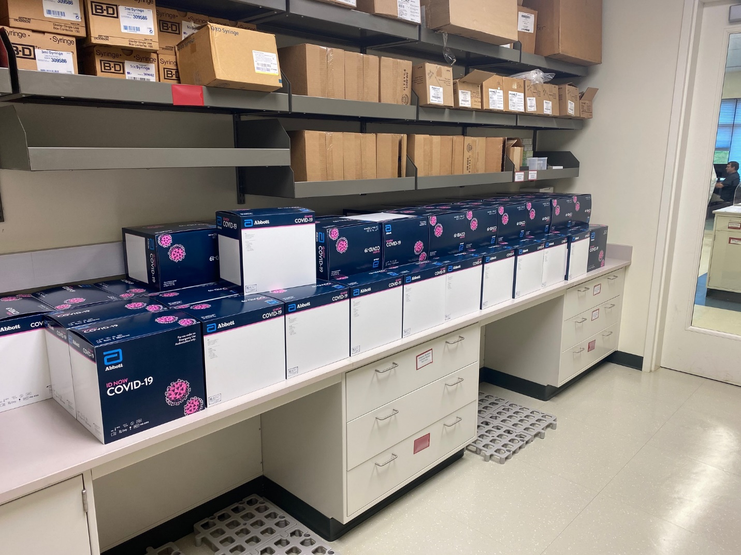 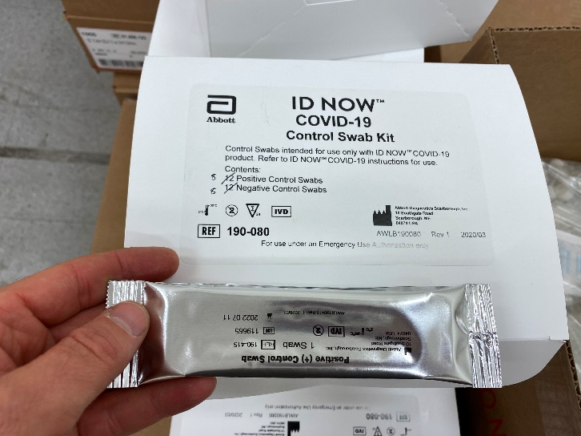

Abbott ID NOW COVID-19 **CONTROL Kits**

Abbott ID NOW COVID-19 **TEST Kits**

**Commercial Laboratory Testing:** OHA has contracts with Quest Diagnostics and LabCorp for commercial testing for entities that do not have their own testing capability within a health system laboratory or through their own contract with a commercial or private laboratory. Quest and LabCorp can supply their own specimen collection kits. Local entities will collect the samples, using OHA guidelines, and Quest or LabCorp couriers will pick up the specimens and test them at their out of state laboratories. Some locations in Oregon are not in the Quest pick up area, so Air Bills will be provided for shipping directly to Quest.

**These collection kits need to be used and returned to LabCorp or Quest promptly.**

**NOTE:**  LabCorp and Quest Diagnostics will be used for those entities that do not already have sufficient access to lab testing through an existing contract or through in-house testing. This resource is only available for testing that follows OHA’s [Guidance for Health Systems Regarding COVID-19 Testing](https://sharedsystems.dhsoha.state.or.us/DHSForms/Served/le2267.pdf). Requests to access COVID-19 testing through these contracts would follow the normal OpsCenter request process.

**If there are any questions, please contact:** [**COVID.19@dhsoha.state.or.us**](mailto:COVID.19@dhsoha.state.or.us)