Notice of Community Needs Virtual Hearing
Five-Year Consolidated Plan FY 2021-25
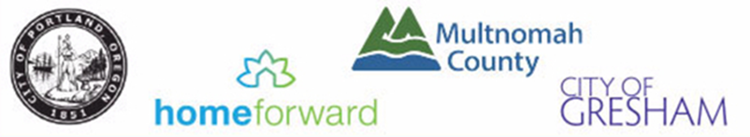

The Portland Consortium, which includes the City of Gresham, City of Portland, and Multnomah County, is beginning its five-year Consolidated Plan process for FY 2021-25. The process serves as the framework for a community-wide dialogue to identify housing and community development priorities that align and focus funding from the federal Department of Housing and Urban Development (HUD)’s formula block grant programs, Community Development Block Grant (CDBG), HOME Investment Partnerships (HOME, Emergency Solutions Grants (ESG), and Housing Opportunities for Persons with AIDS (HOPWA), to address ascertained community needs.

The purpose of these hearings is to collect community feedback regarding the housing, infrastructure, economic and social service needs of area residents and prioritize those needs during the preparation of the Consortium’s FY2021-25 Consolidated Plan. Due to the public health crisis, these hearings will be held remotely via Zoom. For each jurisdiction, call or review website for instructions regarding public testimony, meeting times, website registration and phone information. The two upcoming virtual opportunities to attend a public hearing in your community and give your feedback are:

City of Portland Community Needs Hearing
Nov 10, 2020, 5:30 P.M.–7:00 P.M. via Zoom
Register in advance for this meeting. Registration information to be announced.
After registering, look for a confirmation email with information to join the meeting and to sign up for testimony.

The City of Portland is committed to providing meaningful access. To request translation, interpretation, modifications, accommodations, or other auxiliary aids or services, contact 503-823-5312, or Relay: 711, three days prior to the meeting.

For additional information on the Consolidated Plan process or the Portland community hearing contact Uma.Krishnan@PortlandOregon.gov

City of Gresham & Multnomah County Community Needs Hearing
Nov 17, 2020, 5:30 P.M.–7:00 P.M. via Zoom
Register: To register call 503-618-2814 or contact Rachel.Nehse@GreshamOregon.gov.

The City of Gresham and Multnomah County are committed to providing meaningful access. To request translation, interpretation, modifications, accommodations, or other auxiliary aids or services, call 503-618-2814 or email Rachel.Nehse@GreshamOregon.gov three days prior to the meeting.

For additional information on the Consolidated Plan process or the Gresham & Multnomah County community hearing contact Rachel.Nehse@GreshamOregon.gov (Gresham) and May.P.Cha@Multco.us (Multnomah County)

