Process: OPI waiver request for temporary increase in service plan hours:

In times when OPI funding allows, the OPI case manager may request a waiver for the temporary addition of service plan hours in excess of the 8 hour per 14-day service period cap. The need for additional support must be temporary, and is generally requested after a hospitalization, injury that is expected to heal, nursing facility stay, or other setback from which the consumer is expected to recover or return to baseline. If case managers have a client with a temporary need that does not fit this description, please consult with your Contract Liaison to discuss your client’s need for additional hours.

When ADVSD community services notifies OPI program staff that waiver requests to temporarily increase service plan hours are being accepted:

- Waiver form is posted on ADVSD provider page.
- Case Manager (CM) completes waiver request form and submits to Contract Liaison (CL). Waiver form write-up should include: why temporary hours are needed; total number of extra hours per 14 day service period you are requesting; which I/ADL tasks will be performed, and how many extra hours are needed for each task; and timeframe that includes a start and end date. In addition, CM should make sure there are enough CAPS assessed hours available to cover requested increase in hours.
- CL approves or denies request and notifies CM by email. If approved, CL sends copy of signed waiver for client file.
- CL narrates approval in Oregon ACCESS for client with hours approved and timeframe.
- CL adds signed waiver and places in I drive file “Waiver requests”
- CL adds waiver request to google tracking sheet
- CM adds additional approved waivered hours to service plan with approved end date and sets a custom tickler reminder in Oregon ACCESS OR on worker calendar to reduce hours once approved waiver period ends.
*Custom tickler snapshot below:
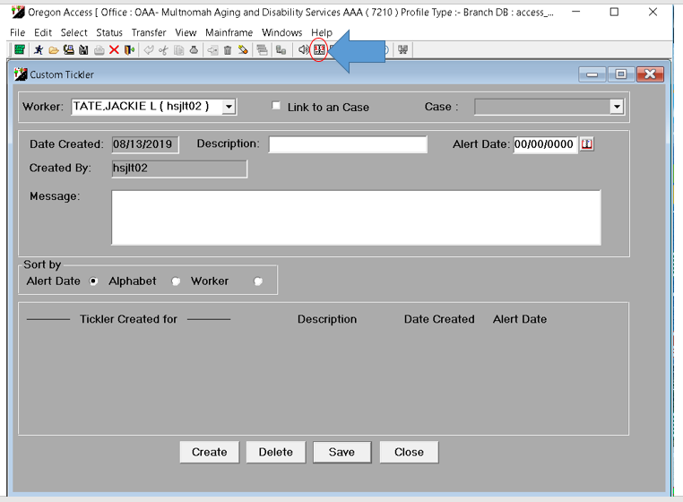

- CM monitors client’s progress weekly, reduces service plan hours if client condition has improved significantly, and narrates this action.
- CM submits 546 to voucher clerk or In Home Agency with information on hours and approved time frame to alert them of temporary hours increase.
- CM sends approval letter to client with approved hours, what hours can be used for, begin date, end date, and contact information. (Please circle the appropriate CL or use delete).
- CM sends new 4105 to HCW on what hours have changed.
- Waivers must end by approved end date. If extension needed, CM must apply with new waiver request.

