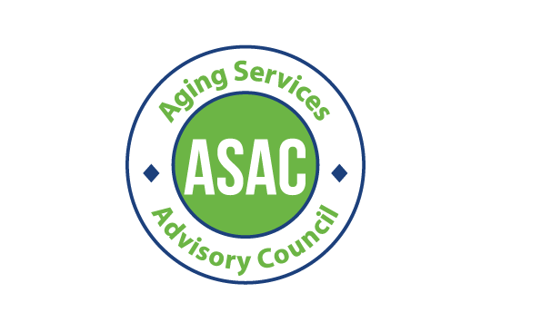**Aging, Disability, and Veterans Services Division Aging Services Advisory Council (ASAC) In Person Meeting / Zoom optional** Tuesday, July 16 2024, 12:30 pm - 2:30 pm 209 SW 4th Ave, Portland, OR 97204

# Pine Room

Zoom Info:

[https://multco-us.zoom.us/s/96157906854?pwd=eWNOclg4aDU3MkN4NHJvQUNLRTc4Zz09#success](https://multco-us.zoom.us/s/96157906854?pwd=eWNOclg4aDU3MkN4NHJvQUNLRTc4Zz09&success)

Meeting ID: 961 5790 6854 Passcode: ASAC2024!

Meeting goals:

* Introduction of new council staffer and Commissioner Sharon Meieran
* Update on new and current area plan
* Ideate survey and focus group questions for new area plan

Note: 12:30 pm Zoom Meeting will open for Accessibility, Connectivity, and Connection check in

|  |  |  |  |
| --- | --- | --- | --- |
| **Time** | **Item** | **Purpose** | **Lead** |
| 12:30 pm  5 min | Connection and grab lunch etc. |  | All |
| 12:35 pm  5 min | Welcome | Introduction of new ADVSD Staff | Raquel |
| 12:40  5 mins | Land and labor acknowledgements | Honoring community and addressing ongoing systems of oppression | Raquel |
| 12:45  5 mins | Quick introductions  Meeting Goals and Agenda Review |  | Raquel |
| 12:50 pm  10 min | Commissioner Meieran-Welcoming remarks | Commissioner staffer | Commissioner Sharon Meieran |
| 1:00 pm  10 mins | Update on New 25-29 Area Plan  - Accepting suggestions from Dave |  | Jason + Nicole  + Raquel |
| 1:10  15 min | Area Plan: final year update:  -ADRC; staffing  -New Nutrition Contractors |  | Marina |

|  |  |  |  |
| --- | --- | --- | --- |
|  | -OPIM; staffing  -Veteran Services |  |  |
| 1:25 pm  (25  Minutes) | Update on Operational Area Plan for council to review |  | Alex |

|  |  |  |  |
| --- | --- | --- | --- |
| 1:50 pm  (10 min) | Break - Get Lunch, Take a Break, Stretch, Connect! | Rest and Refresh | All |

|  |  |  |  |
| --- | --- | --- | --- |
| 2:00 pm  (30  Minutes) | What:  For the new area plan we are doing a needs assessment |  | Jason + Raquel |
| 2:10pm (20 min) | Ideation:  Sticky notes and sharpies |  | Nicole and Jason |
| 2:30pm | Adjourn! |  | All |

# Upcoming Meetings:

Common acronyms used in ASAC Meetings - While we strive to avoid acronyms and jargon here are some you may hear in ASAC meetings

* ADVSD - *Aging, Disability and Veterans Services Division* - a division of Multnomah County Department of Human Services
* APD - *Aging and People with Disabilities* - a work unit of the Oregon Department of Human Services
* BIPOC - *Black, Indigenous, and other People of Color*
* DCHS - *Department of County Human Services*
* DSAC - *Disability Services Advisory Council*
* LTSS - *Long Term Services and Supports*

# NEMT - Non-Emergent Medical Transportation

* O4AD - *Oregon Association of Area Agencies on Aging and Disabilities*
* ODHS *- Oregon Department of Human Services (also called DHS)*
* OPI and OPI-M - *Oregon Project Independence and Oregoin Project Independence - Medicaid*

Prioritization and is anything missing?