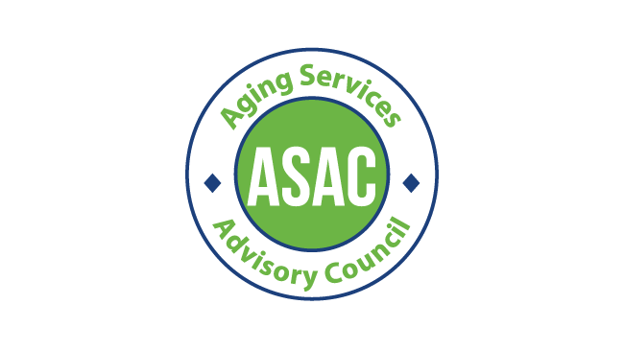**Aging, Disability, and Veterans Services**

**Division Aging Services Advisory Council (ASAC)**

**In Person Meeting** Tuesday, September 17 2024, 11 am - 1 pm 209 SW 4th Ave, Portland, OR 97204

Pine Room

Zoom Info (Optional):

[https://multco-us.zoom.us/s/96157906854?pwd=eWNOclg4aDU3MkN4NHJvQUNLRTc4Zz09#suc](https://multco-us.zoom.us/s/96157906854?pwd=eWNOclg4aDU3MkN4NHJvQUNLRTc4Zz09&success)

[cess](https://multco-us.zoom.us/s/96157906854?pwd=eWNOclg4aDU3MkN4NHJvQUNLRTc4Zz09&success)

Meeting ID: 961 5790 6854 Passcode: ASAC2024!

**Regular Meeting**

Providing on-going advice and guidance on area plan and program development for service delivery to older adults.

**Purpose**

|  |  |
| --- | --- |
| **Time** | **Agenda** |
| 11 am | Welcome |
| 11:10 am | ADVSD Leadership updates |
| 11:20 am | Area Plan updates |
| 11:50 am | BREAK |
| 12 pm | Commitment and active role to share area plan needs assessment survey |
| 12:10 pm | Ideate on public listening session |
| 12: 50 pm | Public Comment |

Notes: