**Aging, Disability, and Veterans Services Division**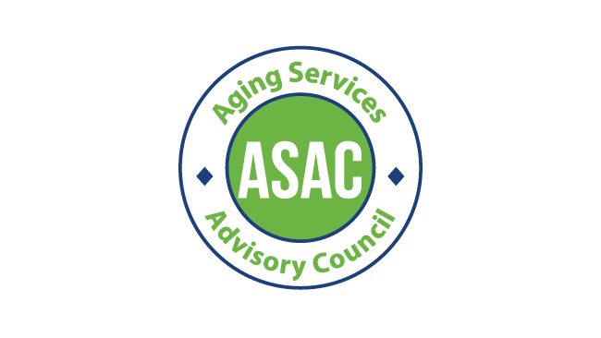

**Aging Services Advisory Council (ASAC)**

**In Person Meeting**

Tuesday, September 17 2024, 11 am - 1 pm

209 SW 4th Ave, Portland, OR 97204

Pine Room

**Zoom Info (Optional)**:

<https://multco-us.zoom.us/s/96157906854?pwd=eWNOclg4aDU3MkN4NHJvQUNLRTc4Zz09#success>

Meeting ID: 961 5790 6854 Passcode: ASAC2024!

**Regular Meeting**

|  |  |
| --- | --- |
| **Purpose** | Providing on-going advice and guidance on area plan and program development for service delivery to older adults. |

|  |  |
| --- | --- |
| **Time** | **Agenda** |
| 11 am | Welcome |
| 11:10 am | ADVSD Leadership updates |
| 11:20 am | Area Plan updates |
| 11:50 am | BREAK |
| 12 pm | Commitment and active role to share area plan needs assessment survey |
| 12:10 pm | Ideate on public listening session |
| 12: 50 pm | Public Comment |

Notes:

* We activated our brains by using sticky notes to answer how we felt at public events.
* **ADVSD Updates**

**Marina** - team is focused on the Area Plan.

**Irma** - We are working with the state on a quality improvement project for the ONE system. Giving recommendations on how the system can be improved concerning the work we do. **Dave** asked how the state feels about our input on this subject. **Irma** hopes they are taking the suggestions into consideration. They are taking input from our agency plus the Self Sufficiency agency. The state has come to some of our branches to observe the use of ONE by our staff.

**Irma** - We are also working with Area Agency (O4AD) on a workload model, which has not been updated since 2017, which was before ONE was implemented. We are fortunate to be able to use the county general fund to help with costs. With our advocacy we did get an increase in funding amount for this year - but not for next.

**Irma** - Our Homeless Mobile Intake team received a national award for innovation for the work we are doing - this award was from USAging. This team is funded through supportive housing funds (not medicaid funded).

**Marina** - ADRC began availability 24/7. They took 2407 calls in July. They are helping in so many areas. Setting appointments, giving referrals, and helping LTSS with intake referrals among other things consumers call and need help with.

**Marina** - OPI expansion program (OPIM) rolled out in June. We had 321 consumers on the waitlist and we have gotten 42 of those approved. OPIM systems are still being worked on and developed at this point. We are also keeping track of consumers who decline to be involved in this program - it is based on total asset disclosure and may create a barrier for people (Medicaid rules).

* **Area Plan Updates**

The 2025-2029 Area Plan describes how we will provide comprehensive coordinated delivery systems to older adults in our community for the next four years. Thank you to our ASAC/DSAC help in July with the process of developing questions for our consumers. We are asking you to share this survey with all of your contacts - you will receive an email concerning this in the next few weeks.

**Nicole** - for the survey we talked with both councils, looked at previous surveys, discussed them and met with internal staff of each program who use the Older American Act funds. Key takeaways: we need to make sure people are aware of these services, they know how to access them, and that the names of these programs are easily identified.

**Dave** - Have we looked at the public facing side and how these groups get information to our consumers? I have noticed big differences in different groups, such as website accessibility and content. **Irma** - we are trying to figure out ways to help our consumers maintain their websites.

**Jason** - we really tried to come up with simple language and questions for the survey that would help encompass what ASAC/DSAC wanted in the survey and was important to them. Across the entire survey, we tried to get access, awareness, and use mixed into each question. We really wanted to ask questions to see if people are aware that specific services and community partners exist.

**Brandy** - will organizations get feedback from this survey? Jason said from the data side they can do this.

**Nicole** - her dream is that after we meet this timeline we can create more culturally specific report outs.

**Irma** - hopes that this will help us understand where our funding should be spent.

**Nicole** - there are specific questions on the survey that would popup to the ADRC immediately. Things like are you homeless or hungry.

**John** - shared about when he found himself and family in a situation to get help needed as an older person. He called the county. He called the county. He wants everyone to know they have this help if needed. Kaiser referred him to the Hollywood Senior Center, but they did not service where he lives. They referred him to Friendly House. He wishes it had been a bit easier to know where to go.

**Raquel** - The survey will be open October 1st - 25th. Providers, libraries, health clinics, community partners, and you and your networks - we are helping will all help us get this out to consumers.

**Brandy** - reaching out to senior housing for long term care facilities would be a good place to send the survey. **Raquel** - [raquel.barajas@multco.us](mailto:raquel.barajas@multco.us) told Brandy to reach out and let's talk about this. **Marina and Jacob-** We can connect with Steven who runs home care facilities program and LTSS program.

**Dave** - do the commissioners engage with us on this survey? Do they send it out to their constituents? I recommend asking for their help. **Raquel-** Our communications person will be reaching out to commissioner Meieran and Chair to put on their newsletter. **Barb** agrees with Dave. They have newsletters, could they send it out with those? Have we talked to the Health Department? (We have).

**Anne** - this survey could go out on so many channels. Particularly the community partners - have we asked them to make specific plans on sharing this survey? It would also be great to get the city involved in sending it out to their contacts.

* **Ideate on public listening session**

Completed an activity to help create a public listening session that would generate

Interest and input. Raquel will share what this information gathering has shown us as

soon as she has looked at it.

* **Welcome to John!**
* **Public Comment**

**Barb** - I like the intros at the beginning of the meeting, that way I know who is there if I am not in the room.

**Anne** - we are getting ready for open enrollment for Medicare. Let your community know they can change their enrollment at this time. They can call the ADRC if they would like to schedule an appointment with a SHIBA counselor. 503-988-3646