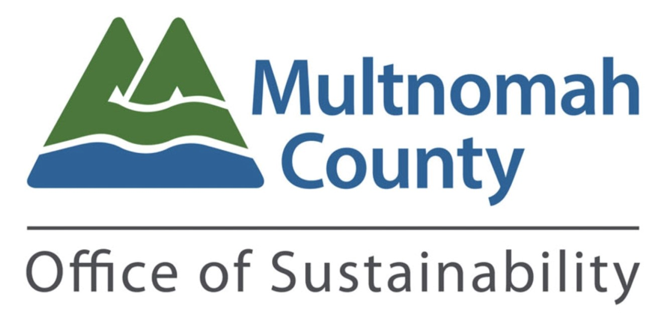***Climate Justice Plan Community Forum | Resources***

| **Strategy Analysis Dimensions** | |
| --- | --- |
| *Resilience* | Resilience is the capacity of the community—its people, institutions, infrastructure, and natural systems—to anticipate, prepare for, respond to, and recover from adverse events, while adapting and thriving in the face of long-term challenges and opportunities. |
| *Greenhouse Gas Mitigation* | Greenhouse gas mitigation refers to any action taken by governments, businesses, or people to reduce or prevent greenhouse gas emissions, or to enhance carbon sinks that remove these gasses from the atmosphere. |
| *Equity (Benefits & direct impacts)* | Equity recognizes that people’s lives and experiences are often shaped by past and current disparate treatment of individuals and communities based on race, gender, ability and socioeconomic status. Equity seeks to address these differences through intentional processes that ensure everyone has access to opportunities and resources that are tailored to what they need to thrive. |
| *Cost to Government* | Local governments are obligated to adopt budgets that balance revenues and costs, and are intended to reflect the priorities of the community. Costs can be financial, for example hiring new staff and providing community grants, or reflect opportunity costs such as prioritizing one policy/program over another using existing resources. There are opportunities to leverage outside funding or partner resources through collaboration or grants. Both the scale and type of costs are important considerations. |
| *Momentum/Readiness/Context* | Every strategy should be considered in the context of readiness. Some strategies may align well with efforts that have been underway for years and are supported by a wide coalition. Others may be new efforts that require doing research, gathering best practices, building awareness of an issue and starting to convene interested or impacted parties. The economic and political circumstances are also critical to understanding if and how a strategy is ready to move forward, |

| **SMART Goals** | |
| --- | --- |
| *Specific* | A specific goal clearly identifies what is expected, why it is important, who's involved, where it is going to happen, and which resources are involved in its achievement. It answers the 'W' questions: What, Why, Who, Where, and Which. |
| *Measurable* | Goals should be measurable so that there is tangible evidence that you have accomplished the goal. They should answer questions like: How much? How many? How will I know when it is accomplished? |
| *Attainable* | Goals should be achievable; they should stretch you slightly so you feel challenged, but defined well enough that you can achieve them. An achievable goal will usually answer the question: How can I accomplish this goal? |
| *Relevant* | A relevant goal can answer yes to these questions: Does this seem worthwhile? Is this the right time? Does this match our other efforts and needs? |
| *Timely* | Goals should be time-bound. This means that they have a start and finish date. |

| **Guiding Questions** |
| --- |
| Do you have questions about these metrics? |
| Do these metrics look adequate in terms of measuring progress toward outcomes? Any adjustments you would offer? |
| What other metrics would you add? What is the source of data? |
| Which strategies would you like to discuss today? Are there any strategies that you would modify? |
| Do the draft strategies align with county or community priorities as you see them? |
| Which strategy, from the ones that are listed, should be a priority for Multnomah County? |
| Are there any other strategies you would like to see in order to help achieve this goal? |

| **Shared Agreements** | | |
| --- | --- | --- |
| Respect each other | | Expect and accept discomfort (and joy) |
| Never a failure, always a lesson | | Practice community and self-care |
| Make space, take space/share airtime. Balance participation in the room. | | |
| “Bike rack” to capture off topic or detailed questions or ideas that arise | | |
| Listen to understand, not to respond. Don’t interrupt. | | |

| **Typology of Strategies** | | |
| --- | --- | --- |
| Type of Strategy | Description | Examples |
| *County Policy* | Multnomah County is a Home Rule county and is able to implement laws that are not expressly preempted by federal or state law.The Board of County Commissioners is able to amend the County Code through a majority vote.Voters are also able to amend the County Charter through the Charter review process and referral to voters. | [Wood smoke curtailment ordinance](https://www.multco.us/health/staying-healthy/wood-burning-restrictions)  [Commercial building energy reporting](https://www.portland.gov/bps/climate-action/energy-reporting#:~:text=Requires%20commercial%20buildings%2020%2C000%20square,by%20April%2022%20each%20year.)  [Building deconstruction requirements](https://www.portland.gov/bps/climate-action/decon/deconstruction-requirements) |
| *Create/fund programs* | The County Chair and Board of County Commissioners have wide discretion in how they allocate revenue raised by taxes and fees through the budget process.The County also has the power to increase certain taxes and fees, ask voters to increase certain taxes, or create new sources of revenue through a vote of the Board or by referral to voters.Programs can be implemented by County employees or contracted through private companies or non-profits. | [Clean Air Construction](https://www.portland.gov/omf/brfs/procurement/clean-air-construction)  [Wood Burning Exchange program](https://www.multco.us/dchs/wood-burning-exchange) |
| *Advocacy* | Many authorities and powers are beyond the scope of Multnomah County’s authority. In those cases, the County and our partners can advocate for other government bodies to implement new policies or develop programs.Advocacy is often done in coalition with other governments with the same priorities, or with community organizations, non-profits, and impacted individuals to amplify shared goals and drive systemic change. | [Cleaner Air Oregon (DEQ)](https://www.oregon.gov/deq/aq/cao/pages/default.aspx)  [Low-Income Utility Rates (PUC)](https://edocs.puc.state.or.us/efdocs/HAH/um2211hah114912.pdf) |
| *Game changers* | Game-changing initiatives often come from outside of government or through a partnership of outside advocates and government.This approach often involves innovative thinking and a willingness to challenge the status quo to achieve significant progress or transformation.These strategies refer to taking steps that exceed the existing powers or jurisdiction of an individual, organization, or government body, and often include a referral to voters to grant new authorities or revenues. | [Portland Clean Energy Fund](https://www.portland.gov/bps/cleanenergy)  [Portland](https://www.portland.gov/transition/overview#:~:text=The%20City%20of%20Portland%20is,council%20and%20new%20leadership%20roles.) [Charter Reform](https://www.portland.gov/transition/overview#:~:text=The%20City%20of%20Portland%20is,council%20and%20new%20leadership%20roles.),  [Preschool for All](https://www.multco.us/preschool) |
| *Governance/third space* | These strategies emphasize the importance of building and enhancing social connections among community members as a means to improve the quality of life in neighborhoods and tackle various social issues.By creating a "shared space" or "third space" where community and government meet as peers to find shared priorities and strategies, new solutions to address the effects of the climate crisis that center the people and communities who experience systemically created disparities can emerge.Third spaces build and invest in community capacity.Strong social networks can lead to better community support, increased civic engagement, and a greater sense of belonging, all of which are essential for community revitalization and problem solving. | [MADE for Health Justice](https://www.coalitioncommunitiescolor.org/ccc-news/2024/12/2/celebrating-stories-made-for-health-justice)  [Climate Justice by Design (CJxD)](https://multco.us/info/climate-justice-design) |
| *Mutual Aid* | Actions meant to support the common good among people that take place without government coordination or involvement.Mutual aid does not require a formal structure or nonprofit status, although groups sometimes evolve into nonprofit organizations.These initiatives foster a sense of solidarity and self-reliance within communities, addressing immediate needs and building stronger social networks. | [Neighborhood refrigerator pantries](https://pdxparent.com/feeding-families-local-free-fridges-and-pantries-address-food-insecurity/)  [Community gardens](https://www.portland.gov/parks/community-gardens) |