**Aging, Disability, and Veterans Services Division**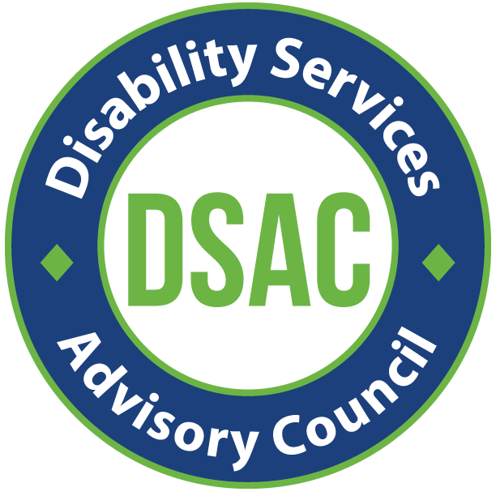

**Disabilities Services Advisory Council (DSAC)**

**In Person Meeting / Zoom optional**

Thursday, September 19 2024, 12 pm - 2 pm

209 SW 4th Ave, Portland, OR 97204

Pine Room

Zoom Info:

<https://multco-us.zoom.us/s/96157906854?pwd=eWNOclg4aDU3MkN4NHJvQUNLRTc4Zz09#success>

Meeting ID: 961 5790 6854 Passcode: ASAC2024!

**Regular Meeting**

|  |  |
| --- | --- |
| **Purpose** | Helping advise on service eligibility guidelines, evaluating program effectiveness, and advocating for issues pertinent to the life and welfare of people with disabilities. |

|  |  |
| --- | --- |
| **Time** | **Agenda** |
| 12 pm | Welcome |
| 12:10 pm | ADVSD Leadership updates |
| 12:20 pm | Area Plan updates |
| 12:50 pm | BREAK |
| 1 pm | Commitment and active role to share area plan needs assessment survey |
| 1:10 pm | Ideate on public listening session |
| 1:50 pm | Public Comment |

* **Introductions and Brain Activation Activity**
* **ADVSD Leadership Updates**

**Joe** - We sent your survey answers to OR Eligibility, for the state, they looked the report and felt it would be great to explore this.The state has created a task force to explore ADVSD going back to serving the mainly older and disabled population - and going away from the No Wrong Door model approach. We hope to see an update in the coming months.

**Joe** - We have seen an increase in security issues, as well as expulsions, at the Five Oak Building. This has been very concerning for the safety of our staff and consumers. We will be installing sturdier barriers at the front desk - so that when they are hit, they do not break.

**Barb** - mentioned security was great today.

**Jesse** - feels the plexi glass is impersonal.

**Charmaine** - feels we need a balance for personal and safety.

**Carolyn Snell** - she has dealt with the people behind the plexiglass, and most of the time they are wonderful, sometimes you can tell they are having a bad day.

**Kalah** - Commented that the security guards are there to protect us, not engage with us.

**Barb** - Do you call 911 immediately when security issues arise, or do we call clinical teams to assist?

**Joe** - Our Homeless Mobile Intake Team won a national award from USAging. Irma was in attendance, in Tampa FL, when they presented the award. It was given for innovation in the homeless community. This team is a great diverse team with some lived experience. This team began in 2022.

**Joe** - We are working on a workload model project - to show the state how much they are paying us, and how much more it really costs to do this work.

**Joe** - ONE system - we have been giving the state input on what needs to be changed or added to the ONE system to help it do a better job.

**Joe** - leaving the county, this will be his last meeting.

* **Area Plan Updates** - The 2025-29 Area Plan describes how we will provide comprehensive coordinated delivery systems to older adults in our community for the next four years. Thank you to all our DSAC/ASAC members for the help in July with the process of developing questions for our consumers. We are asking you to share this survey with all your contacts, you will receive an email in the next few weeks concerning this.
* **Nicole** - for the survey we spoke with both councils, discussed them and met with internal staff of each program who use the Older American Act funds. Key takeaways: we need to make sure people are aware of these services, they know how to access them, and they are named in a way that is easily identified.
* **Jason** - went over few examples of questions.
* **Carolyn Snell** - asked who the surveys will go out to and how to and how do people get them.
* **Barb** - has this gone to the printer yet? The language seems not easily understandable.
* **Gail** - mentioned she did not know about the services our community partners offer.
* **Members** - get them a list of services the Older American Act covers. Also, can anyone go to NARA or NAYA or is that only for Native American people?
* **Jason** - in the survey we really made sure to have our contact info in lots of places.
* Survey open Oct 1-25 online. You will get a $20 gift card for completion. We can mail the surveys if requested. They will be in 13 languages. There will also be a QR code to access the survey.
* **Carolyn Snell** mentioned filling out surveys on her phone can be hard.
* **Kalah** - How do we access the questionnaire? You will have an email by the end of September telling you how to do that.
* **Barb** - both ASAC and DSAC have not done enough recruitment to expect them to spread this survey.
* **Irma** - we are asking you to share with your networks, we are sharing with all out networks.
* **Jesse** - Native American community likes hard copy.
* Gift cards will be for Safeway, Target or Fred Meyer, you choose.
* **Barb** - can you email the gift cards - no we cannot.

**Ended the meeting doing a brainstorming of how we could create interest in a public listening session**