**Aging, Disability, and Veterans Services Division**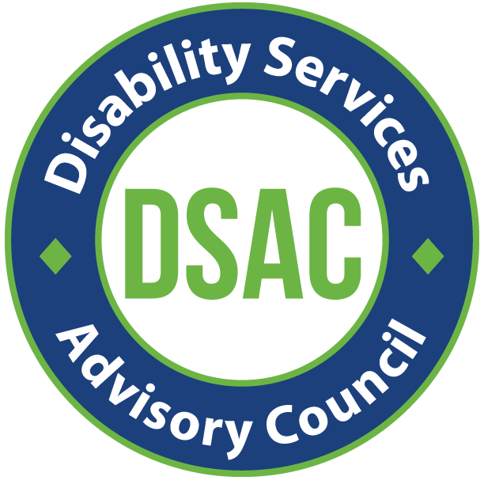

**Disabilities Services Advisory Council (DSAC)**

**In Person Meeting / Zoom optional**

Thursday, September 19 2024, 12 pm - 2 pm

209 SW 4th Ave, Portland, OR 97204

Pine Room

Zoom Info:

<https://multco-us.zoom.us/s/96157906854?pwd=eWNOclg4aDU3MkN4NHJvQUNLRTc4Zz09#success>

Meeting ID: 961 5790 6854 Passcode: ASAC2024!

**Regular Meeting**

|  |  |
| --- | --- |
| **Purpose** | Helping advise on service eligibility guidelines, evaluating program effectiveness, and advocating for issues pertinent to the life and welfare of people with disabilities. |

|  |  |
| --- | --- |
| **Time** | **Agenda** |
| 12 pm | Welcome |
| 12:10 pm | ADVSD Leadership updates |
| 12:20 pm | Area Plan updates |
| 12:50 pm | BREAK |
| 1 pm | Commitment and active role to share area plan needs assessment survey |
| 1:10 pm | Ideate on public listening session |
| 1:50 pm | Public Comment |