Multnomah County
Aging, Disability and Veterans Services Division
2021-2025 Area Plan
Year 1 Update

2022-07-26



Table of Contents
Section A: Area Agency Planning and Priorities 1
A-1 Introduction 1
A-2 Mission, Vision, Values 3
A-3 Planning and Review Process 5
A-4 Prioritization of Discretionary Funding 12
Section B: Planning and Service Area Profile 14
B-1 Population Profile 14
B-2 Prioritized Populations 35
B-3 AAA Services and Administration 37
B-4 Non-AAA Services, Service Gaps and Partnerships to Ensure Availability of Services Not Provided by the AAA 42
Section C: Focus Areas, Goals and Objectives 44
C-1: Information and Referral Services and Aging and Disability Resource Connection 44
C-2: Nutrition Services 51
C-3: Health Promotion 59
C-4: Family Caregivers 64
C-5: Legal Assistance and Elder Rights 70
C-6: Older Native Americans 78
C-7: Trans and Nonbinary Elders 83
Section D: OAA/OPI Services and Method of Service Delivery 91
D-1: Administration of Oregon Project Independence (OPI): 91
D-2: Services provided to OAA and/or OPI consumers: 100
Appendix A: 2021-25 Area Plan Organizational Chart 101
Appendix B: Advisory Councils and Governing Bodies 102
Advisory Councils 102
Aging Services Advisory Council (ASAC) 102
Disability Services Advisory Council (DSAC) 102
Governing Body – Multnomah Board of County Commissioners 103
Appendix C: Public Process 104
Appendix D: Final Update on Accomplishments from 2017-20 Area Plan 109
Nutrition Services Goals 110
Health Promotion Goals 111
Family Caregiver Support Program Goals 112
Elder Rights and Legal Assistance Goals 113
Older Native Americans Goals 114
Veterans Goal 115
Behavioral Health Goals 116
Health System Transformation Goal 119
Transportation Goal 120
Appendix E: Emergency Preparedness Plans 121
Appendix F: Designated Focal Points (OAA Section 306(a)(3)(B)) 122
Appendix H: Statement of Assurances and Verification of Intent 123
Attachment C: Service Matrix and Delivery Method 125
Attachment E: 2021-2025 Area Plan Needs Assessment Survey Results 134
Needs Ranking by Identity 136

Section A: Area Agency Planning and Priorities

A-1 Introduction
The Kathlamet, Wasco, Clackamas, Bands of Chinook, Tualatin, Kalapuya, Molalla, Multnomah, and other Tribes lived along the Columbia and Willamette Rivers for thousands of years where the boundaries of Multnomah County are drawn today. We honor these tribes as the original stewards of this land. We acknowledge the intentional and ongoing attempts to destroy Native people and erase Native culture. We recognize and honor the lives of the African people who were stolen and enslaved by White occupiers to perform unpaid labor to further the colonization of these stolen lands. The Aging, Disability and Veterans Services Division recognizes that the history of these lands has been intentionally unspoken and White dominated, the impacts of which remain largely unaddressed and palpably reverberate in this place that is recognized today as Multnomah County, Oregon.
Multnomah County is the most populated county in Oregon with an estimated 829,560 residents, representing nearly one-fifth of the state population. Recent estimates show that 151,827 or 18.3% of the county’s residents are people 60 and older. Older adults, 48,767 people with disabilities, and the estimated 37,495 Veterans that live in Multnomah County are the primary service populations for the Multnomah County Aging, Disability and Veterans Services Division (ADVSD).
ADVSD is one of four divisions comprising the Department of County Human Services. The other divisions are Intellectual and Developmental Disabilities Services, Youth and Family Services, and the Preschool and Early Learning. ADVSD is the designated Area Agency on Aging (AAA) for Multnomah County. As a Type B Transfer AAA, we offer access to services for older adults and people with disabilities at five District Centers, eight Enhancing Equity providers, five Medicaid Long Term Services and Supports (LTSS) offices throughout the county. Services include assisting in finding resources such as, Supplemental Nutrition Assistance Program (SNAP), health care coverage, long-term and community-based care services, Oregon Project Independence (OPI), and Older Americans Act (OAA) programs and services. ADVSD administers Adult Protective Services, Adult Care Home Licensing, and Public Guardian and Conservator programs to assist those most vulnerable and at risk. ADVSD offers seamless entry to services to ensure that people receive appropriate services and strive for a “No Wrong Door” approach. To further that aim, three of the five District Centers co-locate with Medicaid LTSS offices. All LTSS branches serve both older adults and people with disabilities.
The primary goal for ADVSD is that elders and adults with disabilities to live as independently as possible by offering a range of services—some directly and others through contracts with community agencies. A complete list of services is included in Section B-3, AAA Service and Administration, and Section D-2 Services Provided through OAA and OPI. ADVSD has two advisory councils—the Disability Services Advisory Council (DSAC), and the Aging Services Advisory Council (ASAC). The ASAC and DSAC bring expertise, lived experience, and consumer voice into the work of ADVSD by making recommendations and advocating on important issues affecting seniors and people with disabilities.
ADVSD must be a leader in the work toward racial justice both in the county and in our systems. We recognize that multiple systems of oppression are reinforced in ADVSD policies, practices, and processes. We are called to be humble, brave, and committed to addressing them as a division. This plan strives to weave Multnomah County’s Leading with Race pledge and the Equity and Empowerment Lens tools into its work. The analysis and goals give focus to people who have been marginalized based on their race, gender, sexual orientation, ability, age, and other forms of oppression. We understand that marginalization compounds when the multiple identities people hold intersect, particularly for people of color. This plan, for ADVSD, is a tool to continue our reorientation towards racial justice. Read more about Leading with Race and The Workforce Equity Strategic Plan: https://multco.us/safety-trust-and-belonging-workforce-equity-initiative
For questions or comments, please call (503) 988-3646 or email areaplan@multco.us

A-2 Mission, Vision, Values
ADVSD mission: Promote independence, dignity, and choice in the lives of older adults, people with disabilities and veterans.
ADVSD vision: All older adults, people with disabilities and veterans thrive in diverse and supportive communities.
ADVSD mission and vision are founded on the following organizational values:
- Put People First
- Act with Integrity
- Promote Equity, Empowerment, and Inclusion
- Collaborate
- Pursue Excellence
- Accept Personal Responsibility
- Foster Creativity and Innovation
- Act as Change Agents
- Bring Our Best Selves to Work
ADVSD provides services directly and in concert with multiple community partners. The non-profit organizations that partner with us bring expertise and deep connections to the communities they serve. They provide coverage across the county and to provide culturally responsive and culturally specific services. We coordinate activities that have regional impacts with neighboring counties, cities within Multnomah County, and with agencies across the state. We strive to provide trauma-informed and person-centered services. We embrace innovation and learn from our peers across the nation and in communities across the globe. We are working to reduce and remove silos within our program areas, across the Department of County Human Services, and between Multnomah County Departments.
ADVSD is committed to dismantling systemic racism, White supremacy, and other related and connected systems of oppression in ADVSD processes and the services we provide and fund. We do this to honor all the people aging in Multnomah County and their choice, dignity, and independence. Some of our partners include:
- Asian Health and Service Center
- Asian Pacific American Senior Center
- Community for Positive Aging
- Ecumenical Ministries of Oregon
- El Programa Hispano Católico
- Friendly House

- Immigrant and Refugee Community Organization
- Impact NW
- Independent Living Resources
- Meals on Wheels People
- Native American Rehabilitation Center
- Native American Youth and Family Center
- Neighborhood House
- Q Center
- SAGE Metro Portland
- Store to Door
- Urban League of Portland
- YWCA

A-3 Planning and Review Process
To inform the 2021-2025 Area Plan Needs Assessment and Planning Process ADVSD utilized the following methods and tools:

Review, Research, and Alignment
In September 2019, ADVSD began a review and analysis of the past three Multnomah County Area Plans and current Area Plans of PSA of similar size, community profile, those known to have responsive approaches to community engagement, and innovative approaches to services. To understand current and emerging trends in issue areas and gaps in services, ADVSD reviewed program data, local, regional, population-level, and topic-specific planning documents, national research, and policy documents. This plan draws upon and reflects the work of other divisions and departments across Multnomah County, such as:
- Multnomah County Workforce Equity Strategic Plan
- The Equity and Empowerment Lens
- Being Trans and Gender Diverse in Multnomah County
- Community Powered Change – The Multnomah County Community Health Improvement Plan
- Multnomah County Mental Health System Analysis
- Poverty in Multnomah County
- Domicile Unknown
- Point in Time Count
- Violence Prevention and Intervention Framework

Demographic Analysis – See Section B-1 Population Profiles.

Community Survey
In March 2020, ADVSD was poised to launch an in-person interview approach to the needs assessment when the State of Oregon went into lockdown to stop the spread of the COVID-19 virus. With input from the Advisory Councils, ADVSD decided that an online survey was the safest means to gather community input and needs. We understood that an online-only tool limits who can participate due to barriers to digital access and the length of the survey. ADVSD invested in support by funding community partners to do outreach and provide survey support by telephone and various online platforms.

Highlights of the Survey Tool, Approach, and Response
- The survey took place from December 1-31, 2020.
- The survey was offered in 17 languages, as follows:
- English
- Español [Spanish]
- 繁體中文 [Traditional Chinese]
- 简体中文 [Simplified Chinese]
- 한국어 [Korean]
- Tiếng Việt [Vietnamese]
- Россия [Russian]
- українська [Ukrainian]
- Kiswahili [Swahili]
- Oromoo [Oromo]
- नेपाली [Nepali]
- ဗမာ [Burmese]
- ቋንቋ [Ahmaric]
- ትግርኛ [Tigrinya]
- فارسی [Farsi/Persian]
- عربى [Arabic]
- Soomaali [Somali]
- The survey garnered 1,893 total responses. The preliminary analysis included 1,392 of those responses.
- A total of 460 people took the survey in languages other than English. To provide phone-based survey support and to ensure responses in each language, ADVSD partnered with the language bank at the Immigrant and Refugee Community Organization (IRCO) to make calls to individuals and reached 128 participants using this approach. The survey was utilized in all languages except Somali.
- ADVSD contracted with 11 new and existing partners to provide outreach and survey support via telephone and Zoom.
- The survey included 48 issue-related questions, 33 expanded demographic and identity questions, a needs ranking exercise, 16 open-ended questions, and 13 comment fields for the community to provide additional information related to each topic area.
- ADVSD paid each eligible survey respondent a $10 gift card as an incentive for taking the survey.
More information on the survey results can be found here: https://multco.us/ads/2021-2025-advsd-area-plan

Community Interviews
Multnomah County worked with two Transgender and Nonbinary community members to lead a process to bring the voices of Transgender and Nonbinary older people into the 2021-25 Area Plan. This process involved promoting survey participation and conducting eight community interviews with Transgender and Nonbinary older adults and one Two Spirit Elder. This work is documented throughout the plan and in section C-1.

Community Listening Sessions
Two public listening sessions were hosted by ADVSD, the Aging Services Advisory Council (ASAC), and the Disability Services Advisory Council (DSAC) in March 2021. Invitations were sent to senior centers and Enhancing Equity providers, their staff, and the community members they serve. The listening sessions were advertised via notices distributed by Multnomah County communication channels, email lists, and social media. ADVSD provided American Sign Language interpretation, closed captioning, and language interpretation upon request. Public comment was invited via email, postal mail, telephone, voice mail recording in any language, and at the public hearings.
On April 1, 2021 Multnomah County Board of County Commissioners passed R. 3 Resolution approving the Aging, Disability and Veterans Services Division 2021-2025 Area Plan, giving ADVSD permission to submit the draft 2021-2025 Area Plan to the state for review, and to begin implementation on July 1,2021.

Role of Advisory Committees
The ASAC and the DSAC served as the steering committee for the 2021-2025 Area Plan. ADVSD consulted with ASAC and DSAC members on the approach, survey instruments, and provided updates on the process and analysis at monthly meetings. ASAC and DSAC members were key contributors at the Community Listening Sessions and had the opportunity to contribute comments to the draft.
Over the coming months, ADVSD staff, ASAC and DSAC members will conduct outreach on the plan and will provide a briefing on the plan with staff and representatives of local jurisdictions, Tribal Governments, and Native organizations.

Scope of Need
Graphic #1: Top Needs as identified by the Community ranked 1-9. Responses to this question: 1,288

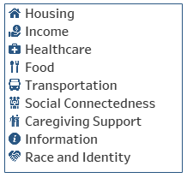
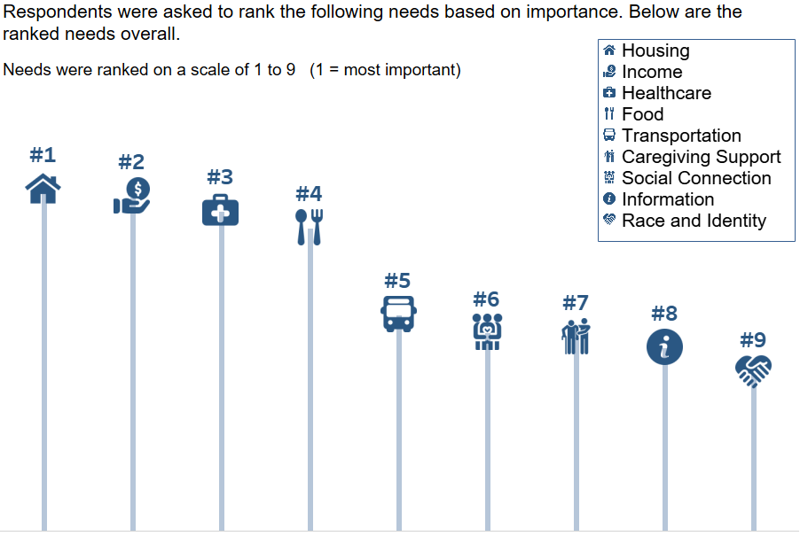
Income, housing, health care and food were nearly unanimously identified as the top four most important needs among survey respondents of all incomes, race, or identity intersections. Transportation was most often ranked at number five. Needs relating to race and identity, information, social connection, and caregiving moved among the six through nine positions, but with little difference indicated in their ranking. See Graphic #2 on the next page.

Graphic #2: Top Needs as identified by the Community shown by average ranking. Responses to this question: 1,288

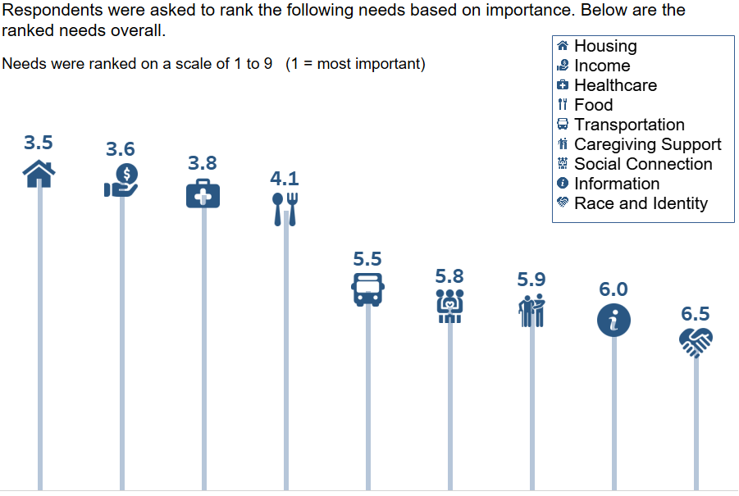
In addition to the ranked needs, the following were identified as important needs by community members:
- Improved safety and sense of security
- Employment opportunities and support
- Greater access to public spaces, especially parks and other green spaces
- More technology training and ways to access information for those who do not use technology.

Issues facing older adults in Multnomah County:
- Housing affordability and costs relating to maintaining a home. Older adults, people with disabilities, and low-income people of color are being displaced by rising housing costs at a disproportionate rate.
- Affordable, accessible, and flexible transportation. Transportation is a critical component to maintain independence, receive health care, increase social connection, food access, and use of community-based services.
- Meeting food needs. Food is a costly regular expense. Older adults on living low or fixed incomes struggle to buy the food they need.
- Mental and Behavioral Health Resources. There are too few providers with practices that focus on older adults experiencing social isolation, depression, and substance use disorders. Too few providers accept Medicare.
- Equitable language access. Language remains a barrier for older adults with limited English proficiency to equitably navigate health, transportation, and other systems. A burden is placed on community-based organizations or other informal networks of support to fill this gap.
- LGBTQ+ elder spaces and improved community competency. Transgender and Nonbinary older adults identified the need for improved LGBTQ+ competency in ASDVD and the aging services network. They also called for spaces offered by trusted partners for LGBTQ+ elders to access services and programs.

The Impact of COVID-19 on Older Adults, the Area Plan Approach and Needs Assessment
Conducting a needs assessment during the time of an evolving and worsening global pandemic was exceedingly difficult. The challenges were intensified by grief felt across the community, young and old, following the murders of George Floyd and Breonna Taylor, incidents sparked protests in response to these tragedies and ongoing systemic and institutional violence against the Black people in Oregon and the United States. In September 2020, forest fires in Oregon, which threatened the property and lives of many Oregonians, further intensified feelings of grief, fear, and insecurity in the community.
COVID-19 has exacted unknowable fear and loss in the lives of older adults and had an incalculable impact on older adults’ caregivers. Since the beginning of the COVID-19 pandemic, The Centers for Disease Control and Prevention clearly stated that people over 65 are at increased risk for severe illness, hospitalization, and death due to COVID-19. Emergency orders were issued in March 2020 by the State of Oregon and Multnomah County, imploring older adults to stay home, keep their distance from family and friends, wear masks, and only go out when necessary. In effect, COVID-19 made many older adults and people with disabilities involuntarily homebound serving to further isolate a population already at high risk for loneliness and neglect.
To address these impacts communities and organizations serving older adults shifted their models at warp-speed. From congregate meals they implemented home meal delivery, added welfare checks, grocery and medication delivery, technology support, and worked tirelessly to stay connected to their elders. This work happened while meeting evolving COVID-19 safety protocols in the many settings where older adults are served.
The shifts in the needs and community consciousness around the wellbeing and welfare of older adults made it an extraordinary time to conduct a needs assessment. As outlined above it was necessary to shift all needs assessment engagement from in-person community-focused events to an online survey and outreach and engagement by telephone and virtual platforms. This shift in approach dramatically changed who we could reach, the participant experience, and limited the communities participating. While the response to the survey was high compared to our goals, there are underrepresented voices due to the demands on community partners, technological barriers, cultural barriers, and staff capacity.
ASAC and DSAC recommended further work to understand the experiences of older adults who are Black, Indigenous, and from communities of color and that the future goals reflect those findings. ADVSD will add goals and activities related to the following focus areas: housing, mental health and behavioral health, income, and health care. We will add goals and key tasks specific to the following communities—veterans, older adults who are LGBTQ+, unhoused older adults, and older adults who were previously incarcerated.

Appendix C
Notices and list of meeting where the area plan was discussed.

A-4 Prioritization of Discretionary Funding
ADVSD will lead with Race and use the Equity and Empowerment lens and tool in all funding decisions and will apply additional scrutiny to scenarios and proposed cuts that will reduce services to communities that have been impacted by historic and systemic racism and those who have been identified as priorities in this plan.
In all cases ADVSD strives to prioritize services for those at highest risk and those with the greatest need, utilizing assessment tools to guide our decisions. ADVSD prioritizes funding for programs and services that are evidence based or that are proven to have a positive impact on the community being served, while continuing to pursue innovations.
When funding limits require, ADVSD will direct district center and Enhancing Equity partners to place any newly referred individuals on a waitlist.
- Oregon Project Independence (OPI) in-home services and support:
  - OPI Wait List Risk Assessment Tool is completed, and consumers are prioritized with those most at risk for nursing facility placement being put at the top of the list. Other factors, such as the risk of self-neglect or of abuse/neglect by others are considered in priority ranking.
  - Options counseling provided.
- Transportation assistance:
  - For waitlisted individuals with a case manager, risk and need is assessed to determine prioritization.
  - Consumers without a case manager will receive information and assistance notifying them of other resources in the community for transportation.
- Family Caregiver Support Program:
  - A family caregiver offered Options counseling is accordingly referred.
  - The family caregiver is informed of other services such as support groups, education and training and respite options such as adult day services.
During the process of the 2021-25 plan ADVSD will review the funding formula applied for programming through an open request for proposals process.
COVID-19 and the countywide shut-down brought attention for the need to support elders in crossing the digital divide. Prioritization includes programs and wrap-around support so older adults can access the internet, join Zoom events, participate digitally, access telehealth, and stay connected with friends and family. Goals include access to technology, internet, and training and technical support for participants.

We have never seen a world in which so many were so isolated from family, from friends, from activities, from healthcare. And we have never seen a world in which the “connections” to everything—services, shopping, learning about new products, listening to music, meeting people, talking to a doctor—are all made through an alphabet soup of technology, delivered by almost monopoly-like tech firms from Amazon to Zoom.
Generations Now: The Digital Divide—Why Haven’t All Older Adults Crossed it” by Laurie Orlov

Section B: Planning and Service Area Profile

B-1 Population Profile

As the Area Agency on Aging, ADVSD is asked to analyze who makes up the community of older adults and people with disabilities that may seek services and support. For the purposes of the Area Plan four age ranges are generally used: 18-59, 60+, 65+ and 85+, as well as various characteristics related to race, origin, disability status, and geographic location. The age bands relate to ADVSD service populations are as follows:
- People ages 18-59 with a disability who are eligible Medicaid Home and Community-based Services eligibility
- People age 60+ are eligible for Older Americans Act programs and services
- People 65+ are eligible for Medicare
- People 85+ are an important demographic group for planning purposes because at age 85 and beyond people may require more services and supports through home and community-based services

NB: A dash (-) in a table indicates that the information is not provided.

Table 1: Population Characteristics by ADVSD Service Area
 | County | East District | Mid District | N/NE District | SE District | West District
Total | 151,827 | 33,281 | 31,823 | 32,193 | 22,790 | 33,701
Below 185% FPL | 33,890 | 6,404 | 9,590 | 6,566 | 5,260 | 6,069
People of Color | 31,185 | 5,436 | 9,640 | 7,728 | 3,948 | 4,433
People 18-59 with disability | 48,767 | 11,219 | 12,180 | 10,791 | 7,729 | 6,848
Persons 60+ with disability | 47,865 | 10,263 | 12,679 | 9,598 | 6,620 | 8,706
People speaking primary languages other than English | 6,373 | 1,074 | 2,948 | 626 | 1,001 | 724
African | 973 | 1,074 | 268 | 314 | 1 | 236
American Indian or Alaska Native | 2,419 | 506 | 587 | 428 | 506 | 392
Asian | 10,615 | 1,570 | 4,163 | 1,719 | 1,942 | 1,221
Black or African American | 7,683 | 776 | 1,633 | 4,041 | 437 | 796
Native Hawaiian or Pacific Islander | 732 | 210 | 180 | 169 | 132 | 41
Latino, Latinx or Hispanic | 4,978 | 1,102 | 1,535 | 1,034 | 565 | 743
Middle Eastern | 966 | 313 | 202 | 86 | 54 | 311
Slavic | 5,011 | 910 | 1,685 | 511 | 838 | 1,067
White | 132,026 | 27,500 | 25,918 | 26,656 | 20,128 | 31,824

Table 2: Population Characteristics of Older Adults 85+ by ADVSD Service Area
 | County | East District | Mid District | N/NE District | SE District | West District
Total | 11,915 | 2,572 | 3,440 | 1,895 | 1,855 | 2715
Below 185% FPL | 3,864 | 1,031 | 1,243 | 409 | 603 | 578
People of Color (POC) | 2,241 | 358 | 164 | 441 | 370 | 428
Below 185% FPL POC | 878 | - | - | - | - | -
Persons 85+ with disability | 8,193 | 1,719 | 2,468 | 1,234 | 1,207 | 1,565
People speaking primary languages other than English | 670 | 124 | 199 | 43 | 164 | 141
African | 66 | - | - | - | - | 66
American Indian or Alaska Native | - | - | - | - | - | -
Asian | 1,046 | 139 | 130 | 150 | 197 | 159
Black or African American | 391 | 45 | 58 | 241 | 11 | 12
Native Hawaiian or Pacific Islander | 30 | - | - | - | - | -
Latino, Latinx or Hispanic | 232 | 11 | 62 | 28 | 72 | 55
Middle Eastern | 192 | 48 | 53 | 14 | - | 73
Slavic | 466 | 95 | 45 | 34 | 99 | 173
White | 10,452 | 2,354 | 451 | 1,506 | 1,468 | 2,308
Multnomah County is the most populous county in the state of Oregon with an estimated 829,560 residents, representing nearly one fifth of the state’s residents. People 65 years and over make up 18.6% of Oregon’s estimated population. Multnomah County has 113,099 residents who are 65 and older or 13.9% of the county’s residents.

People 60+ in Multnomah County
The number of residents in the 60+ population continues to grow. This steady growth is in part due to the longevity and size of the baby boom generation (those born between 1946-1964).
- The 60+ population has increased 8.37% to a total population of 151,827 since the adoption of the 17-20 Area Plan.
- 18.3% of the county population are age 60 or older, or nearly 1-in-5 of county residents.
- Currently, the West and East service districts have the highest number of older adult residents, which is a shift from the 2017 analysis when most lived in the Mid and East service districts.

85+ Older Adults
Current estimates show a small decline in the 85+ population since the last plan, but projections show that this age band will grow incrementally over the next decade. Given the steady growth in this age range, it is important to note that people 85+ often have greater need for support and services.
- The 85+ community in the county has declined 2% from 13,285 in 2017 to 11,915 in 2021.
- Within the next 10 years, there are approximately 5,000 individuals that will be entering into the 85+ population.
- 68.76% of the 85+ population lives with a disability, more than twice as high as the county or the 60+ population averages.

Disability
Close to 100,000 individuals in Multnomah County identify as having a disability. The size of the 60+ community that identifies as having a disability has decreased slightly since 2017. This trend is likely to change as older adults have a higher rate of living with a disability and as a large portion of our population enter into this age group within the next decade.
- The population 60+ with a disability decreased by 1.2% in the last four years and now makes up 4% less of the population within the county.
- The percentages of those 18-59 with a disability and those 60+ with a disability are nearly even and together make up nearly 50% of the total ADVSD service population.

Table 3. Top 10 Languages Spoken by those Aged 60+ in Multnomah County
Language | Population Estimate | % of 60+ Population
English | 132,833 | 87.49%
Spanish | 3,835 | 2.53%
Vietnamese | 2,901 | 1.91%
Chinese | 2,322 | 1.53%
Russian | 1,465 | 0.96%
German | 1,042 | 0.69%
French | 788 | 0.52%
Tagalog | 674 | 0.44%
Romanian | 552 | 0.36%
Japanese | 478 | 0.31%

Table 4. Linguistically isolated households – No one in the household over the age of 14 speaks English. Sometimes referred to as “Limited English Proficiency.”
Language | Population Estimate | % of 60+ Population
Vietnamese | 1,599 | 1.05%
Spanish | 869 | 0.57%
Russian | 725 | 0.48%
Chinese (zho) | 613 | 0.40%
Yue Chinese (yue, Cantonese) | 367 | 0.24%
Korean | 335 | 0.22%
Romanian | 250 | 0.16%
Ukrainian | 197 | 0.13%
Chinese Mandarin | 181 | 0.12%
Tagalog | 119 | 0.08%

Spoken Languages
There are an estimated 19,000 people 60+ whose primary language is not English in Multnomah County. Spanish, Vietnamese, Chinese (all dialects), and Russian are the most common languages spoken following English.
In the ADVSD services area, nearly 6,400 of people are linguistically isolated, which is defined as no one in their household over the age of 14 speaks only English or speaks English “very well.”
- Older adults who speak Vietnamese, Russian, Spanish, and Chinese have higher numbers of speakers who are linguistically isolated
- The proportion of the population considered linguistically isolated has decreased 0.3% since 2017
- Vietnamese is spoken by 2,901 (1.9%) of the 60+ population which is almost twice as many as the second highest non-English language spoken
- Nearly half of those that are linguistically isolated live within the Mid service district

Table 5: Population by Identity Characteristics^{2,}
Characteristic | Population estimate | % of 60+ population
Total 60+ | 151,827 | 100%
Total People of Color | 31,185 | 20%
Persons 60+ with disability | 47,865 | 31.53%
Person 18-59 with disability | 48,767 | NA
Persons living in linguistically isolated households | 6,373 | 4.20%
Race and Origin | Population estimate | % of 60+ population
African | 973 | 0.64%
American Indian or Alaska Native | 2,419 | 1.59%
Asian | 10,615 | 6.99%
Black or African American | 7,683 | 5.06%
Latino, Latinx or Hispanic | 4,978 | 3.28%
Middle Eastern | 966 | 0.63%
Native Hawaiian or Pacific Islander | 732 | 0.48%
Slavic | 5,011 | 3.30%
White | 132,026 | 86.90

Poverty
The number of older adults in Multnomah County who have an income at or below 185% of the federal poverty level (FPL) has decreased by over 6,000 within the last four years. Currently, 22% of residents 60+ live at or below 185% FPL.
- Twice as many older adults live at or below 185% FPL compared to those living at or below 100% FPL (9.2%)
- Asian and Black or African American communities have a greater proportion of older adults living at or below 185% FPL compared to other groups
- 3,864 residents 85+ live at or below 185% FPL

Older Adults who are People of Color
Multnomah County’s aging population is more ethnically and racially diverse than ever and continues to grow. It is estimated that for 2020 that residents that identify as Black, African American, Asian, Pacific Islander, Native Hawaiian, Native American, Native Alaskan, Latino, Hispanic, Middle Eastern, and African make up 20% of the aging population in the county.
- Multnomah County’s populations of people of color are not homogenous and racial/ethnic groups tend to be clustered regionally. For example, Black/African Americans make up 5.1% of the County’s population, the community makes up 12.6% in the N/NE district
- The greatest amount of 60+ residents who are identified as people of color live within the Mid County service district at a ratio 10% higher than the County as a whole
- Roughly 60% of the 60+ Middle Eastern population lives within the East or West district

Table 6: Poverty Below 100% and 185% Federal Poverty Level (FPL)
 | Population Estimate | % of county 60+ population | % of 60+ county pop. below 185% FPL
Total 60+ below 185% FPL | 33,890 | 22.32% | 100%
People of Color 60+ below 185% FPL | 10,361 | 6.82% | 30.57%
Total below 100% FPL | 13,927 | 9.17% | -
People of Color 60+ below 100% FPL | 5,318 | 3.50% | -

Table 7: Poverty at 185% Federal Poverty Level (FPL) by Race and Origin
 | Population Estimate | % of county 60+ population | % of 60+ county pop. below 185% FPL
African population | 436 | 0.29% | 1.29%
American Indian or Alaskan Native | 605 | 0.40% | 1.79%
Asian population | 3,270 | 2.15% | 9.65%
Black or African American population below | 2,761 | 1.82% | 8.15%
Latino, Latinx or Hispanic population below | 1,588 | 1.05% | 4.69%
Native Hawaiian or Pacific Islander population | 141 | 0.09% | 0.41%
Middle Eastern population below | 313 | 0.21% | 0.92%
Slavic population | 1,853 | 1.22% | 5.47%
White population | 27,532 | 18.13% | 81.24%

Poverty
The number of older adults in Multnomah County who have an income at or below 185% of the Federal Poverty Level (FPL) has decreased by over 6,000 within the last four years. Currently, 22% of residents 60+ live at or below 185% FPL.
- There are twice as many older adults living at or below 185% FPL as there are living at or below 100% FPL (9.2%)
- Asian and Black/African American communities have a greater proportion of older adults living at or below 185% compared to other groups
- 3,864 residents 85+ live at or below 185% FPL

Notes on the Area Plan population estimates

Shift to 10-way Visibility Initiative
The 10-Way Visibility Initiative is the Department of County Human Services’ framework that guides how race and ethnicity data is collected. Two of the key principles of this framework are that community members are able to self-identify and that they are able to select multiple identities. The Initiative includes 9 race and ethnicity categories, including a decline to state category, that were established in collaboration with community partners and reflect the communities that currently makeup Multnomah County.

Population Tables
The Department of County Human Services (DCHS) utilizes a data collection policy called the 10-Way Visibility Initiative. The 10-Way Visibility Initiative was created to identify racial and ethnic disparities in access, services, and program outcomes. Key principles of the 10-Way Visibility Initiative that allow Multnomah County to better understand the makeup of local populations they serve. Key among these principles are self-identification and recognition of multiple identities. The chosen race and ethnicity categories included in the inclusive identity questions reflect the makeup of local populations at the time of writing of the DCHS Race/Ethnicity Data Collection Policy as well as the recommendations of the Coalition of Communities of Color.
To develop the estimates for the 2021-2025 Area Plan ADVSD partnered with the Portland State University Population Research Center (PRC). There are many different sources that collect and provide population information. To plan for the many unique populations ADVSD serves, the Area Plan must utilize data from very detailed sources. The population estimates provided by the PRC for Multnomah County and each ADVSD service district are developed using Public Use Microdata Sample (PUMS) from the 2015-19 American Community Survey (ACS). PUMS data provides estimates for characteristics included in the 10-Way Visibility Initiative and characteristics specific to ADVSD’s service population. These characteristics are not reported in more widely known population data sources, such as the decennial census, which acts as a complete enumeration or count of the population, or the American Community Survey, which represents a sample of the population.
The Population estimates are developed by distributing PUMS data across census tracts based on how existing data is already distributed. PUMS use geographic boundaries called Public Use Microdata Areas (PUMAs) of 100,000 or more persons, and consist of different census tracts. Multnomah County contains five PUMAs, which do not align with the ADVSD service areas. ADVSD service areas can, however, be recreated from the same tracts that are included in each PUMAs. In order, to convert from PUMAs to service areas, PUMA results were first distributed into the census tracts within each PUMA using a related characteristic. For example, the total number of persons 60 and older in the PUMA might be distributed across tracts according to the percentage of persons 65 and older in each tract, which can be found from published ACS tables. Then, census tracts are combined, and the results reported by ADVSD service district.
Like the ACS, PUMS data represents a sample of the population and has a large margin of error, which is the numerical range that the true population number could fall within. PUMS ACS estimates may have a small estimate and a wide margin of error. Small estimates could also be a result of how population categories are defined. For example, the Visibility Initiative category of African does not have a matching ACS category. To estimate a count in the ACS, interrogative methods must be applied to race, ancestry, and nativity questions. To be included in the African category, we selected ACS respondents who were born in a Sub-Saharan country of Africa, had parents born in the same region, and claimed single ancestry from a country in the region. Northern African countries such as Libya, Tunisia, Morocco, and Egypt were included in the counts of Middle Eastern people if similar conditions on nativity and ancestry were met.

Aging, Disability, and Veteran Services Division (ADVSD) Service District Profiles
The Service District Profiles are designed as an information and planning tool to familiarize the community members with the five ADVSD service districts, their geography, and the people who live within the district. The Service District Profiles provide a map of the district indicating the locations of ADVSD branch offices, district center locations, and meal sites for older adults. This information is paired with a short spatial description as well as a description of the district population. By providing both spatial and demographic data in a single document, the community can compare and contrast ADVSD service providers and the populations within and between each district for planning purposes.

Components
The first page of each District Profile provides a map that outlines that district’s location within Multnomah County with markings that indicate where ADVSD service providers are located. The map narrative provides a description of the district boundaries and mentions some aging-related service providers.
The second page provides a narrative of demographic characteristics of the people that live within that district. These characteristics include race and country of origin, income related to poverty, disability, and languages spoken. A comparison table is included at the bottom of the page that shows the population in that district relative to the population in the County. The boxes entitled “Takeaways” highlight information about significant population estimates and changes regarding size, proportion, or distribution and location of service providers in the district.

How to Use
As mentioned above, the District Profiles were developed to familiarize community members with service district geography, providers, and to show population trends amongst older adults within each district. Some community -based organizations are named on these profiles as they provide services to older adults in partnership with ADVSD through a contractual relationship with Multnomah County. Many organizations beyond those identified provide services to older adults, including some through county contracts, but those identified serve as service hubs or front doors to services funded by Multnomah County ADVSD.
People seeking information about services available for older adults in the district are encouraged to call the Aging and Disability Resource Center at (503) 988-3646.

Glossary
BIPOC or POC – Terms used to refer to people with racialized identities. BIPOC stands for Black, Indigenous, and other People of Color. POC stands for People of Color.
Contracted provider – Organizations that provide programs and services to older adults in Multnomah County funded through a contract with Aging, Disability, and Veterans Services.
District Center – Organizations designated as District Center Partners provide a service array that is unique to each organization, but typically includes: providing information and connections to services, options counseling, access to transportation services, Older Americans Act and Family Caregiver case management, and access to Oregon Project Independence that specializes in in–home services and assistance for older adults. District Centers are also brick and mortar locations where older adults can seek social connection, programs, and services.
Enhancing Equity Partner – Organizations that provide community–specific services and meet the definitions of Culturally Specific. These organizations serve older adults 60+ who identify as African American, Native American, or Alaska Native, Asian, Pacific Islander, Latino, Hispanic, Lesbian, Gay, Bisexual, Transgender or Nonbinary or are people aging either HIV or AIDS. Enhancing Equity Partners provide various services unique to each agency. Services may include cultural celebrations, advocacy, Recreation, meals, translation and interpretation, and systems navigation, as well as options counseling, case management, and referrals to Oregon Project Independence that specializes in in–home services and assistance for older adults.
Federal poverty level (FPL) – The economic measure or threshold of annual income to indicate qualification for certain means tested programs and benefits.
Gentrification – The process in which residents of a neighborhood that are lower-income are displaced due to people with higher—incomes moving into the neighborhood. Original characteristics of the neighborhood are often changed through an increase in residential and business development or renovation.
Group quarters – A group quarters is a place where people live or stay, in a group living arrangement that is owned or managed by an entity or organization providing housing and/or services for the residents.
Linguistically isolated – Defined by the U.S. Census Bureau as living in a household in which all members aged 14 years and older speak a non-English language and also speak English less than “very well” (i.e., have difficulty with English).
Size – The number of individuals, related to a geographic area or a characteristic
Proportion/Percentage – A fraction or part of the total population (sometimes the total population that has a certain characteristic)

East Service District Profile
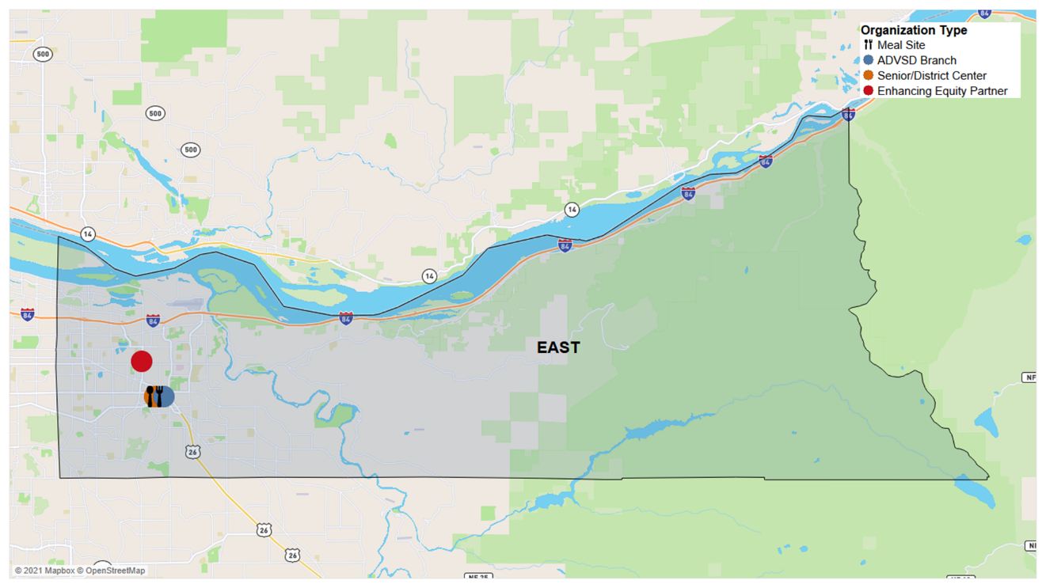
Figure 1. East Service District Contracted Providers
This map marks the locations of ADVSD branch offices, dining sites, district centers, and Enhancing Equity locations that offer access to services, programs, and provide meals to older adults.
The East service district begins at SE 162nd Avenue and stretches to Bonneville at the eastern border of Multnomah County. This district is the largest in area and second largest in population. This district is home to the ADVSD East Branch Office, one Enhancing Equity Partner, El Programa Hispano Católico and one District Center Partner, YWCA of Greater Portland, all of which are in Gresham. The Ambleside Center Meals on Wheels dining site, the only dining site in the district, and the YWCA of Greater Portland are both co-located with the ADVSD East Branch Office in the Multnomah County East Building. Gresham Senior Center is also in this district.
There is one dining site offering meals to older adults. For information on specific services in this district please call the Aging and Disability Resource Connection at (503) 988-3646.
The population of 60+ adults in the East service district is 33,281. Pacific Islanders make up 0.6% of the service district with a higher number of Pacific Islander residents (210) than any other service district. There are 313 (0.9%) Middle Eastern residents living in the district.
Takeaways
Highest
Number of Middle Eastern older adults of all districts
30%
Of older adults in the district identify as having a disability
One
Dining site location in the district
Lowest
Service provider to population ratio out of all districts
A relatively small proportion of the population in this district is linguistically isolated (3.2%). 301 households speak Spanish as their primary language with Russian-speaking households being the second highest (181). The district also has one of the highest number of multigenerational households (1,714).
About 19.3% of the population in the East district has an income that is at or below 185% FPL, a smaller proportion compared to the overall County (22.3%).
10,263 or 30.8% of the 60+ population in this district reports living with a disability. The proportion of those 18-59 living with a disability is 33.7%.
Table 1 – East Service District and County Populations
Characteristic | County Population Estimate | County  % of 60+ Population | East Dist. Population Estimate | East Dist.  % of 60+ Population
Total | 151,827 | 100% | 33,281 | 100%
Total People of Color | 31,185 | 20% | 5,436 | 16.33%
African | 973 | 0.64% | 154 | 0.46%
American Indian or Alaska Native | 2,419 | 1.59% | 506 | 1.52%
Asian | 10,615 | 6.99% | 1,570 | 4.72%
Black or African American | 7,683 | 5.06% | 776 | 2.33%
Native Hawaiian or Pacific Islander | 732 | 0.48% | 210 | 0.63%
Latino, Latinx or Hispanic | 4,978 | 3.28% | 1,102 | 3.31%
Middle Eastern | 966 | 0.63% | 313 | 0.94%
Slavic | 5,011 | 3.30% | 910 | 2.73%
White | 132,026 | 86.96% | 27,500 | 82.63%

Mid County Service District Profile
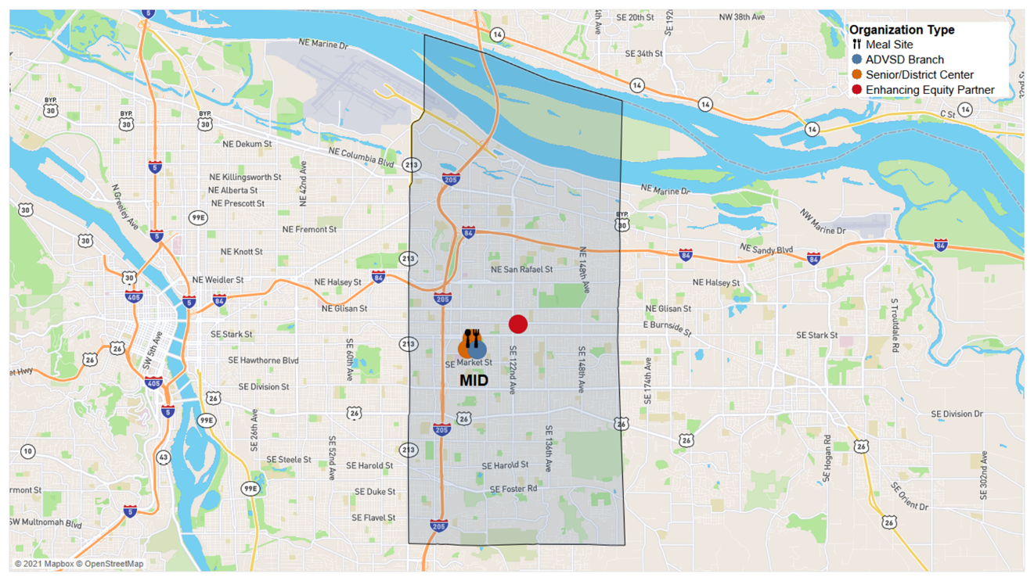
Figure 2. Mid County Service District Contracted Providers
This map marks the locations of ADVSD branch offices, dining sites, district centers, and Enhancing Equity locations that offer access to services, programs, and provide meals to older adults.
The Mid County service district begins at SE 82nd Avenue and extends out to SE 162nd Avenue. All the contracted service providers are located within the center of the district. There are no contracted service providers located north of where I-84 meets I-205 or south of Highway 26.
The ADVSD Mid County Branch Office is located near the East Portland Community Center and the Immigrant and Refugee Community Organization (IRCO). Both locations serve as district senior centers. The Cherry Blossom Center shares a building with the East Portland Community Center and is also a dining site.
There is one dining site offering meals to older adults in the district and it offers culturally specific meals through an Enhancing Equity Partner contract. For information on specific services in this district please call the Aging and Disability Resource Connection at (503) 988-3646.
The 31,823 people that are 60+ live in the Mid County (Mid) service district. Asian-identifying people comprise 13.1% of the Mid District population. This is a significantly higher proportion than within the County (Table 2). The proportion of people of color is also greater than the County by almost 10%.
Takeaways
4,163 Asian residents
District with the largest Asian population
(30.3% of residents are people of color
District with the highest population size and proportion of people of color
2,948 linguistically isolated households
District with the largest population of households that speak a primary language
30.1% of residents
District with the highest percent of residents living at or below 185% FPL
Highest proportion of people with a disability
This service district has the greatest proportion of households that are linguistically isolated (9.3%) compared to the County (4.2%) and other service districts. Vietnamese is the most widely spoken language among linguistically isolated people in this district (1,035), along with Chinese dialects (378) and Russian- with 356 households only speaking Russian.
30.1% of the 60+ population in the Mid district live at or below 185% FPL, the greatest proportion of all service districts. Both the 18-59 with a disability and 60+ with a disability have populations that are nearly 7% greater than any other district.
Table 2 – Mid County Service District and County Populations
Characteristic | County Population Estimate | County  % of 60+ Population | Mid Dist. Population Estimate | Mid Dist.  % of 60+ Population
Total | 151,827 | 100% | 31,823 | 100%
Total People of Color | 31,185 | 20% | 9,640 | 30.29%
African | 973 | 0.64% | 268 | 0.84%
American Indian or Alaska Native | 2,419 | 1.59% | 587 | 1.84%
Asian | 10,615 | 6.99% | 4,163 | 13.08%
Black or African American | 7,683 | 5.06% | 1,633 | 5.13%
Native Hawaiian or Pacific Islander | 732 | 0.48% | 180 | 0.57%
Latino, Latinx or Hispanic | 4,978 | 3.28% | 1,535 | 4.82%
Middle Eastern | 966 | 0.63% | 202 | 0.63%
Slavic | 5,011 | 3.30% | 1,685 | 5.29%
White | 132,026 | 86.96% | 25,918 | 81.44%

North/Northeast Service District Profile
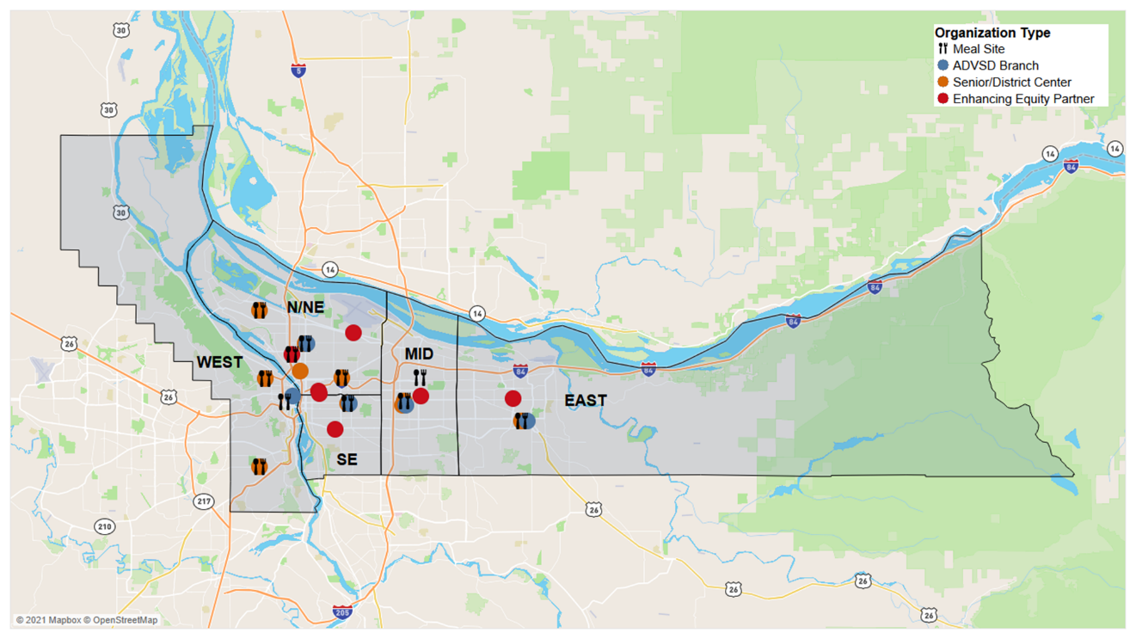
Figure 3. North/Northeast Service District Contracted Providers
This map marks the locations of ADVSD branch offices, dining sites, district centers, and Enhancing Equity locations that offer access to services, programs, and provide meals to older adults.
The North/Northeast (N/NE) service district is the second largest in area. The eastern boundary follows along the Willamette River with the southern boundary ending a few blocks past I-84. This service district is home to seven contracted service providers, the highest of all districts. Many service providers (three Enhancing Equity Partners, one consortium District Center, and the ADVSD N/NE Branch) are clustered near the southeastern corner which is closer to central Portland.
There are four dining sites offering meals to older adults in the district, one of which is an Enhancing Equity Partner site at Q Center. The ADVSD N/NE Branch, Q Center, Community for Positive Aging, and Charles Jordan Community Center offer service and dining sites. For information on specific services please call the Aging and Disability Resource Connection at (503) 988-3646.
The North/Northeast (N/NE) service district is the location of several historically Black and African American neighborhoods. Black and African American community members were first limited to these neighborhoods due racist housing policies then subsequently forced out decades later due to racist planning. This took place in the form of unjust and inequitable revitalization efforts that lead to the displacement and gentrification of the community. Black and African American residents make up 12.6% of the district.
Takeaways
4,041 Black/African American residents
District with largest Black/African American population
1/2
of Multnomah County’s Black/African American residents live in the NE service district
314 African residents
District with largest African population
Highest amount
Of contracted providers out of all districts
A smaller number of the population lives in a linguistically isolated household, speaking either Spanish only, Vietnamese only, or Chinese only.
This service district has one of the lowest numbers of residents living in group quarters while also having higher numbers of residents who live in non-family households or living alone. There are 6,566 (20.4%) individuals living at or below 185% FPL in the N/NE service district.
Table 3 – N/NE Service District and County Populations
Characteristic | County Population Estimate | County  % of 60+ Population | N/NE Dist. Population Estimate | N/NE Dist.  % of 60+ Population
Total | 151,827 | 100% | 32,193 | 100%
Total People of Color | 31,185 | 20% | 7,728 | 24.01%
African | 973 | 0.64% | 314 | 0.98%
American Indian or Alaska Native | 2,419 | 1.59% | 428 | 1.33%
Asian | 10,615 | 6.99% | 1,719 | 5.34%
Black or African American | 7,683 | 5.06% | 4,041 | 12.55%
Native Hawaiian or Pacific Islander | 732 | 0.48% | 169 | 0.52%
Latino, Latinx or Hispanic | 4,978 | 3.28% | 1,034 | 3.21%
Middle Eastern | 966 | 0.63% | 86 | 0.27%
Slavic | 5,011 | 3.30% | 511 | 1.59%
White | 132,026 | 86.96% | 26,656 | 82.80%

Southeast District Profile
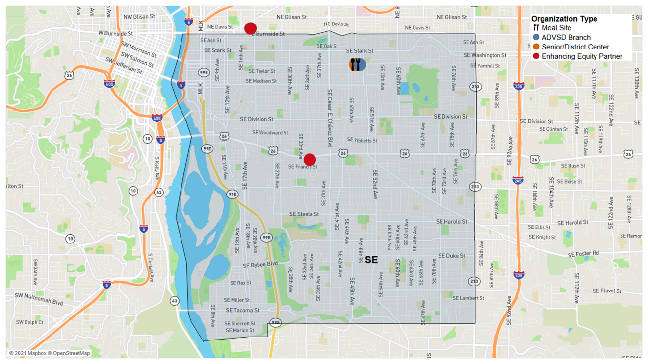
Figure 4. Southeast Service District Contracted Partners
This map marks the locations of ADVSD branch offices, dining sites, district centers, and Enhancing Equity locations that offer access to services, programs, and provide meals to older adults.
The Southeast (SE) Service District starts at the Willamette and extends east to NE 82nd Avenue. Its northern boundary starts at East Burnside Street. and continues south, ending near SE Tacoma Street and the Sellwood-Moreland neighborhood. The ADVSD SE Branch location shares a building with Impact NW, a contracted provider that operates a collocated District Center. Asian Health and Service Center (AHSC), an Enhancing Equity Partner, is the southernmost provider in this district located on SE Powell Boulevard.
There are two dining sites offering meals to older adults in the district, one of which is an Enhancing Equity Partner site at AHSC. The ADVSD SE Branch, AHSC and Impact NW offer services and dining sites. For information on specific services in this district please call the Aging and Disability Resource Connection at (503) 988-3646.
The SE service district has a total of 22,790 people 60+, the smallest population size of all the districts. 23.1% of this population lives at or below 185% FPL which is slightly greater than the County average.
Takeaways
1 in 5
Residents live at or below 185% FPL
2.2% of 60+ Native American residents
District with the largest proportion of American Indian/Alaskan Native populations
1,001 (4.4%) households
Large population of households that speak a primary language other than English
31.2% of 60+ residents
live alone, a proportion higher than any other district
The SE district has the largest proportion of Native American/Alaska Native residents (2.2%) despite not having the largest number of Native residents. The estimated number of the 60+ people of color is the smallest among all districts (Table 4).
Out of the total households that speak a primary language other than English, nearly 60% of those households speak Vietnamese or Chinese (Mandarin or Cantonese).

30% of 60+ residents in the SE service district live alone, a higher percentage than any other district. 33.9% of 18-59 residents and 29.1% of 60+ residents in the SE district residents identify as having a disability.
Table 4 – SE Service District and County Populations
Characteristic | County Population Estimate | County  % of 60+ Population | SE Dist. Population Estimate | SE Dist.  % of 60+ Population
Total | 151,827 | 100% | 22,790 | 100%
Total People of Color | 31,185 | 20% | 3,948 | 17.32%
African | 973 | 0.64% | 1 | 0.00%
American Indian or Alaska Native | 2,419 | 1.59% | 506 | 2.22%
Asian | 10,615 | 6.99% | 1,942 | 8.52%
Black or African American | 7,683 | 5.06% | 437 | 1.92%
Native Hawaiian or Pacific Islander | 732 | 0.48% | 132 | 0.58%
Latino, Latinx or Hispanic | 4,978 | 3.28% | 565 | 2.48%
Middle Eastern | 966 | 0.63% | 54 | 0.24%
Slavic | 5,011 | 3.30% | 838 | 2.60%
White | 132,026 | 86.96% | 20,128 | 88.32%

West Service District Profile
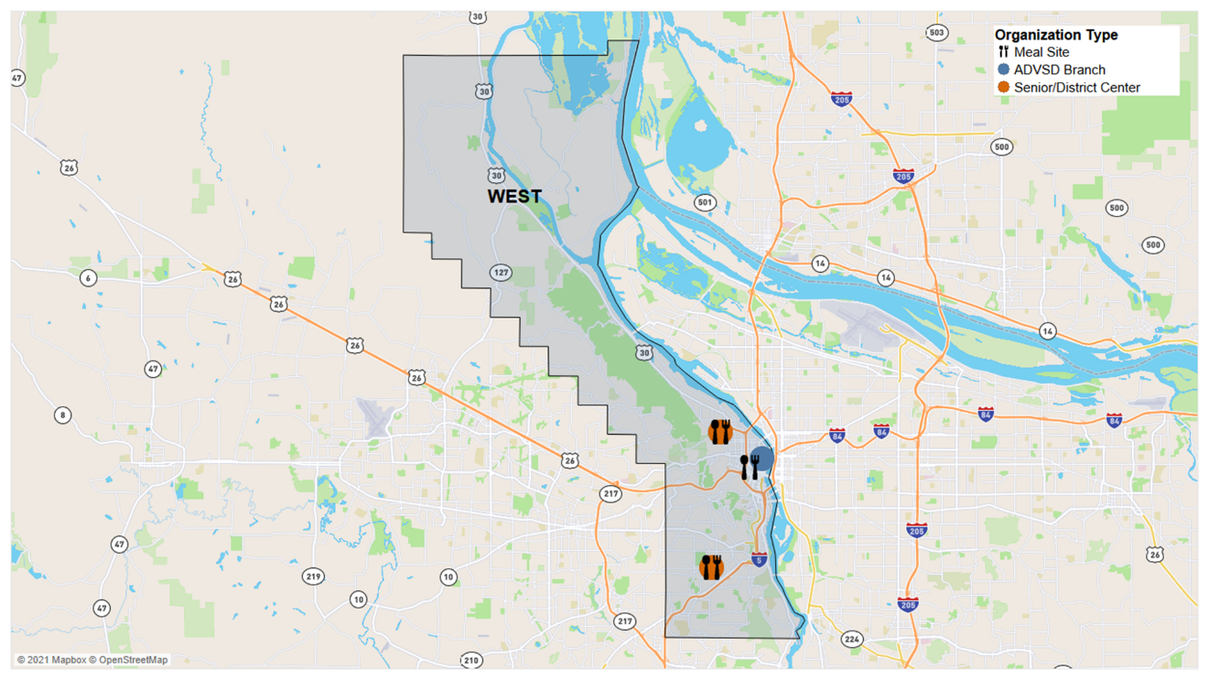
Figure 5. West Service District Contracted Providers
This map marks the locations of ADVSD branch offices, dining sites, district centers, and Enhancing Equity locations that offer access to services, programs, and provide meals to older adults.
The West service district includes the entire portion of the City of Portland west of the Willamette. The district ends south of I-5 near SW Boones Ferry Road. The ADVSD West Branch office is in Downtown Portland in the Five Oak Building. There are four contracted service providers located in the West service district. Friendly House serves as a District Center and a Meals on Wheels dining site, in a consortium approach with Neighborhood House serving Multnomah Village and Hillsdale. SAGE Metro Portland is collocated with Friendly House in Northwest Portland.
There are three dining sites offering meals to older adults in the district, none of which are offered by Enhancing Equity Partners. For information on specific services in this district please call the Aging and Disability Resource Connection at (503) 988-3646.
The total population of the West service district is 33,701 which is the highest population of any district. People of color make up the smallest percentage of the district population out of any other district (13.2%). Simultaneously, the district also has the highest proportion of White residents out of all districts (Table 5).
Takeaways
13.2%
District with lowest percentage of residents who are people of color
1/3
of Middle Eastern Multnomah County residents live in the West service district
18%
District with the lowest percentage of households living at or below 185% FPL
20.3% and 25.8%
Lowest percentage of 18-59 and 60+ residents with a disability
The majority of households speak English as their primary language. Out of the 724 households that are linguistically isolated, 128 speak only Spanish and 119 speak only Mandarin Chinese. There is also a relatively small number of families living in multigenerational households (706).
The 18-59 and the 60+ populations that identify as having a disability are significantly lower in the West service district than within Multnomah County. Only 6,848 (20.3%) of those between 18-59 with a disability and 8,706 (25.8%) of those 60+ with a disability live within this district. This district also has the lowest proportion of its residents living at or below 185% FPL out of all districts (18%).
Table 5 – West Service District and County Populations
Characteristic | County Population Estimate | County  % of 60+ Population | West Dist. Population Estimate | West Dist.  % of 60+ Population
Total | 151,827 | 100% | 33,701 | 100%
Total People of Color | 31,185 | 20% | 4,433 | 13.15%
African | 973 | 0.64% | 236 | 0.70%
American Indian or Alaska Native | 2,419 | 1.59% | 392 | 1.16%
Asian | 10,615 | 6.99% | 1,221 | 3.62%
Black or African American | 7,683 | 5.06% | 796 | 2.36%
Native Hawaiian or Pacific Islander | 732 | 0.48% | 41 | 0.12%
Latino, Latinx or Hispanic | 4,978 | 3.28% | 743 | 2.20%
Middle Eastern | 966 | 0.63% | 311 | 0.92%
Slavic | 5,011 | 3.30% | 1,067 | 3.17%
White | 132,026 | 86.96% | 31,824 | 94.43%

B-2 Prioritized Populations
The Multnomah County Aging, Disability and Veterans Services Division (ADVSD) recognizes that older adults and people with disabilities experience discrimination and marginalization based on the perception of age and ability. This discrimination and marginalization are compounded when race, ethnicity, national origin, housing status, gender, gender identity, gender expression, and sexual orientation are considered. To address historic and systemic disparities experienced by people based on their identities, ADVSD employs the Leading with Race framework as outlined in the Multnomah County Workforce Equity Strategic Plan. Leading with race allows ADVSD to recognize that racial inequities are foundational to and pervasive in the culture of the United States and all levels of government.
“Focusing on racial equity provides the opportunity to introduce a framework, tools, and resources that can also be applied to other areas of marginalization. The prioritization is not based on the intent to create a ranking of oppressions (that is, belief that racism is “worse” than other forms of oppression) but rather to create strategies that will impact all communities.”
To begin to address the ways that race plays a role in ADVSD systems and the compounded marginalization experienced by older adults who are people of color ADVSD funds five district centers and nine Enhancing Equity partners to provide access to Older Americans Act services and programs. These agencies use culturally and community responsive, and specific approaches to begin to address marginalization and the impact on people we serve.
One of every five people 60+ in Multnomah County is a person of color (POC). People of Color are disproportionately represented among those 60+ living in poverty—particularly Black and Latino older adults. Elders who are people of color are at greater risk for race-based marginalization, including barriers to services, housing instability, health disparities, and diminished food security. ADVSD currently collaborates and contracts with nine culturally specific and culturally responsive organizations to support their unique missions and to provide Older Americans Act programs and other services to Black, Native American, Asian, Pacific Islander, Latinx, Hispanic, immigrant, refugee, Lesbian, Gay, Bisexual, and Transgender elders, and older adults. These organizations are known to and respected by the communities they serve. Many serve as hubs for whole families and provide services to older adults beyond what ADVSD funds.
Older adults and people with disabilities experiencing loneliness, anxiety and depression, substance use disorder, hoarding behaviors, or mental health or behavioral health diagnoses continue to be a priority population to ADVSD. COVID-19 and the related health and safety recommendations were a genesis or exacerbated many of these issues faced by older adults and people with disabilities. ADVSD will provide referrals to the Older Adult Behavioral Health Initiative (OABHI) team for complex case consultation through the ADRC, LTSS offices, and the network of providers. OABHI does considerable outreach to health providers, community partners, and older adults to increase awareness of issues impacting older adults related to mental health and addiction, cognitive decline, hoarding behavior, and stigma related to these health challenges.
In 2017, ADVSD conducted a system-wide contracting request for qualified proposals process. This process resulted in ADVSD shifting and increased funding to culturally and community-specific organizations. We believe this has supported increased capacity for those organizations. To equitably serve older adults who are people of color ADVSD will need to fund and resource services differently. ADVSD will again examine the funding allocation during this plan period. We will conduct further analysis to identify gaps in our service system, outreach approaches, and reimbursement models. We have included measurable objectives and key tasks to address disparities. ADVSD will conduct community-specific listening sessions in advance of the upcoming system-wide contracting request for proposals process.
Lastly, ADVSD will continue to ensure diverse representation in marketing materials, enact a division-wide translation and interpretation practice, continue to support equitable access approaches and standards for meetings, including alternatives to relying on technology for access, and utilizing multiple methods of engagement to reduce barriers. ADVSD remains committed to making inroads with isolated and disenfranchised people, such as deaf-blind people, residents without citizenship status who are isolated by fear of retribution, people who are isolated by language, and people who have been disenfranchised by institutions such as Native American veterans, LGBTQ+ veterans, and people aging with HIV. The Aging, Disability and Veterans Services Division will continue to utilize the Equity and Empowerment Lens tools in planning, decision-making, and service delivery.

B-3 AAA Services and Administration
See also Attachment C that further describes services provided to OAA/OPI consumers.
Advocacy: Focuses on monitoring, evaluating, and, where appropriate, commenting on all policies, programs, hearings, levies, and community actions that affect older adults. Activities include representing the interests of older persons; consulting with and supporting the Oregon Association of Area Agencies on Aging and Disabilities (O4AD), the statewide AAA advocacy organization; and coordinating efforts to promote new or expanded benefits and opportunities for older adults.
Adult Day Care/Adult Day Health: Personal care for dependent older adults in a supervised, protective, and congregate setting during some portion of a day. Services offered in conjunction with adult day care/adult day health typically include social and recreational activities, training, counseling; and services such as rehabilitation, medications assistance and home health aide services for adult day health.
Caregiver Access Assistance: A service that assists caregivers in obtaining access to available services and resources in their communities. To the maximum extent possible, it ensures that the individuals receive the services needed by establishing adequate follow-up procedures.
Caregiver Cash and Counseling: Services provided or paid for through allowance, vouchers, or cash to participants so that they can obtain the supportive services they want.
Case Management: Case management provides access to an array of service options to assure appropriate levels of service and to maximize coordination in the service delivery system. Case management must include four general components: access, assessment, service implementation, and monitoring. Case Management for Elders is a comprehensive service provided to individuals age 60 and over who are experiencing complex or multiple problems that affect the individual’s ability to remain independent. Additionally, Case Management for Family Caregivers is a comprehensive service provided to family caregivers who are caring for people age 60 and over, or for individuals who are grandparents 55 years of age or older who is a relative caregiver of a child. The definition of family caregiver has been broadened to include friends, neighbors and domestic partners who care for someone age 60 or older.
Cash and Counseling: Services provided or paid for through allowance, vouchers, or cash to participants so that they can obtain the supportive services they need.
Chore: A service for eligible OPI consumers that provides assistance such as heavy housework, yard work, sidewalk maintenance, and bed bug treatment preparation. (Administration on Aging, Title III/VII Reporting Requirements Appendix – www.aoa.gov) Note: Chore services are provided on an intermittent basis.
Chronic Disease Management, Prevention, and Education: Programs such as the evidence-based Living Well with Chronic Conditions (Stanford’s Chronic Disease Self-Management program – CDSMP), that prevent and self-management of the effects of chronic disease, (http://patienteducation.stanford.edu/programs/)
The CDSMP suite of programs that our community based partners plan to offer as part of their Evidence Based Health Promotion contracts includes:
- Living Well with Chronic Conditions.
- Tomando Control de su Salud will be provided to Hispanic or Latino elders under ADVSD Enhancing Equity contracts.
- Positive Self-Management Program for HIV (PSMP). The Positive Self-Management Program is a workshop for people with HIV given two and a half hours, once a week, for six weeks, in community settings. Workshops are facilitated by two trained leaders, one or both of whom are non-health professionals with HIV.
Newer variations to the CDSMP suite that are available for our contracted Evidence Based Health Promotion partners include:
- Chronic Pain Self-Management Program.
- Better Choices, Better Health is the online/asynchronous interactive version of the Chronic Disease Self-Management Program.
- Cancer: Thriving & Surviving.
- Diabetes Self-Management Program.
Congregate Meal: A meal provided to a qualified individual in a congregate or group setting that meets all the requirements of the Older Americans Act, state and local laws.
- Five meal sites provide culturally specific cuisine to Asian, Latino, Latinx or Hispanic, Slavic, and Native American elders, four of which are funded under ADVSD Enhancing Equity contracts.
Elder Abuse Awareness: Public education and outreach for individuals, including caregivers, professionals, and paraprofessionals on the identification, prevention, and treatment of elder abuse, neglect, and exploitation of older individuals, with particular focus on prevention and enhancement of self-determination and autonomy.
Evidence Based Health Promotion: Evidence based health promotion (EBHP) programs are those that are founded on the best available research and are recommended based on a systematic review of the published, peer reviewed research. Evidence based health promotion programs are a good way to engage older adults, improve health outcomes and address health inequities in our community through partnerships with local community -based organizations (CBO) including our Enhancing Equity partners. EBHP activities, offered in partnership with our contracted CBOs, include, but are not limited to Walk with Ease, Tai Chi for Better Balance, Diabetes Prevention Program, and the Arthritis Exercise Program.
Financial Assistance: Limited financial assistance for people with low income, aiding them in maintaining their health and/or housing. Services may include prescription, medical, dental, vision care or other health care needs not covered under other programs; and the cost of utilities such as heat, electricity, water/sewer service or basic telephone service, and rental or moving assistance to support a stable housing plan.
Guardianship/Conservatorship: Performing legal and financial decision making, care planning and transactions on behalf of a vulnerable adult when legal authority and intervention is required for health and safety (e.g., essential part of the protective services continuum), including consultations and establishing a guardianship or conservatorship for protection when no less restrictive alternatives are available.
Homemaker: Assistance such as preparing meals, shopping for personal items, managing money, using the telephone, or doing light housework.
Home-Delivered Meals: A meal provided to a qualified individual in their residence that meets all the requirements of the Older Americans Act and state and local laws. (Note: The spouse of the older person, regardless of age or condition, may receive a home-delivered meal if, according to criteria determined by the area agency, receipt of the meal is in the best interest of the homebound older person.)
Information & Assistance: Provides individuals with a) information about services available in the community; b) links individuals to services and opportunities that are available in the community; and c) to the maximum extent practicable, establishes adequate follow-up procedures.
Information for Caregivers: A service for caregivers that provides the public and individuals with information about resources and services available to individuals in their communities. These activities are directed to large audiences of current or potential caregivers and include disseminating publications, conducting media campaigns, etc.
Interpretation and Translation: Provides information and services in people’s preferred language. Provides access and accommodation to people with disabilities.
Legal Assistance: Legal advice or representation provided by an attorney to older individuals with economic or social needs, including counseling or other appropriate assistance by a paralegal or law student acting under the direct supervision of an attorney, or counseling or representation by a nonlawyer when permitted by law. Priority legal assistance issues include income, health care, long-term care, nutrition, housing, utilities, protective services, defense of guardianship, abuse, neglect, and age discrimination. Legal services may also include assistance to older individuals who provide unpaid care to an adult child with disabilities, and counsel to assist with permanency planning for the child. Assistance with will preparation is not a priority service except when a will is part of a strategy to address an OAA prioritized legal issue. Support in accessing legal resources outside this scope is provided by the ADRC Helpline.
Nutrition Education: Provides information and instruction as it relates to nutrition or diet sensitive illness to participants and/or caregivers in a group or individual setting overseen by a dietician or individual of comparable expertise.
Options Counseling: Counseling that supports informed long-term care decision making through assistance provided at six Enhancing Equity sites and five district centers to individuals and families to support their strengths, needs, preferences and unique situations and translates this knowledge into possible support strategies, plans and tactics based on the choices available in the community. Culturally specific, culturally responsive, and community specific Options Counseling is available to Asian, African American, Native American. Lesbian, Gay, Bisexual, Transgender (LGBT), Immigrant and Refugee, and Hispanic or Latino elders at Enhancing Equity sites.
Personal Care: In-home services to maintain, strengthen, or restore an individual’s functioning in their own home when an individual is dependent in one or more Activities of Daily Living (ADL), or when an individual requires assistance for ADL needs. Assistance can be provided either by a contracted agency or Homecare Worker paid in accordance with the collectively bargained rate.
Physical Activity and Falls Prevention: Programs for older adults that provide physical fitness, group exercise, and dance-movement therapy, including programs for multigenerational participation provided through local educational institutions or community-based organizations. Programs that include a focus on strength, balance, and flexibility exercise to promote physical activity and/or prevent falls; that are based on best practices; and that have been shown to be safe and effective with older populations are highly recommended. Programming may also include classes that are part of the Evidence Based Health Promotion contracts from the suite of program options. Programs are offered as part of activities with our district center partners and our Enhancing Equity partners along with those agencies that have Evidence Based Health Promotion contracts.
Public Outreach and Education: Services or activities that provide information to groups of current or potential consumers and/or to aging network or other community partners regarding available services for older adults. Examples include community senior fairs, publications, conferences, mass media campaigns, presentations at local district centers sharing information on OAA services, etc.
Recreation: Activities that promote socialization, such as sports, performing arts, games, and crafts, either as a spectator or as a participant.
- Asian, Native American, LGBT, Immigrant and Refugee, and Hispanic or Latino elders will be provided community and culturally specific and other recreation activities under ADVSD Enhancing Equity contracts.
Senior Center Assistance: Financial support for use in the general operation costs (i.e., administrative expense) of a district center.
Transportation: Assist older adult consumers and those acting on behalf of older adults with transportation scheduling and coordination. This includes bus passes and tickets, cab rides, and door-to-door rides through contracts with local transportation providers to access services so older adults are independent in the community for as long as they choose. This service includes activities such as:
- Screening for eligibility for transportation services,
- Assessing transportation needs,
- Verification of eligibility for transportation,
- Assisting in the completion of forms and applications for transportation,
- Advocacy on behalf of older adults requesting transportation services,
- Scheduling and coordinating rides with transportation providers,
- Distribution of bus passes and tickets.
People needing transportation will be prioritized according to the following criteria:
- Medical trips (doctors, therapists, hospital, or health-related treatment) for non-Medicaid consumers,
- Congregate nutrition,
- Multiple supportive services (e.g., multicultural centers, district centers, etc.).
Volunteer Recruitment: Identifying, training, and assigning individuals to a volunteer position.
Volunteer Services: Uncompensated supportive services to AAAs, nutrition sites, and other contracted partners. Examples of volunteer activities include meal site management, board and advisory council positions, home-delivered meal deliveries, office work, support group facilitation, case management assistance etc.

B-4 Non-AAA Services, Service Gaps and Partnerships to Ensure Availability of Services Not Provided by the AAA
The services listed below complement those provided by the Multnomah County Aging, Disability and Veterans Services Division (ADVSD) and information about them is available at the Aging and Disability Resource Connection (ADRC) website, www.adrcoforegon.org, or by calling the ADRC at (503) 988-3646. Providers noted can also be contacted directly.
Service | Contact
Alzheimer’s Resources | Multnomah County Family Caregiver Support Program offers the STAR Caregiver Program which is a 6-week one-on-one evidence-based training for family caregivers caring for a person with Alzheimer’s or another dementia. This program is offered in English, Spanish, Russian, and Ukrainian. The Family Caregiver Support Program collaborates with the Alzheimer’s Association on specific community outreach events.
Disability Services Programs | ADVSD partners with Independent Living Resources (ILR) on grant-funded projects. The ADRC, district centers, and Enhancing Equity partners refer people with disabilities to ILR and other disability services providers as their needs dictate.
Employment Services | ADVSD is a host site for the Title V Senior Community Service Employment Program, providing limited part-time employment to eligible individuals. ADVSD also is a host site for Portland Community College Occupational Skills program, providing limited part-time employment experience and mentorship to eligible individuals. The ADRC refers consumers to community Work Source providers and other employment services in Multnomah County.
Energy Assistance | Low-income energy assistance is provided by county community action agencies, including ADVSD contracted partners, such as El Programa Hispano Católico, Impact Northwest, Immigrant & Refugee Community Organization, and NAYA Family Center. The ADRC manager meets annually with community action agency staff to distribute energy assistance information to the aging and disability network.
Food Access & Emergency Food Pantries | The ADRC, district centers, and Enhancing Equity partners provide referrals to food pantries located throughout the county to provide emergency food boxes to those in need. Several district centers host senior emergency food box programs. Store to Door delivers and unloads groceries and prescriptions to homebound older adults and people with physical disabilities to parts of Multnomah and Washington counties. Farmers markets offer neighborhood-based access to fresh produce. SNAP benefits can be used at some farmers markets and some markets offer matching funds through the Double-up Food Bucks program.
Housing | The ADRC refers consumers to housing services based on their identified need (e.g., low-income residences, independent senior living, assisted living, etc.). Referrals are made to Home Forward, NW Pilot Project, and several other housing providers.
Information & Assistance | Through an agreement with 211info and the City/County Information and Referral hotline, ADVSD ensures that older adults and adults with disabilities are referred to the ADRC for information and assistance.
Mental Health & Addiction Services | ADRC refers consumers to mental health services based on their presenting issue (e.g., depression, anxiety, bereavement, etc.). Treatment options include outpatient and inpatient counseling, group therapy, home-based mental health, support groups, and peer counseling. The ADRC and the County Mental Health Crisis Call Center cross-train and share cross-referral processes. The Older Adult Behavioral Health Initiative offers cross-system program support, community resources and complex case coordination across mental health, aging, and addictions program areas.
Transportation Resources & Services | Non-Emergent Medical Transportation (NEMT) and its more limited companion service, Non-Medical Community Transportation services for long-term care recipients, are key benefits for members of the Oregon Health Plan (OHP). NEMT assists older adults as well as adults with disabilities to go to and from routine or scheduled OHP-covered medical services. Community transportation assists older adults and adults with disabilities who qualify for long-term services and supports to go grocery shopping, conduct personal business, and participate in community activities that are part of their person-centered long-term care service plan authorized by their case manager. Ride Connection provides older adults and people with disabilities with information and access to all transportation options in the region, travel training, door-to-door transportation for any reason, and other mobility enhancing services.
Older adults & people with disabilities that are experiencing houselessness | Older adults and people with disabilities experiencing houselessness are referred for service screening with the Coordinated Access system. 211info screens people shelter systems such as family, domestic violence, and some women’s shelters. Otherwise, those unhoused need to themselves call each shelter serving adults for bed availability. NW Pilot Project uses a screening tool to identify resources, e.g., temporary, permanent housing, as well as other available resources.

Section C: Focus Areas, Goals and Objectives

C-1: Information and Referral Services and Aging and Disability Resource Connection

Profile
The Aging and Disability Resource Connection (ADRC) is a specialized information and assistance hub for older adults, people with disabilities, families, caregivers, and organizations. The ADRC resource is often the front door for many community members to learn about services and resources for older adults, people with disabilities and family caregivers. The Multnomah County ADRC Helpline can be accessed by telephone, (503) 988-3646 or (855) 673-2372, TRS, email to adrc@multco.us, and at www.adrcoforegon.org. The ADRC is a 24-hour a day resource and is operated by ADVSD staff and contracted partners. The ADRC provides language access by employing bi-lingual information and assistance specialists and through phone-based interpreters. Information and assistance services are also provided through the contracted network of district centers and Enhancing Equity partners to provide this specialized service in the community and with culturally specific and responsive approaches. The ADRC and our contracted information and assistance (I&A) partners are key to ADVSD’s No Wrong Door access to long-term services and support for older adults, people with disabilities, veterans, and their families. This includes pre-screening and referrals for Family Caregiver Support Program, Options Counseling, Oregon Project Independence, Veterans benefits, and the suite of Older Americans Act funded services.
The Multnomah County ADRC receives on average 2,500 inquiries each month from 2,000 callers. Promotion and outreach for the ADRC and I&A services is shared among regional AAAs, aging network providers, jurisdictional partners, health care systems, and County and departmental communications work groups. Outreach includes promotional materials in the 11 most commonly spoken languages in the county, social media outreach, community events, and extensive community-based or word-of-mouth referrals among social services and health care providers.
The Multnomah County ADRC is committed to providing quality information and referral related services it provides as well as supporting contracted partners. The ADRC team is responsible for maintaining approximately 750 community resource records in the statewide ADRC database. The staff work with community partners annually to ensure the accuracy of the information provided to ADRC callers. In partnership with the Metro ADRC consortium that includes Washington, Clackamas, and Columbia counties, a satisfaction survey is conducted by the Portland State University Institute on Aging. Internally, ADVSD analyzes metrics related to the quantity and length of calls, demographics of the callers, and needs expressed from information collected in GetCare to improve the service. Multnomah County ensures the sustainability of the ADRC by funding it with 85% Medicaid funds and 15% County General Fund. The ADRC is one of the primary entry points to the aging and people with disabilities service system in Multnomah County, providing easy access to Long Term Services and Supports to those new to the service system, as well as current participants. Additionally, Multnomah County draws Medicaid funding for the Care Transitions Intervention program. The Care Transitions Intervention has been modified to include options counseling and connections to the ADRC as needed.

Need Statement
The topic of information, described as, “Finding information about needed services, resources, or the advice of an attorney” ranked eight out of nine in our recent community survey. However, the topic of information elicited strong comments from community members and surfacing needs such as, a desire for clearer pathways to information, a centralized list of resources, and assistance with navigating resource systems. The survey also showed that the telephone remains the primary communication tool for older adults. 90% of survey respondents over 65 indicated that they use the telephone to communicate with friends, family, or neighbors and 97% indicated they use smartphones, basic cell phones, and/or home phones for communication or finding information.
For all their wonders, devices such as cell phones, tablets, and computers are not great equalizers for older adult information seekers in tech-savvy Multnomah County. As information pathways grow faster and more elegant to some, they remain complex and impersonal for others. A recent survey by The Pew Research Center showed that nine out of 10 people said that the internet became an essential or important tool during the COVID-19 pandemic. Despite 84.9% of households in Multnomah County having access to internet or broadband, it is utilized unevenly by older adults particularly for those with low-incomes or who live in a linguistically isolated household or low digital literacy. Research related to the Multnomah County exploration of municipal broadband stated that for households earning under $30,000 closer to 78% do not have internet in their home. People who are over age 65 the number of households with internet drops to 72%. As COVID-19 has pushed much of our lives and community connection online, including schooling, work and health care, a gap remains for older adults and people with disabilities. The feedback and stories shared by elders at our community listening sessions on this plan shows that much work is needed to address this gap and to support the needs and preferences about how information is shared and what is required to access it. Supporting the independence and self-determination of older adults and people with disabilities, especially for communities of color, is core to the mission of ADVSD. To continue to meet this aspect of our mission information access and digital literacy will be a focus area in this plan.

Information and Assistance (I&A) and Aging and Disability Resource Connection (ADRC) Goals and Objectives
- Older adults and people with disabilities and their caregivers recognize and utilize the ADRC as a tool for accessing information, resources, and services.
 | Key Tasks | Lead Position and Entity | Time Frame for Action  (Month/year) |  | Accomplishment or Update
 | Key Tasks | Lead Position and Entity | Start Date | End Date | Accomplishment or Update
Measurable Objective 1-1  Increase utilization of the ADRC to decrease isolation and barriers to access experienced by physically, socially, culturally, or linguistically isolated older adults. | - Build online training tools increase access to ADRC and partner I&A resources | Community Services manager, Community Resource program manager | July 2022 | June 2023 | All partner agencies encourage to sign up for AIRS network training to receive ongoing I&A training. Encourage ADRC staff and partners to attend monthly training sessions put on by Community Services and Supports Unit (CSSU)  Timeframe changed due to capacity related to ongoing COVID response work.
 | - Conduct community listening sessions to understand barriers to accessing information and assistance services in marginalized communities. | Community Services manager, Community Resource program manager, program & development specialist | July 2022 | June 2023 | Timeframe changed due to capacity related to ongoing COVID response work.
 | - Increase social media outreach and engagement among friends and family of older adults and people with disabilities. | Community Services manager, Community Resource program manager | July 2021 | June 2025 | SHIBA marketing on FB, mailed materials to over 500 agencies locally and statewide.  Conducted outreach at 30 in-person and virtual events, cooling kit outreach to 2850 individuals
 | - Develop marketing and outreach plans related to prioritized communities. | Community Services manager, Community Resource program manager | September 2021 | January 2023 | Developed outreach plan prioritizing Native Americans, ESL speakers, those of a limited income, African Americans, LGBTQ+, people with disabilities, and rural residents
 | - Continue to clarify and document role in emergency management and public health crisis response | Community Services manager, Community Resource program manager | June 2022 | June 2023 | March 2022, ADVSD began coordination related to upcoming health emergencies including conversations with contracted partners to provide cooling kits, marketing materials and fans.  Opened a contract in July 2022 for transportation coordination to cooling centers, cooling shelters, to natural supports, in addition to 24/7 resource line.  Monthly coordination call with 311, Library, 211, Bureau of Emergency Management at City of Portland, Multco emergency Management and Public Health - related to coordinated emergency events response and public communications .  ADVSD continues acting as a liaison between the Health Dept and ADVSD partners to relay COVID information.

 | Key Tasks | Lead Position and Entity | Time Frame for Action  (Month/year) |  | Accomplishment or Update
 | Key Tasks | Lead Position and Entity | Start Date | End Date | Accomplishment or Update
Measurable Objective 1-2  Community partners and entities with community connections to historically and systematically marginalized identities know about and use the ADRC and the I&A network. | - Review current information dissemination policy and develop goals to increase information access pathways and modes of communication. | ADVSD Leadership, Community Services management, planning & development specialist, ASAC & DSAC | September 2022 | June 2023 | Timeframe changed due to capacity related to ongoing COVID response work.
 | - Conduct community interviews to understand and document barriers to information pathways. | Community Services management, planning & development specialist | July 2022 | December 2022

- Older adults, people with disabilities, their families and caregivers are well connected to resources and services through the information, referral, and assistance network.
 | Key Tasks | Lead Position and Entity | Time Frame for Action  (Month/year) |  | Accomplishment or Update
 | Key Tasks | Lead Position and Entity | Start Date | End Date | Accomplishment or Update
Measurable Objective  Increase utilization of the ADRC to decrease isolation and barriers to access experienced by physically, culturally, or linguistically isolated older adults. | - Continue to expand information and assistance resources by supporting community and culturally specific organizations and community groups. | Community Services manager, Community Resource program manager | July 2021 | June 2025 | In January, ADRC staff updated all resource records in Get Care to reflect most update organization information with an emphasis on Culturally specific and community specific organizations.  Over the past years 9,980  more contacts through Culturally Specific contractors.
 | - Work with community and culturally specific providers to develop and implement community competency models for information and assistance. | Community Services manager, Community Resource program manager | January 2023 | December 2023
 | - Build relationships among current community-based health promotion networks, such as Community Health Workers. | Community Resource program manager, Older Adult Behavioral Health Initiative | July 2022 | June 2025 | ADRC training and Abuse Reporting to 50 CHW.
 | - Expand network of Gatekeeper partners through outreach and engagement. | Community Resource program manager | July 2022 | June 2025
 | - Develop an online Gatekeeper training module and digital outreach collateral. | Community Services manager, Community Resource program manager | January 2023 | June 2023 | Timeframe changed due to capacity related to ongoing COVID response work.
 | - Expand network of partners through outreach and engagement to Villages Communities | Community Resource program manager | January 2023 | June 2024 | Timeframe changed due to capacity related to ongoing COVID response work.
 | - Increase connection to and explore partnership opportunities with Community Information Exchanges | Community Services manager, Community Resource program manager | January 2022 | June 2025 | ADVSD Director and Planning and Development Specialist working with State and local partners on input and advocacy related to CIE.
 | - Increase connections to existing systems that support people with systems navigation. | Community Resource program manager, Older Adult Behavioral Health Initiative | September 2021 | June 2025 | Developed outreach plan prioritizing Native Americans, ESL speakers, those of a limited income, African Americans, LGBTQ+, people with disabilities, and rural residents

C-2: Nutrition Services

Profile
Eating ties us to our humanity. Whether it is a peanut butter and jelly sandwich eaten over the kitchen sink or a plate laden from a potluck table eaten from your lap, food helps us meet our basic needs for nourishment, connection, and pleasure. The purpose of the Older Americans Act (OAA) nutrition program is to reduce hunger and food insecurity and to support older adults’ good health and wellbeing by providing access to nutritious meals. It also serves to bring people out of isolation, to promote connection and socialization.
As people age, a nutritious diet is key to managing diet-sensitive health conditions. The benefits of a nutritious diet include increased mental acuity, resistance to illness and disease, higher energy levels, a more robust immune system, and faster recuperation from illness and medical treatments. Additional aspects of the OAA nutrition programs are to support the health and wellbeing of adults 60 and older and provide opportunities to be physically active and to prevent or delay the onset of disease.

COVID-19 Pandemic Nutrition Program Approach
The COVID-19 stay at home order immensely impacted older adults in Multnomah County—particularly those relying on congregate meal programs. On March 12, 2020, all in-person meals sites closed in response to the governor’s COVID-19 “Stay Home, Save Lives” order. Currently, all meals are home delivered.
The standard model of service for the OAA nutrition program shifted in a matter of days to exclusively a home-delivery model. Organizations swiftly implemented new safety measures to protect older adults and those preparing and delivering the meals. Stay home orders spotlighted how vulnerable we are to isolation and diminished food security. Despite challenges, ADVSD staff and partners moved to ensure the unique aspects of the OAA nutrition program continue by reaching elders with food and connection.
This increase in the demand for meals required providers to shift from daily deliveries to one to two deliveries a week. The network of meal providers continued culturally responsive approaches. For example, a community of older adults did not feel safe receiving meals cooked outside their home, so providers provided food baskets as an option to home-delivered meals.
Especially for older adults and community organizations serving them we anticipate significant challenges as COVID-19 health and safety measures evolve. ADVSD is committed to support the safety and well-being of older adults related to congregate meals and anticipate the need for programmatic flexibility.

Current Nutrition Program Services Approach
ADVSD contracts with several community agencies to provide congregate meals. The Meals on Wheels People (MOWP) has eleven congregate meal sites and four satellite sites in the county. ADVSD provides partial funding for five of these locations with Title III C funds. Meals on Wheels People sites offer two daily lunch options in the interest of appealing to diverse tastes, and a few locations provide meals that are culturally appropriate to the racially and culturally diverse people in the area. A full schedule for MOWP is available at www.mealsonwheelspeople.org/what-we-do/dining-centers. Meals from Enhancing Equity partners are detailed following the need statement below.
Title III C-1 dollars support five culturally specific agencies that provide meals to the racially and culturally diverse older adults they serve with a person-directed service approach. Asian Health and Service Center, NAYA Family Center, El Programa Hispano Católico, Immigrant and Refugee Community Organization, and Ecumenical Ministries of Oregon provide culturally specific meals for Asian, Native American, Hispanic, Slavic, and African elders, and HIV long-term survivors over age 50.
Culturally appropriate meals are currently delivered in three ways. Meals are prepared and transported to meal sites; culturally appropriate meals are prepared by restaurants and served at Enhancing Equity sites providing culturally specific services; and culturally appropriate meals are prepared in the agency commercial kitchen and served onsite.
Twelve of the sixteen congregate meal sites are co-located with either district centers or Enhancing Equity sites or agency staff to provide a natural link to services such as Options counseling, family caregiver support, health promotion, OPI, and other vital community-based services. Agency staff at sites that are not co-located receive training to assure appropriate and timely referrals to additional services.
All locations have written donation policies posted at sign-in and placed next to a marked, locked donation box that is opaque to make the donation amount private. The donation box is monitored, donations are counted and recorded in a standardized process.
The Meals on Wheels People provide home-delivered meals to older adults who cannot attend a meal site because they are frail, have a chronic condition that limits their mobility or are recuperating from surgery or a hospital stay. Because many homebound older adults have special dietary needs, low sodium, soft food, vegetarian, and diabetic meals are available as part of this service. The Meals on Wheels People program also provides social contact, and information dissemination. Nutrition education is provided quarterly for all congregate meal sites and annually for home-delivered meals, following Oregon Congregate and Home-Delivered Nutrition program standards. Ecumenical Ministries of Oregon began delivering a week’s supply of frozen meals to HIV long-term survivors who are unable to visit a congregate meal site. These meals are funded with a mix of Title III B, Title III C-1, and C-2 funds.

Need Statement
Among the many drawbacks of conducting a needs assessment during the COVID-19 pandemic is understanding existing challenges among those that are unique or emerging during this time. The COVID-19 pandemic brought food access challenges into sharp focus, increased barriers to obtaining food, and intensified affordability issues, especially for older adults and people with disabilities.
Food insecurity and hunger have serious impacts on older adults. Skipping meals can contribute to and exacerbate physical and mental health conditions, increase fatigue, impaired cognition, and amplify depression and anxiety. Limited food intake consistently may lead to reduced muscle mass and increased risk of falls. The most recent Oregon State Health Assessment emphasized falls as the leading cause of injury-related death among older adults and the most common cause of nonfatal injuries and hospital admissions for trauma.
An estimated 13.8% of county residents are food insecure—a comparable local analysis of food security among older adults is not available. However, for the purposes of this analysis income will be used as a proxy for food security. In the county 33,890 people 60 and older have incomes at or below 185% of the federal poverty level and potentially eligible for food resources like the Supplemental Nutrition Assistance Program (SNAP). More than one-third of those older adults are people of color, with Black and Latinx older adults being over-represented in relation to population size. Deep levels of poverty impact 13,927 older adults that have incomes at or below 100% of the federal poverty level of $1,063 or less each month.
“Enough food to eat that supports my specific dietary preferences, needs, and that is culturally appropriate,” was consistently identified as the fourth most important need among all survey respondents of the Area Plan Needs Assessment Survey. Of those responding, 475 reported ordering groceries or household goods online for the first time during COVID-19. 41% of respondents shared using food assistance programs like SNAP or food pantries more often. Community members shared that cost was a barrier to purchasing fresh produce. Comments also showed that food continues to be a costly regular expense, and affordability impacts food buying habits.
Congregate and home-delivered meals are vital resources for people 60 years and older. However, many older adults could benefit from additional flexible food resources that support choice and self-determination. SNAP, in combination with OAA nutrition programs, will increase food security among older adults. It can expand access to fresh foods to support health and wellbeing, and that is culturally appropriate.
Enhancing Equity OAA Nutrition Sites
- Asian Health and Service Center (AHSC), 9035 SE Foster Road, Portland.
  - Pre-COVID-19: Tuesday-Friday congregate meal program primarily serving Chinese, Vietnamese, and Korean elders. The AHSC largest congregate program offered by an Enhancing Equity partner.
  - COVID-19: Unable to do a home-delivered meal program as elders are concerned about receiving prepared hot meals. AHSC implemented a food box program. Each food box contains enough food to prepare four to five meals per person, supplemental food, and hygiene items.
- Ecumenical Ministries of Oregon (EMO), 4619 N Michigan Avenue, Portland.
  - Pre-COVID-19: Home-delivered meal program serving HIV long-term survivors 50 and older. Weekly delivery on Wednesday or Thursday consisted of seven days of frozen meals.
  - COVID-19: Added supplemental food boxes. Otherwise, the program maintained the same schedule and model. Added twelve to fifteen participants.
- El Programa Hispano Católico (EPH), 333 SE 223rd Avenue, Gresham.
  - Pre-COVID-19: Monday-Thursday congregate meal program serving about twenty-five Hispanic elders.
  - COVID-19: Monday-Thursday delivery of one meal per person (four meals weekly) from culturally specific restaurants. Added supplemental food boxes from culturally specific markets.
- Immigrant and Refugee Community Organization (IRCO), 10301 NE Glisan Street, Portland, and 709 NE 102nd Avenue, Portland (Africa House).
  - Pre-COVID-19: Congregate program serving immigrant and refugee seniors. Restaurant and MOWP provided food served at IRCO on Tuesdays and Wednesdays, and IRCO Africa House on Thursday.
  - COVID-19: Culturally specific restaurant provided food then packaged at IRCO. Home-delivered or takeout Tuesday or Thursday, providing two meals a day for a total of four meals a week and supplemental food boxes; Africa House participants receive a restaurant or staff delivered meal Tuesday and Wednesday for two meals weekly to approximately thirty participants. IRCO also delivered supplemental food boxes.
- Native American Youth and Family Center (NAYA), 5135 NE Columbia Boulevard, Portland.
  - Pre-COVID-19: Monday-Friday congregate breakfast and lunch program cooked onsite serving about twenty-five elders.
  - COVID-19: Home-delivered meals prepared in their kitchen. Tuesday delivery of three meals, and Friday delivery of four meals for seven meals, plus a supplemental food box.
- Meals on Wheels People (MOWP) office and central kitchen, 7710 SW 31st Avenue, Portland.
  - Pre-COVID-19: Monday-Friday congregate lunch program and home-delivered meal distribution at five contracted sites.
  - COVID-19: Home-delivered meals prepared at the central kitchen and distributed from the five sites. Elm Court has limited daily delivery and/or grab-and-go meals for consumers with mental health and housing challenges.
- Elm Court Center, 1032 SW Main Street, Portland
- Martin Luther King Jr. Center, 5325 NE MLK Jr. Boulevard, Portland
- Belmont Center, 4610 SE Belmont Street, Portland
- Cherry Blossom Center, 740 SE 106th Avenue, Portland
- Ambleside Center, 600 NE 8th Street, Gresham

Nutrition Services Goals and Objectives
- Older adults will have ready access to enough food that is affordable, culturally appropriate, and that supports their health.
 | Key Tasks | Lead Position and Entity | Time Frame for Action  (Month/year) |  | Accomplishment or Update
 | Key Tasks | Lead Position and Entity | Start Date | End Date | Accomplishment or Update
Measurable Objective 1-1  Increase utilization among older adults of federally funded nutrition programs, such as SNAP. | - Expand SNAP outreach and application assistance to older adults. | ADRC program manager, planning & development specialist | September 2022 | June 2025 | Timeframe changed due to capacity related to ongoing COVID response work.
 | - Explore potential SNAP outreach and application assistance models for older adults. | Planning and development specialist | September 2022 | January 2022 | Timeframe changed due to capacity related to ongoing COVID response work.
 | - Analyze utilization of federally funded nutrition programs among older adults and people with disabilities. | Planning & development specialist, research & development specialist sr. | September 2022 | January 2022 | Timeframe changed due to data available re: SNAP utilization from state agency.

 | Key Tasks | Lead Position and Entity | Time Frame for Action  (Month/year) |  | Accomplishment or Update
 | Key Tasks | Lead Position and Entity | Start Date | End Date | Accomplishment or Update
Measurable Objective 1-2  Provide access to low or no-cost and food in a variety of settings to meet the diverse needs of older adults. | - Provide meals containing one-third of the US RDA to [homebound] older adults each year. | Program manager, nutrition services contract liaison | July 2021 | June 2025 | Total People Served - 4,416  Culturally Specific Programs  - People Served – 1,680  Meals served – 85,239
 | - Provide seven meals a week containing one-third of the US RDA to homebound HIV Long-Term Survivors over the age of 50 each year. | Program manager, nutrition services contract liaison | July 2021 | June 2025 | From July 21-June 2022, 10,689 meals to 45 people who homebound HIV Long-Term Survivors over the age of 50 each year by Ecumenical Ministries of Oregon.
 | - Provide culturally appropriate meals containing one-third of the US RDA to older adults through Enhancing Equity meal sites. | Program manager, nutrition services contract liaison | July 2021 | June 2025 | Meals being provided alternately due to pandemic. EE providers are delivering culturally specific meals and/ or food boxes to participants  Culturally Responsive Programs  - People Served – 2,770  Meals served – 419,425
 | - All recipients will receive individual nutritional assessments completed annually. | Program manager, nutrition services contract liaison | July 2021 | June 2025 | This work is conducted by contracted partners.
 | - Congregate nutrition sites will provide nutrition education a minimum of four times yearly. | Program manager, nutrition services contract liaison | July 2021 | June 2025 | Nutrition education is being provided annually to individuals since congregate meal program in on hold due to safety
 | - All recipients of home-delivered meals will receive nutrition education upon enrollment and annually thereafter. | Program manager, nutrition services contract liaison | July 2021 | June 2025 | This work is conducted by contracted partners.

- Support community led efforts to increase food access for older adults and people with disabilities, with emphasis on Black, Indigenous and other People of Color.
 | Key Tasks | Lead Position and Entity | Time Frame for Action  (Month/year) |  | Accomplishment or Update
 | Key Tasks | Lead Position and Entity | Start Date | End Date | Accomplishment or Update
Measurable Objective  Food access and nutrition resources are prioritized for older adults who are marginalized based on race and other identities. | - Collect and analyze applicable food security and nutrition program utilization data for prioritized populations annually. | Planning & development specialist, data analyst, research & development specialist sr. | September 2022 | June 2025 | Timeframe changed due to data available re: SNAP utilization from state agency.
 | - Understand utilization of food and nutrition programs by community. | Planning & development specialist, research & development specialist sr. | September 2022 | June 2025 | Timeframe changed due to capacity related to ongoing COVID response work.
 | - Develop strategy to increase food security among older adults | Planning & development specialist, ASAC | September 2023 | January 2023 | Timeframe changed due to capacity related to ongoing COVID response work.
 | - Establish a workgroup to increase community voice in Older Adult food security and nutrition work. | Program manager, nutrition services contract liaison, planning & development specialist, ASAC | January 2023 | December 2022 | Timeframe changed due to capacity related to ongoing COVID response work.
 | - Document successful strategies for food access during the COVID-19 pandemic. | Community Services manager, nutrition services contract liaison, planning & development specialist | June 2022 | December 2022 | - Congregate moved to a home delivered model  - culturally specific meals delivered 64,783 (EPH,IRCO and NAYA)  - Restaurant delivered meals from EPH: 6,636  - AHSC culturally specific food boxes to clients not comfortable in receiving prepared meals 11,060 boxes.  - Culturally specific foods being purchased from culturally specific stores for food boxes.  Culturally specific food shopping opportunity at a culturally specific store.

C-3: Health Promotion

Profile
Across a person’s life course, health is not only the absence of disease, but is also the presence of resources, activities, and practices that support health and wellbeing. Multnomah County Aging, Disability, and Veterans Services Division (ADVSD) envisions a Health Promotion program that promotes connection, provides health-related activities, and supports prevention or management of chronic conditions for older adults.
To realize this vision, ADVSD partners with six culturally specific community -based organizations (CBOs) and two District Centers with Older Americans Act (OAA) IIID Health Promotion funding to provide Evidence Based Health Promotion activities and classes for our older adult community. In addition, ADVSD partners with five district senior centers and six culturally specific CBOs to provide healthy activities and recreational opportunities with OAA IIIB funding that promote movement, socialization and engagement, and healthy active lifestyles. ADVSD recognizes the importance of good mental health and the interconnectedness of mental and physical health. ADVSD funds the evidence-based Program to Encourage Active, Rewarding Lives (PEARLS) program, provided by two CBO partner agencies.
ADVSD continues to utilize the Stanford Suite of chronic disease self -management programs, as the classes are valuable and well-liked by participants. In addition, our partners have robust Tai Chi for Better Balance ongoing programming and have found success with Walk with Ease and Arthritis Foundation Exercise Program cohorts. During the COVID-19 pandemic and stay-at-home orders, CBO partners have shifted to providing online video meetings, whenever possible.

Need Statement
Half of all adults in the United States have at least one chronic condition, and nearly a third have multiple chronic conditions, according to a recent report by the Centers for Disease Control. The analysis identified adults aged 65 and older as being one of the groups with the highest prevalence. Multnomah County is not insulated against the statistics cited above. In addition to the harsh data for US older adults and chronic conditions, the data for people of color is even more dire. According to Frank Franklin, Ph.D., principal epidemiologist for Multnomah County, “African Americans die from chronic diseases at a higher rate than any other demographic group. In fact, the combined cost of health inequalities in Multnomah County runs about $442 million per year, including $332 million from premature death and more than $100 million in direct medical costs.” (Multnomah County Board Briefing February 13, 2019)
To address these health disparities, ADVSD continues to partner with culturally specific CBOs that promote and provide appropriate programs to older adults in multiple languages. ADVSD also ensures geographic availability across the county and ensures the availability of contracted services at different times of the day. Additionally, ADVSD participates with the Multnomah County Health Department in the Racial and Ethnic Approaches to Community Health (REACH) program and is committed to uplifting REACH’s mission. The REACH program collaborates with the ACHIEVE Coalition and its multisectoral partners to work collaboratively to redress chronic disease burden and disparities among Black/African immigrants and refugees, infants, youth, adults, and elders.
As the number of older adults, particularly those with chronic conditions, continues to grow at a rapid pace with the aging of the Baby Boom generation, the need to increase and diversify program offerings is compounded. English and Spanish-language programs specializing in pain management, HIV-focused self-management, and diabetes prevention, have been identified as areas where growth is needed.
ADVSD intends to offer an array of programs and choices throughout the year so that consumers and referral sources can easily connect with upcoming programs or join ongoing programming. Each year, prior to the start of the new fiscal year/funding period, ADVSD Contract Liaisons connect with the network of providers to plan for the upcoming year. During the 2019 fiscal year, the availability of Health Promotion programs was expanding, however, due to funding cuts at the State-level, programming was reduced and re-prioritized the following year.
Funding reductions have shifted ADVSD’s focus to increasing healthcare coordination. Establishing and strengthening relationships with local healthcare agencies and other health providers could potentially increase the amount of program offerings and funding streams. Over the coming years ADVSD will look to strengthen regional and local partnerships related to Health Promotion activities. ADVSD is an active member in the Oregon Wellness Network (OWN), a division of the Oregon Association Area Agencies on Aging and Disabilities (O4AD), which was developed to help individual AAAs create a value proposition for the social services they provide. ADVSD has been promoting Evidence Based Health Promotion activities and services to health system partners and has been exploring opportunities for Medicare reimbursement through OWN in this service area. ADVSD continues to seek partnerships with other local entities, such as Portland Parks and Recreation and REACH. These kinds of partnerships are deeply connected to Age-Friendly work, seeking to make Multnomah County and the City of Portland truly Age-Friendly communities, offering multigenerational coordination of programs for health and wellness.

Health Promotion Goals and Objectives
- Older adults and people with disabilities are strongly connected to their community in support of their wellbeing and physical and mental health.
 | Key Tasks | Lead Position and Entity | Time Frame for Action  (Month/year) |  | Accomplishment or Update
 | Key Tasks | Lead Position and Entity | Start Date | End Date | Accomplishment or Update
Measurable Objective  Increase availability of health promotion classes and activities for older adults through partnership and network development. | - Bolster partnership with health systems, aging services partners, and the Oregon Wellness Network (OWN) to leverage resources. | Community Services manager, program manager | July 2021 | June 2025 | Community Services Manager and Program Manager are actively participating in OWN and seeking additional connections in health care.
 | - Increased availability of physical activity programs in virtually and in person provided by community-specific providers. | Community Services manager, program manager | July 2021 | June 2025 | Five of seven community partner agencies for older adults provided EBHP courses, virtually, and then in person for two agencies in Spring 2022. The courses provided included: TaiChi, Diabetes Prevention & Management, Arthritis Exercises, Walking, Living well with chronic health conditions, and PEARLS [Program to Encourage Active Rewarding Lives].
 | - Increase coordination with Multnomah County Health Department Public Health. | Community Services manager, program manager | January 2023 | June 2025 | Timeframe changed due to capacity related to ongoing COVID response work.
 | - Expand funding for programs with OWN. | Community Services manager, program manager | July 2021 | June 2025 | In collaboration with OWN, the Metro Care Transitions Program has expanded. The MCTP Contract with Providence Health Systems now includes Providence Newberg. NWSDS, AAA that covers Yamhill county, is now part of the collaborative program offering Care Transitions to prevent hospital readmissions.
 | - Design staffing model to increase community utilization and support coordination among providers. | Community Services manager, program manager | September 2022 | December 2022 | Timeframe changed due to capacity related to ongoing COVID response work.
- Older adults actively participate in health promotion activities to address chronic conditions, improve health, and decrease isolation.
 | Key Tasks | Lead Position and Entity | Time Frame for Action  (Month/year) |  | Accomplishment or Update
 | Key Tasks | Lead Position and Entity | Start Date | End Date | Accomplishment or Update
Measurable Objective  More older adults participate in activities to support their health and wellbeing. | - Reestablish coordination and outreach network. | Community Services manager, program manager | January 2023 | June 2024
 | - Strengthen relationships with partners, such as public pools, gyms, and parks departments. | Community Services manager, program manager | July 2022 | June 2025
 | - Increase class offerings to community members who are historically and systemically marginalized based on their identities. | Community Services manager, program manager | July 2022 | June 2025
 | - Expand outreach channels to include social media, such as Facebook and Nextdoor. | Community Services manager, program manager | July 2021 | June 2025 | Video produced on the importance of falls prevention awareness on County social media in partnership with community partners. Video was Shared via Facebook and Twitter.

Section C: Focus Areas, Goals and Objectives

C-4: Family Caregivers

Profile
A family member is often first in the line of care and support for many older adults. The Multnomah County Family Caregiver Support Program (FCSP) provides training, community, and needed resources to family caregivers and other informal or non-traditional caregivers providing for long term care needs of a loved one or family member under 18. Caregivers deserve access to a wide variety of information provided in a person-centered or family-centered perspective. Caregiving can be a demanding role, the FCSP is designed to leverage the strengths of the caregivers and provide resources to complement their strengths.
Family Caregiver Support Program information and referrals are provided by the ADRC. Intake is provided by case managers at contracted community partners. Case managers meet with family caregivers to address family caregiver needs identified by Options Counseling tools. For family caregivers needing financial assistance a family caregiver intake form is completed. One-on-one caregiver assistance is provided through contracts with four district centers and four Enhancing Equity partners. Enhancing Equity partners ensure that caregivers are served by trusted organizations in culturally specific or culturally responsive approaches. Relatives raising children are connected to existing training in the community through case managers and the FCSP coordinator. The annual one-day Grandparent Retreat is offered to relatives raising children and is coordinated by the County Family Caregiver Support Program and community agencies serving families.
Family caregivers needing financial assistance can complete a family caregiver intake form following the federally outlined screening elements including living in a rural situation-census tract and caring for a person with Alzheimer’s or another dementia. FCSP grants pay for counseling, respite, and supplemental services for eligible caregivers—including older relatives raising children 18 and younger. ADVSD and community partners provide training and support groups to family caregivers. Older relatives raising children can access financial assistance, training opportunities, support groups and referrals to out-of-school xtime activities for their children. Outreach is done through community, school, and government agencies in contact with older relatives raising children.
ADVSD funds relief services to unpaid family members, friends, neighbors, or domestic partners caring for someone 60 or older or for a person of any age with Alzheimer’s or another dementia. Funds can be used for respite services and supports from homecare agencies, adult day care centers, facilities that provide overnight respite, and goods and services such as, mobility aids, durable medical equipment, medical alert systems, home modifications, and incontinence supplies. Up to $300 for counseling, respite, durable medical equipment, or other items supporting the caregiver is available to all unpaid family caregivers caring for an elder once each program year. The Family Caregiver Support Program can provide Options counseling so family caregivers can determine the best path forward for someone in their care. Detailed information about the FCSP is available from the ADRC or at https://multco.us/ads/grants-family-caregivers.
The Family Caregiver Support Program offers evidence-based training including: Savvy Caregiver (6-weeks, 2-hours a week), Powerful Tools for Caregivers (6-weeks, 90-minutes a week), and the STAR Caregiver Program. Trained STAR Caregiver consultants work with family caregivers individually in their home to provide the curriculum for 1-hour a week for 6-weeks (by telephone during the governor’s COVID-19 “Stay Home, Save Lives” order). STAR Caregiver participants receive monthly follow-up for 4-months after training.
Community based events for caregivers to people experiencing dementia are offered at the popular Memory Café at the Sunrise Center. The Memory Café expanded to include an event designed to serve Black and African American caregivers created with the OHSU PreSERVE Coalition along with partnership with the Urban League of Portland and Kaiser Permanente. Some events moved to virtual platforms during COVID-19 and some postponed and will resume post COVID-19.

Need Statement
The number of people caring for a friend, neighbor, or family member has grown to include more than 1-in-5 people nationally. Caregivers perform tasks from simply picking up groceries or bathing and dressing to medical support (e.g., medication management or advanced wound care). Most people enter this work with little more than love for the person they are caring for and lack training or systems of support.
For all its rewards, caregiving can also cause stress—physical, emotional, and financial—and can have substantial impacts on the caregiver’s health and wellbeing, especially when coupled with work and other family responsibilities. Caregivers responding to a recent ADVSD needs assessment survey reported a 29% net increase in caregiving hours during the COVID-19 stay at home order. 71% of family caregivers in a recent AARP survey reported experiencing high emotional stress. Increased caregiver stress and burden levels can jeopardize a caregiver’s ability to continue to provide care.
During COVID-19 family caregivers shared that they experienced significant social isolation. Family members supporting school-aged children struggled with distance learning technology and supporting and directing student learning at home. Community members providing family caregiving specifically commented about needs relating to transportation costs and accessing specialized equipment to support their caregiving.

Family Caregiver Goals and Objectives
- Promote family caregiver services and resources to family and informal caregivers with emphasis on services for people who are marginalized based on their race and other identities.
 | Key Tasks | Lead Position and Entity | Time Frame for Action  (Month/year) |  | Accomplishment or Update
 | Key Tasks | Lead Position and Entity | Start Date | End Date | Accomplishment or Update
Measurable Objective  Increase participation by family and informal caregivers, prioritizing services to caregivers who are marginalized based on their race and other identities by establishing baseline participation data by identity and community. | - Hold community listening sessions to understand community-specific needs related to family caregiving. | Program manager, planning & development specialist, program coordinator | January 2023 | January 2024 | Timeframe changed due to capacity.
 | - Collect and analyze unmet needs of family caregivers to caregivers by community. | Quality & Business Services, program manager, program specialist, planning & development specialist | July 2021 | December 2022 | FCSP coordinator has worked closely with CM’s from Asian Health & Service Center to strategize ways, and remove barriers to accessing the FCSP grant. The data team has prepared a FCSP survey I will administer in July and the coordinator has asked that the sample of 75 folks be weighted more heavily with BIPOC community members. FCSP coodinator plans to meet with our other bipoc partners as well.  FCSP has offered an ongoing virtual Black Caregiver support group, and has at the request of the facilitator/therapist provided therapeutic books to the group members as part of the groups process.
 | - Hold bilingual outreach event(s) for elders who speak Spanish, their caregivers, and professionals who serve the Spanish-speaking community. | Program manager, program coordinator | April 2022 | June 2025 | Currently establishing relationships with Community leaders.
 | - Collaborate with PreSERVE Coalition to increase access to Black and African American family caregivers | Program coordinator | January 2022 | June 2025 | The FCSP coordinator attends Preserve’s monthly meetings and shares all program events with that network and they offer feedback regarding ways to connect with the black community in a deeper and more inclusive way.
 | - Increase participation, training, and support to LGBTQ+ family caregivers, with a priority on the needs of caregivers to Transgender and Nonbinary elders. | Program coordinator, development specialist | September 2021 | June 2025 | Engagement planning underway.
 | - Collect and analyze program utilization data by identity to establish participation benchmarks. | Program manager, program coordinator, data analyst | January 2022 | June 2022 | Planning started will intersect with Service Equity.
 | - Develop participation goals and improvement benchmarks for caregivers. | Program manager, program coordinator, data analyst | September 2022 | September 2023
- Family caregivers receive person-centered and culturally specific services.
 | Key Tasks | Lead Position and Entity | Time Frame for Action  (Month/year) |  | Accomplishment or Update
 | Key Tasks | Lead Position and Entity | Start Date | End Date | Accomplishment or Update
Measurable Objective  Increase the number of family caregivers that receive services that are culturally relevant and responsive consistent with benchmarks set in Goal 1. | - Host quarterly Memory Café & Social with goal of reaching 80 unduplicated individuals and their caregivers | program manager, program coordinator | January 2022 | June 2025 | Memory cafe in person is restarting July 2022 and will be monthly, the second Tuesday of every month. The location will rotate throughout the metro area to allow to increase accessibility.
 | - Prioritize the needs of African American or Black Community by continuing a community-specific Memory Café in partnership with community partners. | program manager, program coordinator | April 2022 | June 2025 | Program coordinator has started a conversation with Preserve and Urban league regarding hosting a community specific memory café for Black and African American Older Adults and Elders.

Section C: Focus Areas, Goals and Objectives

C-5: Legal Assistance and Elder Rights

Profile

To preserve their independence, choice, and financial security, older adults are entitled to legal consultation on civil issues funded by the Older Americans Act. The Aging, Disability and Veterans Services Division (ADVSD) contracts with the Legal Aid Services of Oregon (LASO) to provide counsel and representation on tenant rights, eligibility for public benefits, and other matters. LASO maintains a corps of attorneys who volunteer their time to provide 30-minute consultations to county residents 60 years and older or spouses of someone 60 years and older. Those residents with low incomes may be eligible for continuing pro bono legal services if they meet eligibility guidelines. LASO, along with District Center and Enhancing Equity Partners that host legal clinics and along with Aging and Disability Resource Connection (ADRC) and Adult Protective Services (APS), and Long Term Services and Supports (LTSS) staff system-wide provide referrals to the long-term care ombudsman for issues related to Long Terms Services and Supports. This network of partners also assists with outreach to raise awareness of abuse prevention interventions.

Engaging in community and civic life and having good health or health care access are protective factors for older adults against abuse, neglect, and exploitation. Promoting these connections is a critical aspect of supporting safety for older adults, as is having a strong response network for suspected abuse. ADVSD APS investigates abuse cases in collaboration with local law enforcement and benefits from referrals from the aging services network and healthcare partners. APS provides training to the community partners, the district center, enhancing equity, and branch staff (managers and case managers) on identifying abuse, the reporting process, APS services, and mandatory abuse reporting. APS provides access to the five Multi-Disciplinary Teams (MDTs) that support case managers and investigators. Additionally, APS holds a monthly Law Enforcement Staffing with legal and public safety partners to identify potential cases and staff them appropriately. Multnomah County APS convenes the Interagency Committee for Abuse Prevention (ICAP) that includes law enforcement, legal entities, financial institutions, community partners, State of Oregon Long Term Care Ombudsman’s Office, and public guardian staff to identify needs and gaps in abuse prevention services across the system and recommend solutions to address salient issues.

In 2020, Multnomah County APS opened 597 investigations of alleged abuse in licensed long-term care settings and 2,912 investigations of alleged elder abuse in the community. Of those cases reported, 227 facility cases had at least one substantiated claim of abuse. There were 737 Community cases with at least one substantiated claim of abuse. In substantiated community allegations, the most common forms of abuse are financial exploitation, physical abuse, and verbal abuse. Regarding substantiated abuse cases statewide, the state of Oregon reported that, “Over two-thirds of alleged perpetrators (in community cases) are family members. The top two alleged perpetrator relationships are adult child and spouse.”

COVID-19 Impacts
The number of abuse reports was initially down during the early months of the COVID-19 pandemic (March, April, May 2020) across the state and within the county. The number of abuse reports have since increased. March 2021 saw the highest number of reports of suspected abuse since January 2020. ADVSD worked with other APS agencies across the state network on a media outreach campaign to educate and raise awareness of the signs of abuse and where to reach out for help or to report suspected abuse.
The closure of district centers and Enhancing Equity sites reduced outreach on the Senior Law Project significantly. Access to OAA legal consultation primarily moved to telephone consultation or meetings via a virtual platform from referrals via the Aging and Disability Resource Connection and reassurance calls with district center and enhancing equity partner staff. Virtual platforms and telephone access create significant access issues for older adults—particularly those living on a low income with limited or no internet access, limited or no device support, or few cellular telephone minutes.

Need Statement
Older adults deserve to feel safe in their homes, workplaces, and community. ADVSD recognizes that safety is most often defined by White dominant culture, failing to recognize, and thereby omitting specific needs of people of color and other marginalized groups. One of the recurring themes in the 21-25 Area Plan is to better understand the experiences of people of color who are older adults and translate those experiences into program improvements and measurable objectives.
For many reasons, the full scope of the problem of elder abuse is not known because it often goes unreported, particularly among Black and Brown communities that are over-policed or intervened upon. Over the course of the 2021-2025 Area Plan, ADVSD will continue work to understand the needs related to abuse reporting among marginalized communities and develop goals, objectives, and tasks to address those needs. As is the case with other AAAs, the loss of funding for the Gatekeeper Program shifted the responsibility of this training, outreach and referral support to the ADRC and APS staff. While ADVSD has strong partnerships with gatekeeper entities, a gap in the referral network remains.
The topic of information, described as “Finding information about needed services, resources, or the advice of an attorney” ranked eight out of nine in our recent community survey. However, the need for legal consultation appeared in comments from community members ranging from getting identification to accessing Medicaid or other benefits.
The 2020 report on the Senior Law Project stated that 21% of community members served were reported as minorities, of which 1% were non-English speakers. Black, Indigenous, and other People of Color (BIPOC) older adults have a higher likelihood of civil legal issues than White older adults. ADVSD recognizes the need to provide equitable access to OAA funded legal consultation services for older adults and elders with marginalized intersecting identities, particularly those who are linguistically isolated. According to the Oregon Bar Foundation 2018 Civil Legal Needs Study, members of the Latinx community, particularly Spanish speakers, were least likely to look for legal help and therefore least likely to know that this legal help exists. Latinx survey participants researched legal issues at 66% the rate of others and Spanish speakers researched at 33% the rate of others. To support and monitor the effectiveness of Multnomah County’s Senior Law project, monthly reports are submitted, as well as an annual report that report on contractual agreements and program standards, such as number of clinics, hours, people attending, legal issues presented, as well as characteristics of the participants. This information, in addition to needs identified through the ADRC helps to ensure that older adults are about to access legal assistance consistent with the Older Americans Act intent.

Legal Assistance and Elder Rights Goals and Objectives
- Older adults can access legal consultation through the Senior Law Project with an emphasis on expanded access for historically and systematically marginalized communities.
 | Key Tasks | Lead Position and Entity | Time Frame for Action  (Month/year) |  | Accomplishment or Update
 | Key Tasks | Lead Position and Entity | Start Date | End Date | Accomplishment or Update
Measurable Objective 1-1  Older adults access legal consultation through the Senior Law Project with an emphasis on expanded access for people who are marginalized based on their race and other identities. | - Volunteer legal professionals will provide free 30-minute consultations to individuals through community-based legal clinics. | Program manager, contract liaison | July 2021 | June 2025 | LASO has provided 451 hours of volunteer attorney services to 416 Senior clients while visiting 9 Senior Centers, and including 1 direct referral, and 24 referrals ‘not at centers’.  LASO Volunteer attorneys made 13 visits to Senior Centers [including 6 for Enhancing Equity Program participants], meeting with 392 clients. LASO paid Staff Attorneys provided 735.2 hours of support to an additional 102 clients.
 | - Review utilization data by community and report to ASAC and DSAC, annually. | Program manager, contract liaison, planning & development specialist | September 2021 | June 2025 | Completed.

 | Key Tasks | Lead Position and Entity | Time Frame for Action  (Month/year) |  | Accomplishment or Update
 | Key Tasks | Lead Position and Entity | Start Date | End Date | Accomplishment or Update
Measurable Objective 1-2  Increase capacity to serve historically and systematically marginalized elders through the Senior Law Project. | - Recruit legal professionals to provide community and language-specific services. | Program manager, contract liaison, planning & development specialist | September 2022 | June 2025 | Delayed due to contractor staffing changes.
 | - Support outreach efforts to 8 new community-specific organizations Senior Law Project outreach. | Program manager, contract liaison, planning & development specialist | January 2023 | June 2025 | Timeframe shifted due to contractor staffing changes.
 | - Hold 12 community and language-specific outreach events to reach marginalized and underserved older adults. | Program manager, contract liaison, planning & development specialist | January 2023 | June 2025 | Timeframe changed due to capacity related to ongoing COVID response work, staff capacity and turnover.
 | - Increase awareness of services related to health care decision -making, protection of assets for the care of unmarried partners, and navigating federal VA, Ryan White, and other entitlements among people aging with HIV Long-Term Survivors. | Program manager, contract liaison | July 2021 | June 2025 | The number of attorney contacts/assistance related to issues concerning Health (8), Wills/Estate (178), Family (9), Individual Rights (19), and Income maintenance (9)
 | - Understand the legal needs of older adults who are Transgender and Nonbinary. | Planning & development specialist | January 2023 | June 2025 | Timeframe changed due to capacity related to ongoing COVID response work.
- Older adults have community-based resources for peer support and self-advocacy.
 | Key Tasks | Lead Position and Entity | Time Frame for Action  (Month/year) |  | Accomplishment or Update
 | Key Tasks | Lead Position and Entity | Start Date | End Date | Accomplishment or Update
Measurable Objective 2-1  Develop an outreach campaign to promote existing self-advocacy resources and peer networks. | - Understand current resources for older adults on self-advocacy and peer support networks. | Community Services manager, Older Adult Behavioral Health Initiative | September 2022 | March 2023 | Timeframe changed due to capacity related to ongoing COVID response work.
 | - Develop curated list of resources for older adults for ADRC and community partners. | Community Services manager, Older Adult Behavioral Health Initiative | March 2023 | June 2023 | Timeframe changed due to capacity related to ongoing COVID response work.
 | - Conduct two annual presentations or community events related to the promotion of self-advocacy and peer support. | Community Services manager, Older Adult Behavioral Health Initiative | July 2021 | June 2025 | Held Fair Housing training in March 2022 and ongoing support and training regarding hording in housing situations

 | Key Tasks | Lead Position and Entity | Time Frame for Action  (Month/year) |  | Accomplishment or Update
 | Key Tasks | Lead Position and Entity | Start Date | End Date | Accomplishment or Update
Measurable Objective 2-2  Develop or implement a self-advocacy model for community use. | - Research program models on self-advocacy. | Community Services manager, Older Adult Behavioral Health Initiative | September 2022 | June 2023
 | - Study feasibility of adding self-advocacy to current service assortment. | Community Services manager, Older Adult Behavioral Health Initiative | September 2022 | December 2022
 | - Support development of self-advocacy model for local implementation. | Community Services manager, Older Adult Behavioral Health Initiative Team | January 2023 | June 2023
- Older adults and people with disabilities have access to protection against abuse and financial exploitation, and neglect, with particular attention focused on financial stability.
 | Key Tasks | Lead Position and Entity | Time Frame for Action  (Month/year) |  | Accomplishment or Update
 | Key Tasks | Lead Position and Entity | Start Date | End Date | Accomplishment or Update
Measurable Objective 3-1  Increase utilization of the Oregon Money Management Program (OMMP) | - Continue to accept referrals to OMMP and develop ways to prioritize risk as the program reaches capacity and has limited ability to take on additional representative payee consumers. |  | September 2021 | June 2022 | OMMP continues to partner with Adult Protective Services to take referrals for those who have been financially exploited and are at high risk for ongoing exploitation.  OMMP, using leading with race principles, is working to increase referrals from communities of color and how the program can better reach these communities to increase support from OMMP.  OMMP clients: 188
 | - Deliver two educational events each year for OMMP consumers and others that cover topics related to avoiding financial fraud and budgeting and managing your money.
 | - Meet quarterly with APS staff to discuss program utilization. | program manager, APS manager | July 2021 | June 2025

 | Key Tasks | Lead Position and Entity | Time Frame for Action  (Month/year) |  | Accomplishment or Update
 | Key Tasks | Lead Position and Entity | Start Date | End Date | Accomplishment or Update
Measurable Objective 3-2  3,500 Multnomah County Medicare/Medicaid beneficiaries will receive personalized counseling by skilled volunteers, prioritizing underserved Older Adults. | - Design a culturally responsive program approach for the Statewide Health Insurance Benefits Advisors (SHIBA) program | Community Resource manager, program specialist | September 2022 | June 2025 | Timeframe changed due to capacity related to ongoing COVID response work.
 | - Recruit new SHIBA volunteers from historically marginalized communities. | Community Resource manager | September 2022 | June 2025 | Timeframe changed due to capacity related to ongoing COVID response work.
 | - Develop and implement improved competency model for SHIBA volunteers serving Transgender and Nonbinary older adults. | Community Resource manager, program specialist, planning & development specialist | January 2023 | October 2022 | Timeframe changed due to capacity related to ongoing COVID response work.
 | - Review SHIBA service data by community for annual presentation to ASAC & DSAC annually. | Community Resource manager, program specialist, planning & development specialist, ASAC and DSAC | July 2021 | June 2025 | Annual review complete. Community-level data not available.

C-6: Older Native Americans
NOTE: What follows is a draft. Our goal is to develop this portion of the plan with Elders, Tribes, Native-led organizations serving Elders and the regional Tribal Navigator. ADVSD is working with Clackamas County and Washington County to identify goals we have in common and that align with the strengths and needs of Native American Elders and the organizations that serve them.

Profile
Native Americans are the original inhabitants and stewards of what is known today as Multnomah County. Tribes, including the Kathlamet, Wasco, Clackamas, Bands of Chinook, Tualatin, Kalapuya, Molalla, and Multnomah, among others, lived along the Columbia and Willamette rivers. In 1953 more than 60 of tribes were terminated by the federal government across the state and today, there are nine federally recognized Tribes in Oregon.
Multnomah County is home to Native people who are descendants of over 380 tribes, including an estimated 2,419 Native American or Alaska Native Elders, 60 years of age and older. Area Agencies on Aging (AAA), including ADVSD, are directed by the Older Americans Act to collaborate with the Title VI Tribal partners in planning for selected programs to service native elders. However, ADVSD currently collaborates with the Native American Youth and Family Center (NAYA) and the Native American Rehabilitation Association (NARA) and is building relationships with the Confederated Tribes of Siletz Indians and the Confederated Tribes of Grand Ronde in coordination with Clackamas and Washington County through the Tribal Meet and Greet initiative. AAAs in this region will strive to employ a collaborative approach in relationship building, learning, and planning in recognition of the impact on Tribes and Native-led organizations.
NAYA and NARA provide services to Native Elders including meal programs, outreach, referrals to Oregon Project Independence and other programs, including culturally specific OAA case management (NAYA) for which ADVDS provides funding. However, much of the work these organizations do with Elders is an outgrowth of their individual missions to serve the urban Native communities and care for the Elders. In 2020, a Tribal Navigator position was established to serve Native Elders in Washington, Clackamas and Multnomah Counties. The position, which is a part of the statewide Tribal Navigator Program, is a positive development for Native Elders seeking services, including those provided by the AAAs. The Tribal Navigator is a key element in ensuring that Native American Elders are honored and cared for in Multnomah County.
The estimated number of Native Americans 60+ in Multnomah County is growing. Since the 2017-2021 analysis, the estimated number of Native elders has grown from less than 0.5 to 1.59% of the 60+ population. This is consistent with national trends among the Native population. Some factors that contributed to the increase include: undercounting of Native Americans in previous Census, greater participation among Native Americans in recent population surveys, and more Elders reporting they are American Indian in combination with one or more races.

Need Statement
Native American, Alaska Native and Native Hawai’ian Elders are uplifted by cultures that embrace and honor them. The relational nature of these cultures can be a protective factor for many Elders against the traumas of discrimination, intentional dehumanization, genocide, and cultural erasure. These truths present challenges for government entities, including ADVSD, as AAAs strive to serve Native Elders equitably and consistent with their values and culture, as well as the charges of the Older Americans Act.
ADVSD’s recent needs assessment survey had 65 respondents that identify as Native American or Alaska Native. Native Hawai’ian elders participated in the survey and their responses are combined with Pacific Islander older adults. In combination, the respondents identified income, housing, food security, and health care access as their top four most important needs (See Attachment E: Needs Ranking by Identity), which is consistent with the ranking of the general population. Of note, this group of respondents prioritized Race and Identity, defined as Services and programs that recognize and respect race, personal identity, and culture as an inseparable part of [my] life, experience, and wellbeing, as their #5 need, which is a departure from other people of color. The survey data is not explicitly generalizable to the whole population of Native American, Alaska Native, and Native Hawai’ian elders in Multnomah County, however, we can use this information to guide ADVSD’s planning work with Elders in partnership with Native-led organizations, Tribal governments, and coordination with regional AAA partners.
The National Council on Indian Aging’s 2019 report, The State of Tribal Elders, shares the personal, health, and economic impact of policy and practice on elders, including marked health disparities, over representation in poverty, greater need for long-term services and supports, and caregiver support. The report notes¹⁴:
- American Indian and Alaska Natives have higher mortality rates than other Americans for several conditions including chronic liver disease and cirrhosis (368% higher), diabetes mellitus (177% higher), unintentional injuries (138% higher), and chronic lower respiratory diseases (59% higher [Indian Health Services 2014])
- Twice the percentage of older American Indians and Alaska Natives live below poverty as compared to the general population.
- 32% of American Indians age 65 and over require assistance as compared to 10% of the general population.
This Native-led research reiterates well documented disparities experienced by Native Elders.
The wellbeing of Native Elders in Multnomah County inseparable from the well-being of the Native Community as a whole. The current service approaches, models, and funding structures employed by the Multnomah County as a whole, including ADVSD do not fit the culturally and community-informed approach of Title VI Tribal entities and Native-led organizations serving Urban Native Elders. This continues to be the opportunity to explore over the course of the 21-25 Area Plan, including our work on the upcoming contracting process.

Older Native Americans Goals and Objectives
- Serve Native American elders living in urban areas by supporting agencies that serve them.
 | Key Tasks | Lead Position and Entity | Time Frame for Action  (Month/year) |  | Accomplishment or Update
 | Key Tasks | Lead Position and Entity | Start Date | End Date | Accomplishment or Update
Measurable Objective 1-1  Native American Elders utilize ADVSD-funded programs and services consistent with newly established benchmarks for participation. | - Participate in regional and state conversations with leaders from Native American communities and Tribal leaders. | Community Services manager, planning & development specialist, contract liaison | July 2021 | June 2025 | Attended virtual meet and greet 10/21/21
 | - Support equity-focused re-design of compensation model with community partners serving Native Elders. | Community Services manager, planning & development specialist, contract liaison, Multnomah Idea Lab | July 2023 | June 2023 | Timeframe changed due to capacity related to ongoing COVID response work.
 | - Collect and analyze program data to understand utilization by Native American Elders. | Community Services manager, planning & development specialist, contract liaison, data analyst | September 2021 | December 2021 | Complete.

 | Key Tasks | Lead Position and Entity | Time Frame for Action  (Month/year) |  | Accomplishment or Update
 | Key Tasks | Lead Position and Entity | Start Date | End Date | Accomplishment or Update
Measurable Objective 1-2  Native elders create a plan related to their care and wellbeing, as well as that of their families, to be implemented in partnership with ADVSD in coordination with local Tribal governments and Native-led organizations. | - Work with Clackamas and Washington counties in partnership to serve Native Elders | Community Services manager, planning & development specialist | July 2021 | June 2025 | Ongoing and continued coordination meeting between the counties.
 | - Support Tribal Navigator in addressing barriers to services for Native Elders. | Community Services manager, contract liaison | July 2021 | June 2025 | Offered training and support in OPI and LTSS to previous staff. Position is currently vacant.

Section C: Focus Areas, Goals and Objectives

C-7: Trans and Nonbinary Elder Interview Summary
ADVSD 2021-2025 Area Plan Needs Assessment, February 12, 2021

Context: The Area Plan on Aging
- Multnomah County Aging Disability and Veterans Services Division (ADVSD) serves as the local Area Agency on Aging (AAA). As the AAA, Multnomah County is charged with supporting all older adults and people with disabilities live their lives with choice, independence and dignity in their homes and communities. ADVSD provides services and supports in their five branch Aging and People with Disabilities offices and through contracts with “on-the-ground” organizations.
- The Area Plan on Aging is a guiding document that is written every four years by AAAs. Each AAA is asked to conduct a needs assessment for older adults and elders. The information is intended to inform an Area Plan outlining needs and goals and actions to address those needs. The 21-25 Area Plan is due to state and tribal governments on April 2, 2021.

Context: Input from Priority Populations
After reviewing results from the 2017-2020 Area Plan, it was found that Transgender elders were among the most underrepresented in the needs assessment information. This time around, Multnomah County worked with community members and organizations to create a plan to ensure more representation among these groups.
Why only look at trans communities vs. LGBTQ+ communities as a whole? Out of LGBTQ communities surveyed in the last Area Plan, trans people were significantly underrepresented or indistinguishable within the data and there was no means to distinguish their experience and insights. In addition, respecting differences between sexual orientation and gender identity means not lumping the experiences of Transgender and Nonbinary people solely into LGBTQ+ data.
There is an existing report from the 2017-2020 Area Plan about LGBTQ+ elders, that identifies areas of need for the group as a whole.

Transgender and Nonbinary Communities: Survey Responses and Outreach
Because of COVID-19, Multnomah County had to adjust the original strategy of community outreach in-person. Instead, the process primarily used a survey tool that was offered online in 17 languages and provided $10 of compensation for each respondent. Recognizing the limitations of surveys, the team plans to use more community-based methods in the future.
“Unusable” survey responses indicate that the respondents either did not complete enough information or did not live in Multnomah County (exception: Houseless respondents and Native/Indigenous respondents were included regardless of zip code.)
People were asked to share their racialized identity by choosing all that apply and may be counted in more than one identity, which accounts for discrepancies in total counts.

Survey
- 1,392 responses that met the inclusion criteria from 1,893 total responses
- 1,163 people shared their gender identity and/or sexual orientation
- 166 – Identified as LGBTQ+
- 49 – Shared their gender identity as follows:
  - Self-describe – 15: 2 Nonbinary, 1 Genderqueer, 1 Transman, 11 non-applicable description
  - Questioning – 3
  - Two-Spirit – 13
  - Transfeminine – 5
  - Transmasculine – 8
  - Gender Expansive – 7
- Race and origin among those 49:
  - White – 37
  - Native American or Alaska Native – 11
  - Black/African American – 4
  - Slavic – 3
  - Latino/Hispanic – 1
  - Native Hawaiian or Pacific Islander – 1
  - African – 1
  - Chose to self-identify – 9
  - Not indicated – 3

Outreach
- Multnomah County paid organizations that work with BIPOC, LGBTQ+, and houseless respondents to gather responses, share on social media, etc.
- Multnomah County hired consultants for trans and nonbinary community work in part because of the lower number of trans community organizations working with elders and people with disabilities
- Consultants for trans and nonbinary work shared information about the survey with numerous community organizations, as well as online social groups for trans and nonbinary individuals, community organizers, and individuals who participated in LGBTQ+ specific programs for older adults.

Interviews with Trans and Nonbinary Communities

Interviews
- Nine individuals ranging in age from 55-72, including four trans women, one trans man, one gender nonbinary person, one BIPOC, and two Indigenous/Two Spirit elders.
- In-depth conversations lasted an average of 90 minutes via phone or zoom
- All interviewees were compensated for their time
- Interviewer was a trans consultant who had been in community and/or worked with most of these individuals
- This resulted in high-trust and candid sharing

Key Themes from Trans and Nonbinary Interviews
The interviewees shared generously. We heard that most had not imagined themselves becoming elders. Also, many experience significant physical pain, several are caregivers to their own family members, and some are very desiring of writing, storytelling, and intergenerational connections. Below are the key insights we believe can be applied to change at Multnomah County ADVSD.

Trans and nonbinary elders underutilize ADVSD for a variety of reasons
- Lack of information: “ADVSD needs some kind of information/marketing campaign. It is like it is the best kept secret in town with what they offer.”—62-year-old TNB community member
- Confusion/bureaucracy: “The level of systematic bureaucracy that you have to go through to access the services you are entitled to at ADVSD is Machiavellian.”—64-year-old TNB community member
- Expectation of discrimination: “I would hesitate to access services in Multnomah County because of possible anti-LGBTQ bias.”—57-year-old TNB community member

Trans and nonbinary elders experience discrimination in many services
- “It has been a challenge navigating services in health care with people/providers who are not comfortable with who I am.”—57-year-old TNB community member
- “Walking into an adjudication is a triggering and maybe life-threatening situation. The implication is that you are on your own.”—64-year-old TNB community member
- “You do know what the reaction will be when you have to share who you are as a trans or queer person.”—62-year-old TNB community member

Trans and nonbinary elders experience isolation in profound ways
- “Now my world is smaller than I would have expected it to be.”—65-year-old TNB community member
- “Finding a partner and love as an older trans woman and identifying lesbian is something I didn't anticipate.”—71-year-old TNB community member
- “For older adults especially, connecting with another human being is really important.”—62-year-old TNB community member
- “Resilience comes up in mental health, but a person’s mental health issues related to being LGBTQ+ is not going to need the same program as our cisgender white friends.”—57-year-old TNB community member

Trans and nonbinary elders desire LGBTQ+-specific space and/or caregivers from their own LGBTQ+ community
- “I would look forward to accessing senior center services if there was a community of people there who were friends, acquaintances, etc. and it was solely a LGBTQ+ space.”—65-year-old TNB community member
- “There needs to be a LGBTQ+ senior center which would provide a safe place for our older community members.”—57-year-old TNB community member
- “I would have to be pretty desperate” (to go to a non-LGBTQ senior center.)—64-year-old TNB community member

Trans and nonbinary people have priority needs in housing, healthcare, and employment
- “There are too many of us without adequate housing and housing is healthcare.”—55-year-old TNB community member
- “Mental health services people could access when dealing with depression, social isolation, and other mental health issues as well as offering grief counseling would be beneficial.”—71-year-old TNB community member
- “Employment help, housing, and healthcare as top three programs/services.”—66-year-old TNB community member

Recommendations for Multnomah County ADVSD
“When I think of this community, it is a community that can offer so much to the rest of the world, the LGBTQ aging community. We are civically minded, and often the first to volunteer. We can really give back if our county and state will invest in us.”—57-year-old TNB community member
Immediate recommendation: Create and fund a Multnomah County Task Force for Trans and NB Care—bring together ADVSD staff, community partners, and trans community members to make detailed recommendations and review data from this assessment process as well as past work including “Being Trans and Gender Diverse in Multnomah County: Understanding Experience Using Human Centered Design.”

Additional Recommendations
- Fund LGBTQ-specific services for seniors and people with disabilities
Explore San Francisco and other existing Transgender and LGBTQ+ elder program models; learn from what made eRa at Q Center so successful and welcoming of trans elders.
- Increase trans and nonbinary cultural competency at ADVSD and with aging services providers
Provide broad implicit bias training for all frontline staff. Identify opportunities and build strategy to provide the same training for homecare workers and other non-county staff.
- Support expansion of housing, health, and employment programs
Build strategy to increase mental health resources through ADVSD. Work with the Joint Office of Homeless Services, Health Department, etc. to ensure representation of trans elders and trans people with disabilities on advisory committees. Build on ORCHWA’s past work to develop training for trans and nonbinary Community Health Workers.
- Recruit and retain more TNB staff, especially people of color
Integrate trans culture competency into HR process of assessing KSA (Knowledge, Skills and Abilities) and salary for new and existing hires.
“Actively search out and recruit trans people to fill positions at ADVSD… I see black and brown people when I go to reception and screening offices and they are directing you to where you need to go but the people who are actually supposed to help me become fairer and fairer until I get to places of power and then it’s almost all white folks.”—64-year-old TNB community member

Care of Transgender and Nonbinary Older Adults and Two Spirit Elders Goals and Objectives
- Transgender and Nonbinary Older Adults and Two Spirit Elders are well connected to a caring community and can access services and programs to support their wellbeing, independence, and self-determination as they age.
 | Key Tasks | Lead Position and Entity | Time Frame for Action  (Month/year) |  | Accomplishment or Update
 | Key Tasks | Lead Position and Entity | Start Date | End Date | Accomplishment or Update
Measurable Objective  Increase the number of Transgender and Nonbinary Older Adults and Two Spirit Elders seeking and accessing services from ADVSD and the aging services network. | - Support and expand capacity building for community led efforts that serve and care for LGBTQ+ elders. | Community Services manager, planning & development specialist | July 2021 | June 2025 | Supported additional investments in community specific services for LGBTQ+ older adults and elders in budget process.
 | - Support the creation and implementation of competency model related to serving Transgender and Nonbinary Older Adults and Two Spirit Elders in the places where community members would seek services. | TNB taskforce, planning & development specialist, ASAC | July 2022 | January 2024
 | - Develop experience and satisfaction evaluation tool prioritizing understanding the experiences of Transgender and Nonbinary Older Adults and Two Spirit Elders. | Planning & development specialist, Quality & Business Services | September 2022 | June 2023
 | - Support community-led efforts to increase community competency in all service settings. | Community Services manager, planning & development specialist | July 2022 | January 2024
- Transgender and Nonbinary Older Adults and Two Spirit Elders lead a community-centered process on access to services for older adults and people with disabilities.
 | Key Tasks | Lead Position and Entity | Time Frame for Action  (Month/year) |  | Accomplishment or Update
 | Key Tasks | Lead Position and Entity | Start Date | End Date | Accomplishment or Update
Measurable Objective  Transgender and Nonbinary Older Adults and Two Spirit Elders identify, prioritize, and make service recommendations related to their needs related to home and community-based services. | - Establish a taskforce on the care of Transgender and Nonbinary Older Adults and Two Spirit Elders within ASAC. | Community Services manager, planning & development specialist, ASAC | January 2023 | January 2024 | Timeframe changed due to capacity related to ongoing COVID response work.
 | - Collect and analyze available data on the utilization of home and community-based services by Transgender and Nonbinary Older Adults and Two Spirit Elders. | TNB taskforce, planning & development specialist, ASAC | January 2022 | December 2023 | ADVSD attempted to pull data from Get Care and beyond, but there are few systems that include nonbinary and transgender as options.  ADVSD did complete a inventory of gender and sexual identity categories across data systems and intends to implement action plans to improve the availability of this data.
 | - Utilize data collected from community interviews to inform service recommendations. | TNB taskforce, planning & development specialist | January 2022 | June 2023 | Staff capacity increasing in August 2022 to being this work.
 | - Identify and prioritize investments and interventions to increase access to employment, income, and housing. | TNB Taskforce, planning & development specialist | July 2022 | January 2023
 | - Research and document LGBTQ+ knowledge, skills, and abilities (KSA) in new and existing staffing models within ADVSD. | Community Services manager, planning & development specialist | January 2023 | June 2023 | Timeframe changed due to capacity related to ongoing COVID response work.

Section D: OAA/OPI Services and Method of Service Delivery

D-1: Administration of Oregon Project Independence (OPI):
In accordance with OAR 411-032-0005(2) the area agency must submit an Area Plan containing, at a minimum, the agency’s policy, and procedures for each of the questions below.
Provide the following information or policies about how your agency (or your contractor) administers and implements the OPI program. Note: If the AAA is participating in the OPI Expansion for Adults with Disabilities, clarify if the policies and procedures vary for that population.
a. What are the types and amounts of authorized services offered? (OAR 411-032-0005 2 b A)
In-home services are provided at a maximum level of 8-hours per 14-day service plan for both traditional OPI (age 60+, or younger with dementia diagnosis) and OPI Expansion consumers. Authorized services include:
Home care
Personal care
Chore
Assistive technology devices
Adult day services
Service coordination
The OPI expansion program also includes home-delivered meals. Our AAA also offers a grocery shopping service with socialization through our contract with Store to Door.
b. State the cost of authorized services per unit. (OAR 411-032-0005 2 b B)
Home Care: Our AAA encourages the use of state home care workers whenever possible at $19.89 an hour. We also contract with four in-home care agencies at an average rate of $30.88 an hour for home care. The rate for Store to Door shopping service is $30.00 per shopping trip, including custom order and delivery, and short friendly visit when safe to be face-to-face.
Personal Care: Our AAA encourages the use of state home care workers whenever possible at $19.89 an hour. We also contract with four in-home care agencies at an average rate of $31.62 an hour for personal care.
Chore: Our AAA contracts with two agencies for chore service. Average hourly rates: moving – $103.80; packing – $80.00; extreme cleaning – $100.00; and bed bug treatment preparation – $95.00.
Adult Day Services: $95 per day and $105 for their Sundown program for an hour.
Service Coordination: Our AAA contracts with seven community partners to administer the traditional OPI program. We negotiate the hourly rate for OPI service coordination with each contractor. The average hourly rate for OPI service coordination is $55.50. The OPI expansion is administered by us internally and case management is provided by Multnomah County employees.
Home Delivered Meals: (OPI Expansion Program only) $11.75 per meal
c. Delineate how the agency will ensure timely response to inquiries for service. Include specific time frames for the determination of OPI benefits. (OAR 411-032-0005 2 b C)
OPI case managers are required by the ADVSD contract agreement and ADVSD case management policy and procedures to respond to inquiries for service within five days of the referral. All contracted partners maintain an active OPI waitlist. People inquiring about OPI services are screened for eligibility based on any disqualifying Medicaid and other programs they may be receiving. If determined potentially eligible, agency staff complete the OPI waitlist tool and enter their name and risk score into the OPI waitlist. Eligibility for OPI cannot be conclusively determined until the consumer has risen to the top of the waitlist based on risk score, and a CA/PS assessment is completed.
d. Describe how consumers will receive initial and ongoing periodic screening for other community services, including Medicaid. (OAR 411-032-0005 2 b D)
OPI case management is based on a holistic assessment of a person’s needs and preferences, and personal choice. The case manager considers and identifies appropriate services for the total needs of the person. The assessment is not restricted to an evaluation of problems for which an agency has services. The case manager coordinates and implements a service plan, taking into consideration the consumer’s preferred natural support system, such as family and non-family unpaid caregivers; consumer co-pays; and third-party payments, etc., and uses these prior resources before OPI services. Case managers advocate to obtain assistance for an individual by working with other service agencies and by identifying and coordinating community resources and natural supports for all new referrals and ongoing consumers. OPI may be used as a supplement to these primary resources as the person’s needs necessitate. Consumers are reassessed annually or sooner if needed. The case manager documents the gross monthly income of the household, the allowable deductions of the household and determines a co-pay, if any, for OPI services.
If OPI and natural supports no longer meet a person’s needs, and appears eligible for Medicaid services, with their consent, the case manager makes the referral to a Medicaid Services intake.
e. Specifically explain how eligibility will be determined and by whom. (OAR 411-032-0005 2 b E)
An applicant is eligible to receive OPI services if they:
Are 60 years old or older, or under 60 years of age and diagnosed as having Alzheimer’s Disease or a related disorder (for OPI) or are between the ages of 19 and 59 (OPI Expansion Program).
Are not receiving financial assistance or Medicaid, except SNAP, Qualified Medicare Beneficiary or Supplemental Low Income Medicare Beneficiary Programs.
Are at immediate risk for nursing facility placement. Immediate risk is defined as the probability that the consumer’s condition will deteriorate in eight to ten months after the loss of OPI services to a point that nursing facility placement is necessary.
Score as high risk on the OPI waitlist tool. This tool considers activities of daily living, natural supports, the frequency of falls, etc. and is used to determine the priority of consumers served when OPI waitlists are being maintained.
Are already receiving an authorized OPI service and their condition indicates upon reassessment that the service is still needed.
Meet eligibility criteria of the OPI Rules and Oregon Administrative Rules.
CA/PS assessment Survival Priority Level of 1-18 required.
An OPI case manager assesses the consumer using the Oregon ACCESS Consumer Assessment and Planning System (CA/PS) and develops a comprehensive plan of care with the consumer. If the consumer’s assessment and care plan warrant the provision of supportive services to maintain independence in activities of daily living in their home, case managers may authorize OPI services, depending on the needs and preferences of the consumer.
f. Plainly state and illustrate how the services will be provided. (OAR 411- 032-0005 2 b F)
Service determination is based on an individual’s financial, physical, functional, medical, and social need for such services and in accordance with OAR chapter 411, division 015. 032-0005 2 b F.
ADVSD contracts with five culturally responsive district centers and four culturally specific enhancing equity community organizations to provide traditional OPI services, including service coordination, to eligible people. Each district center serves older adults in their geographic portion of the county: east, mid, north-northeast, southeast, or west county. The four enhancing equity contractors provide culturally specific services to the African American population, Immigrant Refugee population, Asian population (Cantonese, Mandarin, Korean and Vietnamese speakers) and the LGBTQ population. Older adults eligible for OPI may choose to be served by the district center that corresponds to their home location, or by the enhancing equity organization of their choice.
One ADVSD case manager administers the OPI Expansion program to consumers age 19-59.
An OPI case manager assesses the consumer using the Oregon ACCESS Consumer Assessment and Planning System (CA/PS) and develops a comprehensive service plan with the consumer based on the needs identified by the assessment. If the consumer’s assessment and allowable service hours warrant the provision of services to maintain independence in activities of daily living in the consumer’s home, case managers may authorize OPI services, depending on the needs and preferences of the consumer. Authorized hours are subject to the extent of consumer need and the availability of funds; currently and for the past several years, the maximum number of service plan hours has been 8-hours per 14-day service period. Case managers authorize in-home services only to the extent necessary to supplement potential or existing resources within the consumer’s natural support system. Case managers select an appropriate service provider based on the consumer’s needs and preferences, availability of the service, and the cost to the consumer.
Personal care and home care are provided by the state Home Care Worker (HCW) program and by ADVSD contracted in-home care agencies. Before considering the state HCW program to provide in-home services, the case manager assesses the capacity of the consumer or their chosen representative to supervise and direct the work of the HCW. Services are established (via a service plan) and authorized by the case manager who develops a detailed task list with the consumer to provide to the in-home agency or HCW. The case manager monitors and evaluates the services being provided by the agency or HCW through visits to the consumer’s home, consumer feedback, and communication with the in-home care agency or HCW. Consumer reassessments are conducted annually or sooner if needed. HCW rates are established by the Home Care Commission collective bargaining agreement, and in-home care agency rates are established through the ADVSD contracting process.
Other OPI funded providers under contract with ADVSD are respite/adult day services, personalized grocery shopping service, and chore services, all by contract with ADVSD with all services authorized by OPI case managers.
For all services funded by OPI, the case manager makes the referral and authorizes the number of hours of service, typically per 14-day service period or per month if on-going, sending the authorization form to the provider along with any other instructions, such as a task list needed to support the consumer’s service plan. The service provider and the case manager communicate with one another when there are service quality concerns, changes in the consumer’s condition/needs, or when there is a change in the number of authorized service hours.
g. Describe the agency policy for prioritizing OPI service delivery for both the waiting list and hours/types of services for the individual. (OAR 411- 032-0005 2 b G)
OPI services are prioritized for frail and vulnerable adults who lack or have limited access to other long-term care services; those who lack natural supports; and those who meet the OPI service priority rule.
When OPI waitlists are being maintained, contracted partner agencies with waitlists prioritize individuals who score as highest risk on the OPI waitlist tool and would therefore be at the greatest risk for nursing facility placement if OPI services are reduced or eliminated.
When creating the service plan for an OPI consumer, the case manager works with the consumer to identify natural supports to meet as many identified ADL needs as possible. The most important remaining unmet needs are then addressed by assigning service hours to contracted service providers or to an HCW depending upon the consumer’s preferences.
h. Describe the agency policy for denial, reduction, or termination of services. (OAR 411-032-0005 2 b H)
Consumers are informed in writing 30-days before the effective date of termination, reduction, or denial of services. Once the decision is made to terminate, reduce, or deny services, the case manager works with the consumer to identify and coordinate other supportive services.
Contracted in-home care agencies (IHCA) are required to provide services for all consumers referred for OPI services. IHCA will make a special effort to meet the needs of consumers with unique living and personal situations, including consumers with challenging behavioral issues, and are expected to initiate and continue services under less-than-ideal conditions while an acceptable plan is being developed in cooperation with the case manager.
In-home care agencies may not refuse service to any consumer referred unless the caregiver would be in danger of immediate physical injury, including active use of illegal drugs by anyone in the home. In such cases, the IHCA will immediately contact the case manager with the pertinent details, to be followed by a written confirmation from the provider of the situation to ADVSD within two days.
An IHCA may discontinue services to any consumer who sexually harasses caregivers or professional staff after having provided a warning to the consumer to stop such behavior. The IHCA will notify the case manager with a written copy of the warning provided to the consumer.
In the event the IHCA is unable to provide or retain a worker for a consumer due to other consumer-related causes:
- The IHCA supervisor will investigate the problem and report findings to the case manager for mutual resolution. The provider will then place a second caregiver with the consumer after appropriate measures are taken to address the problem.
- If a second caregiver is unable to fulfill the required service, the IHCA will advise the case manager and consumer of the problem both by phone and in writing.
- If the second caregiver is unable to provide the services authorized, the provider may be released from serving the consumer.
i. Specify the agency’s policy for informing consumers of their right to grieve adverse eligibility, service determination decisions and consumer complaints. (OAR 411-032-0005 2 b I)
Each partner agency provides each OPI consumer with a document on their agency’s letterhead, listing their rights, and outlining how to request a review of their case if they believe any of the rights listed have been violated. The consumer signs the document to acknowledge receipt.
- The RIGHT to be treated as an individual with respect and dignity.
- The RIGHT to privacy and confidentiality.
- The RIGHT to services as eligibility and resources permit, including case management services, which are focused on remaining independent in one’s home.
- The RIGHT to full participation in planning for services to achieve their goals and to decline participation in any recommended services.
- The RIGHT to equal access to available services (within the scope of community agency policies and guidelines) regardless of age, race, color, national origin, sex, religion, sexual orientation, disability, or marital status.

Complaint Resolution Process
If you feel that any of the above RIGHTS have been violated, please contact [name of agency] Senior Services Program Manager; [name of program manager] at [program manager’s phone number]. You will receive a response to your call within five working days.
The [name of agency] Senior Services Program Manager will work with you to resolve the problem. If after contacting the District Center Manager you are not satisfied, you may contact the [name of agency] Executive Director; [name of executive director or other responsible staff person] at [phone number].
If you are still concerned or have questions, please contact Multnomah County Aging, Disability and Veteran Services Contract Liaison at (503) 988-8124 if you are served by a District Senior Center, or (503) 988-3765 if you are served by an Enhancing Equity organization. If you are still concerned, please contact the State Unit on Aging OPI Program Analyst at (503) 930-6552.
j. Explain how fees for services will be developed, billed, collected, and utilized. (OAR 411-032-0005 2 b J)
For consumers at or below the federal poverty level, the OPI case manager invoices the consumer for a $25 one-time fee; the consumer mails the payment to ADVSD. For consumers above the federal poverty level, OPI case managers calculate the percentage of the consumer’s co-pay fee using a state fee calculation worksheet, and a state sliding scale fee schedule customized to show co-pay percentages based on rates for the in-home care agencies our AAA contracts with. In-home agencies are provided with each consumer’s co-pay percentage in writing on the service plan document sent to them by the case manager. The agency then bills the consumer for their co-pay after services have been rendered each month, collects the fee, and submits the funds to ADVSD.
Case managers send consumers with co-pays an invoice for home care worker services after services have been rendered, and consumers send their payments directly to ADVSD.
All fee payments are tracked per consumer in our AAA Universal Consumer Registry (UCR) system. Fees collected are applied directly to expanding the OPI program as directed in OAR 411-032-0044 (1) (g)
k. Describe the agency policy for addressing consumer non-payment of fees, including when exceptions will be made for repayment and when fees will be waived. (OAR 411-032-0005 2 b K)
- Consumer fees are a mandatory feature of the OPI program and are not voluntary. If the consumer refuses income information or refuses to pay appropriate fees, the case manager cannot authorize OPI services. In circumstances where consumer payment of fees is in arrears, these collection procedures are followed:
- Service provider or in-home agency provides OPI case managers with names of consumers with unpaid balances; or if the consumer utilizes an HCW, the case manager uses the UCR to generate a report of consumer co-pays that are outstanding.
- Case manager monitors payment of fees using the UCR and is responsible for the investigation and correction of non-payment situations using these steps:
- Confirms consumer payment status with in-home care agency, if applicable, prior to speaking with consumer. The payment status of consumers utilizing home care workers can be confirmed using UCR.
- Informs consumer of arrearage and discusses payment with consumer, reviewing consumer co-payment expectations of the OPI program.
- Clarifies consumer income information, medical expenses, and adjusts consumer fees where appropriate.
- Determines whether money management services are indicated due to consumer difficulty in handling bill payment generally.
- Notifies consumer in conversation and in writing that non-payment may result in termination of service and establishes deadline for payment not more than 30-days from day of notice.
- Reminds consumer at least 2-weeks prior to termination that service will end and provides the reason for termination.
- Consumer non-payment of OPI fees results in termination of service.
Exceptions to the repayment of fees will only be made in extreme situations, such as when it would become a financial hardship for the consumer. Even then, the OPI case manager will make every effort to work with the consumer on a plan to repay the balance of the fees.
l. Delineate how service providers are monitored and evaluated. (OAR411-032-0005 2 b L)
ADVSD conducts regular monthly monitoring of our service providers at the time of invoicing. Monitoring includes:
Timeliness of invoice submission.
Accuracy of the invoice reconciled with consumer data.
Validating that consumers who receive services through an in-home agency have a current assessment and service plan.
Review of OPI report from our data analyst, showing consumers who have not received case management or in-home services in the past three months.
In addition, ADVSD conducts random audits of in-home agency invoices, comparing invoiced data with actual timesheets to ensure that services billed were provided.
ADVSD also conducts monitoring on various programs administered by community contracted partners via the State Community Services and Supports Unit (CCSU, formerly SUA – State Unit on Aging) monitoring schedule, including both traditional OPI and OPI Expansion program monitoring, every two years.
m. Delineate the conflict-of-interest policy for any direct provision of services for which a fee is set. (OAR 411-032-0005 2 b M)
Not applicable.

D-2: Services provided to OAA and/or OPI consumers:
​The AAA is required to provide comprehensive and coordinated community based services in a manner that facilitates accessibility and utilization, designed to assist older Oregonians in leading independent, meaningful and dignified lives in their own homes and communities. Please see Service Units and Definitions for Older Americans Act and Oregon Project Independence Programs at
https://www.oregon.gov/DHS/SENIORSDISABILITIES/SUA/AAABusinessTraining/oaa-opi-serv-def.pdf for a full description of services and unit definitions.

Appendix A: 2021-25 Area Plan Organizational Chart
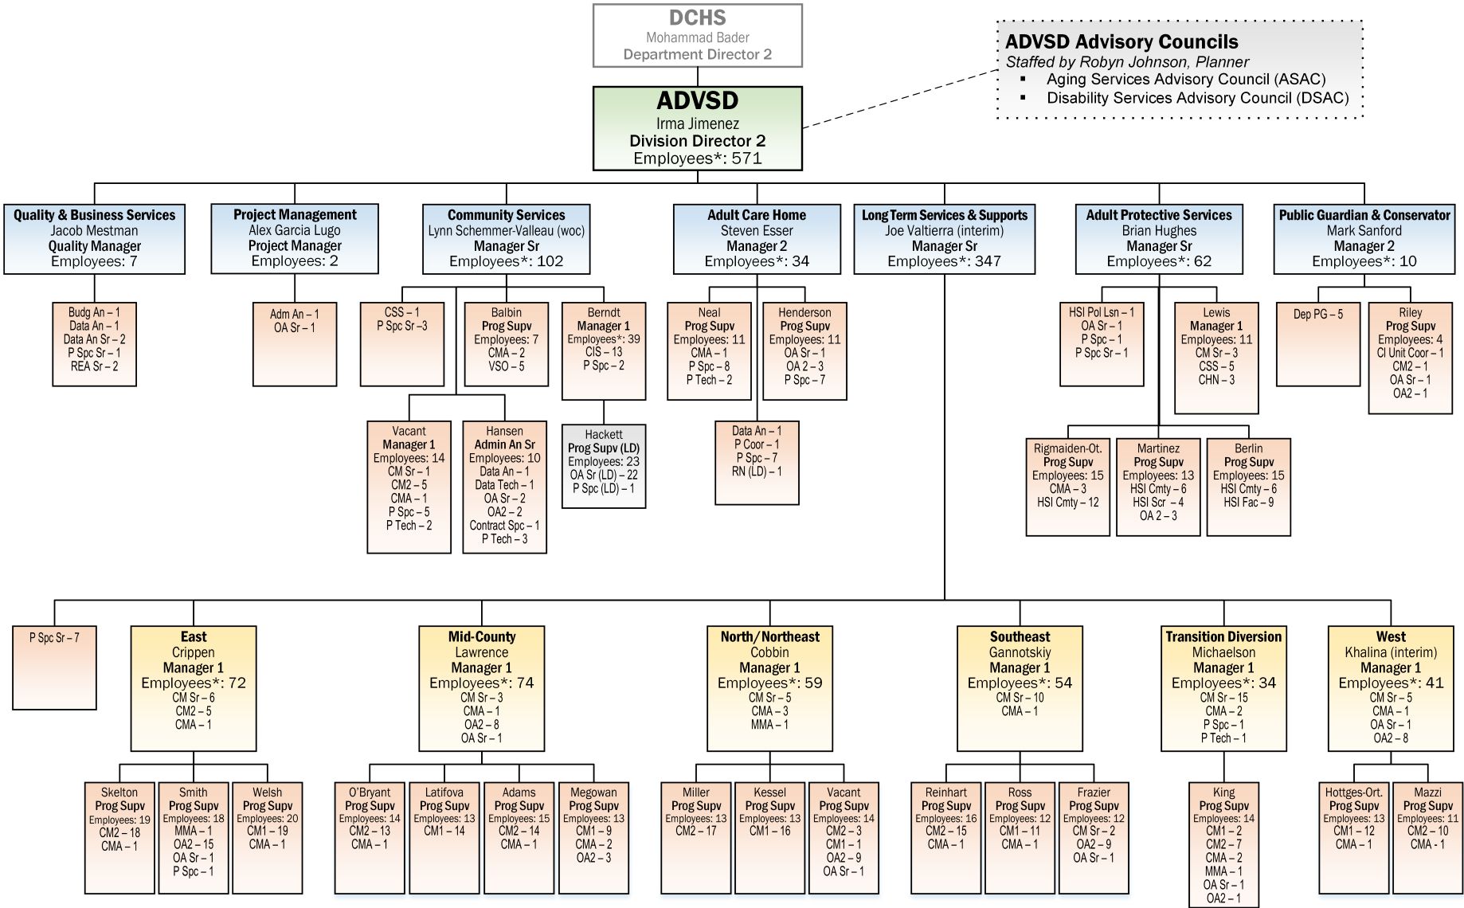

Appendix B: Advisory Councils and Governing Bodies

Advisory Councils

Aging Services Advisory Council (ASAC)

Council members
- Betty Cox

- Anne Lindsay
- Scott Moore

- Leslie Houston
- David Daley
- Bill Richard

- Lawrence Macy

- April Rohman

Demographic Data
- Total number age 60 or over = 5
- Total number People of Color or LGBTQ+ = 4
- Total number self-indicating having a disability = 0
- Total number rural = 0

Disability Services Advisory Council (DSAC)

Council members
- Ashley Carroll

- Dennis Lavery
- Alysia Yamasaki
- Barb Rainish
- Cassie Sorensen
- Erin Pidot

Demographic Data:
- Total number age 60 or over = 1
- Total number People of Color or LGBTQ+ = 1
- Total number rural = 0
- Total number self-indicating having a disability = 5

Governing Body – Multnomah Board of County Commissioners
Name & Contact Information | Office | Term Expires
Deborah Kafoury  Phone: (503) 988-3308 | Chair, Multnomah County Board of Commissioners | 12/31/22
Sharon Meieran  Phone: (503) 988-5220 | Commissioner, District 1 | 12/31/24
Susheela Jayapal  Phone: (503) 988-5219 | Commissioner, District 2 | 12/31/22
Jessica Vega Pederson  Phone: (503) 988-5217 | Commissioner, District 3 | 12/31/24
Lori Stegmann  Phone: (503) 988-5213 | Commissioner, District 4 | 12/31/24

Appendix C: Public Process

2021-2025 Area Plan Needs Assessment
- The survey information can be found at https://multco.us/ads/2021-2024-area-plan-aging-%E2%80%A2-your-input-needed

2021-2025 Area Plan Public Website
- A comprehensive webpage to house information and documentation related to the Area Plan is at https://multco.us/ads/2021-2025-advsd-area-plan

Public Meetings on the 2021-2025 Area Plan
- All regularly scheduled Aging Services Advisory Council meetings September 2019-May 2021
- ADVSD Monthly provider meetings September 2019-May 2021
- Community Listening Sessions – ADVSD held two Community Listening sessions March 23 & 25, 2021. Information and materials are accessible at https://multco.us/ads/2021-2025-advsd-area-plan. See exhibit A for screenshots of the webpage.
- Board Presentation – A link to the April 1, 2021 presentation to the Board of County Commissioners and the related documents can be found at http://multnomah.granicus.com/ViewPublisher.php?view_id=3. See exhibit B for the County resolution to adopt the Area Plan.

Outreach on Public Processes related to the 2021-2024 Area Plan
- Outreach through community partners and aging services providers
- Social Media posts on Facebook and Twitter
- Cross County communications channels

Exhibit A – Images of the ADVSD 2021-2025 Area Plan webpage
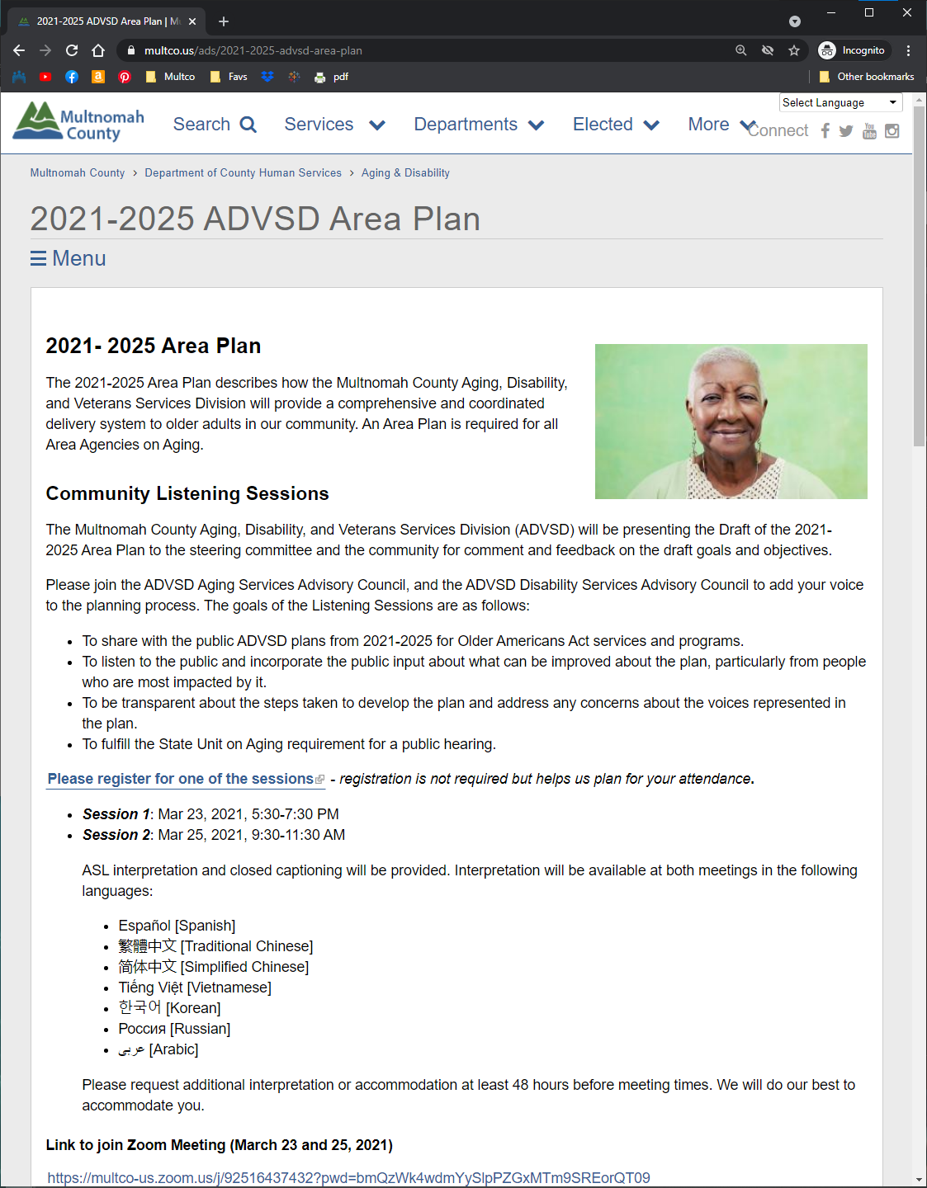

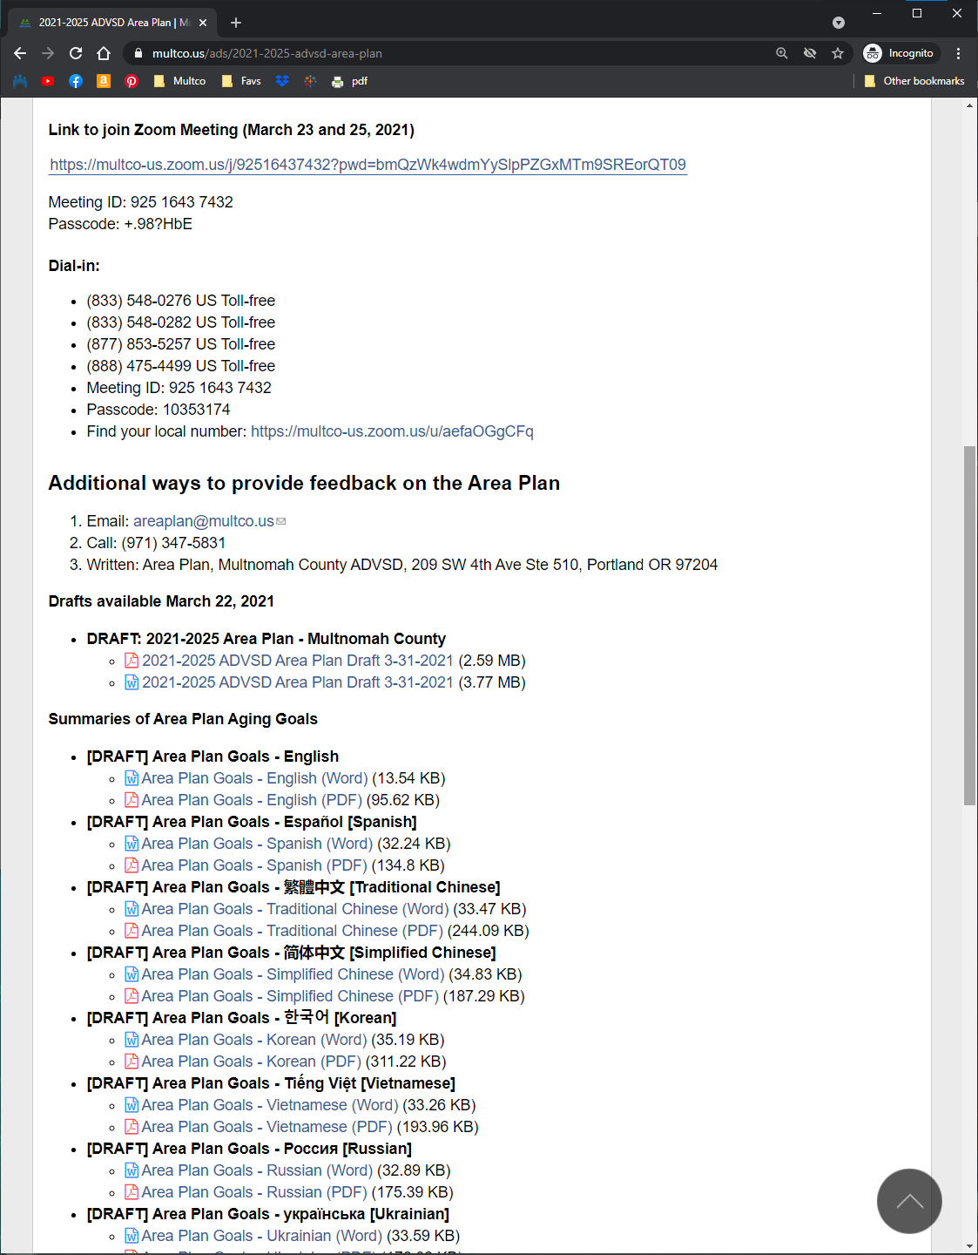

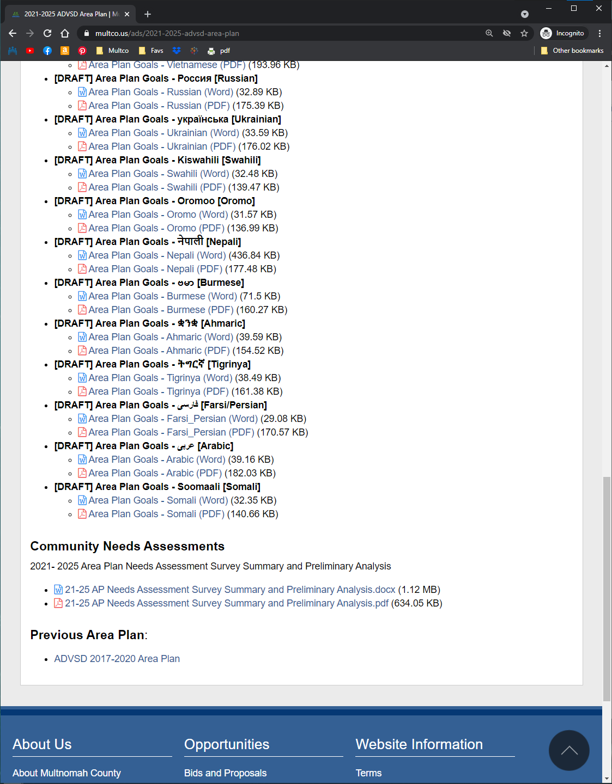

Exhibit B – Multnomah County resolution to adopt the ADVSD 2021-2025 Area Plan
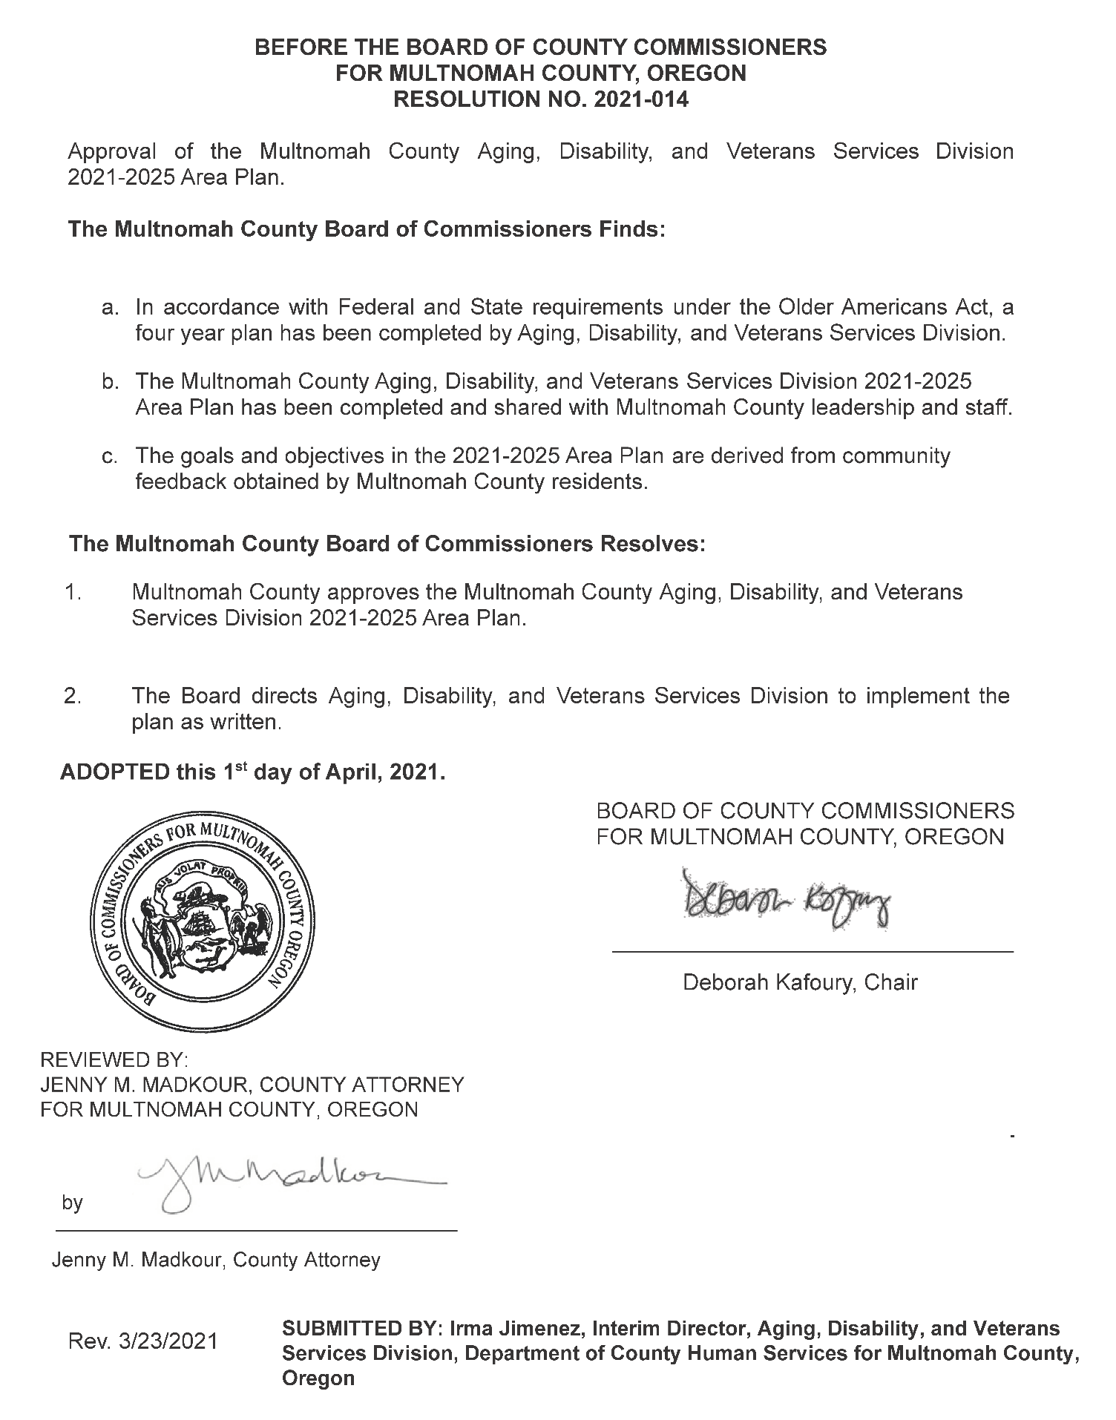

Appendix D: Final Update on Accomplishments from 2017-20 Area Plan

Information & Assistance/ADRC Goals
- Decrease isolation and barriers to access experienced by physically, emotionally, culturally, or linguistically isolated older adults.
- ADRC is recognized by the community as a valuable resource for older adults and people with disabilities.

Objectives:
- Build capacity to provide inclusive and culturally specific services.
Objective met and ongoing. Through monthly team meetings and regional conferences, the ADRC has trained ADRC helpline staff to increase their knowledge of the ADRC website and to become better navigators of the ADRC services. Multnomah County ADRC increased funding to culturally specific organizations for the 2018-2022 contract period. Four culturally specific organizations now provide information and assistance (I&A) services. The ADRC team trained three culturally specific partner agencies on Medicare benefits, and with the Senior Health Insurance Benefits Assistance Program (SHIBA), recruited and trained more bilingual SHIBA volunteers to meet the needs of an increasingly diverse retiree population. These partner agencies promote the ADRC as a front door to accessing assistance with Medicare benefits.
- Utilize a targeted outreach approach that builds on existing relationships, trusted cultural centers, and leverages the strengths of the community.
Objective met and ongoing. The ADRC began communicating more closely with and strengthened relationships with I&A teams at Enhancing Equity (EE) partner agencies and district centers (DC). More in-person meetings and virtual meetings were held between staff at these partner agencies.
The outreach team created goals and metrics for reaching more older adults and people with disabilities with limited incomes and English proficiency, as well as older adults who identify as Native American and African American. The ADRC translated its outreach materials into six different languages and utilized statewide ADRC outreach materials in additional languages.
- Utilize a multimodal approach to promote ADRC as front door/coordinated entry to all ADVSD/ Enhancing Equity services.
Objective met and ongoing. After training three culturally specific partner agencies on Medicare benefits, these agencies promote the ADRC as the front door to accessing SHIBA assistance for navigating Medicare benefits. The outreach team continued to promote the ADRC as a front door to all ADVSD and enhancing equity services at community events, external and internal staff meetings, and community presentations.
- 85% of ADRC consumers will express satisfaction (excellent or good) with services and activities provided at these community access points.
Objective met and ongoing. The ADRC has been conducting regular quality improvement activities during bimonthly meetings with partners. Funding to culturally specific organizations was increased for the 2018-2022 contract period. ADRC staff provided training to ADVSD Long Term Services and Supports offices on after hours alerts and consultant services to improve 24-hour access. An increase in overall consumer satisfaction is anticipated.

Nutrition Services Goals
- Older adults will have ready access to healthy food that is affordable and supports a healthy diet.
- Be a leader in equity around food security.

Objectives:
- Provide access to low or no-cost healthy food in a variety of settings to meet the diverse needs of older adults.
Objective met. However, the variety of settings decreased in 2020 due to the coronavirus pandemic, which led to the elimination of congregate dining. These closures caused an increase in social isolation and an increase in the request for meals. Almost all partner agencies shifted to a home-delivered program except for one, which chose to prepare food boxes. The definition of homebound changed, allowing for the delivery of more meals regardless of an individual’s ability to pay. Meal programs began to include fresh fruits and vegetables in their meal delivery. Nutrition education was provided to the recipients of meals, and the Universal Consumer Registry (UCR) tool allowed for improvements in tracking nutritional assessments.
- Programming is targeted to the highest need population.
Objective met. County staff provided training to organizations interested in responding to an [RFPQ] related to providing nutrition services to culturally specific communities. Culturally specific providers increased their nutritional services due to the disproportionate impact of COVID-19, and an on-call dietician was hired to consult with these providers. The nutrition guidelines were relaxed for the pandemic, however most providers still adhered to them. County staff worked with the State of Oregon on allowing culturally specific restaurants to supplement meals.

Health Promotion Goals
- Improve countywide access to and utilization of services by racial, ethnic, cultural minority and other underserved groups of older adults that address the social determinants of health and/or forge links between health systems and community services and work to develop other funding sources to support these activities.
- Involvement in health promotion programs will reduce social isolation by providing older adults and people with disabilities support through social networks and direct linkages to community resources offered by our contracted partners.

Objectives:
- Maintain access and utilization of culturally and linguistically diverse evidenced-based workshops and activity offerings throughout the region based on funding availability.
Objective met. Eight community agencies provide evidence-based health promotion services to the local older adult population. Six of these agencies provide culturally specific services: The Native American Rehabilitation Association (NARA), the Native American Youth and Family Center (NAYA), El Programa Hispano Católico, The Asian Health and Service Center, the Immigrant and Refugee Community Organization (IRCO), and the Q Center. Two district centers, the Community for Positive Aging, and Impact NW, provide evidence-based health promotion services in a culturally responsive manner.
- Older adults and people with disabilities and chronic conditions will learn disease specific information through regional efforts to improve coordination, leverage resources and build capacity of evidence-based health promotion and self-management education programs.
Objective met. This past year the coursed offered by our community partners included Chronic Disease Self-Management, Tai Chi for Better Balance, Diabetes Health Prevention, and Walk with Ease. Powerful Tools for Caregivers classes supported those assisting our older adults. Community partners also offered classes addressing high blood pressure, nutrition, stress and relaxation, and COVID-19. Some partners set-up clinics to provide flu vaccines. Programming was significantly reduced because of the reduction in state funding.
- Participate with and explore opportunities through the Portland and Multnomah County Age-Friendly Health Services, Equity, and Prevention Committee.
Objective met. The ADVSD Community Services manager participates on the executive board and continues to monitor opportunities. Staff attended the AARP sponsored Age Friendly webinars about senior living and transportation. Staff also attended a conference on aging, mobility and transportation sponsored by Portland State University.
- Participants in evidence-based health promotion programs will have access to ADRC, options counseling, nutrition programs, etc.
Objective met. Information and referral support is available at all eight community agencies providing evidence-based health promotion services. Prior to the outbreak of the coronavirus pandemic, all our Enhancing Equity partners provided meals at their sites. Four Enhancing Equity partners provide evidence-based health promotion programs, and all partners offering evidence-based health promotion programs provide additional social activities at their sites.

Family Caregiver Support Program Goals
- Support quality services for family caregivers.
- Promote access to family caregiver services and resources, including respite services, to meet the needs and preferences of family and informal caregivers from diverse cultural backgrounds.

Objectives:
- Provide culturally relevant caregiver training.
Objective met. In 2019, through an ACL dementia grant, the STAR Caregiver (STAR C) evidence-based program was translated into Russian and Spanish. Two IRCO senior services case managers, and a case manager from the YWCA was trained were trained in the STAR C program. All three case managers received STAR Caregiver teaching certifications from the University of Washington. The IRCO case managers provided STAR C training in Russian and Ukrainian to six family caregivers in 2019. The YWCA certified case manager provided STAR C training in Spanish to two family caregivers.
- Increase participation by family and informal caregivers that identify in racial, ethnic, and cultural minority groups.
Objective was partially met and is ongoing. The ADVSD Family Caregiver Support Program hosted 12 Memory Cafes at the Sunrise Center in 2019 and one Memory Cafe in 2020, before Memory Cafes were cancelled due to COVID-19. The ADVSD Family Caregiver Support Program (FCSP) and the OHSU PreSERVE Coalition solidified a partnership in January 2020 to co-create and co-sponsor Memory Cafe events focused on the African American Community. The project was joined by Kaiser Permanente, the Urban League of Portland, and other community organizations. Quarterly Memory Café events were scheduled, however because of COVID-19 all Memory Cafés for the African American community were cancelled for 2020 and 2021. In response to the pandemic FCSP joined PreSERVE and offered virtual events for the African American community focused on older adults and their family caregivers. As of March 2021, two virtual events were provided to the African American community.

Elder Rights and Legal Assistance Goals
- Ensure that older adults and people with disabilities have access to protection against abuse, financial exploitation, and neglect, with particular attention focused on resources, access, and financial stability.
- Ensure adequate and equitable access to legal support, peer support, and advocacy for older adults.

Objectives:
- Adult Protective Services (APS) will demonstrate effective response to complaints.
Objective ongoing. The Multi-Disciplinary Team (MDT) Outcome tool was redesigned and implemented in October 2019. The MDT database is used in the evaluation of the effectiveness of the tool. APS meets the requirement to ask and collect race and ethnicity information as required by the state. An MDT Nurse works with Slavic and Eastern European immigrants. Multnomah County used radio and television outreach campaigns about elder abuse to encourage community members to check on older adults.
- 1,500 Multnomah County Medicare/Medicaid beneficiaries will receive personalized counseling by skilled volunteers, with special attention devoted to increasing the number of Hispanic/Latino and urban American Indian/Alaskan Native beneficiaries.
Objective met. Senior Health Insurance Benefits and Assistance (SHIBA) volunteers assisted 6,070 individuals with Medicare benefits during the 2017-2020 plan period. ADVSD conducted culturally specific outreach activities to reach Hispanic/Latino and urban American Indian/Alaskan Native Medicare beneficiaries with information about and assistance for Medicare benefits, Medicare Part B premium costs, Medicare Part D prescription drug costs, Medicare preventive health services, and Medicare fraud and abuse. Outreach activities included community events, such as the NAYA Neerchokikoo Powwow, the NARA Spirit of Giving Conference, the Latino Festival, and the Latina Health, Health Symposium. Other outreach activities included presentations, and newspaper and social media advertisements in English and Spanish. All SHIBA program brochures, Senior Medicare Patrol (SMP) brochures, Medicare preventive health services materials, and Oregon Medicare Savings Connect (OMSC) flyers are available in Spanish and distributed at outreach events.
- Develop a new program to create a scalable Volunteer Benefits Information & Enrollment Center (VBIEC) model that may serve up to 1,000 older adults who need additional assistance with applications for various benefit programs, including Medicare Savings programs.
Objective not met. The VBIEC program was cut from the Multnomah County budget on July 1, 2019 because of funding constraints.
- An average of 850 older adults will receive civil legal assistance yearly with an emphasis on developing capacity to serve racial, ethnic, and cultural minority group elders.
Objective partially met. Staff capacity at the contracted partner limited recruitment of new legal volunteers. New outreach events were provided at Enhancing Equity sites.

Older Native Americans Goals
- Increase accessibility to culturally specific services and support the needs identified by Native American Elders.
- Enhance services for urban Native American elders by promoting capacity-building in agencies that serve them.

Objectives:
- Work with current culturally specific providers, stakeholders, and community members to better identify and provide the services and supports needed and desired by Native American Elders.
Objective met and ongoing. Multnomah County ADVSD meets regularly with Tribal entities and other stakeholder groups to explore enhancing services through collaboration, coordination, and effective partnerships. At the regional “Tribal Meet and Greet”, Siletz and Grand Ronde Tribal representatives, NAYA and NARA staff members, and Area Agencies on Aging staff members from Clackamas, Washington, and Multnomah County met to discuss partnership building. Multnomah County ADVSD coordinated its Area Plan needs assessment through collaboration with the Title VI and AAA regional stakeholders. A Memorandum of Understanding (MOU) was developed with NARA for the Tribal Navigator Project, and ADVSD has offered training and support to the Tribal Navigator. NARA has been hosting the Pi-Nee-Waus evening gathering, and the County has provided some OAA case management training to NARA staff. ADVSD has contracted with NAYA to provide Older Americans Act case management, options counseling, evidence-based health promotion, recreation, and congregate meals—although this work has been impacted by COVID-19.
- Provide technical assistance to culturally specific providers.
Objective met and ongoing. NAYA instituted a virtual senior center, expanded their nutrition program to meet increased demand due to the coronavirus pandemic and expanded their community engagement during COVID-19.

Veterans Goal
- Older adults leverage entitlements to benefits through the federal Veterans Administration, as well as state and county resources to meet and maintain their individualized care needs.

Objectives:
- Provide targeted community outreach and engagement to older adults that previously served in the military or are the eligible family member of someone who served in the military.
Objective met and ongoing. The Multnomah County Veterans Services Office expanded and reorganized their walk-in schedule to maximize accessibility to services. The Veterans Services Office actively engaged with and provided community outreach to older adults that previously served in the military or who are the surviving spouse of someone who served in the military. Outreach activities included tabling at conferences, resource and street fairs, such as the Aging Well Conference, AARP Vital Aging Conference, East PDX Senior Resource Fair, Rose Haven Resource Fair, Montavilla Street Fair, Pride Northwest Festival, Salute to Veterans Car Show. Outreach activities also included presentations to community partners and senior residences. In addition to the outreach events, a County veterans service officer (CVSO) worked from the Community for Positive Aging for increased accessibility to older veterans and their family members. The onset of COVID-19 in 2020 impacted the Veterans Services program’s ability to conduct in-person outreach activities, and most outreach efforts shifted towards virtual formats and other media.
- Collaborate with Veterans Health Administration (VHA) and community-based agencies to engage residents and providers in the long-term service and support system to reach veterans and/or their surviving spouse to help them gain access to lesser-known benefits through the federal VA. The goal is to help veterans and families age in place.
Objective met and ongoing. The outreach veterans resource and referral specialist (VRRS) is developing a process to identify independent living facilities to reach our 55+ veteran population and plans to coordinate with the Oregon Department of Veterans Affairs Aging Veterans Outreach Specialist. Two presentations were done at the Terwilliger Plaza Retirement Community and the Heights at Columbia Knoll. The Veterans Direct Care Program is a statewide program that has expanded significantly. There are currently 17 enrolled in Multnomah County.
- Identify community-based partners who may serve veterans and their families to increase awareness and referrals to the Veterans Service Office.
Objective met and ongoing. The Multnomah County Veterans Task Force was established to assess and identify the services provided to military veterans in the County. This group is specifically tasked with locating barriers and opportunities for change and improvement in services. The task force is composed of representatives from different County departments, community organizations, and other state and federal partners. The task force meets monthly to address gaps in the local veterans service continuum, and encourage networking and enhanced collaboration between partners.

Behavioral Health Goals
- People needing services know where to go and feel comfortable seeking out services.
- Develop a system that provides services and supports to people with multiple needs who do not fit into one system.
Note: Funds from the federal and state budget were eliminated in August 2020. Currently, ADVSD uses Title 3–Aging, and Title 3D–Health funding to provide support to PEARLS through the year ending June 30, 2021.

Objectives:
- Have extended and far-reaching outreach for current services.
Objective met and ongoing. Prior to COVID, The Asian Health Services Center (AHSC) screened up to 150 people for the PEARLS program and enrolled between 60 to 80 people annually. Since the onset of COVID-19, enrollment has dropped from 55 to 11 people—however, enrollment is slowly increasing. The AHSC health care workers have a consumer list of 5,000 people from community connections and outreach efforts. The COVID Community Counseling Program (CCCP), that is connected to OHA, and the Coordinated Asian Response Team (CART) contribute to this outreach database.
Prior to the COVID-19 pandemic, Jewish Family and Child Services (JFCS) enrolled and provided services to 101 consumers. Services stopped when PEARLS program funding was eliminated in August 2020. Services resumed when Multnomah County awarded PEARLS Evidence Based Health Promotion funds in October 2020. These funds were retroactive to August 2020 if they had continued to provide services. JFCS is currently supporting 57 consumers.
JFCS has a well-established network of community partners and provide presentations and outreach events throughout the year. Community partners include Purim, OHSU, Providence, Legacy, Rose Schnitzer Manor, NW Place, Cedar Sinai Housing, Q Center, SAGE, and Friendly House.
- Strengthen partnerships with culturally specific agencies to promote the development of resources and to engage community members in existing services
Objective met and ongoing. Two community partners provide PEARLS to people living in Multnomah County. The AHSC is a central contact for Asian people living in Portland and Oregon. AHSC provides PEARLS services in English, Cantonese, Mandarin, Korean, and Vietnamese. JFCS provides PEARLS services in English and Russian. Any PEARLS provider can develop additional resources for post-PEARLS completion, such as peer support groups or PEARLS counselor led refreshers and support groups.
- Service providers are training to navigate systems to access services for consumers with complex needs.
Objective met. The Older Adult Behavioral Health Initiative team (OABHI) provided comprehensive training to Long Term Services and Support staff and community partners on making referrals to their team for complex case consultation.
- Work with ADRC staff to increase their skill in recognizing behavioral health needs in community members calling the Helpline.
Objective met. The OABHI team worked with ADRC staff to increase the number of referrals to their team for complex case consultation and newly formed peer support groups.
- Best practices will be incorporated into existing care coordination models to better serve consumers with complex needs.
Objective met. The PEARLS program requires staff to be certified in the structured counseling model that is designed to address anxiety and depression. The model has a component addressing support for people with substance misuse, but this has not been a required service in the contractual agreements.
- Workforce development – service providers will have training readily available to increase their skill working with consumers who are facing a myriad of physical, mental, and social health issues.
Objective met and ongoing. Both PEARLS community partner agencies offer referrals for other requested or needed services.
- Advocate for the development of older adult-specific behavioral health services that are needed such as: home-based services, geriatric-competent therapy, services in languages other than English and peer services.
Objective met. Partner agencies see the value of the PEARLS program and are strong advocates for increasing the financial support and expanding the service. Both partners are leaders in their communities and advocate to improve services and to develop new services to meet the needs of their consumers.
One partner provides a free virtual group and could provide more sessions if they had the funding for staff planning and facilitation, equipment, and tech support.

Health System Transformation Goal
- Improve coordination of care, enhance member engagement in care coordination, improve coordination of transitions across settings, and improve cross-system education related to older adults and adults with disabilities.

Objectives:
- Work with health plans, hospitals, primary care clinics, and community organizations to map, analyze and improve coordination in transitions across settings for older adults and adults with disabilities.
Objective met. A regional cross-systems transitions workgroup was formed, and meetings held bi-monthly. The workgroup focused on identifying barriers to coordination and gaps in resources and collaborative discussed ways to address these barriers and gaps. The workgroup produced a paper titled Multi-system Perspectives on Transitions of Care Involving Individuals with Complex Needs. A mini-transitions summit was held with 70 attendees from across health and social services sectors.
- Plan and develop ongoing cross-system learning and networking opportunities for health systems, aging and disability, and community partners.
Objective met. Due to staff transitions for the long-term care innovator agent, some activities related to this objective were interrupted. However, the Older Adult Behavioral Health Initiative team continued to be active in cross-system learning and networking. The Multnomah Planning Group organized the Chaos or Coordination Conference for March 2, 2019 and March 4, 2020.
- Expand member engagement and health system partner participation in interdisciplinary care coordination conferences.
Objective met. Partnerships with CareOregon, Providence, and Kaiser were strengthened. The Multnomah County long-term care innovator agent worked with Health Share and Washington County to add intensive care coordination conferences with Tuality Health Care and Kepro. The long-term care innovator agent provided quarterly reports to Health Share and the steering committee on the intensive care coordination conferences, and annual data was provided by Health Share for analysis regarding those conferences.

Transportation Goal
- Transportation coordination and resources will be readily available, easy to navigate, and distributed equitably across ADVSD service areas.

Objectives:
- Promote inter-agency coordination and centralization of network information, referral, and scheduling systems.
Objective met and ongoing. Multnomah County ADVSD and community partner agency staff that provide information and referral/assistance and transportation coordination met regularly (at least bimonthly and more often if needed). The COVID-19 pandemic increased need and created new staff roles and responsibilities. From March 2020 through December 2020, each service group met separately as needed to accommodate staffing shortages resulting from the county COVID-19 response. Both service groups resumed the bimonthly meeting schedule in February 2021.
Transportation coordination and rides are provided through Ride to Care and First Transit for people with Medicaid. Multnomah County coordinates monthly transportation services for adults 18 years and older with disabilities and contracts with nine community partners offering district center activities to do the same for older adults. Transportation coordination services include assessing eligibility, identifying sustainable levels of transportation service, purchasing, and sending TriMet HOP Cards, punch cards or tickets, as well as authorizing and scheduling premium rides, cab rides, and specialized transportation vehicles.

Appendix E: Emergency Preparedness Plans
- Available at https://www.multco.us/ads/2021-2025-advsd-area-plan-emergency-preparedness-plan

Appendix F: Designated Focal Points (OAA Section 306(a)(3)(B))
The term ‘‘focal point’’ means a facility established to encourage the maximum collocation and coordination of services for older individuals.
The ADVSD contracted senior district centers and Enhancing Equity sites are the designated focal points in the county and are listed below.

Enhancing Equity Focal Point Partners:
- Asian Health & Service Center, 9035 SE Foster Road, Portland, OR 97266
- El Programa Hispano Católico, 333 SE 223rd Avenue Ste 3, Gresham, OR 97030
- Immigrant & Refugee Community Organization, 10615 SE Cherry Blossom Drive, Portland, OR 97216
- Native American Rehabilitation Association, 1776 SW Madison Street, Portland, OR 97205
- Native American Youth and Family Center, 5135 NE Columbia Boulevard, Portland, OR 97218
- Q Center, 4115 N Mississippi Avenue, Portland, OR 97217
- SAGE Metro Portland, 1737 NW 26th Avenue, Portland OR 97210
- Urban League of Portland, 10 N Russell Street, Portland, OR 97227

District Center Focal Point Partners:

East County
- YWCA, 600 NE 8th Street, Room 100, Gresham, OR 97030

Mid County
- Immigrant & Refugee Community Organization, 10615 SE Cherry Blossom Drive, Portland, OR 97236

North/Northeast Consortium
- Community for Positive Aging (lead agency), 1820 NE 40th Avenue, Portland, OR 97212
- Urban League of Portland Multicultural Senior Center (partner agency), 5325 NE Martin Luther King Jr. Boulevard, Portland, OR 97211

Southeast
- Impact NW Multicultural Service Center, 4610 SE Belmont Street, Portland, OR 97215

West Consortium
- Friendly House (lead agency), 1737 NW 26th Avenue, Portland, OR 97209
- Neighborhood House (partner agency), 7688 SW Capitol Highway, Portland, OR 97219

Appendix H: Statement of Assurances and Verification of Intent
For the period of July 1, 2022 through June 30, 2025, Multnomah County Aging, Disability and Veterans Services Division (ADVSD) accepts the responsibility to administer this Area Plan in accordance with all requirements of the Older Americans Act (OAA) as amended in 2020 (P.L. 116-131) and related state law and policy. Through the Area Plan,
ADVSD shall promote the development of a comprehensive and coordinated system of services to meet the needs of older individuals and individuals with disabilities and serve as the advocacy and focal point for these groups in the Planning and Service Area. ADVSD assures that it will:
Comply with all applicable state and federal laws, regulations, policies and contract requirements relating to activities carried out under the Area Plan.

OAA Section 306, Area Plans

(a) Each area agency on aging designated under section 305(a)(2)(A) shall, in order to be approved by the State agency, prepare and develop an area plan for a planning and service area for a two-, three-, or four-year period determined by the State agency, with such annual adjustments as may be necessary. Each such plan shall be based upon a uniform format for area plans within the State prepared in accordance with section 307(a)(1). Each such plan shall—

(1) provide, through a comprehensive and coordinated system, for supportive services, nutrition services, and, where appropriate, for the establishment, maintenance, modernization, or construction of multipurpose senior centers (including a plan to use the skills and services of older individuals in paid and unpaid work, including multigenerational and older individual to older individual work), within the planning and service area covered by the plan, including determining the extent of need for supportive services, nutrition services, and multipurpose senior centers in such area (taking into consideration, among other things, the number of older individuals with low incomes residing in such area, the number of older individuals who have greatest economic need (with particular attention to low-income older individuals, including low-income minority older individuals, older individuals with limited English proficiency, and older individuals residing in rural areas) residing in such area, the number of older individuals who have greatest social need (with particular attention to low-income older individuals, including low-income minority older individuals, older individuals with limited English proficiency, and older individuals residing in rural areas) residing in such area, the number of older individuals at risk for institutional placement residing in such area, and the number of older individuals who are Indians residing in such area, and the efforts of voluntary organizations in the community), evaluating the effectiveness of the use of resources in meeting such need, and entering into agreements with providers of supportive services, nutrition services, or multipurpose senior centers in such area, for the provision of such services or centers to meet such need;

(2) provide assurances that an adequate proportion, as required under section 307(a)(2), of the amount allotted for part B to the planning and service area will be expended for the delivery of each of the following categories of services—
(A) services associated with access to services (transportation, health services (including mental and behavioral health services), outreach, information and assistance (which may include information and assistance to consumers on availability of services under part B and how to receive benefits under and participate in publicly supported programs for which the consumer may be eligible) and case management services);
(B) in-home services, including supportive services for families of older individuals with Alzheimer's disease and related disorders with neurological and organic brain dysfunction; and
(C) legal assistance;
and assurances that the area agency on aging will report annually to the State agency in detail the amount of funds expended for each such category during the fiscal year most recently concluded;

(3) (A) designate, where feasible, a focal point for comprehensive service delivery in each community, giving special consideration to designating multipurpose senior centers (including multipurpose senior centers operated by organizations referred to in paragraph (6)(C)) as such focal point; and
(B) specify, in grants, contracts, and agreements implementing the plan, the identity of each focal point so designated;

(4) (A)(i)(I) provide assurances that the area agency on aging will—
(aa) set specific objectives, consistent with State policy, for providing services to older individuals with greatest economic need, older individuals with greatest social need, and older individuals at risk for institutional placement;
(bb) include specific objectives for providing services to low-income minority older individuals, older individuals with limited English proficiency, and older individuals residing in rural areas; and

(II) include proposed methods to achieve the objectives described in items (aa) and (bb) of sub-clause (I);

(ii) provide assurances that the area agency on aging will include in each agreement made with a
provider of any service under this title, a requirement that such provider will—
(I) specify how the provider intends to satisfy the service needs of low-income minority individuals, older individuals with limited English proficiency, and older individuals residing in rural areas in the area served by the provider;
(II) to the maximum extent feasible, provide services to low-income minority individuals, older individuals with limited English proficiency, and older individuals residing in rural areas in accordance with their need for such services; and
(III) meet specific objectives established by the area agency on aging, for providing services to low-income minority individuals, older individuals with limited English proficiency, and older individuals residing in rural areas within the Planning and Service Area; and

(iii) with respect to the fiscal year preceding the fiscal year for which such plan is prepared —
(I) identify the number of low-income minority older individuals in the planning and service area;
(II) describe the methods used to satisfy the service needs of such minority older individuals; and
(III) provide information on the extent to which the area agency on aging met the objectives described in clause (i).

(B) Provide assurances that the area agency on aging will use outreach efforts that will—
(i) identify individuals eligible for assistance under this Act, with special emphasis on—
(I) older individuals residing in rural areas;
(II) older individuals with greatest economic need (with particular attention to low-income minority individuals and older individuals residing in rural areas);
(III) older individuals with greatest social need (with particular attention to low-income minority individuals and older individuals residing in rural areas);
(IV) older individuals with severe disabilities;
(V) older individuals with limited English proficiency;
(VI) older individuals with Alzheimer’s disease and related disorders with neurological and organic brain dysfunction (and the caretakers of such individuals); and
(VII) older individuals at risk for institutional placement, specifically including survivors of the Holocaust; and

(ii) inform the older individuals referred to in sub-clauses (I) through (VII) of clause (i), and the caretakers of such individuals, of the availability of such assistance; and
(C) contain an assurance that the area agency on aging will ensure that each activity undertaken by the agency, including planning, advocacy, and systems development, will include a focus on the needs of low-income minority older individuals and older individuals residing in rural areas.

(5) provide assurances that the Area Agency on Aging will coordinate planning, identification, assessment of needs, and provision of services for older individuals with disabilities, with particular attention to individuals with severe disabilities, and individuals at risk for institutional placement, with agencies that develop or provide services for individuals with disabilities;

(6) provide that the area agency on aging will—
(A) take into account in connection with matters of general policy arising in the development and administration of the area plan, the views of recipients of services under such plan;
(B) serve as the advocate and focal point for older individuals within the community by (in cooperation with agencies, organizations, and individuals participating in activities under the plan) monitoring, evaluating, and commenting upon all policies, programs, hearings, levies, and community actions which will affect older individuals;
(C)(i) where possible, enter into arrangements with organizations providing day care services for children, assistance to older individuals caring for relatives who are children, and respite for families, so as to provide opportunities for older individuals to aid or assist on a voluntary basis in the delivery of such services to children, adults, and families;
(ii) if possible regarding the provision of services under this title, enter into arrangements and coordinate with organizations that have a proven record of providing services to older individuals, that—
(I) were officially designated as community action agencies or community action programs under section 210 of the Economic Opportunity Act of 1964 (42 U.S.C. 2790) for fiscal year 1981, and did not lose the designation as a result of failure to comply with such Act; or
(II) came into existence during fiscal year 1982 as direct successors in interest to such community action agencies or community action programs;
and that meet the requirements under section 676B of the Community Services Block Grant Act; and
(iii) make use of trained volunteers in providing direct services delivered to older individuals and individuals with disabilities needing such services and, if possible, work in coordination with organizations that have experience in providing training, placement, and stipends for volunteers or participants (such as organizations carrying out Federal service programs administered by the Corporation for National and Community Service), in community service settings;
(D) establish an advisory council consisting of older individuals (including minority individuals and older individuals residing in rural areas) who are participants or who are eligible to participate in programs assisted under this Act, family caregivers of such individuals, representatives of older individuals, service providers, representatives of the business community, local elected officials, providers of veterans’ health care (if appropriate), and the general public, to advise continuously the area agency on aging on all matters relating to the development of the area plan, the administration of the plan and operations conducted under the plan;
(E) establish effective and efficient procedures for coordination of—
(i) entities conducting programs that receive assistance under this Act within the planning and service area served by the agency; and
(ii) entities conducting other Federal programs for older individuals at the local level, with particular emphasis on entities conducting programs described in section 203(b), within the area;
(F) in coordination with the State agency and with the State agency responsible for mental and behavioral health services, increase public awareness of mental health disorders, remove barriers to diagnosis and treatment, and coordinate mental and behavioral health services (including mental health screenings) provided with funds expended by the area agency on aging with mental and behavioral health services provided by community health centers and by other public agencies and nonprofit private organizations;
(G) if there is a significant population of older individuals who are Indians in the planning and service area of the area agency on aging, the area agency on aging shall conduct outreach activities to identify such individuals in such area and shall inform such individuals of the availability of assistance under this Act;
(H) in coordination with the State agency and with the State agency responsible for elder abuse prevention services, increase public awareness of elder abuse, neglect, and exploitation, and remove barriers to education, prevention, investigation, and treatment of elder abuse, neglect, and exploitation, as appropriate; and
(I) to the extent feasible, coordinate with the State agency to disseminate information about the State assistive technology entity and access to assistive technology options for serving older individuals;

(7) provide that the area agency on aging shall, consistent with this section, facilitate the areawide development and implementation of a comprehensive, coordinated system for providing long-term care in home and community-based settings, in a manner responsive to the needs and preferences of older individuals and their family caregivers, by—
(A) collaborating, coordinating activities, and consulting with other local public and private agencies and organizations responsible for administering programs, benefits, and services related to providing long-term care;
(B) conducting analyses and making recommendations with respect to strategies for modifying the local system of long-term care to better—
(i) respond to the needs and preferences of older individuals and family caregivers;
(ii) facilitate the provision, by service providers, of long-term care in home and community-based settings; and
(iii) target services to older individuals at risk for institutional placement, to permit such individuals to remain in home and community-based settings;
(C) implementing, through the agency or service providers, evidence-based programs to assist older individuals and their family caregivers in learning about and making behavioral changes intended to reduce the risk of injury, disease, and disability among older individuals; and
(D) providing for the availability and distribution (through public education campaigns, Aging and Disability Resource Centers, the area agency on aging itself, and other appropriate means) of information relating to—
(i) the need to plan in advance for long-term care; and
(ii) the full range of available public and private long-term care (including integrated long-term care) programs, options, service providers, and resources;

(8) provide that case management services provided under this title through the area agency on aging will—
(A) not duplicate case management services provided through other Federal and State programs;
(B) be coordinated with services described in subparagraph (A); and
(C) be provided by a public agency or a nonprofit private agency that—
(i) gives each older individual seeking services under this title a list of agencies that provide similar services within the jurisdiction of the area agency on aging;
(ii) gives each individual described in clause (i) a statement specifying that the individual has a right to make an independent choice of service providers and documents receipt by such individual of such statement;
(iii) has case managers acting as agents for the individuals receiving the services and not as promoters for the agency providing such services; or
(iv) is located in a rural area and obtains a waiver of the requirements described in clauses (i) through (iii);

(9) (A) provide assurances that the area agency on aging, in carrying out the State Long-Term Care Ombudsman program under section 307(a)(9), will expend not less than the total amount of funds appropriated under this Act and expended by the agency in fiscal year 2019 in carrying out such a program under this title;
(B) funds made available to the area agency on aging pursuant to section 712 shall be used to supplement and not supplant other Federal, State, and local funds expended to support activities described in section 712;

(10) provide a grievance procedure for older individuals who are dissatisfied with or denied services under this title;

(11) Provide information and assurances concerning services to older individuals who are Native Americans (referred to in this paragraph as "older Native Americans"), including—
- (A) Information concerning whether there is a significant population of older Native Americans in the planning and service area and if so, an assurance that the Area Agency on Aging will pursue activities, including outreach, to increase access of those older Native Americans to programs and benefits provided under this title;
- (B) An assurance that the Area Agency on Aging will, to the maximum extent practicable, coordinate the services the agency provides under this title with services provided under Title VI; and
- (C) An assurance that the Area Agency on Aging will make services under the Area Plan available, to the same extent as such services are available to older individuals within the planning and service area, to older Native Americans;

(12) provide that the area agency on aging will establish procedures for coordination of services with entities conducting other Federal or federally assisted programs for older individuals at the local level, with particular emphasis on entities conducting programs described in section 203(b) within the planning and service area.

(13) Provide assurances that the Area Agency on Aging will—
(A) maintain the integrity and public purpose of services provided, and service providers, under this title in all contractual and commercial relationships;
(B) disclose to the Assistant Secretary and the State agency—
(i) the identity of each nongovernmental entity with which such agency has a contract or commercial relationship relating to providing any service to older individuals; and
(ii) the nature of such contract or such relationship;
(C) demonstrate that a loss or diminution in the quantity or quality of the services provided, or to be provided, under this title by such agency has not resulted and will not result from such contract or such relationship;
(D) demonstrate that the quantity or quality of the services to be provided under this title by such agency will be enhanced as a result of such contract or such relationship; and
(E) on the request of the Assistant Secretary or the State, for the purpose of monitoring compliance with this Act (including conducting an audit), disclose all sources and expenditures of funds such agency receives or expends to provide services to older individuals;

(14) provide assurances that preference in receiving services under this title will not be given by the area agency on aging to particular older individuals as a result of a contract or commercial relationship that is not carried out to implement this title;

(15) provide assurances that funds received under this title will be used—
(A) to provide benefits and services to older individuals, giving priority to older individuals identified in paragraph (4)(A)(i); and
(B) in compliance with the assurances specified in paragraph (13) and the limitations specified in section 212;

(16) provide, to the extent feasible, for the furnishing of services under this Act, consistent with self-directed care;

(17) include information detailing how the area agency on aging will coordinate activities, and develop long-range emergency preparedness plans, with local and State emergency response agencies, relief organizations, local and State governments, and any other institutions that have responsibility for disaster relief service delivery;

(18) provide assurances that the area agency on aging will collect data to determine—
(A) the services that are needed by older individuals whose needs were the focus of all centers funded under title IV in fiscal year 2019; and
(B) the effectiveness of the programs, policies, and services provided by such area agency on aging in assisting such individuals; and

(19) provide assurances that the area agency on aging will use outreach efforts that will identify individuals eligible for assistance under this Act, with special emphasis on those individuals whose needs were the focus of all centers funded under title IV in fiscal year 2019.

Section 306 (e)
An area agency on aging may not require any provider of legal assistance under this title to reveal any information that is protected by the attorney-client privilege.

Sec. 307, STATE PLANS

(a) Except as provided in the succeeding sentence and section 309(a), each State, in order to be eligible for grants from its allotment under this title for any fiscal year, shall submit to the Assistant Secretary a State plan…
Each such plan shall comply with all of the following requirements:

(11) The [State] plan shall provide that with respect to legal assistance —
(A) the plan contains assurances that area agencies on aging will
(i) enter into contracts with providers of legal assistance which can demonstrate the experience or capacity to deliver legal assistance;
(ii) include in any such contract provisions to assure that any recipient of funds under division (i) will be subject to specific restrictions and regulations promulgated under the Legal Services Corporation Act (other than restrictions and regulations governing eligibility for legal assistance under such Act and governing membership of local governing boards) as determined appropriate by the Assistant Secretary; and
(iii) attempt to involve the private bar in legal assistance activities authorized under this title, including groups within the private bar furnishing services to older individuals on a pro bono and reduced fee basis;
(B) the plan contains assurances that no legal assistance will be furnished unless the grantee administers a program designed to provide legal assistance to older individuals with social or economic need and has agreed, if the grantee is not a Legal Services Corporation project grantee, to coordinate its services with existing Legal Services Corporation projects in the planning and service area in order to concentrate the use of funds provided under this title on individuals with the greatest such need; and the area agency on aging makes a finding, after assessment, pursuant to standards for service promulgated by the Assistant Secretary, that any grantee selected is the entity best able to provide the particular services.

(E) the plan contains assurances that area agencies on aging will give priority to legal assistance related to income, health care, long-term care, nutrition, housing, utilities, protective services, defense of guardianship, abuse, neglect, and age discrimination.

(12) The [State] plan shall provide, whenever the State desires to provide for a fiscal year for services for the prevention of abuse of older individuals—
(A) the plan contains assurances that any area agency on aging carrying out such services will conduct a program consistent with relevant State law and coordinated with existing State adult protective service activities for—
(i) public education to identify and prevent abuse of older individuals;
(ii) receipt of reports of abuse of older individuals;
(iii) active participation of older individuals participating in programs under this Act through outreach, conferences, and referral of such individuals to other social service agencies or sources of assistance where appropriate and consented to by the parties to be referred; and
(iv) referral of complaints to law enforcement or public protective service agencies where appropriate;
(B) the State will not permit involuntary or coerced participation in the program of services described in this paragraph by alleged victims, abusers, or their households; and
(C) all information gathered in the course of receiving reports and making referrals shall remain confidential unless all parties to the complaint consent in writing to the release of such information, except that such information may be released to a law enforcement or public protective service agency.

(15) The [State] plan shall provide assurances that, if a substantial number of the older individuals residing in any planning and service area in the State are of limited English-speaking ability, then the State will require the area agency on aging for each such planning and service area—
(A) to utilize in the delivery of outreach services under section 306(a)(2)(A), the services of workers who are fluent in the language spoken by a predominant number of such older individuals who are of limited English-speaking ability; and
(B) to designate an individual employed by the area agency on aging, or available to such area agency on aging on a full-time basis, whose responsibilities will include—
(i) taking such action as may be appropriate to assure that counseling assistance is made available to such older individuals who are of limited English-speaking ability in order to assist such older individuals in participating in programs and receiving assistance under this Act; and
(ii) providing guidance to individuals engaged in the delivery of supportive services under the area plan involved to enable such individuals to be aware of cultural sensitivities and to take into account effectively linguistic and cultural differences.

(16) The [State] plan shall provide assurances that the State agency will require outreach efforts that will—
(A) identify individuals eligible for assistance under this Act, with special emphasis on—
(i) older individuals residing in rural areas;
(ii) older individuals with greatest economic need (with particular attention to low-income older individuals, including low-income minority older individuals, older individuals with limited English proficiency, and older individuals residing in rural areas);
(iii) older individuals with greatest social need (with particular attention to low-income older individuals, including low-income minority older individuals, older individuals with limited English proficiency, and older individuals residing in rural areas);
(iv) older individuals with severe disabilities;
(v) older individuals with limited English-speaking ability; and
(vi) older individuals with Alzheimer’s disease and related disorders with neurological and organic brain dysfunction (and the caretakers of such individuals); and
(B) inform the older individuals referred to in clauses (i) through (vi) of subparagraph (A), and the caretakers of such individuals, of the availability of such assistance.

(18) The [State] plan shall provide assurances that area agencies on aging will conduct efforts to facilitate the coordination of community-based, long-term care services, pursuant to section 306(a)(7), for older individuals who—
(A) reside at home and are at risk of institutionalization because of limitations on their ability to function independently;
(B) are patients in hospitals and are at risk of prolonged institutionalization; or
(C) are patients in long-term care facilities, but who can return to their homes if community-based services are provided to them.

(26) The [State] plan shall provide assurances that area agencies on aging will provide, to the extent feasible, for the furnishing of services under this Act, consistent with self-directed care.

Obtain input from the public and approval from the AAA Advisory Council on the development, implementation and administration of the Area Plan through a public process, which should include, at a minimum, a public hearing prior to submission of the Area Plan to ODHS. ADVSD shall publicize the hearing(s) through legal notice, mailings, advertisements in newspapers, and other methods determined by the AAA to be most effective in informing the public, service providers, advocacy groups, etc.
July 26, 2022 |  | 
Date |  | Irma Jimenez  Division Director 2,  Multnomah County Aging, Disability & Veterans Services Division
July 19, 2022 |  | Approved by consensus
Date |  | Aging Services Advisory Council
July 28, 2022 |  | Approved by consensus with comments to be delivered separately to ADVSD and CSSU
Date |  | Disability Services Advisory Council
July 26, 2022
Date |  | Irma Jimenez  Legal Contractor Authority  Division Director 2,  Multnomah County Aging, Disability & Veterans Services Division

Attachment C

Service Matrix and Delivery Method
#1 Personal Care (by agency)
Funding Source: OAA OPI Other Cash Funds
Contracted Self-provided
Contractor name and address (List all if multiple contractors):
- GERAS 6901 SE Lake Rd, Ste 22, Milwaukie, OR 97267
- Caregivers NW, 4804 NE 106th Ave, Portland, OR 97220
- Home Instead Senior Care (Doing Business As HD Industries), 640 SW Sunshine Ct Ste 400 Beaverton, OR 97005
- Meany Family Home Care, 5257 NE MLK Jr. Blvd, Ste 102, Portland, OR 97213
All these are for-profit agencies
Note if contractor is a “for-profit agency”
#1a Personal Care (by HCW)
Funding Source: OAA OPI Other Cash Funds
#2 Homemaker (by agency)
Funding Source: OAA OPI Other Cash Funds
Contracted Self-provided
Contractor name and address (List all if multiple contractors):
- GERAS, 6901 SE Lake Rd, Ste 22, Milwaukie, OR 97267
- Caregivers NW, 4804 NE 106th Ave, Portland, OR 97220
- Home Instead Senior Care (DBA HD Industries), 9640 SW Sunshine Ct Ste 400 Beaverton, OR 97005
- Meany Family Home Care, 5257 NE MLK Jr. Blvd, Ste 102, Portland, OR 97213
All these are for-profit agencies.
Note if contractor is a “for-profit agency”
#2a Homemaker (by HCW)
Funding Source: OAA OPI Other Cash Funds
#3 Chore (by agency)
Funding Source: OAA OPI Other Cash Funds
Contracted Self-provided
Contractor name and address (List all if multiple contractors):
- Pegasus Social Services, 15120 NE Clackamas St Portland, OR 97230
- Store to Door, 7730 SW 31st Ave, Portland, OR 97219
- Supportive Services of Oregon, PO Box 1086, Oregon City, OR 97045
Note if contractor is a “for-profit agency”
Pegasus and Supportive Services are for profit companies.

#3a Chore (by HCW)
Funding Source: OAA OPI Other Cash Funds
#4 Home-Delivered Meal
Funding Source: OAA OPI Other Cash Funds
Contracted Self-provided
Contractor name and address (List all if multiple contractors):
- Ecumenical Ministries of Oregon, 0245 SW Bancroft St, Ste B, Portland, OR 97239
- Meals on Wheels People, 7710 SW 31st Ave, Portland OR 97219
Note if contractor is a “for-profit agency”
#5 Adult Day Care/Adult Day Health
Funding Source: OAA OPI Other Cash Funds
Contracted Self-provided
Contractor name and address (List all if multiple contractors):
- Volunteers of America - Oregon, 3910 SE Stark St, Portland, OR 97214
Note if contractor is a “for-profit agency”
#6 Case Management
Funding Source: OAA OPI Other Cash Funds
Contracted Self-provided
Contractor name and address (List all if multiple contractors):
- Asian Health & Service Center, 9035 SE Foster Rd, Portland, OR 97266
- El Programa Hispano Católico, 333 SE 223rd Ave, Ste 100, Gresham, OR 97030
- Friendly House, 2617 NW Savier St, Portland, OR 97210
- Community for Positive Aging, 1820 NE 40th Ave, Portland, OR 97212
- Immigrant & Refugee Community Organization, 10301 NE Glisan St, Portland, OR 97220
- Impact NW, 10055 E Burnside St. Portland, OR 97216
- Native American Youth and Family Center, 5135 NE Columbia Blvd, Portland, OR 97218
- Urban League of Portland, 10 N Russell St, Portland, OR 97227
- YWCA, PO Box 4587, Portland, OR 97208
Note if contractor is a “for-profit agency”
#7 Congregate Meal
Funding Source: OAA OPI Other Cash Funds
Contracted Self-provided
Contractor name and address (List all if multiple contractors):
- Asian Health & Service Center, 9035 SE Foster Rd, Portland, OR 97266
- El Programa Hispano Católico, 333 SE 223rd Ave, Ste 100, Gresham, OR 97030
- Immigrant & Refugee Community Organization, 10301 NE Glisan St, Portland, OR 97220
- Meals on Wheels People, 7710 SW 31st Ave, Portland OR 97219
- Native American Youth and Family Center, 5135 NE Columbia Blvd, Portland, OR 97218
Note if contractor is a “for-profit agency”
#8 Nutrition Counseling
Funding Source: OAA OPI Other Cash Funds
#9 Assisted Transportation
Funding Source: OAA OPI Other Cash Funds
Contracted Self-provided
Contractor name and address (List all if multiple contractors):
Note if contractor is a “for-profit agency”
#10 Transportation
Funding Source: OAA OPI Other Cash Funds
Contracted Self-provided
Contractor name and address (List all if multiple contractors):
- Friendly House, 2617 NW Savier St, Portland, OR 97210
- Community for Positive Aging, 1820 NE 40th Ave, Portland, OR 97212
- Immigrant & Refugee Community Organization, 10301 NE Glisan St, Portland, OR 97220
- Impact NW, 10055 E Burnside St. Portland, OR 97216
- Radio Cab (for profit agency), 1613 NW Kearney St, Portland, OR 97209
- Ride Connection, 9955 NE Glisan St, Portland, OR 97220
- TriMet, 4012 SE 17th Ave, Portland, OR 97202
- YWCA, PO Box 4587, Portland, OR 97208
Note if contractor is a “for-profit agency”
#11 Legal Assistance
Funding Source: OAA OPI Other Cash Funds
Contracted Self-provided
Contractor name and address (List all if multiple contractors):
- Legal Aid Services of Oregon, 520 SW 6th Ave, Ste 1130, Portland, OR 97204
All these are for-profit agencies.
Note if contractor is a “for-profit agency”
#12 Nutrition Education
Funding Source: OAA OPI Other Cash Funds
Contracted Self-provided
Contractor name and address (List all if multiple contractors):
- Asian Health & Service Center, 9035 SE Foster Rd, Portland, OR 97266
- Ecumenical Ministries of Oregon, 0245 SW Bancroft St, Ste B, Portland, OR 97239
- El Programa Hispano Católico, 333 SE 223rd Ave, Ste 100, Gresham, OR 97030
- Immigrant & Refugee Community Organization, 10301 NE Glisan St, Portland, OR 97220
- Meals on Wheels People, 7710 SW 31st Ave, Portland OR 97219
- Native American Youth and Family Center, 5135 NE Columbia Blvd, Portland, OR 97218
Note if contractor is a “for-profit agency”
#13 Information & Assistance
Funding Source: OAA OPI Other Cash Funds
Contracted Self-provided
Contractor name and address (List all if multiple contractors):
- Asian Health & Service Center, 9035 SE Foster Rd, Portland, OR 97266
- El Programa Hispano Católico, 333 SE 223rd Ave, Ste 100, Gresham, OR 97030
- Friendly House, 2617 NW Savier St, Portland, OR 97210
- Community for Positive Aging, 1820 NE 40th Ave, Portland, OR 97212
- Immigrant & Refugee Community Organization, 10301 NE Glisan St, Portland, OR 97220
- Impact NW, 10055 E Burnside St. Portland, OR 97216
- YWCA, PO Box 4587, Portland, OR 97208
Note if contractor is a “for-profit agency”
#14 Outreach
Funding Source: OAA OPI Other Cash Funds
Contracted Self-provided
Contractor name and address (List all if multiple contractors):
- Asian Health & Service Center, 9035 SE Foster Rd, Portland, OR 97266
- El Programa Hispano Católico, 333 SE 223rd Ave, Ste 100, Gresham, OR 97030
- Friendly House, 2617 NW Savier St, Portland, OR 97210
- Community for Positive Aging, 1820 NE 40th Ave, Portland, OR 97212
- Immigrant & Refugee Community Organization, 10301 NE Glisan St, Portland, OR 97220
- Impact NW, 10055 E Burnside St. Portland, OR 97216
- Native American Rehabilitation Association, PO Box 1569, Portland, OR 97205
- Native American Youth and Family Center, 5135 NE Columbia Blvd, Portland, OR 97218
- Urban League of Portland, 10 N Russell St, Portland, OR 97227
- YWCA, PO Box 4587, Portland, OR 97208
Note if contractor is a “for-profit agency”
#15/15a Information for Caregivers
Funding Source: OAA OPI Other Cash Funds
Contracted Self-provided
Contractor name and address (List all if multiple contractors):
- Friendly House, 2617 NW Savier St, Portland, OR 97210
- Community for Positive Aging, 1820 NE 40th Ave, Portland, OR 97212
- Immigrant & Refugee Community Organization, 10301 NE Glisan St, Portland, OR 97220
- Impact NW, 10055 E Burnside St. Portland, OR 97216
- YWCA, PO Box 4587, Portland, OR 97208
Note if contractor is a “for-profit agency”
#16/16a Caregiver Access Assistance
Funding Source: OAA OPI Other Cash Funds
Contracted Self-provided
Contractor name and address (List all if multiple contractors):
- Friendly House, 2617 NW Savier St, Portland, OR 97210
- Community for Positive Aging, 1820 NE 40th Ave, Portland, OR 97212
- Immigrant & Refugee Community Organization, 10301 NE Glisan St, Portland, OR 97220
- Impact NW, 10055 E Burnside St. Portland, OR 97216
- YWCA, PO Box 4587, Portland, OR 97208
Note if contractor is a “for-profit agency”
#20-2 Advocacy
Funding Source: OAA OPI Other Cash Funds
Contracted Self-provided
Contractor name and address (List all if multiple contractors):
- Friendly House, 2617 NW Savier St, Portland, OR 97210
- Community for Positive Aging, 1820 NE 40th Ave, Portland, OR 97212
- Immigrant & Refugee Community Organization, 10301 NE Glisan St, Portland, OR 97220
- Impact NW, 10055 E Burnside St. Portland, OR 97216
- YWCA, PO Box 4587, Portland, OR 97208
Note if contractor is a “for-profit agency”
#20-3 Program Coordination & Development
Funding Source: OAA OPI Other Cash Funds
Contracted Self-provided
Contractor name and address (List all if multiple contractors):
Note if contractor is a “for-profit agency”
#30-1 Home Repair/Modification
Funding Source: OAA OPI Other Cash Funds
#30-4 Respite Care (IIIB/OPI)
Funding Source: OAA OPI Other Cash Funds
Contracted Self-provided
Contractor name and address (List all if multiple contractors):
- GERAS, 6901 SE Lake Rd, Ste 22, Milwaukie, OR 97267
- Caregivers NW, 4804 NE 106th Ave, Portland, OR 97220
- Home Instead Senior Care (HD Industries), 9640 SW Sunshine Ct Ste 400 Beaverton, OR 97005
- Meany Family Home Care, 525 NE MLK Jr. Blvd, Ste 102, Portland, OR 97213
All the above are for-profit agencies.
- Volunteers of America, 3910 SE Stark St, Portland, OR 97214
Note if contractor is a “for-profit agency”
#30-5/30-5a Caregiver Respite
Funding Source: OAA OPI Other Cash Funds
Contracted Self-provided
Contractor name and address (List all if multiple contractors):
- GERAS , 6901 SE Lake Rd, Ste 22, Milwaukie, OR 97267
- Caregivers NW, 4804 NE 106th Ave, Portland, OR 97220
- Home Instead Senior Care (HD Industries) 9640 SW Sunshine Ct Ste 400 Beaverton, OR 97005
- Meany Family Home Care, 525 NE MLK Jr. Blvd, Ste 102, Portland, OR 97213
All the above are for-profit agencies.
- Volunteers of America, 3910 SE Stark St, Portland, OR 97214
Note if contractor is a “for-profit agency”
#30-6/30-6a Caregiver Support Groups
Funding Source: OAA OPI Other Cash Funds
#30-7/30-7a Caregiver Supplemental Services
Funding Source: OAA OPI Other Cash Funds
#40-2 Physical Activity and Falls Prevention
Funding Source: OAA OPI Other Cash Funds
Contracted Self-provided
Contractor name and address (List all if multiple contractors):
- El Programa Hispano Católico, 333 SE 223rd Ave, Ste 100, Gresham, OR 97030
- Community for Positive Aging, 1820 NE 40th Ave, Portland, OR 97212
- Immigrant & Refugee Community Organization, 10301 NE Glisan St, Portland, OR 97220
- Impact NW, 10055 E Burnside St. Portland, OR 97216
- Native American Youth and Family Center, 5135 NE Columbia Blvd, Portland, OR 97218
Note if contractor is a “for-profit agency”
#40-3 Preventive Screening, Counseling and Referral
Funding Source: OAA OPI Other Cash Funds
#40-4 Mental Health Screening and Referral
Funding Source: OAA OPI Other Cash Funds
#40-5 Health & Medical Equipment
Funding Source: OAA OPI Other Cash Funds
#40-8 Registered Nurse Services
Funding Source: OAA OPI Other Cash Funds
#40-9 Medication Management
Funding Source: OAA OPI Other Cash Funds
#50-1 Guardianship/Conservatorship
Funding Source: OAA OPI Other Cash Funds
Contracted Self-provided
Contractor name and address (List all if multiple contractors):
Note if contractor is a “for-profit agency”
#50-3 Elder Abuse Awareness and Prevention
Funding Source: OAA OPI Other Cash Funds
Contracted Self-provided
Contractor name and address (List all if multiple contractors):
Note if contractor is a “for-profit agency”
#50-4 Crime Prevention/Home Safety
Funding Source: OAA OPI Other Cash Funds
#50-5 Long Term Care Ombudsman
Funding Source: OAA OPI Other Cash Funds
#60-1 Recreation
Funding Source: OAA OPI Other Cash Funds
Contracted Self-provided
Contractor name and address (List all if multiple contractors):
- Asian Health & Service Center, 9035 SE Foster Rd, Portland, OR 97266
- El Programa Hispano Católico, 333 SE 223rd Ave, Ste 100, Gresham, OR 97030
- Friendly House, 2617 NW Savier St, Portland, OR 97210
- Community for Positive Aging, 1820 NE 40th Ave, Portland, OR 97212
- Immigrant & Refugee Community Organization, 10301 NE Glisan St, Portland, OR 97220
- Impact NW, 10055 E Burnside St. Portland, OR 97216
- Native American Rehabilitation Association, PO Box 1569, Portland, OR 97205
- Native American Youth and Family Center, 5135 NE Columbia Blvd, Portland, OR 97218
- Urban League of Portland, 10 N Russell St, Portland, OR 97227
- YWCA, PO Box 4587, Portland, OR 97208
Note if contractor is a “for-profit agency”
#60-3 Reassurance
Funding Source: OAA OPI Other Cash Funds
#60-4 Volunteer Recruitment
Funding Source: OAA OPI Other Cash Funds
#60-5 Interpreting/Translation
Funding Source: OAA OPI Other Cash Funds
Contracted Self-provided
Contractor name and address (List all if multiple contractors):
- Language Line, 15115 SW Sequoia Pkwy, Portland, OR 97224
- Linguava Interpreters, 7931 NE Halsey St, Ste 305, Portland, OR 97213
- Passport to Languages, 3912 SW 43rd Ave, Portland, 97221
- Telelanguage, 610 SW Broadway, Ste 200, Portland, OR 97205
- United Language Group, 620 SW 5th Ave, Ste 710, Portland, OR 97204
All the above are for-profit agencies.
- • IRCO International Language Bank, 10301 NE Glisan St, Portland, OR 97220
Note if contractor is a “for-profit agency”
#70-2 Options Counseling
Funding Source: OAA OPI Other Cash Funds
Contracted Self-provided
Contractor name and address (List all if multiple contractors):
- Asian Health & Service Center, 9035 SE Foster Rd, Portland, OR 97266
- El Programa Hispano Católico, 333 SE 223rd Ave, Ste 100, Gresham, OR 97030
- Friendly House, 2617 NW Savier St, Portland, OR 97210
- Community for Positive Aging, 1820 NE 40th Ave, Portland, OR 97212
- Immigrant & Refugee Community Organization, 10301 NE Glisan St, Portland, OR 97220
- Impact NW, 10055 E Burnside St. Portland, OR 97216
- Native American Youth and Family Center, 5135 NE Columbia Blvd, Portland, OR 97218
- Urban League of Portland, 10 N Russell St, Portland, OR 97227
- YWCA, PO Box 4587, Portland, OR 97208
Note if contractor is a “for-profit agency”
#70-2a/70-2b Caregiver Counseling
Funding Source: OAA OPI Other Cash Funds
#70-5 Newsletter
Funding Source: OAA OPI Other Cash Funds
#70-8 Fee-based Case Management
Funding Source: OAA OPI Other Cash Funds
#70-9/70-9a Caregiver Training (by agency)
Funding Source: OAA OPI Other Cash Funds
Contracted Self-provided
Contractor name and address (List all if multiple contractors):
- GERAS , 6901 SE Lake Rd, Ste 22, Milwaukie, OR 97267
- Caregivers NW, 4804 NE 106th Ave, Portland, OR 97220
- Home Instead Senior Care (HD Industries), 9640 SW Sunshine Ct Ste 400 Beaverton, OR 97005
- Meany Family Home Care, 525 NE MLK Jr. Blvd, Ste 102, Portland, OR 97213
All these are for-profit agencies
Note if contractor is a “for-profit agency”
#70-10 Public Outreach/Education
Funding Source: OAA OPI Other Cash Funds
#71 Chronic Disease Prevention, Management/Education
Funding Source: OAA OPI Other Cash Funds
Contracted Self-provided
Contractor name and address (List all if multiple contractors):
- Native American Youth and Family Center, 5135 NE Columbia Blvd, Portland, OR 97218
Note if contractor is a “for-profit agency”
#72 Cash and Counseling
Funding Source: OAA OPI Other Cash Funds
#80-1 Senior Center Assistance
Funding Source: OAA OPI Other Cash Funds
Contracted Self-provided
Contractor name and address (List all if multiple contractors):
- Asian Health & Service Center, 9035 SE Foster Rd, Portland, OR 97266
- El Programa Hispano Católico, 333 SE 223rd Ave, Ste 100, Gresham, OR 97030
- Friendly House, 2617 NW Savier St, Portland, OR 97210
- Community for Positive Aging, 1820 NE 40th Ave, Portland, OR 97212
- Immigrant & Refugee Community Organization, 10301 NE Glisan St, Portland, OR 97220
- Impact NW, 10055 E Burnside St. Portland, OR 97216
- Native American Rehabilitation Association, PO 1569, Portland, OR 97205
- Native American Youth and Family Center, 5135 NE Columbia Blvd, Portland, OR 97218
- Urban League of Portland, 10 N Russell St, Portland, OR 97227
- YWCA, PO Box 4587, Portland, OR 97208
Note if contractor is a “for-profit agency”
#80-4 Financial Assistance
Funding Source: OAA OPI Other Cash Funds
Contracted Self-provided
Contractor name and address (List all if multiple contractors):
Note if contractor is a “for-profit agency”
#80-5 Money Management
Funding Source: OAA OPI Other Cash Funds
Contracted Self-provided
Contractor name and address (List all if multiple contractors):
Note if contractor is a “for-profit agency”
Volunteer Services
Funding Source: OAA OPI Other Cash Funds
Contracted Self-provided
Contractor name and address (List all if multiple contractors):
- Asian Health & Service Center, 9035 SE Foster Rd, Portland, OR 97266
- El Programa Hispano Católico, 333 SE 223rd Ave, Ste 100, Gresham, OR 97030
- Friendly House, 2617 NW Savier St, Portland, OR 97210
- Community for Positive Aging, 1820 NE 40th Ave, Portland, OR 97212
- Immigrant & Refugee Community Organization, 10301 NE Glisan St, Portland, OR 97220
- Impact NW, 10055 E Burnside St. Portland, OR 97216
- Native American Rehabilitation Association, PO 1569, Portland, OR 97205
- Native American Youth and Family Center, 5135 NE Columbia Blvd, Portland, OR 97218
- Urban League of Portland, 10 N Russell St, Portland, OR 97227
- YWCA, PO Box 4587, Portland, OR 97208
Note if contractor is a “for-profit agency”

NB: In the context of this document, “OPI” funding includes both Oregon Project Independence and Oregon Project Independence-Expansion.

Attachment E

2021-2025 Area Plan Needs Assessment Survey Results

Area Plan Needs Assessment Background
Aging, Disability, and Veterans Services Division (ADVSD) a division of the Department of County Human Services (DCHS) is the designated Area Agency on Aging (AAA) for Multnomah County. As the AAA, ADVSD is responsible for developing an Area Plan every four years that describes the needs of older adults and people with disabilities in the community, current initiatives, and future goals and activities to address those needs and service gaps over the next four years. As a part of the Area Plan process, ADVSD is required to conduct a needs assessment to engage with older adults and people with disabilities to uncover emerging or existing needs. This survey is one portion of the needs assessment.

Survey Background: Design and Access
ADVSD developed and distributed an online survey to older adults, elders, and people with disabilities living in Multnomah County to learn about their lives, experiences, needs, and priorities related to services. The survey included an informed consent agreement, a needs ranking exercise, 48 issue-related questions, 33 demographic and identity questions, and 29 open-ended questions and comment fields for respondents to provide additional information. The needs ranking exercise and survey questions were organized into the following nine topic areas: transportation, food, caregiving, informational and referral, income, health care access and insurance, social connectedness, housing, and identity.
The survey was open from December 1-31, 2020, and offered in 17 languages. It was made available and distributed by ADVSD and community partners, as well as promoted through DCHS and Multnomah County communications channels. To increase the representation of marginalized community members and overall responses to the survey, ADVSD partnered with and funded 11 new and existing community partners with close ties to communities of older adults and people with disabilities, with a focus on Black and African American Elders, LGBTQ+ elders, Transgender and Gender Nonbinary older adults, older adults whose preferred language is not English, older adults with low-incomes, and homebound older adults. ADVSD also partnered with the Immigrant and Refugee Community Organization (IRCO) International Language Bank to contact individuals and to provide phone-based support to 128 respondents speaking languages other than English. ADVSD staff conducted additional calls out to 40 people who previously used ADVSD services. ADVSD paid each eligible survey respondent with a $10 gift card for taking the survey.

Collecting and Reporting Identity Characteristics like Race/Origin
The typical approach to collecting race/origin is to use an unduplicated count in which each individual is categorized as identifying with one race/origin or those with more than one race/origin categorized as multi-racial. When individuals are lumped into this catch-all category, we are not describing them completely and accurately. Most importantly, the disparities identified cannot be addressed in a culturally-specific, person-centered approach without the disaggregated information. The unduplicated method, while sometimes used, keeps invisible those who identify as multi-racial. For example, to count the number of individuals who are Native American or Alaska Native, if only those who identified as Native American or Alaska Native alone are counted, it would undercount and ignore people in the multi-racial category.
For a more complete description, the use of the ‘alone or in combination’ method (AOIC) in which the multi-racial label is removed and each race/origin identification is added to the single category totals. An individual who identifies as African American and Native American under the AOIC method would be counted as both African American and Native American. The assertion of the Coalition of Communities of Color and the Multnomah County Department of Human Services Visibility Initiative is that while the AOIC results in an over-count, this problem is offset by the greater good of the more accurate count of communities of color.

Survey Participation
The survey gathered 1,893 responses, of which 1,392 responses were included in the analysis. Five hundred and one (501) responses did not meet one or more of the following criteria: agreeing to take the survey, answering one or more survey questions, and meeting primary inclusion characteristics of providing a zip code in Multnomah County while identifying as aged 50+ or aged 18-59 with a disability. Those who did not meet the primary inclusion characteristics were still included if they identified as aged 18+ and Native American or Alaska Native, a caregiver, a Veteran, or unhoused/homeless.

Interpreting the Survey Results
Results from this survey only reflect the ideas and opinions of the community members who responded to the survey and should not be used to represent the broader population, groups, or individuals in Multnomah County. This limitation is due to issues of survey access, sampling technique, the number of responses collected, and differences between respondent characteristics compared to known overall population characteristics.
Although not generalizable, the power of these results comes from the specific perspectives and detailed input voiced through this survey. These results, along with other information from the needs assessment, provide ADVSD with valuable insight into the needs and priorities of community members, as well as how those priorities may differ among communities and identities. These insights have and will continue to inform ADVSD’s exploration and comprehensive planning to address community needs and service gaps over the next four years.
For more information and questions about how to interpret the survey results, please contact Jason Normand, Research and Evaluation Analyst Sr. at jason.normand@multco.us.

Needs Ranking by Identity
Needs ranking for survey respondents identifying as African
Average rank on a scale of 1 to 9 (1 = most important) from 39 responses*
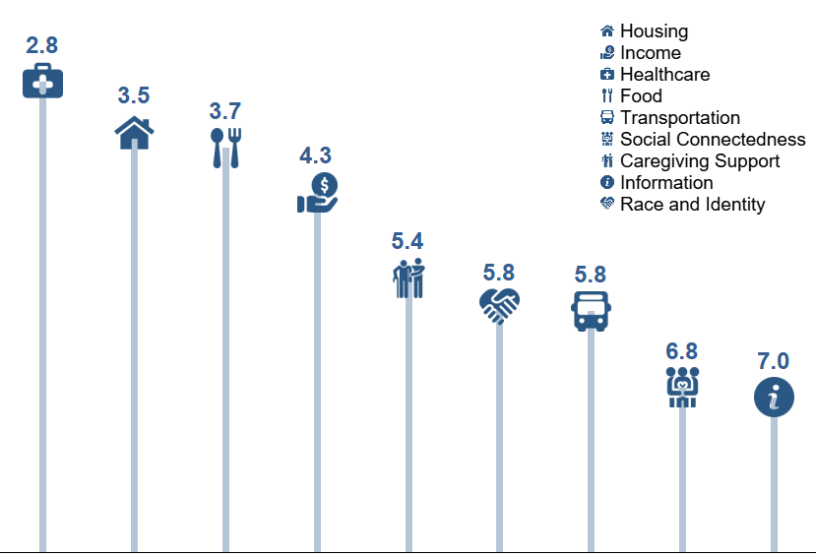
Needs ranking for survey respondents identifying as Asian
Average rank on a scale of 1 to 9 (1 = most important) from 125 responses¹⁵
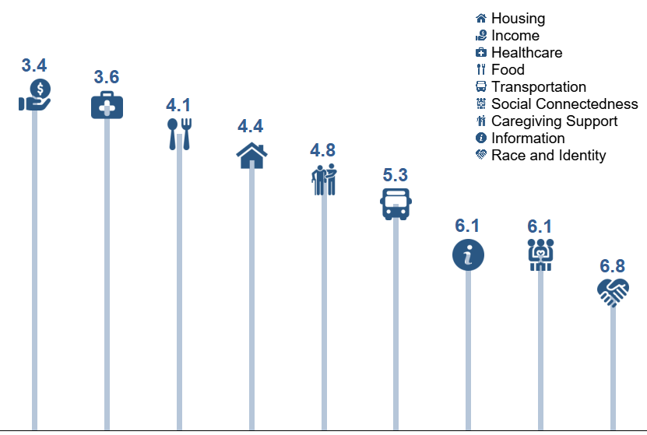
Needs ranking for survey respondents identifying as Black or African American
Average rank on a scale of 1 to 9 (1 = most important) from 138 responses¹⁵
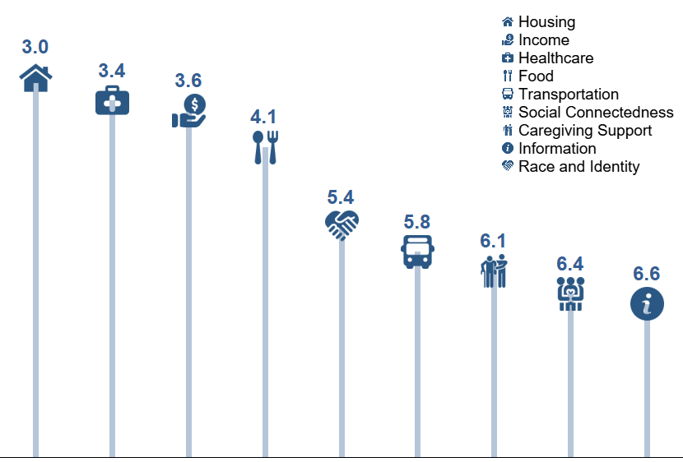
Needs ranking for survey respondents identifying as Latino or Hispanic
Average rank on a scale of 1 to 9 (1 = most important) from 71 responses¹⁵
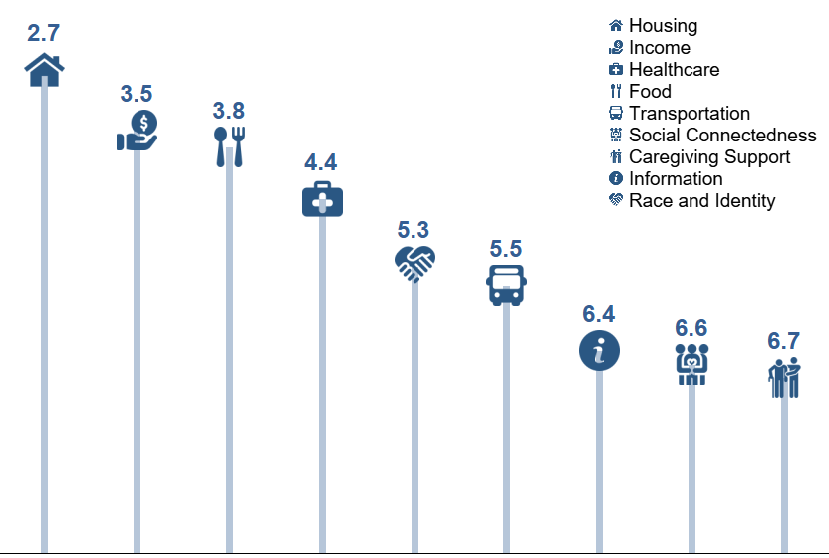
Needs ranking for survey respondents identifying as Middle Eastern
Average rank on a scale of 1 to 9 (1 = most important) from 22 responses¹⁵
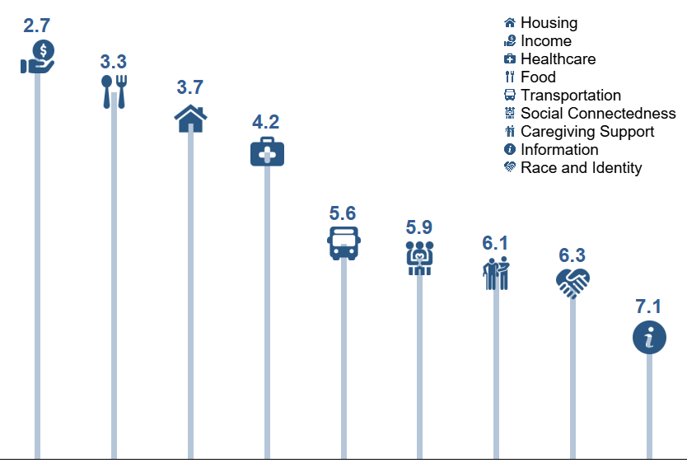
Needs ranking for survey respondents identifying as Native American or Alaska Native
Average rank on a scale of 1 to 9 (1 = most important) from 65 responses¹⁵
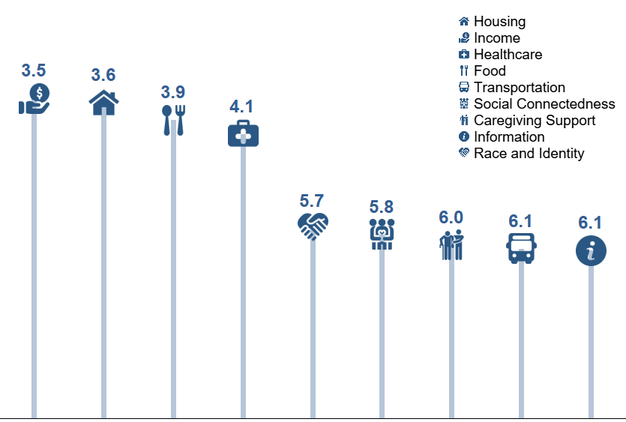
Needs ranking for survey respondents identifying as Native Hawaiian or Pacific Islander
Average rank on a scale of 1 to 9 (1 = most important) from 14 responses¹⁵
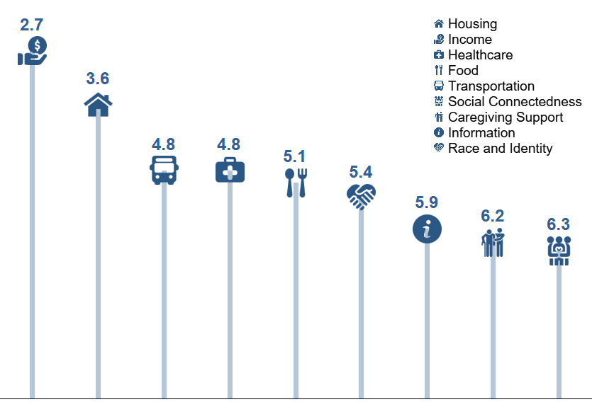
Needs ranking for survey respondents identifying as Slavic
Average rank on a scale of 1 to 9 (1 = most important) from 18 responses¹⁵
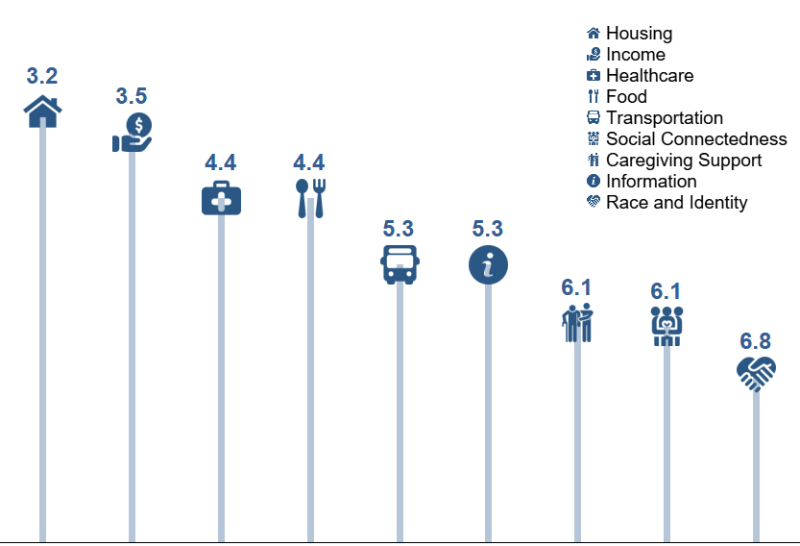
Needs ranking for survey respondents identifying as White
Average rank on a scale of 1 to 9 (1 = most important) from 695 responses¹⁵
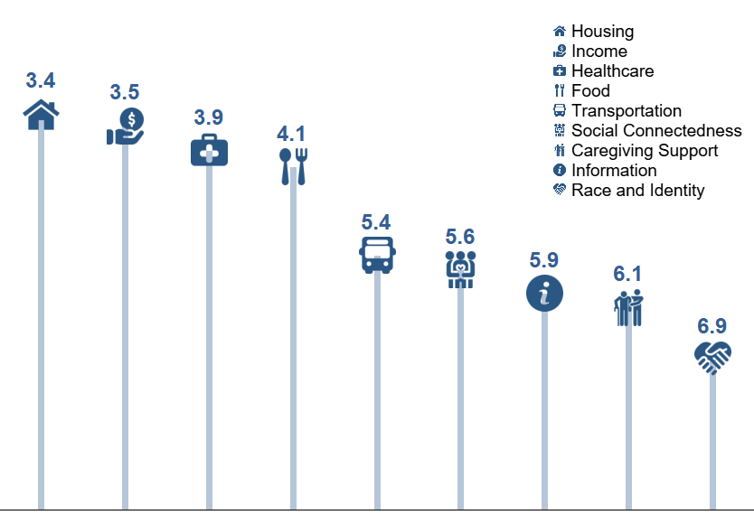
Needs ranking for survey respondents who chose to Self Identify Race or Origin
Average rank on a scale of 1 to 9 (1 = most important) from 57 responses¹⁵
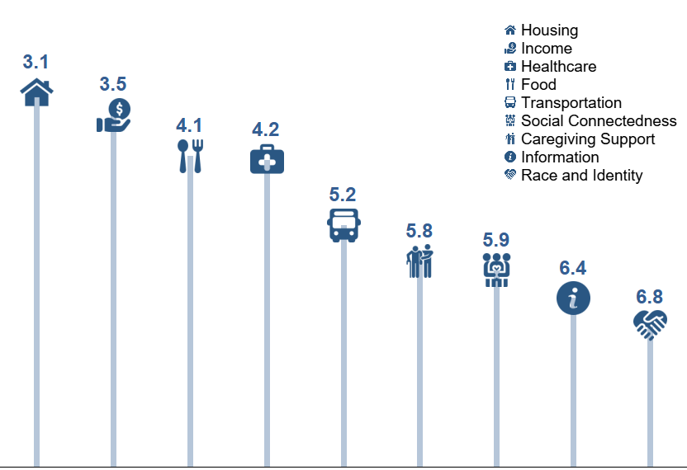
Needs ranking for survey respondents identifying as LGBTQ+
Average rank on a scale of 1 to 9 (1 = most important) from 163 responses¹⁵
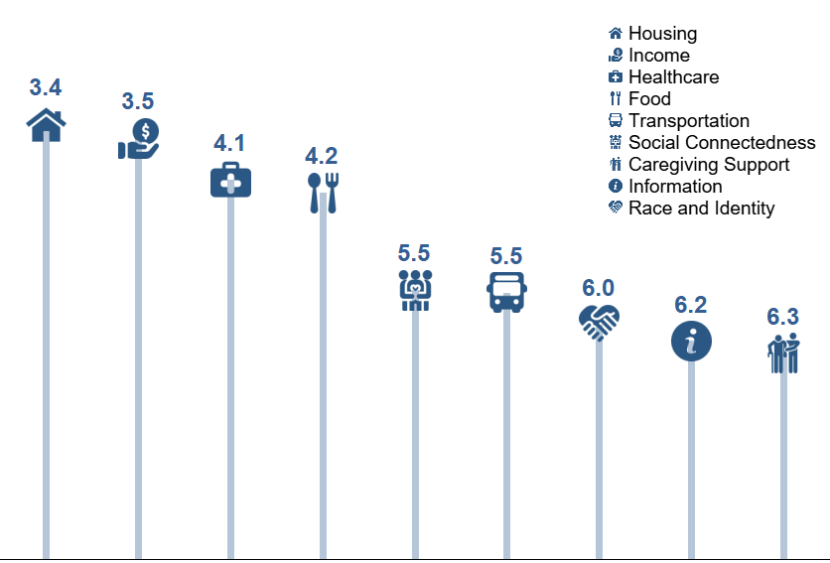
Needs ranking for survey respondents identifying as having a Disability
Average rank on a scale of 1 to 9 (1 = most important) from 443 responses¹⁵
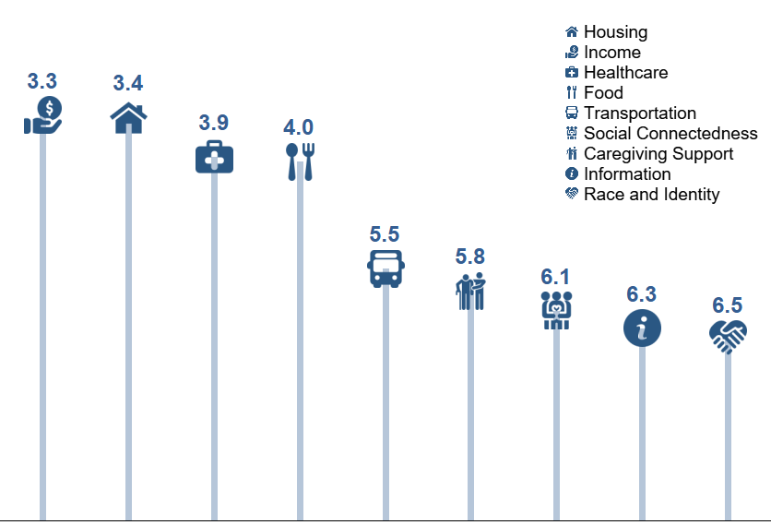
Needs ranking for survey respondents identifying as a Veteran or Served in the Military
Average rank on a scale of 1 to 9 (1 = most important) from 133 responses¹⁵
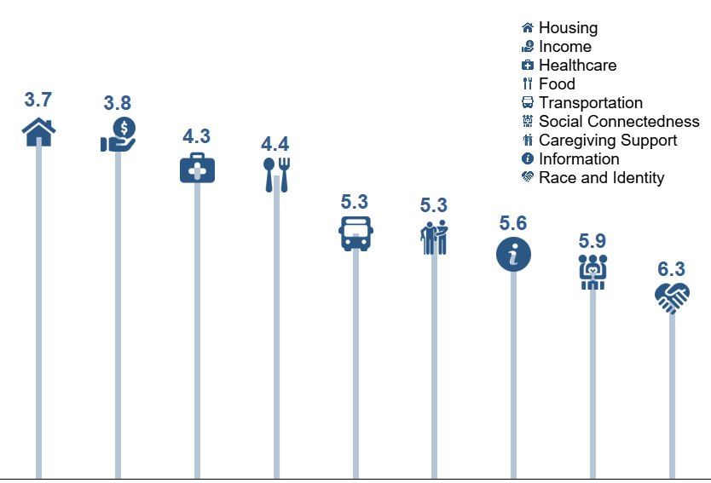
Needs ranking for survey respondents identifying as Homeless or Unhoused
Average rank on a scale of 1 to 9 (1 = most important) from 37 responses¹⁵
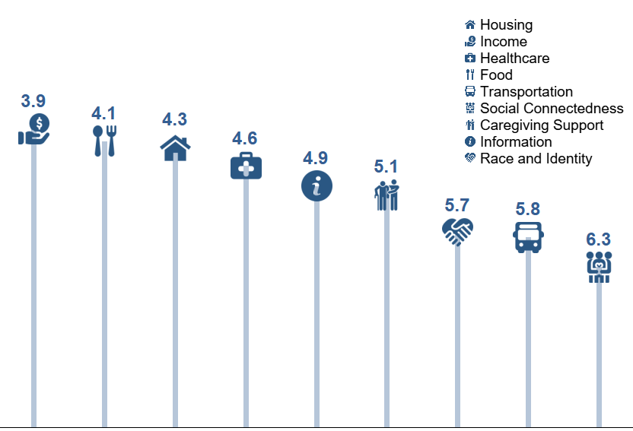
Needs ranking for survey respondents identifying as Transgender and Non-binary
Average rank on a scale of 1 to 9 (1 = most important) from 32 responses¹⁵
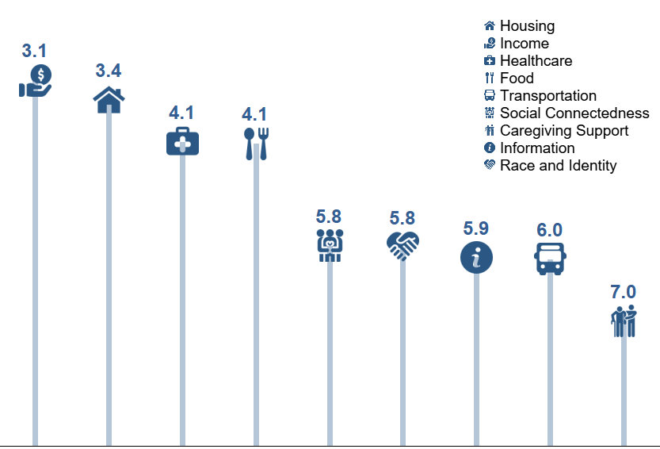
Needs ranking for survey respondents identifying as Female
Average rank on a scale of 1 to 9 (1 = most important) from 789 responses¹⁵
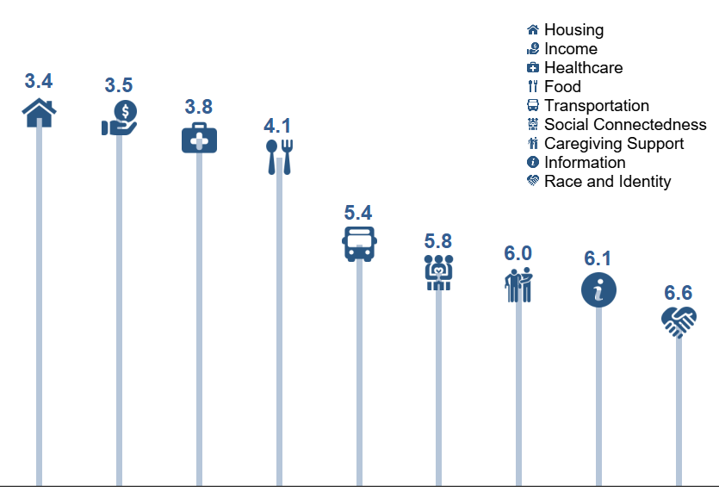
Needs ranking for survey respondents identifying as Male
Average rank on a scale of 1 to 9 (1 = most important) from 298 responses¹⁵
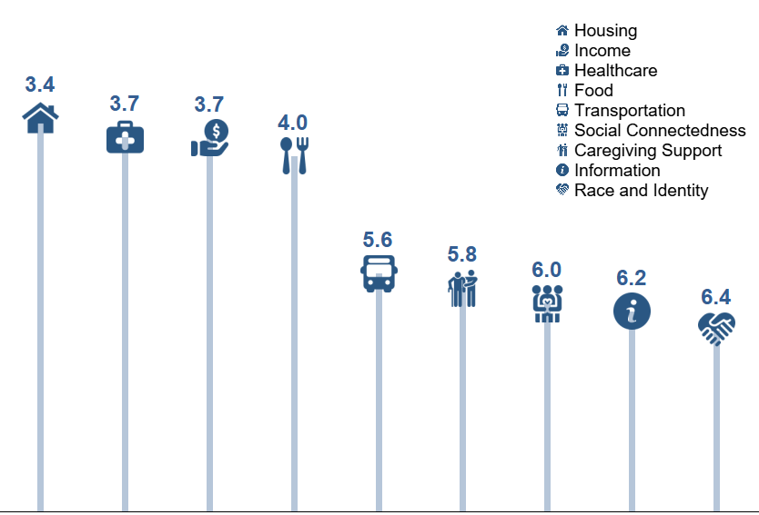
Needs ranking for survey respondents identifying as ages 18-49 with a Disability
Average rank on a scale of 1 to 9 (1 = most important) from 29 responses¹⁵
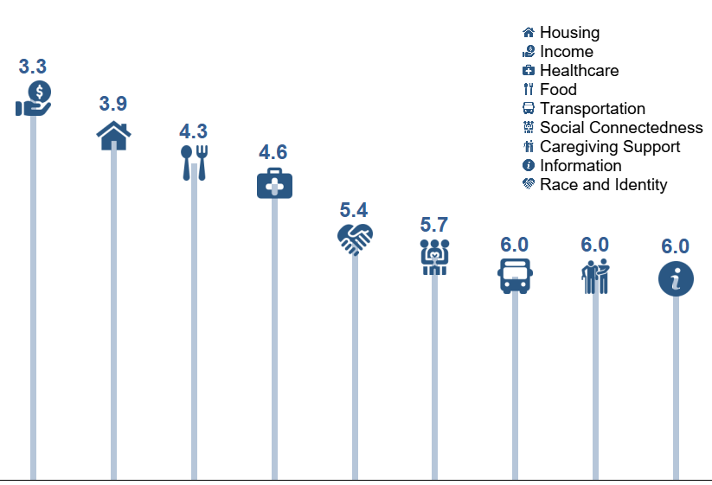
Needs ranking for survey respondents identifying as ages 50+
Average rank on a scale of 1 to 9 (1 = most important) from 1065 responses¹⁵
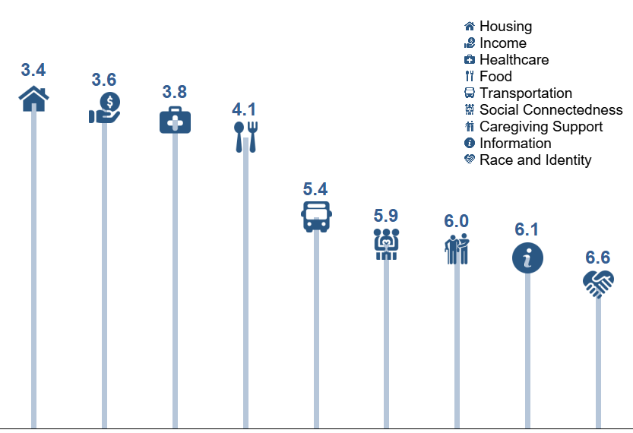

Older Adults and COVID-19 https://www.cdc.gov/coronavirus/2019-ncov/need-extra-precautions/older-adults.html
All estimates are for the 60+ population unless otherwise noted
Portland State University Population Research Center, https://www.pdx.edu/population-research/population-estimate-reports
All estimates are based on populations 60+ unless otherwise noted. [Estimates based on TIGER/Line GIS maps for census areas, ADVSD's shapefile with current district boundaries, Centers of Population for 2010 Census Tracts, 5-year ACS Public Use Microdata Sample (PUMS) for the period 2015-2019, 5-year ACS Summary File (SF) for 2015-2019, Race/ethnicity codes from our conference call, Race/ethnicity codes from OHA Office of Equity and Inclusion: REALD Implementation Guide, document OHA 7721B (10/20).]
Why We Lead with Race – https://multco.us/safety-trust-and-belonging-workforce-equity-initiative/why-we-lead-race
Digital Equity Needs and Opportunities Report - https://www.portlandoregon.gov/oct/article/545834
Municipal Broadband Fiber-to-the-Premises Feasibility Study Final Report https://multco.us/municipal-broadband
Hunger in Older Adults – https://www.mealsonwheelsamerica.org/docs/default-source/research/hungerinolderadults-fullreport-feb2017.pdf?sfvrsn=2
Oregon Health Authority, State Health Assessment – https://www.oregon.gov/oha/ph/About/Pages/HealthStatusIndicators.aspx
2019 Status of Hunger in Multnomah County - https://www.oregonhungertaskforce.org/the-problem
Prevalence of Multiple Chronic Conditions Among US Adults, 2018 - https://www.cdc.gov/pcd/issues/2020/20_0130.htm#:~:text=In%202018%2C%2051.8%25%20of%20US,those%20living%20in%20rural%20areas
Caregiving in the United States 2020 – https://www.aarp.org/ppi/info-2020/caregiving-in-the-united-states.html
FAMILY CAREGIVING IN OREGON: A SURVEY OF REGISTERED VOTERS AGE 40 AND OLDER – https://www.aarp.org/content/dam/aarp/research/surveys_statistics/ltc/2019/oregon-caregiving-survey-chartbook.doi.10.26419-2Fres.00259.033.pdf
2019 Year in Review: Community Cases – https://www.oregon.gov/dhs/SENIORS-DISABILITIES/DataBooks/APS%202019%20Data%20Book.pdf
Barriers to Justice - https://olf.osbar.org/lns/
Curry-Stevens, A., Cross-Hemmer, A., & Coalition of Communities of Color (2011). The Native American Community in Multnomah County: An Unsettling Profile. Portland, OR: Portland State University
NAYA History - https://nayapdx.org/about/history/
The State of Tribal Elders - https://www.nicoa.org/the-state-of-tribal-elders/
Results from this survey only reflect the ideas and opinions of the community members who responded to the survey and should not be used to represent the general population, groups, or individuals in Multnomah County.

