Multnomah County Homeless Youth Continuum

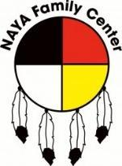
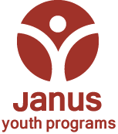


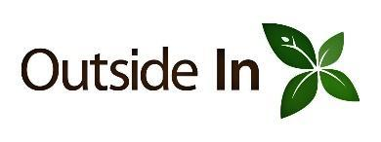



ed Entry
Coordinated Entry – Janus Youth Programs
Access Center (503) 432-3986, 24/7 access, safety off the streets
- Services targeted to youth ages 16-25; Youth under 18 are referred to the Alba Collaborative
- Street outreach & referrals from youth, child welfare, juvenile justice, schools, community
- Mobile screening and site-based access via the Access Center and 3 Day Program sites
- Single screening for all services. Prioritization based on vulnerability (including age and gender)
- Referral to appropriate services with warm hand-off
- Culturally specific services at IRCO & NAYA; Culturally responsive services at all agencies

- Culturally specific services at IRCO & NAYA; Culturally responsive services at all agencies
Assertive Engagement Service Delivery Model
Focus on relationship development and long-term community connections through Positive Youth Development &
culturally responsive practices
- Case management/Assertive Engagement
- Pregnant and Parenting Supports
- Alternative Schools
- Workforce Training, internships
- Health Care
- Flexible service funds to meet individual needs
- Integrated throughout the Continuum
- A/D & Mental Health Specialists and Peer Mentors
- Pro-social recreation & group recovery supports
Recovery Oriented Support
Youth engagement in recovery, connection to treatment, and aftercare

Safety
Coordinated entry & 24-hour safety off the streets

Wrap Around Support
Access & referral to education, employment, health care, & other aligned service systems

Housing
Safe, stable placements in a variety of settings with diverse service options

- Facility-based transitional housing
- Population specific & other shared housing
- Scattered-site community apartments
- Rapid re-housing and rent assistance
- Permanent Supportive Housing
- Access Center
- Crisis response
- Emergency & Short-Term Shelter
- Drop In Services
- Food & Hygiene
- Engagement opportunities
- Culturally Responsive Assessment (race/ethnicity, LGBTQ, gender)
- Culturally specific Drop-In Services

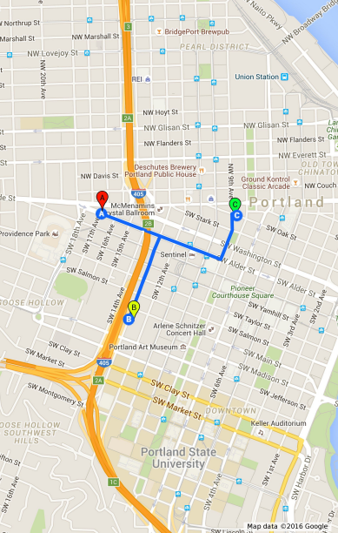
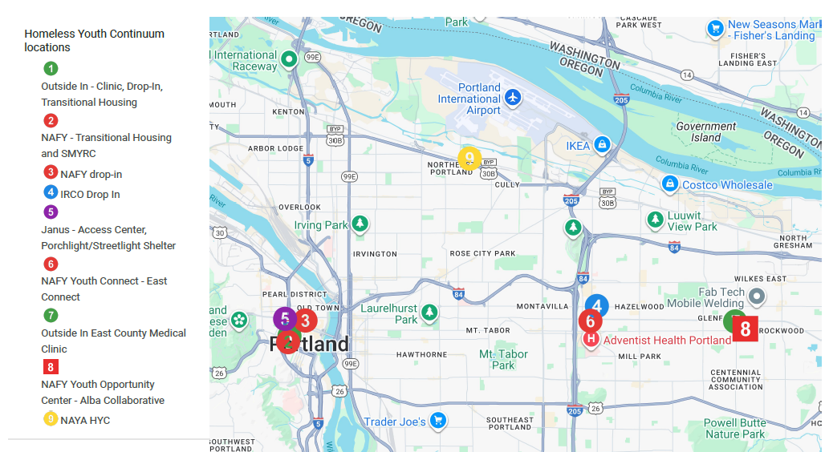
Outside In
outsidein.org
1132 SW 13th Ave
503-535-3849
Drop In Hours
Mon/Weds/Fri – meals only
Tues/Thurs – breakfast, 1pm-6pm
Saturday - CLOSED
Sun – 1pm-6pm
New Avenues for Youth
newavenues.org
314 SW 9th Ave
503-224-4339
outreach@newavenues.org

Drop In Hours
Monday-Saturday
9am-10am, 1pm-3pm, 3:30pm-6:30pm
Sunday - CLOSED
Native American Youth and Family Center
naypdx.org
5135 NE Columbia Blvd
503-288-8177
Drop In Hours - Weds/Thurs – 1pm-4pm
Food boxes by appt T/W/Th
Hygiene items by appt M/W/Th/F by appt Sat/Sun- CLOSED
Immigrant and Refugee Community Organization
irco.org
10401 NE Glisan St
503-234-1541
Drop In Hours
Mon-Fri – 12pm-7pm
Meals 1pm-2pm & 5pm-6pm
Community Activities –
Fri 4pm-6pm
Janus Youth Programs
janusyouth.org
1635 SW Alder St
503-432-3986

Screenings – call 8am-6pm
Shelter – arrive 8:45pm

There is no wrong door

