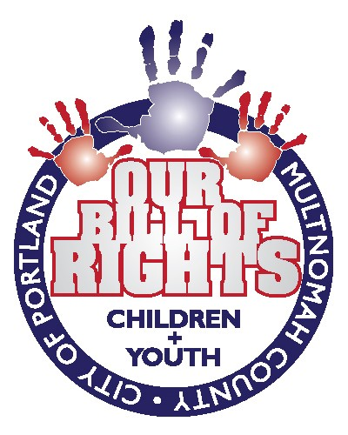

The Bill of Rights for the Children and Youth of the City of Portland and Multnomah County

We, the Children and Youth of the City of Portland, OR and Multnomah County, in order to establish our basic rights, to protect our liberties as human beings, to ensure ourselves a valuable education, and to assert the power to make choices for ourselves, affirm this Bill of Rights for Children and Youth. The decisions we make will affect our individual futures and happiness, as well the future prosperity of our local community and of the world. Therefore, we call upon ourselves and upon other individuals, organizations, elected officials, and government bodies to recognize these rights, to uphold them through observance, and to defend them through progressive legislative measures:

- Voice: We, the Children and Youth of Portland and Multnomah County, are entitled to a voice and opinion in decisions that will impact our lives.
  - Voice in Education: Students should have a say in their education and should be represented on school boards and other decision-making bodies.
  - Voice in Health: We have the right to know the reasoning behind any medical decision made on our behalf, as well as alternate options. We recognize that children should not have control over specific medical decisions; however, we expect that children are completely informed of such decisions and their consequences and as they mature are increasingly engaged in their own health decisions.
  - Voice in the Community: It is our right to be accepted and active members of the community. We have the right to ask questions, receive answers, and have our views acknowledged by adults when making decisions that affect our lives. We have the right to engage in respectful and open dialogue with adults and we insist on being taken seriously when we participate.

- Education: We, the Children and Youth of Portland and Multnomah County, are entitled to a quality public education that will help us succeed in the future, beginning in preschool and continuing through high school and beyond.
  - Extra-Curricular Activities: Extra-curricular activities, including athletics, the arts, linguistics, politics, and any other areas in which students express interest, should be made available to all students, and all students should be supported in their pursuits.
  - Curriculum and subjects: Children and youth are entitled to an education that equips them with basic skills and covers a variety of subjects.
  - Safety and Health of Students: Students’ physical and mental safety and health should be protected inside, outside, and around their school. Students are entitled to schools and playgrounds that are free of drugs and violence.
  - Individual Needs: Schools must respect and accommodate the learning abilities and aptitudes of all students. Children and youth have the right to express their own identity and to be respected for their individuality.
  - School Funding: Sufficient funding should be provided for all children and youth to have a successful educational experience. This may include supplying nutritionally sufficient foods, well-trained and paid teachers, appropriate and up-to-date materials, transportation to school, as well as any additional resources. Children and youth should have access to athletics and other activities regardless of their families’ ability to pay.
  - Preparation for the Future: Schools must provide students the tools deemed necessary for their personal advancement in all aspects of their educational life. Youth have the right to know all their options and choose their own desired path.

- Health: We, the Children and Youth of Portland and Multnomah County, have the right to physical, mental, and spiritual wellness.
  - Physical: We have the right to any medical care, nutrition, and fitness deemed necessary for our health. If children and youth or their families cannot afford medical care, appropriate care should be provided for them.
  - Mental: We have the right to emotional well-being, and the right to an adequate support system.
  - Spiritual: We have the right to follow our own spiritual path.

- General well-being: We, the Children and Youth of Portland and Multnomah County, have the right to be provided with the tools that will lead to a healthy and productive life.
  - Clothing: We have the right to sufficient clothing.
  - Shelter: We have the inherent right to shelter. The City of Portland and Multnomah County should continue their efforts to provide adequate shelter to those who need it.
  - Food: We have the right to access adequate nutrition, and the community should provide for this right.
  - Employment: We are entitled to any funds that we earn.

- Family, Home, and Community: We, the Children and Youth of Portland and Multnomah County, have the right to loving care and a healthy environment at home, as our homes, families and community provides the basis for our development.
  - Safety and Protection: We have the right to be safe in our homes and communities. Furthermore, we have the right to be protected from all types of abuse and exploitation, whether physical, verbal, emotional or sexual, and to be supported in reporting and combating abuse.
  - Love and Value: Every child should be loved, valued and respected. The community should be supportive and should have positive and high expectations of youth.
  - Influences and Role Models: We have the right to live in safe homes and communities with people whom we trust, and who love and guide us.
  - Privacy: We have the right to have privacy in our homes.
  - Freedom from Discrimination and Prejudice: We have the right not to be discriminated against based on our race, color, religion, sex, age, mental or physical disability, national origin, sexual orientation, marital status, familial status, political views, source of income, gender identity or any other basis prohibited by applicable federal, state, and local laws. Such discrimination poses a threat to the health, safety and general welfare of the citizens of Portland and Multnomah County and menaces the institutions and foundation of our community. We have the right not to tolerate any disparaging or insensitive attitudes aimed at the above characteristics.

- Recreation: We, the Children and Youth of Portland and Multnomah County, deserve access to safe and clean recreational areas.
  - Parks: We have the right to safe, clean, and affordable access to parks and facilities, at times, which are convenient to children and youth.
  - Culture: We have the right to access music, art, libraries and museums and other resources that could strengthen our creative and intellectual abilities.
  - Exercise: We have the right to be supported in our pursuit of a healthy lifestyle.
  - Fun: We have the right to experience freedom and enjoyment in a secure environment.

Acknowledgments: Shawn Biggers, Lacy Hawkins, Kelby Larson, Waverley Kronewitter, Jodi Meyerowitz, Margaux Mohler, Dolan Murvihill, Anna Peterson, Doug Piper, Jacob Reingold, Madeleine Rogers, Marina Rulevskaya, Emily Ryan, Claire Smith, Claudia Taber, Estela Vasquez, and the Children and Youth of Portland and Multnomah County.

Supervised by: Justice Evans, Karin Hansen, Sara Ryan, Joshua L Todd, Elizabeth Kennedy-Wong, and Meng Zhou

