SUN YOUTH ADVOCACY
WellSky Community Services Handbook

CONTENTS
SYA PROGRAM MODEL 1
DATA MILESTONES 1
ENTERING A CLIENT 2
RECORDING SERVICES 6
RECORDING YEAR END ANNUAL ASSESMENTS 9
REPORTING PROGRESS TOWARDS CASE PLAN GOALS 10
EXITING A CLIENT 11

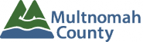

Questions? Contact the current SUN Data Tech or yfsdatasupport@multco.us https://wscs.wellsky.com/pdxmetroarea_hmis

Revised 03.05.2026

SYA WellSky Community Services Handbook - Revision History

- Revised July 2019: Removed ROI work flow
- Revised October 2018: Added Case Manger to workflow
- Revised June 2018: SYA will no longer enter Households
- Revised May 2018: SYA has its own Entry/Exit Assessments, title changes were made
- Revised October 2017: Added new ROI instructions
- Revised October 2016: Added ROI instructions to pg. 2, removed Attendance complies with school attendance policy (Y/N) from exit
- Revised April 2016: Updated Program Model based on 2016 SUN Service System Service Delivery Model, removed Health Insurance, Residence Prior, Disability and Employment History from entry/exit
- Revised June 2015: Added instructions for recording the Year-End Evaluation
- Revised March 2020: Added service category changes and definitions
- Revised August 2022: Edited SYA Data Milestone graphic to exclude ROI work flow
- Revised March 2026: Name revised from ServicesPoint to WellSky Community Services.

SUN YOUTH ADVOCACY PROGRAM MODEL

SUN Youth Advocacy (SYA) fosters youth development and academic achievement by providing a variety of year-round, school-linked, age-appropriate supports to children and youth who are at risk of academic failure and dropping out of school. SYA services are intended primarily to serve middle and high school-age students who are experiencing racial discrimination and structural barriers and who are traditionally underserved. Two areas of focus for SYA support are the transitions from elementary school to middle school and from middle school to high school, as these are key points at which students disengage and/or drop out of school.

Youth Advocates work closely with school staff to identify students who may need support, communicate about students’ needs and collaboratively support youth. Utilizing Assertive Engagement, Youth Advocates create a collaborative, person-centered relationship that allows youth to develop the motivation to change. The goal for SYA is to provide an adequate level and intensity of services and support to students so they can reach their individual goals and attain academic success.

SYA DATA MILESTONES
PROGRESS MONITORING
(Annually)
- Record Annual Assessment in each youth’s profile at the end of the school year

EXIT
- Exit client in WellSky Community Services
- Record progress towards case plan goals

SERVICES
(On going)
- Track services in WellSky Community Services
- All data entry is due by 15th of following month

ENTRY

- Create client profile in WellSky Community Services
Unless client is already in WellSky
- Create program entry for youth

ENTERING AN SYA CLIENT IN WellSky Community Services

- The program entry date should match the date on the client’s intake form and must be on or before the first service date.
- Please add clients sign a Consent to Share. Instructions can be found at:
https://multco.us/info/wellsky-community-services-and-grouptrail-handbooks-guides
1. ENTRY | Without a program entry, clients will not appear in reports
Entry Type | Always choose ‘Basic’
Entry Date | Date of program intake *Defaults to date of data entry - Remember to change*
Section I | Complete for All Household Members
SUN SS Contract | Choose appropriate regional or culturally-specific contract
Date of Birth
Gender
If Other Gender, specify
Inclusive Identity | Click ‘Add’ to enter a client’s self-identified race/ethnicity. Add as many as apply.  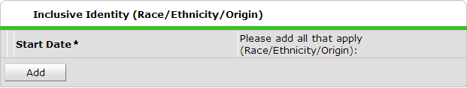
Primary Language
Primary Language-Other | Only required if Primary Language is ‘Other’ - Do not enter a second language
Highest Grade Completed | Do not select current grade
Zip Code of Last Perm Address | Zip code of current residence or last place of permanent residence if homeless
Current School Status
School | Only select current school (as of entry date)
Parental Release of Information | Yes or No
SSID Number | Required for anyone attending school (including alternative schools) or temporarily suspended
Risk Factors? (Y/N) | If yes, click ‘Add’ to specify all that apply
Risk Factor Type | Enter ALL known risk factors at time of entry. Additional factors may be added later as they become known. (See LIST below.)
RISK FACTORS TO IDENTIFY FOR SYA YOUTH
Behavior Issues Homelessness
Delinquent Behavior Individualized Education Plan (IEP)
English Not Primary Language Mental Health
Family Issues: Alcohol & Drugs Poor Academic Performance
Family Issues: Criminality Poor Class Attendance
Family Issues: Discord Poverty
Family Issues: Domestic Violence Substance Abuse
Family Issues: Mental Health Suspension/Expulsion
Foster Care Teen Pregnancy
Gang Involvement (or Risk of)

Section II | For YDC Youth ONLY at Latino Network, NAYA, and SEI
Is Youth being served with the HIGH SCHOOL Youth Developmental Council grant? | Yes or No
Is Youth being served with the MIDDLE SCHOOL Youth Developmental Council grant? | Yes or No

3. ADD CASE MANAGER

Click Case Managers on the Summary screen.

Click ‘Add Case Manager’
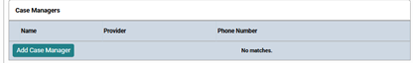

Check boxes next to student  Click the ‘Me’ option to set yourself as the Case Manager  Choose your agency’s SUN YOUTH Advocacy (SYA) 2570  Start Date should be the date you started working with the client.  Click ‘Add Case Manager’ | 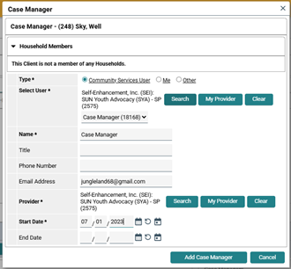
ADD Youth to a Case Manager’s caseload

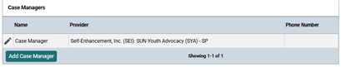
Click on “Pencil”

Enter the last date the Case Manager worked with the Youth.

Remove a Youth from a Case Manager’s caseload
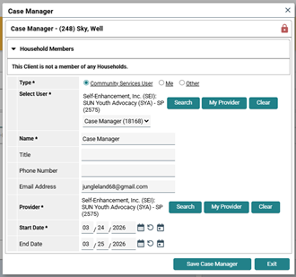

ENTERING SYA SERVICE TRANSACTIONS IN WELLSKY
- Services can be summed by category and entered on the last day of the service month.
- Services entered in Wellsky must match client case files in terms of: service month, type, and hours.

SERVICES
Start Date | Last day of the month services are provided in - if entering monthly
End Date | Leave blank
Service Type | Always Basic Needs - automatically fills if you select a provider-specific service
Provider-Specific Service | Select service (see definitions below)
Service Staff | Select staff person providing services; contact the helpline to update the list if necessary
Number of Units | Total # of service hours provided to client rounded to nearest 15 minutes (.25 hours)
Unit Type | Select Hours

SERVICE DEFINITIONS - SYA
Individual Youth Advocacy: The six categories that fall under this “1:1 Individual Youth Advocacy” bucket encompass activities that support individual students. These might be one-on-one meetings with students, but they also might be activities that have a direct benefit to a specific student. For example, an individual meeting with a student about healthy sleep would fall into this bucket, and so would collaborating with partners and family members to meet a student’s needs.

Cultural Identity Promotion: Cultural identity promotion activities use strengths-based approaches to further a student’s cultural identity and sense of belonging to community and school. This might include helping students learn about culture, advocating to incorporate culture into general studies, identifying cultural events, or encouraging students to lead after school clubs.
Examples:
- Helping a student access a culturally specific club/organization (MECHA, Black Student Union, Prism)
- Attending your school’s Unity Event at the request of a student
- Discussing cultural identity with student during 1:1 check-in

Educational Support: Activities that advance a student’s educational success. This includes working with students to identify academic needs, reviewing attendance and grades, building relationships with school staff, and involving families in their child’s education. Educational support might also include suggesting appropriate after school activities, coordinating field trips that meet student needs, and bringing guest speakers from the community.
Examples:
- Attending a student’s IEP meeting
- Advocating with school staff about any conflicts or student needs
- Reviewing a student’s attendance and grades
- In-class supports or tutoring activities

Goals & Success Plan: Activities that support students in identifying needs, developing goals, and achieving success. Can include one-on-one meetings with students, support for after school and in-class strategies, collaborating with partners to meet student needs, and creating opportunities for job skills, leadership roles, citizenship, etc.
Examples:
- Completing assessment and case plan goal documents with student
- Helping a student create a post-graduation plan
- Checking in with a student about accomplishing, or working towards accomplishing, goals

Life Skills: Activities that support students in developing life skills so that they can achieve their goals and feel supported by their advocate. Life skills emphasizes the one-on-one relationship between advocate and student, and might include helping students understand the importance of healthy minds and healthy relationships, or supporting students in acquiring job skills, leadership skills, or other skills needed to achieve their goals and success plan.

Examples:
- Helping a student by talking through how to navigate a complicated relationship
- Helping a student create a resume
- Discussing time management and school assignments with student

Resource & Referral: Resource and referral begins with assessing a student’s basic needs, identifying barriers to meeting those needs, and collaborating with staff and family to meet needs. May include working with family to complete referral paperwork for agency resources, contacting outside agencies for resources, and conducting home visits with family members.

Examples:
- Helping families find local mental health resources in their own language
- Completing referral documents for rent or energy assistance with family
- Accompanying a student and/or family to a SUN School food pantry or Free Food
Market

Wellness Promotion: Activities during one-on-one meetings that support students in identifying wellness needs and creating health goals. Some wellness topics might include healthy eating, hygiene, sleep habits, mental health, sports participation, and finding culturally appropriate health services.

Examples:
- Helping a student join a sports team
- Supporting/educating a student regarding nutrition goals during a lunch conversation

Group Advocacy: The “Group Advocacy” bucket contains activities that occur in a group setting. However, these group activities should occur in a specific format. They should have group norms and community building activities to create trust within that group.

Group Skill Building: Activities that occur within a group setting. Group activities work to build community, trust, and cohesion in order to increase student sense of belonging, form positive peer relationships, foster positive cultural identity, and increase leadership skills within students, as well as improve attendance.

Example:
- Facilitating groups during lunch
- Hosting an after-school cultural identity peer support group (affinity groups)
- Providing educational support in a group setting during out-of-school time (after school, summer, school breaks)

Collaborative Advocacy: An activity falls in the collaborative advocacy bucket when it focuses on supporting families in engaging with the school community and school system. Thus, if an advocate works with a family to support a specific student’s success (for example, to ensure an IEP is followed), that would fall under the “1:1 Individual Youth Advocacy” bucket. However, if an advocate encourages a family to join a parent leadership team at their school, that would fall here in the “Collaborative Advocacy” bucket.

Family & Community Engagement: Activities that build strong relationships with families and the school community to support family-school collaboration. Through consistent communication and relationship building, family and community engagement activities might include family and youth advisory groups, empowering families to advocate for themselves, increasing family knowledge of and engagement in their child’s education, helping families navigate the school system, and providing civic engagement opportunities.

Examples:
- Attending an IEP meeting with a student’s family member/s
- Helping a family member get connected to Family Leadership Team or other school-based family engagement committees
- Going with a family member to a parent teacher conference
- Assisting a family member in setting up access to ParentVue in Synergy
- Telling family members about culturally relevant events at school, and/or attending these events with the family

Note: Only track direct services provided by staff who are paid by SYA contract funding.

RECORDING AN SYA YEAR-END ANNUAL ASSESMENT EVALUATION
At the end of each school year, all youth expected to continue services in the coming year are required to have an SYA Annual Assessment in their Wellsky client record.

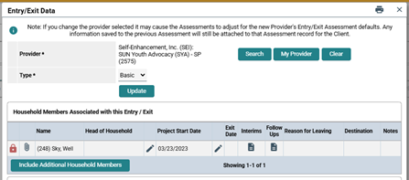

1. Click on the Interims icon in the current SYA program entry

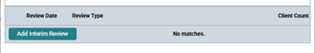
2. In the window that appears, click Add Interim Review

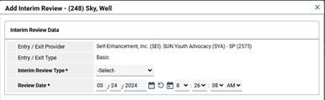
3. Set the Interim Review Type to Annual Assessment

4. Set the Review Date to the date that the Annual Assessment was completed

5. Click Save and Continue.

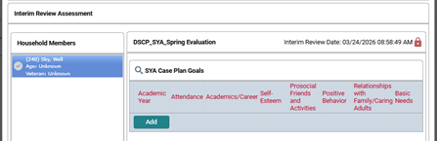

Click Add

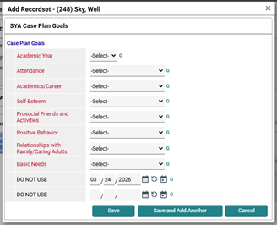

Select the current Academic Year

Record a youth’s progress towards case plan goals as of the end of the current academic year

Click Save to finish

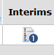
When you’ve successfully submitted the Annual Assessments you’ll see the count increase on the Interims Icon of the Entry/Exit tab

REPORTING PROGRESS TOWARD SYA CASE PLAN GOALS
- Use the following guidelines when recording progress towards case plan goals both during enrollment (in the Year-End Evaluation) and at the time of Exit for services.

ATTENDANCE
Includes:  - Get to school on time  - Attend every/some days  - Increase attendance | - Increase parent’s participation in getting youth to school  Does not include (where it should go):  - Participate in classroom activities (Academic/Career)
ACADEMIC/CAREER
Includes:  - Improve grades  - Turn in homework  - Attend afterschool tutoring or homework club  - Improve academic skills  - Increase benchmark scores  - Increase parent involvement in helping with academics  - Increase classroom participation | - Talk to teacher regarding assignments  - Graduation  - Job search  - Pre-employment experience framing or skill building  Does not include (where it should go):  - Reduce the number of behavior referrals or class disruptions (Positive Behaviors)  Improve getting to school on time or increase attendance (Attendance)
SELF-ESTEEM
Includes:  - Positive self talk  - Cultural connection/pride  - Healthy eating and physical activity  - Hygiene  - Attend therapy support or empowerment groups | Does not include (where it should go):  - Act as a role model (Positive Behaviors)  - Quit smoking (Positive Behaviors)  - Increase prosocial activities (Prosocial Activities/Friends)  - Speak respectfully to others (Positive Behaviors, or Family/Caring Adult if referring to teacher, caring adult/mentor or family member)
PROSOCIAL FRIENDS AND ACTIVITIES
Includes:  - Attend SUN community school or other enrichment classes  - Increase prosocial activities | - Community service projects  - Make new friends  - Hang out with prosocial friends  - Avoid drug using friends
POSITIVE BEHAVIOR
Includes:  - Decrease negative behaviors  - Quit smoking  - Act as a role model | - Stop getting into fights  - Improve communication skills (or use Family and Caring Adult Relationships category if referring specifically to teacher, caring adult/mentor or family member)

RELATIONSHIPS WITH FAMILY AND CARING ADULTS
Includes:  - Improve communication (if specifically with family members, teachers or other caring adult/mentor)  - Improve family relations  - Caring adults and mentors  - Apologize for previous behavior (if specifically with family, teacher or caring adult/mentor)  - Relationship with teacher | Does not include (where it should go):  - Choosing prosocial friends (Prosocial Activities/Friends)  - Increase prosocial activities (Prosocial Activities/Friends)  - Having a positive outlook (Self Esteem)  - Increasing prosocial behaviors (Positive Behaviors)  - Staying calm or staying out of fights (Positive Behaviors)
BASIC NEEDS
Includes:  - Housing  - Food related goals  - Identify community resources  - Acquire clothing  - Utilities  - Health/Mental Health (accessing services, getting glasses, etc.)  - School supplies | Does not include (where it should go):  - Talk to teacher about assignments (Academic/Career)  - Quit smoking or stop using drugs (Positive Behaviors)  - Improve cultural identity (Self Esteem)  - Increase listening skills (could be Family/Caring adults if specific to them or Positive Behaviors)  - Positive energy (Self Esteem)  - Hygiene (Self Esteem)  - Job Search (Academic/Career)

EXITING SYA CLIENTS FROM WELLSKY

- Do not exit a client for summer break. If there is any chance they will continue services in the fall, leave their Entry / Exit open. If they do not resume services in the fall, exit them as of their last service date.
EXIT
Exit Date | Defaults to data entry date. *Change to the last service date.
Reason for Leaving
Destination
Section I
Current School Status at Exit
Section II
Case Plan Goals | Enter progress towards each goal. (See section above for guidance.)

