**Agency LOGO**

**Multnomah County**  Case Manager Name:

**Family Caregiver Support Program**  Email:  
 Phone:

**Welcome!**

Now that you’ve joined our Family Caregiver Support Program (FCSP) at Multnomah County, here’s what to expect. Our Family Caregiver Support Program works creatively to meet the needs of our participants. A list of this year’s trainings, support programs, and community events are included with this letter. Please contact your Case Manager to learn about the details and to sign up.

**What to expect from your Case Manager:**

* Your Case Manager will schedule a time to discuss your caregiving situation utilizing the Oregon Caregiver Assessment Tool (OCAT).
* Your Case Manager will work with you to develop a support plan based on the OCAT and determine which parts of FCSP would best serve you.
* Your Case Manager will be your resource advocate. As new needs arise, please reach out to them for support.
* Your Case Manager can help connect you with the trainings, support groups, and community events offered by FCSP.

The Aging, & Disability Resource Connection (ADRC) provides 24/7 assistance and is an additional way to learn about other county programs and resources outside of the Family Caregiver Support Program. (This is not an emergency help line.)

**Aging Disability Resource Connection:**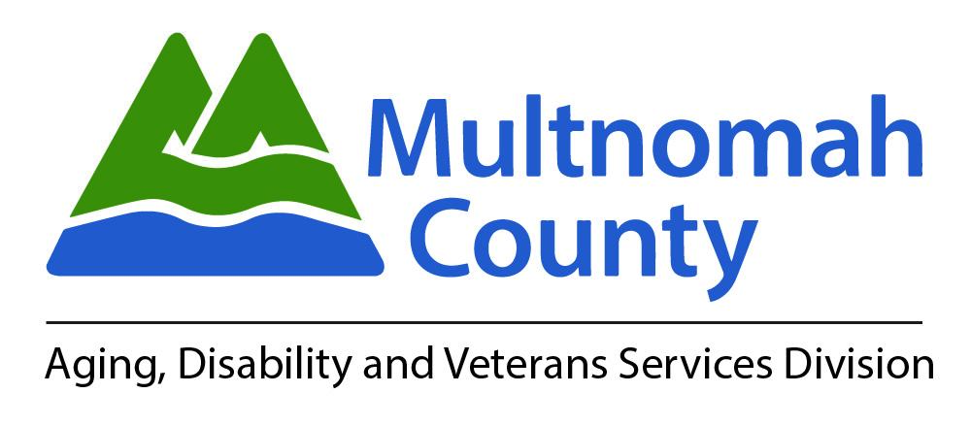

Phone: 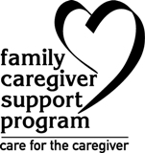(503) 988- 3646.

Email: [ADRC@multco.us](mailto:ADRC@multco.us)